How to connect to Oracle SQL server from Power BI?

To find the server name of the oracle SQL server, type the below in Query in the SQL developer

select sys_context('USERENV','SERVER_HOST') from dual

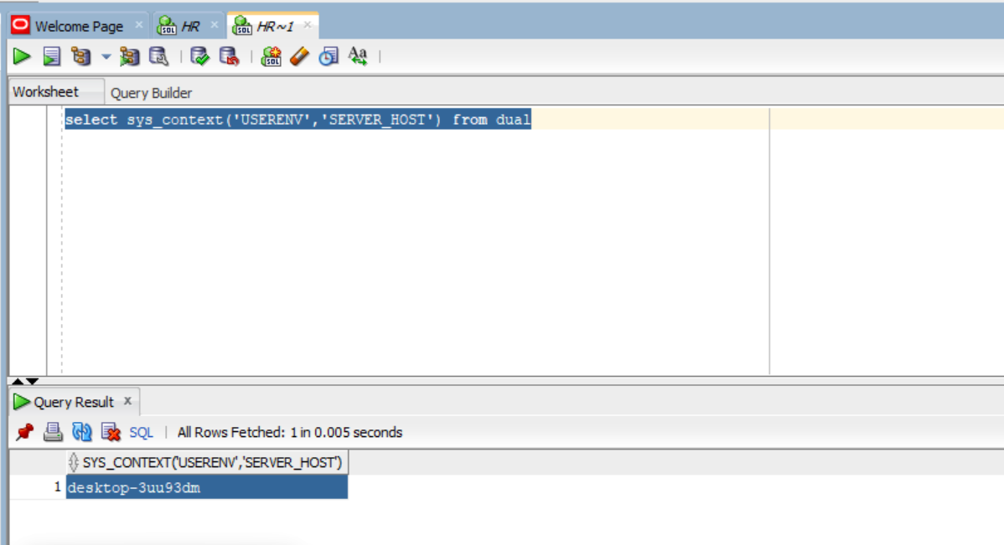

This is the server name to be Provided in the Power BI

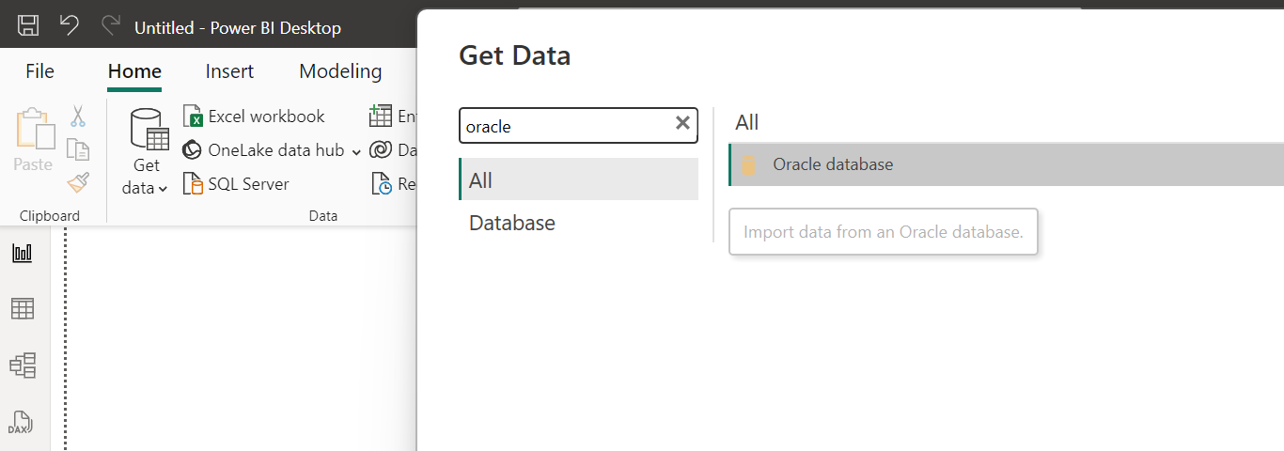

Select Direct Query option…….

Under Advanced Options write the Query to extract the data from the database, donot provide semicolon at the end of the query

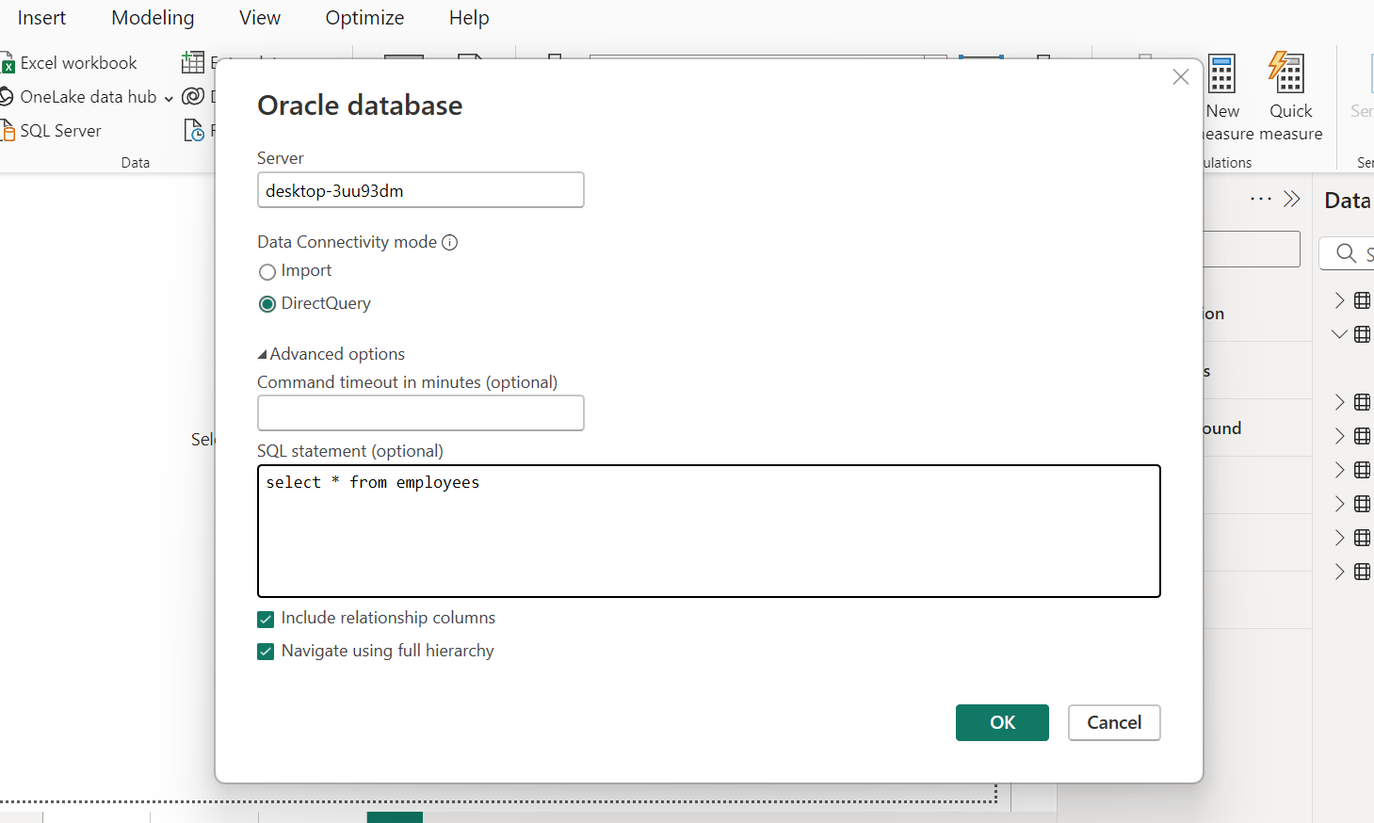

Insert into HR.EMPLOYEES (EMPLOYEE_ID,FIRST_NAME,LAST_NAME,EMAIL,PHONE_NUMBER,HIRE_DATE,JOB_ID,SALARY,COMMISSION_PCT,MANAGER_ID,DEPARTMENT_ID) values (207,'Prathyush','Reddy','REDDY016','515.123.4567',to_date('17-06-03','DD-MM-RR'),'AD_PRES',20000,null,null,90);

commit;