Privacy-Preserving Heart Disease Prediction
using Federated Learning
Part 3 — Backend, System Architecture & Integration
High-Level Design Reference Document
Internal engineering reference · Team Partial Derivatives

Table of contents
1. Purpose & scope
2. Architecture decisions
3. High-level architecture
4. Communication design
5. Database schema (MySQL, owned by Spring Boot)
6. Security model (summary)
7. Federated learning lifecycle (Flower)
8. Design patterns in use
9. Cross-part integration
10. Deployment topology
11. Appendix — resilience details

1. Purpose & scope
This document is the backend architecture reference for Part 3 of the project. It specifies the services, communication protocols, data model, security model, and integration contracts needed to build and deploy the backend without re-litigating design decisions already made.
It assumes the reader is on the team and has context on Parts 1, 2, and 4 — it does not re-explain federated learning fundamentals except where they directly affect backend design.

1.1 Tech stack
Layer | Technology
Frontend | React.js + Tailwind CSS
Main backend | Spring Boot (Java) — modular monolith
ML / FL service | FastAPI (Python)
Federated learning | Flower
ML | Scikit-learn
Data processing | Pandas + NumPy
Database | MySQL
Internal service comms | gRPC (HTTP/2, server streaming)
External / client comms | REST (JSON)
Containerization | Docker + docker-compose
Testing | Postman (REST + gRPC), JUnit, Pytest

2. Architecture decisions
Each row is a decision this document treats as closed. Re-opening one requires a new trade-off discussion, not a silent deviation.
Decision | Choice | Reasoning (short)
Service count | 2 services (Spring Boot + FastAPI) | Only 2 genuine bounded contexts: app/state vs. ML compute. No independent scaling or team-ownership need for more.
Style | Not microservices — modular monolith + 1 compute service | Microservices properties (own DB per service, independent scaling, service discovery) don't apply at this scale.
Client-service comms | REST / JSON | Browser-native, simple, cacheable, easy to test with Postman.
Internal service comms | gRPC, HTTP/2, server streaming | Replaces polling with live round-by-round push; strict typed contracts across Java/Python.
Training progress delivery | Server-streaming RPC + reconciliation on reconnect | Avoids polling waste; reconciliation (not a broker) is the right-sized durability fix for a 2-service system.
Auth model | JWT, role-based (ADMIN / HOSPITAL), tenant-scoped queries | Real multi-tenant isolation without a separate auth service — one enforcement point.
Data ownership | Spring Boot owns MySQL; FastAPI is stateless compute + job registry | Access control and persistence live in one place; FastAPI never touches PII.

3. High-level architecture
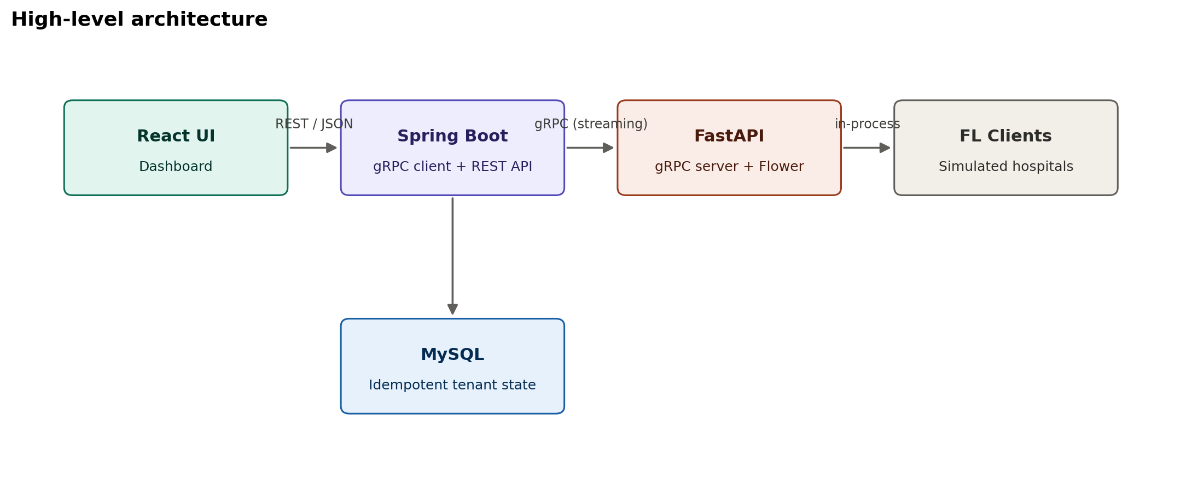

3.1 Service inventory

Spring Boot — main backend (modular monolith)
Single deployable JAR, organized as internal modules. Each module below maps to a Java package, not a separate service.
Module | Responsibility
auth | Login, JWT issuance/validation, refresh rotation, role checks
tenant | Hospital registry, tenant-scoped repository helpers
training | Orchestrates FL sessions via gRPC client, persists round results
prediction | Accepts patient input, calls FastAPI Predict RPC, stores result
metrics | Serves global/comparison metrics to the dashboard
audit | Writes append-only audit_log rows for sensitive actions

FastAPI — ML / FL service
Module | Responsibility
grpc_server | Implements the FLOrchestrator service (see §4.2)
job_registry | Tracks in-flight training sessions, idempotency keys
flower_runner | Drives Flower server + simulated clients, FedAvg aggregation
model_store | Joblib serialization, per-round checkpointing
predictor | Loads active model, runs inference

4. Communication design

4.1 Public REST API (React ↔ Spring Boot)
Endpoint | Role access | Purpose
POST /api/v1/training/start | ADMIN | Start a new FL session
GET /api/v1/training/status | ADMIN, HOSPITAL (scoped) | Live round/status (backed by SSE or polling fallback)
GET /api/v1/clients | ADMIN | Full hospital roster + status
GET /api/v1/clients/me | HOSPITAL | Own client status only
GET /api/v1/metrics/global | ADMIN, HOSPITAL | Global accuracy/loss per round (aggregate — shared)
GET /api/v1/metrics/comparison | ADMIN, HOSPITAL | Centralized vs. federated comparison
POST /api/v1/predict | ADMIN, HOSPITAL | Run prediction on patient input
GET /api/v1/predictions | ADMIN (all), HOSPITAL (own) | Prediction history
GET /api/v1/model/info | ADMIN, HOSPITAL | Active model version metadata

4.2 Internal gRPC contract (Spring Boot ↔ FastAPI)
Not exposed to the browser. Runs on the internal Docker network only (see §7).
service FLOrchestrator {
rpc StartTraining(StartTrainingRequest) returns (StartTrainingResponse);
rpc StreamTrainingProgress(TrainingProgressRequest) returns (stream RoundUpdate);
rpc GetTrainingStatus(StatusRequest) returns (StatusResponse);
rpc Predict(PredictRequest) returns (PredictResponse);
rpc GetModelInfo(ModelInfoRequest) returns (ModelInfoResponse);
}
StartTraining carries a client-generated idempotency_key. StreamTrainingProgress is the steady-state channel for live round updates; GetTrainingStatus is used only for reconciliation after a stream disconnect, never for steady-state polling.

5. Database schema (MySQL, owned by Spring Boot)
FastAPI never connects to MySQL directly — all persistence goes through Spring Boot.
Table | Key columns | Notes
hospital | id, name, contact_email | Tenant registry — first-class entity, not a label
user | id, username, password_hash, role, hospital_id (FK, null for admin) | bcrypt hashes only
training_session | id, status, total_rounds, idempotency_key (unique) | One row per FL run
federated_round | id, session_id (FK), round_number, global_accuracy, global_loss, checkpoint_path | checkpoint_path enables resume/rollback
client_round_status | id, round_id (FK), hospital_id (FK), local_accuracy, local_loss, sample_count | Per-hospital, per-round — tenant scoped
model_version | id, session_id (FK), round_number, model_path, accuracy, precision, recall, f1, is_active | Exactly one is_active=true at a time
prediction | id, hospital_id (FK, nullable), model_version_id (FK), patient_features (JSON, encrypted), result | Tenant scoped; JSON column encrypted at rest
comparison_result | id, session_id (FK), approach_type, accuracy, f1_score, training_time_sec | Generic row shape for centralized vs. federated
audit_log | id, user_id, action, resource_id, ip_address, created_at | Append-only, never updated or deleted

6. Security model (summary)
Layer | Control
Authentication | JWT access (~15 min) + rotated refresh token; bcrypt password hashing; lockout after failed attempts
Authorization | Role check at method entry (deny-by-default) + tenant_id sourced from JWT, never from request body
Transport | TLS on React↔Spring Boot; TLS/mTLS on Spring Boot↔FastAPI gRPC
Data at rest | patient_features JSON encrypted at column level; model artifacts on restricted-permission storage
Secrets | No secrets in Git; injected via environment / container secrets at runtime
API hardening | Bean Validation / Pydantic input validation, rate limiting on /predict and /login, strict CORS, standard security headers
Audit trail | Append-only audit_log; trace ID propagated React → Spring Boot → gRPC metadata → FastAPI
FL-level privacy | Only weight/gradient updates cross the client↔server boundary — enforced by protocol design, not policy
Differential privacy and secure aggregation are documented as roadmap items, not implemented — see §9.

7. Federated learning lifecycle (Flower)
This describes how a training session actually executes inside FastAPI, since it's the part of the system Spring Boot orchestrates but doesn't implement.
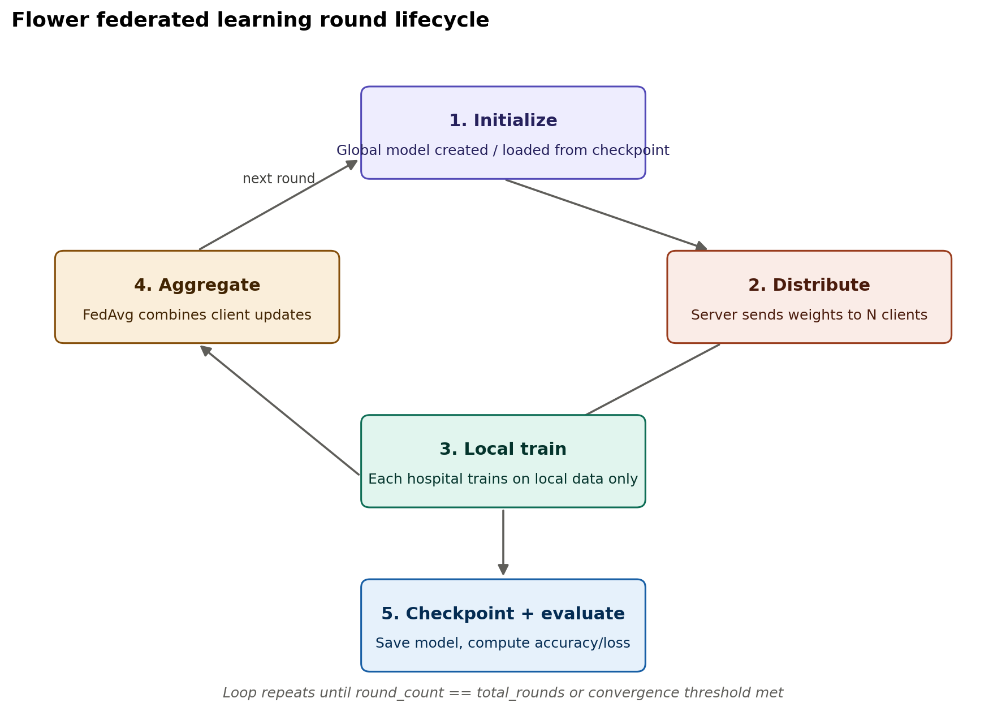
Stage | What happens | Persisted by Spring Boot
Initialize | Global model created, or resumed from last checkpoint if reconciling | training_session row created (or resumed)
Distribute | Server sends current global weights to all simulated hospital clients | —
Local train | Each client trains on its own partition only (Part 2 output); no raw data leaves the client process | —
Aggregate | FedAvg combines client weight updates into a new global model | —
Checkpoint + evaluate | Model serialized to disk; accuracy/loss computed | federated_round row + checkpoint_path
Repeat / stop | Loop continues until total_rounds reached or convergence threshold met | training_session.status updated to COMPLETE

8. Design patterns in use
Pattern | Where | Why
Backend-for-frontend / thin orchestrator | Spring Boot in front of FastAPI | One place for auth, validation, and reshaping — frontend never talks to ML compute directly
Repository pattern | Spring Data JPA repositories, tenant-scoped | Query-level tenant isolation instead of response filtering
Idempotency key | StartTraining RPC | Safe retries on network failure without double-starting training
Circuit breaker + retry with backoff | Spring Boot → FastAPI gRPC client (Resilience4j) | Fail fast instead of cascading when FastAPI is unavailable
Reconciliation on reconnect | StreamTrainingProgress consumer | Recovers from a dropped stream without restarting training
Strategy pattern | Aggregation algorithm selection (FedAvg now, FedProx future) | Swap the aggregation strategy without touching orchestration code
Adapter | FastAPI's grpc_server module wrapping Flower's native API | Keeps Flower's API surface isolated from the gRPC contract
Append-only log | audit_log table | Tamper-evident trail; never mutated after insert

9. Cross-part integration
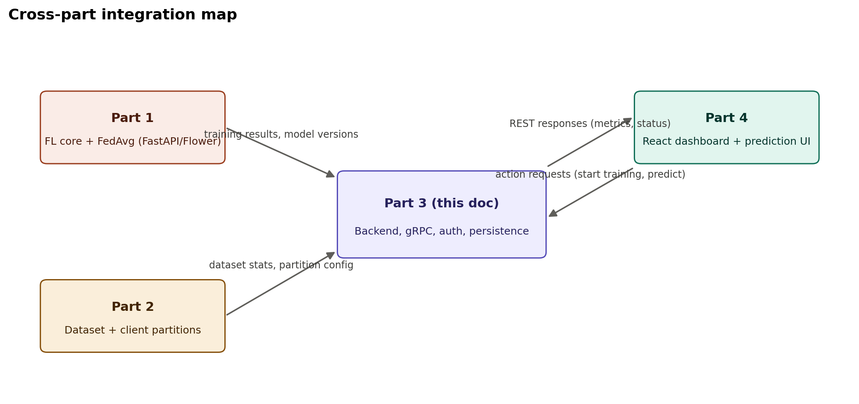

Part 1 (FL core) → Part 3
- Part 1's FedAvg implementation runs inside FastAPI's flower_runner module — it is not a separate service, it's imported and driven by the gRPC server.
- Contract: Part 1 exposes a Python function/class that flower_runner calls per round; it returns (weights, metrics) which the gRPC server turns into a RoundUpdate message.

Part 2 (dataset) → Part 3
- Part 2's partitioned datasets are loaded by the simulated FL clients at startup — Part 3 does not process raw data, only receives dataset statistics (row counts, feature list) to store for dashboard display.
- Contract: a small stats.json (or function call) from Part 2's pipeline feeding the hospital roster's sample_count.

Part 3 → Part 4 (frontend)
- All Part 4 requests go through the public REST API in §4.1 — Part 4 never calls FastAPI or the database directly.
- Live round updates reach the browser via Spring Boot (REST polling or SSE) — the gRPC stream stops at Spring Boot, per §4.2.

10. Deployment topology
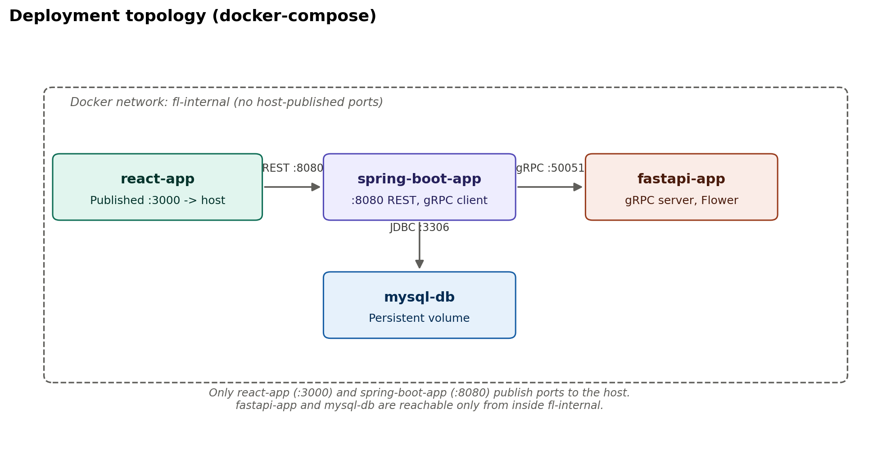
docker-compose brings up all four containers on a shared internal network. Only react-app and spring-boot-app publish ports to the host; fastapi-app and mysql-db are unreachable from outside the network by construction, not convention.

11. Appendix — resilience details

11.1 Reconciliation flow on stream disconnect
- StreamTrainingProgress connection drops (network blip, container restart).
- Spring Boot calls the unary GetTrainingStatus RPC.
- Compares returned current_round against MAX(round_number) already in federated_round.
- Re-subscribes to StreamTrainingProgress from the next expected round — no restart, no duplicate rows.

11.2 What's built vs. roadmap
Built now | Roadmap (documented, not implemented)
JWT auth, tenant-scoped queries, TLS, audit log, rate limiting, input validation, circuit breaker, idempotency | Differential privacy (noise on gradients), secure aggregation (cryptographic), full mTLS with a proper CA, cross-device FL at real hospital scale

