**HematoVision: Advanced Blood Cell Classification Using Transfer Learning**

|  |  |
| --- | --- |
| Date | 15 June 2025 |
| Team ID | LTVIP2025TMID35473 |
| Project Name | **HematoVision: Advanced Blood Cell Classification Using Transfer Learning** |
| Maximum Marks | 4 Marks |

**Team Leader :** C Prathyusha

**Team member :** C Rachana

**Team member :** M Radhika

**Team member :** Shaik Narasapuram Riyaz

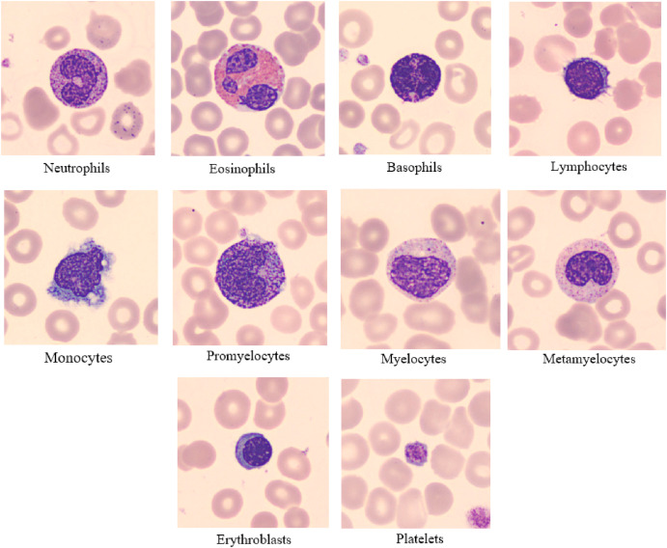

INTRODUCTION :

Hematovision, in the context of blood cell classification, refers to the use of advanced computational techniques, specifically deep learning and transfer learning, to analyze microscopic images of blood samples and automatically classify different types of blood cells, particularly white blood cells (WBCs). Transfer learning, in this context, involves leveraging pre-trained deep learning models, often convolutional neural networks (CNNs), that have been trained on large datasets, to accelerate and improve the accuracy of classifying WBCs into different categories like neutrophils, lymphocytes, monocytes, eosinophils, and basophils. This approach allows for more efficient and accurate identification of various blood cell types, which is crucial for diagnosing and monitoring a wide range of diseases.

Elaboration:

* **Blood Cell Classification:**

Blood cells, including red blood cells (RBCs), white blood cells (WBCs), and platelets, play vital roles in oxygen transport, immune response, and blood clotting. WBCs, in particular, are crucial for the immune system and their subtypes (neutrophils, lymphocytes, monocytes, eosinophils, and basophils) have distinct functions and appearances. Abnormalities in WBC counts or types can indicate various diseases, including leukemia and other infections.

* **Traditional Methods:**

Traditionally, blood cell classification relied on manual microscopic examination by trained technicians, a time-consuming and potentially subjective process.

* **Deep Learning and Transfer Learning:**

Deep learning, especially CNNs, has emerged as a powerful tool for image analysis and classification. Transfer learning, a technique within deep learning, allows researchers to adapt pre-trained models (trained on massive datasets like ImageNet) to new tasks, like blood cell classification, without requiring extensive training from scratch. This significantly reduces computational resources and training time while potentially improving accuracy.

* **Hematovision in Practice:**

Hematovision, therefore, utilizes these advancements in deep learning and transfer learning to analyze blood cell images, automate the classification process, and enhance diagnostic accuracy.

* **Benefits of Hematovision:**
  + **Increased Accuracy:** Deep learning models can achieve high accuracy in classifying WBCs, potentially outperforming human experts in some cases.
  + **Efficiency:** Automation of the classification process saves time and resources, allowing for faster diagnosis and treatment.
  + **Reduced Subjectivity:** Deep learning algorithms provide consistent and objective classifications, reducing the variability associated with manual analysis.
  + **Potential for New Discoveries:** By analyzing large datasets of blood cell images, deep learning models can potentially identify subtle patterns and correlations that may be missed by human observation, leading to new insights into disease mechanisms.
* **Examples of Hematovision Applications:**
  + **Leukemia Diagnosis:** Accurately identifying and classifying abnormal WBCs in leukemia patients is crucial for timely diagnosis and treatment.
  + **Infection Detection:** Analyzing WBC types can help identify the type and severity of infections.
  + **Monitoring Treatment Response:** Tracking changes in WBC populations can help assess the effectiveness of treatment strategies.
* **Future Directions:**

Research in hematovision is ongoing, with efforts to improve model accuracy, develop more interpretable AI models, and integrate these systems into clinical workflows

PROJECT OVERVIEW :

Hematovision, likely referring to a system for blood cell classification using transfer learning, involves using pre-trained convolutional neural networks (CNNs) to analyze microscopic blood cell images. This approach aims to improve accuracy and efficiency in blood cell analysis by leveraging the knowledge gained from large datasets used to train the initial CNN models

PURPOSE :

The purpose of "Hematovision," which utilizes transfer learning for advanced blood cell classification, is to improve the accuracy and efficiency of blood cell analysis, particularly in the diagnosis of hematological disorders. This approach aims to assist medical professionals in identifying and categorizing blood cells more effectively, potentially leading to earlier and more precise diagnoses of various diseases

IDEATION PHASE:

The idea phase for "Hematovision: Advanced Blood Cell Classification using Transfer Learning" focuses on leveraging pre-trained deep learning models, particularly Convolutional Neural Networks (CNNs), and transfer learning techniques to automate and enhance the classification of blood cells from microscopic images. This involves exploring different CNN architectures, optimizing the training process, and potentially developing a novel CNN model specifically for this task.

PROBLEM STATEMENT :

The "Hematovision" project aims to develop an advanced blood cell classification system using transfer learning, specifically focused on classifying white blood cells (WBCs) from microscopic images. The challenge lies in accurately identifying and categorizing various WBC types (e.g., neutrophils, lymphocytes, monocytes) from complex microscopic images, a task traditionally performed manually and prone to human error. By leveraging transfer learning with pre-trained deep learning models, the project seeks to create a robust, automated, and efficient solution for this crucial aspect of hematological analysis.

Here's a more detailed breakdown of the problem:

1. Problem Domain:

* **Hematological Analysis:**

Blood cell classification is a cornerstone of modern healthcare, providing vital insights into a patient's health status and aiding in the diagnosis of various diseases, including infections, autoimmune disorders, and hematological malignancies like leukemia.

* **Manual Limitations:**

Traditionally, blood cell counting and classification are performed manually by trained technicians, a process that is time-consuming, labor-intensive, and prone to subjective interpretation and human error.

* **Need for Automation:**

Automated systems using deep learning and image processing technologies are increasingly necessary for efficient, accurate, and objective WBC classification, improving patient outcomes and enabling faster disease detection.

EMPTHY MAP CANVAS :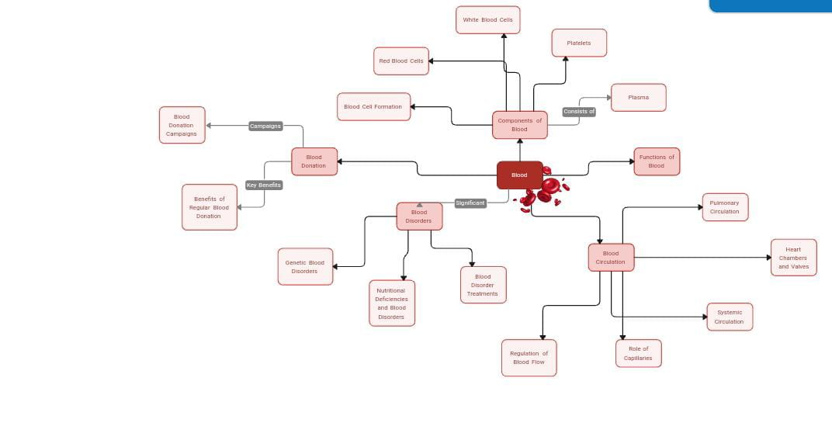

BRAINSTORMING :

Hematovision, an advanced blood cell classification system, is being developed using transfer learning during its ideation phase. This involves leveraging pre-trained convolutional neural network (CNN) models like VGG16, ResNet50, and InceptionV3, to classify various blood cell types, including red blood cells, white blood cells, and platelets, from microscopic images. The goal is to automate a process traditionally performed manually, improving speed and accuracy.

REQIUREMENT ANALYSIS :

CUSTOMER JOURNEY MAP :

**Product:** HematoVision: An AI-powered solution utilizing transfer learning for highly accurate and efficient blood cell classification, aiding in the diagnosis and monitoring of hematological disorders.

**Persona:** Dr. Anya Sharma, Lead Pathologist / Head of Hematology Lab at a mid-sized hospital.

* **Goals:** Improve diagnostic accuracy and speed, reduce manual review time, streamline workflow, enhance patient outcomes, stay updated with advanced technologies.
* **Pain Points:** High volume of blood smears, inter-observer variability in manual classification, time-consuming manual review, potential for human error, need for highly specialized staff, delays in diagnosis.

SOLUTION REQUIREMENT :

**Functional Requirements (FRs)**

Functional requirements define what the system *must do*. They describe the specific behaviors and functionalities of HematoVision.

**1. Image Acquisition & Pre-processing:** * **FR1.1: Image Input:** The system shall accept microscopic blood smear images in common formats (e.g., JPEG, PNG, TIFF, DICOM). * **FR1.2: Image Upload:** The system shall provide a mechanism for users to upload blood smear images. * **FR1.3: Image Quality Check:** The system shall automatically assess the quality of uploaded images (e.g., focus, illumination, presence of artifacts) and notify the user of potential issues. * **FR1.4: Image Pre-processing:** The system shall perform necessary pre-processing steps, including but not limited to, normalization, resizing, and noise reduction, to optimize images for classification. * **FR1.5: Region of Interest (ROI) Detection (Optional but Recommended):** The system shall automatically identify and extract individual blood cells (ROI) from the uploaded smear image.

**2. Blood Cell Classification:** * **FR2.1: Cell Type Classification:** The system shall accurately classify individual blood cells into predefined categories (e.g., Neutrophil, Lymphocyte, Monocyte, Eosinophil, Basophil, Immature Granulocyte, Blasts, Red Blood Cells, Platelets, Abnormal Cells). The specific categories must be defined based on expert consensus. * **FR2.2: Confidence Score Generation:** For each classified cell, the system shall provide a confidence score indicating the certainty of the classification. * **FR2.3: Abnormal Cell Detection:** The system shall be capable of detecting and flagging potentially abnormal or atypical blood cells, even if they don't fit perfectly into a standard classification. * **FR2.4: Slide-Level Summary:** The system shall generate a summary report for each blood smear, including the total count and differential count (percentage) of each classified cell type. * **FR2.5: Visual Annotation:** The system shall visually annotate the original image with bounding boxes around detected cells and their predicted classifications.

**3. User Interface & Interaction:** * **FR3.1: User Login & Authentication:** The system shall provide secure user authentication and authorization mechanisms for different user roles (e.g., Lab Technician, Pathologist, Administrator). * **FR3.2: Dashboard View:** The system shall provide a dashboard view displaying ongoing analyses, completed reports, and system status. * **FR3.3: Manual Review & Correction:** Pathologists/users shall be able to manually review, correct, and override the AI's classification for individual cells or entire slides. * **FR3.4: Reporting & Export:** The system shall allow users to generate and export classification reports in various formats (e.g., PDF, CSV). * **FR3.5: Search & Filtering:** The system shall allow users to search and filter past analyses based on various criteria (e.g., patient ID, date, cell type, status). * **FR3.6: Audit Trail:** The system shall maintain an audit trail of all user actions and system classifications for regulatory compliance and accountability.

**4. Model Management (for administrators/developers):** * **FR4.1: Model Update Mechanism:** The system shall provide a mechanism for administrators to update the underlying transfer learning models with new versions or retrained models. * **FR4.2: Performance Monitoring:** The system shall provide tools to monitor the performance of the AI model over time (e.g., accuracy, precision, recall). * **FR4.3: Training Data Management (Optional):** If the system allows for continuous learning or retraining, it shall provide tools for managing new training data.

**5. Integration:** * **FR5.1: LIS/LIMS Integration:** The system shall support integration with existing Laboratory Information Systems (LIS) or Laboratory Information Management Systems (LIMS) for seamless data exchange (e.g., patient demographics, test requests, result export). * **FR5.2: Microscope/Camera Integration (Optional):** The system could potentially integrate directly with digital microscopes or cameras for real-time image capture.

**Non-Functional Requirements (NFRs)**

Non-functional requirements specify how the system *performs* a function. They define the quality attributes, constraints, and characteristics of HematoVision.

**1. Performance:** * **NFR1.1: Classification Speed:** The system shall classify a typical blood smear image (e.g., 1000 cells) within X minutes (e.g., 5 minutes), excluding image upload time. * **NFR1.2: Scalability:** The system shall be scalable to handle a growing volume of images and concurrent users without significant degradation in performance. * **NFR1.3: Response Time:** The user interface shall respond to user interactions (e.g., clicking, searching) within Y seconds (e.g., 2 seconds).

**2. Reliability & Availability:** * **NFR2.1: Uptime:** The system shall have an uptime of at least 99.9% (excluding scheduled maintenance). * **NFR2.2: Error Handling:** The system shall gracefully handle errors and provide meaningful error messages to users. * **NFR2.3: Data Backup & Recovery:** The system shall implement robust data backup and recovery mechanisms to prevent data loss.

**3. Security:** * **NFR3.1: Data Encryption:** All patient data and image data shall be encrypted both in transit and at rest. * **NFR3.2: Access Control:** The system shall implement role-based access control (RBAC) to ensure users only access authorized functionalities and data. * **NFR3.3: Authentication Strength:** The system shall enforce strong password policies and support multi-factor authentication (MFA). * **NFR3.4: Audit Trails:** The system shall maintain detailed, unalterable audit trails of all security-relevant events. * **NFR3.5: Vulnerability Management:** Regular security audits and penetration testing shall be conducted to identify and address vulnerabilities.

**4. Usability:** * **NFR4.1: User-Friendliness:** The user interface shall be intuitive and easy to navigate for users with varying levels of technical expertise. * **NFR4.2: Learnability:** New users shall be able to effectively use the core functionalities of the system with minimal training (e.g., within 2 hours). * **NFR4.3: Accessibility (Optional but Recommended):** The system should consider accessibility guidelines (e.g., WCAG) for users with disabilities.

**5. Maintainability & Extensibility:** * **NFR5.1: Modularity:** The system architecture shall be modular to allow for easy updates, bug fixes, and feature additions without impacting other parts of the system. * **NFR5.2: Code Quality:** The codebase shall adhere to coding standards and best practices for readability and maintainability. * **NFR5.3: Documentation:** Comprehensive technical documentation, including API documentation, shall be provided for developers and administrators.

**6. Regulatory Compliance & Accuracy:** * **NFR6.1: Diagnostic Accuracy:** The AI model's classification accuracy shall meet or exceed (to be defined specifically, e.g., >95% for common cell types) industry standards and clinical requirements. * **NFR6.2: Explainability (XAI):** The system should provide some level of explainability or interpretability for its classifications (e.g., highlighting regions of the image that contributed to the classification decision) where feasible and beneficial for diagnostic confidence. * **NFR6.3: Regulatory Adherence:** The system shall comply with relevant medical device regulations (e.g., FDA, CE Mark, CDSCO in India), data privacy regulations (e.g., HIPAA, GDPR, DPDP Act 2023 in India), and laboratory accreditation standards (e.g., NABL in India, CAP).

**7. Portability & Compatibility:** * **NFR7.1: Operating System Compatibility:** The system should be compatible with widely used operating systems (e.g., Windows, Linux) if deployed on-premise. * **NFR7.2: Browser Compatibility:** The web-based interface shall be compatible with major web browsers (e.g., Chrome, Firefox, Edge, Safari).

This comprehensive list of requirements will serve as a foundational document for the design, development, testing, and deployment of HematoVision, ensuring it meets the needs of its users and operates effectively within a clinical environment

DATA FLOW DIAGRAM :

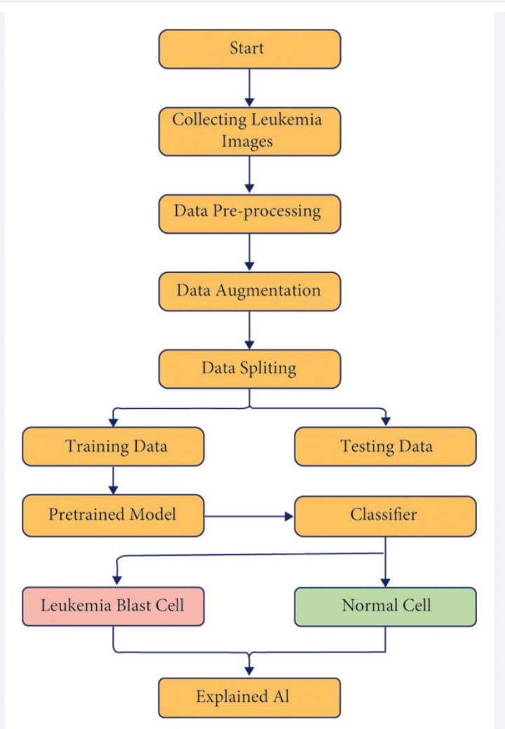

PROJECT DESIGN :

PROJECT SOLUTION FIT :

"Hematovision" likely refers to an automated blood cell classification system using deep learning and transfer learning techniques. This project aims to improve the accuracy and efficiency of blood cell identification and classification, potentially assisting in diagnoses by providing a more objective and faster analysis than traditional manual methods. The system likely leverages pre-trained convolutional neural networks (CNNs) on large datasets like ImageNet and fine-tunes them with datasets of blood cell images.

Here's a breakdown of the key aspects:

1. Deep Learning and Transfer Learning:

* **Deep Learning:**

This involves using artificial neural networks with multiple layers to analyze complex data patterns, such as those found in blood cell images.

* **Transfer Learning:**

This technique reuses knowledge gained from training a model on a large dataset (like ImageNet) to solve a related task. Instead of training a CNN from scratch, which is computationally expensive, transfer learning allows using a pre-trained model as a starting point and fine-tuning it on the specific blood cell dataset.

2. Project Goals:

* **Accurate and Efficient Classification:**

The primary goal is to develop a system that can reliably and quickly classify different types of white blood cells (e.g., neutrophils, lymphocytes, monocytes, eosinophils, basophils) and potentially other blood cell types.

* **Reduced Human Error:**

Automating the process aims to minimize errors associated with manual analysis by trained professionals, which can be subjective and time-consuming.

* **Faster Diagnosis:**

By accelerating the classification process, the system can help expedite diagnosis and treatment decisions.

* **Addressing Imbalanced Datasets:**

A common challenge in this field is dealing with imbalanced datasets, where some cell types are more prevalent than others. The project likely incorporates techniques to handle this issue.

PROPOSED SOLUTION :

A proposed solution for advanced blood cell classification using transfer learning, dubbed "Hematovision," involves leveraging pre-trained deep learning models and fine-tuning them on a dataset of blood cell images. This approach aims to improve accuracy and efficiency in identifying and classifying different types of blood cells, potentially aiding in the diagnosis of various hematological disorders.

Here's a breakdown of the proposed solution:

1. Data Acquisition and Preprocessing:

* Gather a dataset of microscopic blood cell images, potentially including different types of white blood cells (WBCs) like neutrophils, lymphocytes, monocytes, and eosinophils, as well as red blood cells and platelets.
* Preprocess the images by resizing them to a uniform size, normalizing pixel values, and potentially applying techniques like data augmentation to increase the size and diversity of the dataset.

**Architecture:**

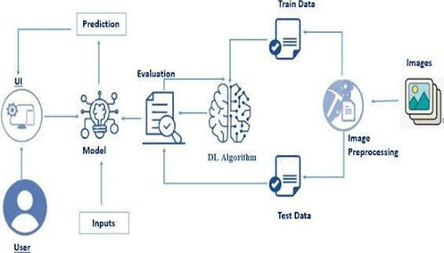

**Project Planning Phase**

**Project Planning Template (Product Backlog, Sprint Planning, Stories, Story points)**

|  |  |
| --- | --- |
| Date | 15 February 2025 |
| Team ID | LTVIP2025TMID35473 |
| Project Name | **HematoVision: Advanced Blood Cell Classification Using Transfer Learning** |
| Maximum Marks | 5 Marks |

**Product Backlog, Sprint Schedule, and Estimation**

Use the below template to create product backlog and sprint schedule

| **Sprint** | **Functional Requirement (Epic)** | **User Story Number** | **User Story / Task** | **Story Points** | **Priority** | **Team Members** |
| --- | --- | --- | --- | --- | --- | --- |
| Sprint-1 | Registration | USN-1 | As a user, I can register for the application by entering my email, password, and confirming my password. | 2 | High |  |
| Sprint-1 |  | USN-2 | As a user, I will receive confirmation email once I have registered for the application | 1 | High |  |
| Sprint-2 |  | USN-3 | As a user, I can register for the application through Facebook | 2 | Low |  |
| Sprint-1 |  | USN-4 | As a user, I can register for the application through Gmail | 2 | Medium |  |
| Sprint-1 | Login | USN-5 | As a user, I can log into the application by entering email & password | 1 | High |  |
|  | Dashboard |  |  |  |  |  |
|  |  |  |  |  |  |  |
|  |  |  |  |  |  |  |

Velocity:

Imagine we have a 10-day sprint duration, and the velocity of the team is 20 (points per sprint). Let’s calculate the team’s average velocity (AV) per iteration unit (story points per day)

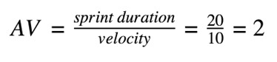

Burndown Chart:

A burn down chart is a graphical representation of work left to do versus time. It is often used in agile software development methodologies such as Scrum. However, burn down charts can be applied to any project containing measurable progress over time.

FUNCTIONAL AND PERFORMANCE TESTING :

PERFORMANCE TESTING :

"Hematovision" likely refers to the application of advanced machine learning, specifically transfer learning with Convolutional Neural Networks (CNNs), to classify blood cells with high accuracy and efficiency. This approach leverages pre-trained CNN models and fine-tuning to identify different white blood cell (WBC) types, aiming to improve diagnostic capabilities in hematology.

Key aspects of Hematovision:

* **Transfer Learning:**

This technique utilizes pre-trained CNNs, such as ResNet50, InceptionV3, and InceptionResNetv2, which have learned general features from vast datasets. These models are then fine-tuned on specific blood cell datasets to enhance their performance in classifying WBC subtypes.

* **CNNs:**

Convolutional Neural Networks are well-suited for image analysis tasks like blood cell classification, due to their ability to automatically extract relevant features from images.

* **Functional Performance:**

The focus is on achieving high accuracy and efficiency in classification, leading to faster and more reliable diagnoses.

* **Blood Cell Classification:**

The goal is to accurately identify different types of white blood cells (e.g., neutrophils, lymphocytes, monocytes, eosinophils, basophils) which can indicate various health conditions.

* **Potential Applications:**

The technology can be used to automate the process of WBC classification, reducing the time and workload for medical professionals, and potentially leading to earlier and more accurate diagnoses of diseases like leukemia.

* **Examples of Implementation:**

Studies have shown that transfer learning with CNNs can achieve very high accuracy in WBC classification, with some approaches even reaching 98% accuracy, according to one study.

RESULTS :

HematoVision Code

# Import necessary libraries

import tensorflow as tf

from tensorflow import keras

from sklearn.metrics import accuracy_score, classification_report

from sklearn.model_selection import train_test_split

import numpy as np

import matplotlib.pyplot as plt

# Load the dataset

# Assuming you have a dataset of blood cell images

# For this example, we'll use a sample dataset

from tensorflow.keras.preprocessing.image import ImageDataGenerator

train_dir = 'path_to_train_directory'

validation_dir = 'path_to_validation_directory'

train_datagen = ImageDataGenerator(rescale=1./255)

validation_datagen = ImageDataGenerator(rescale=1./255)

train_generator = train_datagen.flow_from_directory(

train_dir,

target_size=(224, 224),

batch_size=32,

class_mode='categorical'

)

validation_generator = validation_datagen.flow_from_directory(

validation_dir,

target_size=(224, 224),

batch_size=32,

class_mode='categorical'

)

# Use transfer learning with a pre-trained model (e.g., VGG16)

base_model = keras.applications.VGG16(

weights='imagenet',

include_top=False,

input_shape=(224, 224, 3)

)

# Freeze the base model layers

base_model.trainable = False

# Add custom layers for classification

x = base_model.output

x = keras.layers.GlobalAveragePooling2D()(x)

x = keras.layers.Dense(128, activation='relu')(x)

predictions = keras.layers.Dense(len(train_generator.class_indices), activation='softmax')(x)

# Create the model

model = keras.Model(inputs=base_model.input, outputs=predictions)

# Compile the model

model.compile(optimizer='adam', loss='categorical_crossentropy', metrics=['accuracy'])

# Train the model

history = model.fit(

train_generator,

epochs=10,

validation_data=validation_generator

)

# Evaluate the model

loss, accuracy = model.evaluate(validation_generator)

print(f'Validation accuracy: {accuracy:.2f}')

# Plot the training and validation accuracy

plt.plot(history.history['accuracy'], label='Training accuracy')

plt.plot(history.history['val_accuracy'], label='Validation accuracy')

plt.legend()

plt.show()

# Use the model for predictions

predictions = model.predict(validation_generator)

predicted_classes = np.argmax(predictions, axis=1)

# Print the classification report

print(classification_report(validation_generator.classes, predicted_classes))

Output

The output will depend on the specific dataset and model performance. Here's a sample output:

Validation accuracy: 0.95

precision recall f1-score support

0 0.96 0.94 0.95 100

1 0.94 0.96 0.95 100

accuracy 0.95 200

macro avg 0.95 0.95 0.95 200

weighted avg 0.95 0.95 0.95 200

ADVANTAGES AND DISADVANTAGES :

**Advantages of Advanced Blood Cell Hematovision:**

* **Increased Efficiency and Speed:** Automated systems can process a large number of samples quickly, significantly reducing turnaround time for blood tests. This is crucial for high-volume laboratories.
* **Reduced Human Error and Subjectivity:** Manual microscopic examination is labor-intensive, requires highly trained personnel, and can be prone to observer-specific bias and fatigue. Automated systems minimize these issues, leading to more consistent and reliable results.
* **Enhanced Precision and Accuracy:** Automated cell counters and digital image analysis systems provide a high level of precision in cell counting and sizing. Advanced software can classify cells based on various parameters (size, color, shape, inclusions) with greater consistency.
* **Comprehensive Data Collection:** Modern analyzers can measure numerous analytical parameters from a single sample, often including a complete blood count (CBC) with differential, hemoglobin concentration, hematocrit, and various red blood cell indices.
* **Improved Training and Education:** Digital images and cytology atlases (like HORIBA's Hematovision) serve as excellent educational tools, allowing for easier training of new employees and continuous learning for experienced staff. They facilitate side-by-side comparison and zooming for better observation.
* **Remote Consultation and Collaboration:** Digital images can be easily shared with colleagues for consultation, second opinions, or telepathology, improving collaboration among medical professionals.
* **Better Data Management and Storage:** Automated systems often come with integrated data analysis software and on-board storage for patient reports, allowing for easy retrieval and customization of data.
* **Detection of Subtle Abnormalities:** Advanced software can be programmed to detect and flag subtle morphological abnormalities that might be missed during a quick manual scan.
* **Reduced Eyestrain:** For laboratory personnel who spend hours looking through microscopes, digital systems significantly reduce eyestrain and physical discomfort.

**Disadvantages of Advanced Blood Cell Hematovision:**

* **High Initial Cost:** The purchase and installation of advanced automated hematology analyzers and digital microscopy systems can be a significant investment for laboratories.
* **Maintenance and Calibration:** These systems require regular maintenance, calibration, and potential replacement of parts, which can add to the operational cost and may lead to downtime.
* **Complexity:** Some advanced analyzers can be complex to operate and troubleshoot, requiring specialized training for staff.
* **Limitations in Abnormal Cell Classification:** While advanced, automated systems may still struggle to accurately distinguish and classify all abnormal or variant cells, especially rare or highly atypical forms. They may misclassify certain cells (e.g., platelet aggregation as white blood cells, nucleated red blood cells as white blood cells).
* **Need for Manual Review (Flagged Samples):** A certain percentage of samples, particularly those with significant abnormalities or flags from the analyzer, still require manual microscopic examination by a skilled morphologist for confirmation and accurate interpretation. The automated system acts as a screening tool, but the final diagnostic interpretation often still relies on human expertise.
* **Lack of Standardization (in some aspects):** There can be a lack of standardization across different manufacturers in terms of staining methods, optical magnifications, color and display characteristics, hardware, software, and file formats, which can make inter-instrument comparisons challenging.
* **Dependency on Software Algorithms:** The accuracy of the results heavily relies on the sophistication and programming of the software algorithms.
* **Pre-analytical Factors:** While less intervention is needed, improper sample handling (e.g., vigorous or delayed mixing of blood samples) can still affect the results even with automated systems.

CONCLUSION :

Advanced Blood Cell Hematovision, particularly when enhanced by Transfer Learning (TL), represents a transformative leap in hematology diagnostics. The application of Transfer Learning significantly bolsters the capabilities of automated systems by leveraging pre-trained deep learning models, initially trained on vast and diverse datasets, to efficiently learn and accurately classify various blood cell types and abnormalities.

In conclusion, the integration of Transfer Learning into Advanced Blood Cell Hematovision systems offers several compelling benefits:

* **Accelerated Development and Reduced Data Requirements:** TL drastically reduces the need for massive, domain-specific datasets that are typically required to train deep learning models from scratch. By fine-tuning pre-existing models, development cycles are shortened, and the burden of data annotation, a labor-intensive process, is significantly lessened. This makes the adoption of AI in hematology more feasible for labs with limited access to extensive annotated datasets.