**TO-DO List**

**Domain: To-Do List**

**Interface: Web API**

**Platform: Java**

1. Import the project “iTrellisProj” in Eclipse as shown below

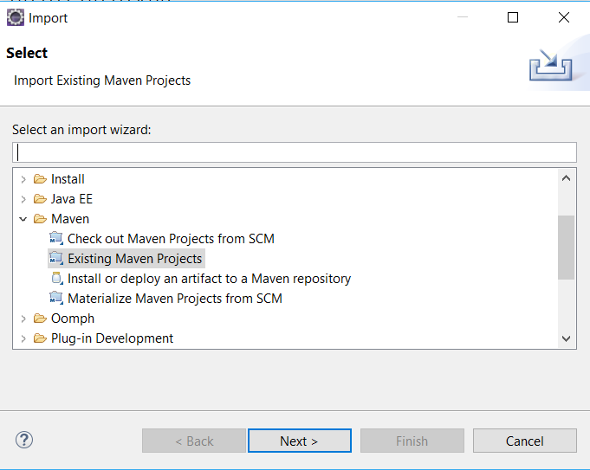

1. Run the Application ()
2. Launch the TodoUI.html present in TodoClient
3. The backend Todo manager service is written in Java and is exposed as REST web service using Spring boot. This REST api can be used by any client web/mobile.
4. The current client UI is a basic HTML(with bootstrap.js and jquery.js) which contacts the exposed REST API and displays the Todo content.

**Adding a TODO task**

Add a TODO task by giving a name, description, date and any more details.

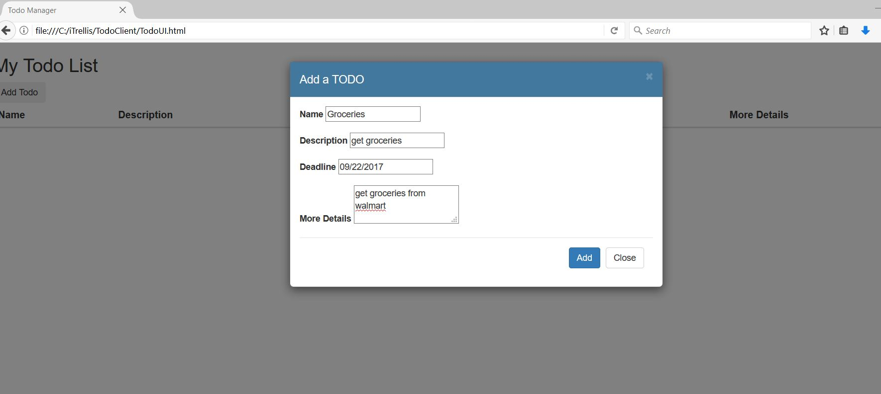

**List of TODOs**

List of TODO tasks -

