**FlyAway.com – Working website Screenshots**

**Author: Prathyusha Kochuru**

**Date: 04/06/2021**

**Concepts used – Java8, Java Servlets, JSP, Hibernate, MySQL, HTML5, JavaMail, Apache Tomcat Server, Maven**

1. **Home Page –** Search for the flights

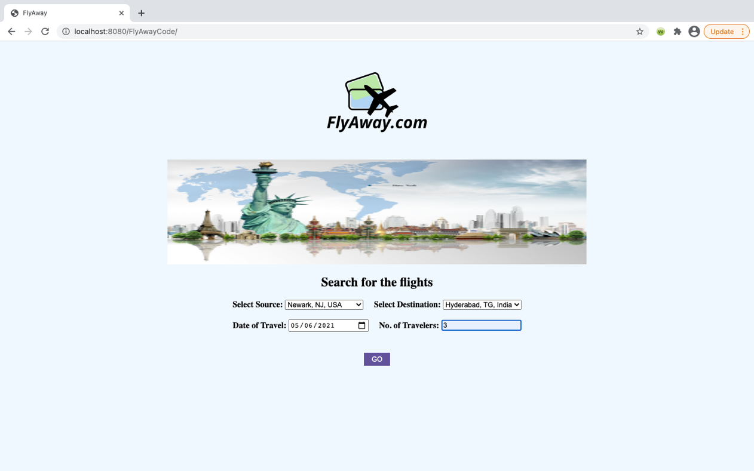

1. **Search Results page –** We can always modify the search on this page using “Modify Search” button.

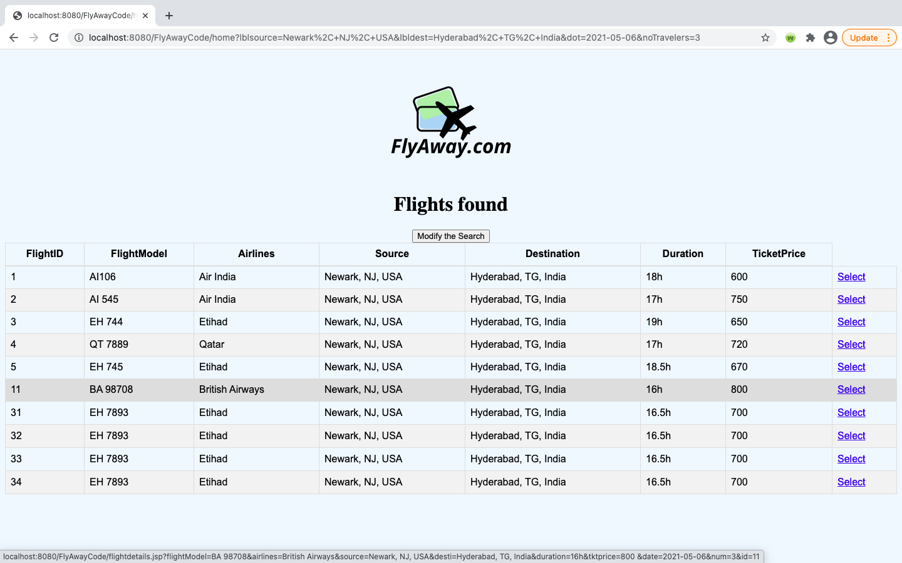

1. **Flight Details page –** Details of the selected flight

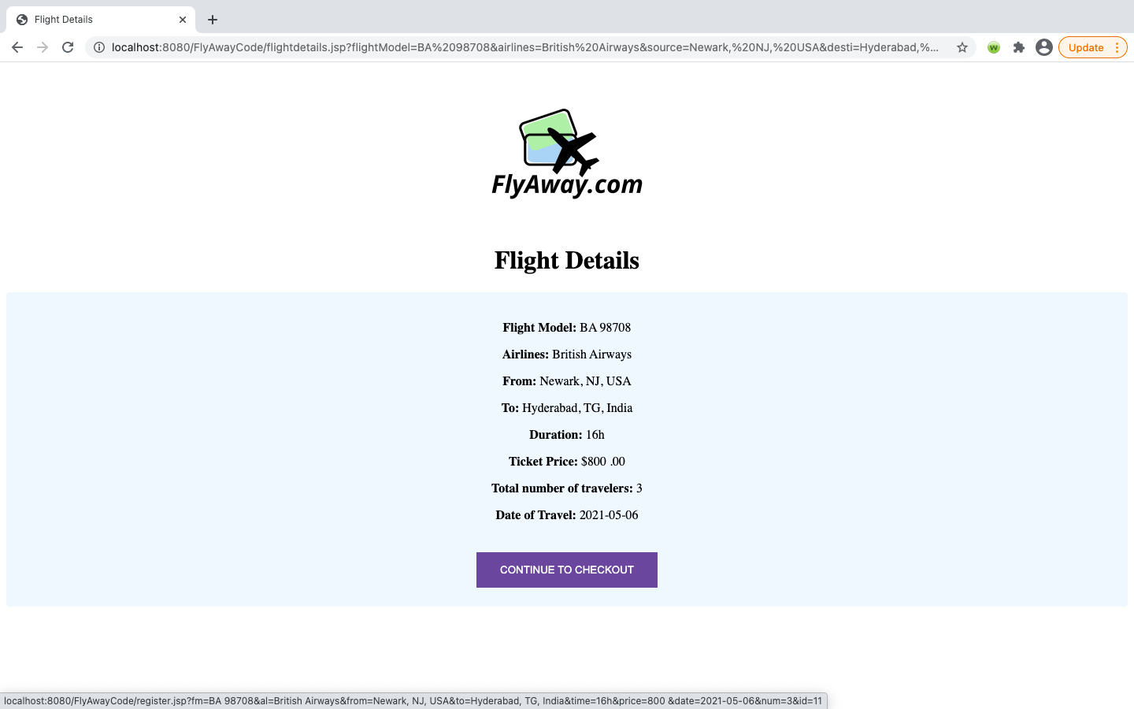

1. **Passenger Details page –** Here we enter the passenger details to continue the flight booking. The total ticket price would be (No. of travelers x single ticket price) – The selected flight details are static (read only) and can’t be changed on this page.

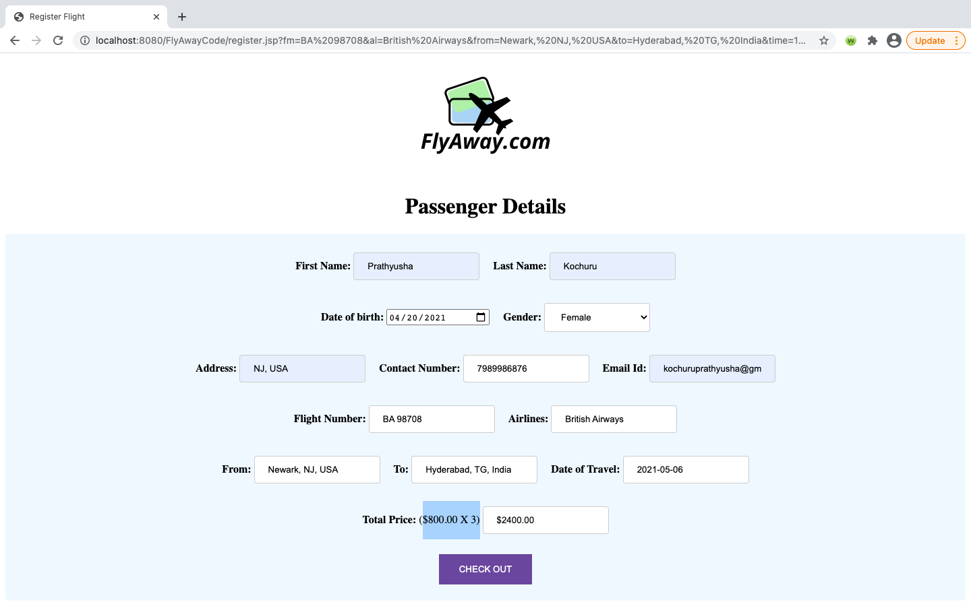

1. **Payment Gateway page –** Where the passenger enters his/her credit card information to make the booking payment. The total ticket price can’t be changed here. i.e., it is read only.

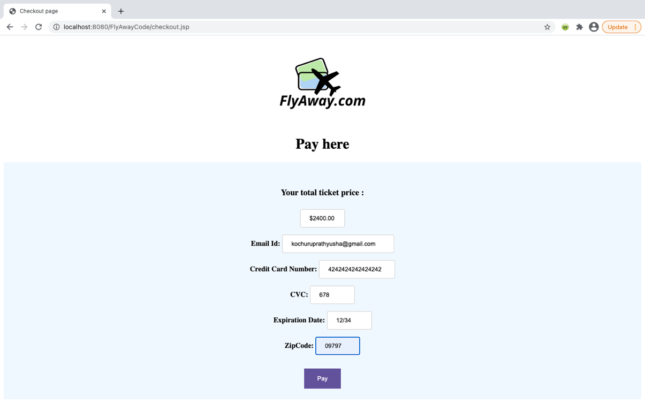

1. **Payment Success page –** Booking reference number is generated and confirmation email is sent to the customer using JavaMail (Gmail Smtp) service

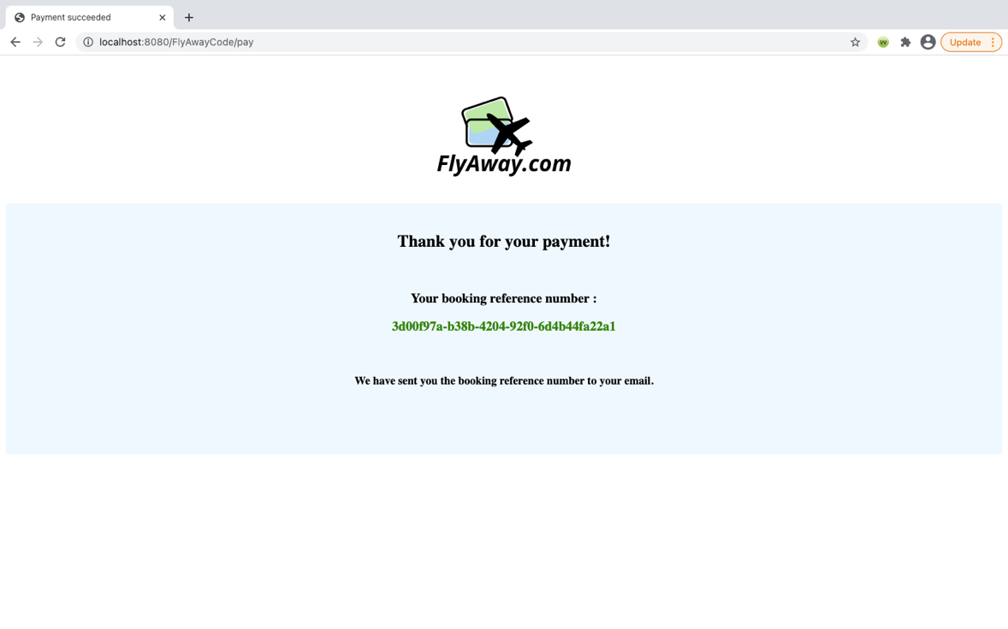

1. **Admin Login page -** Accessed using [www.FlyAway.com/login.jsp](http://www.FlyAway.com/login.jsp) - Only admin can login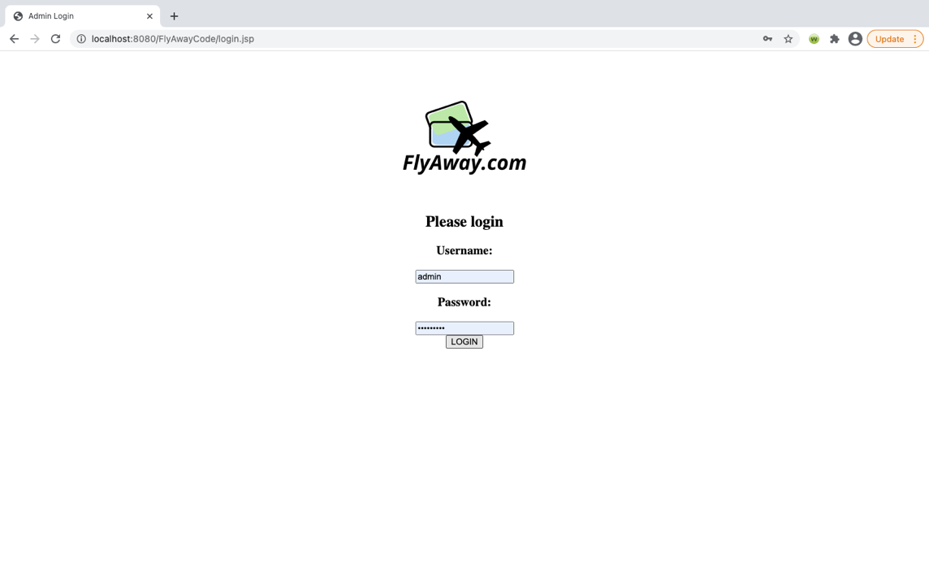
2. **Admin Preferences page –** Can change the admin password & add a new flight into the database – Also can log out – redirects to login.jsp page- login parameters are stored in the session here

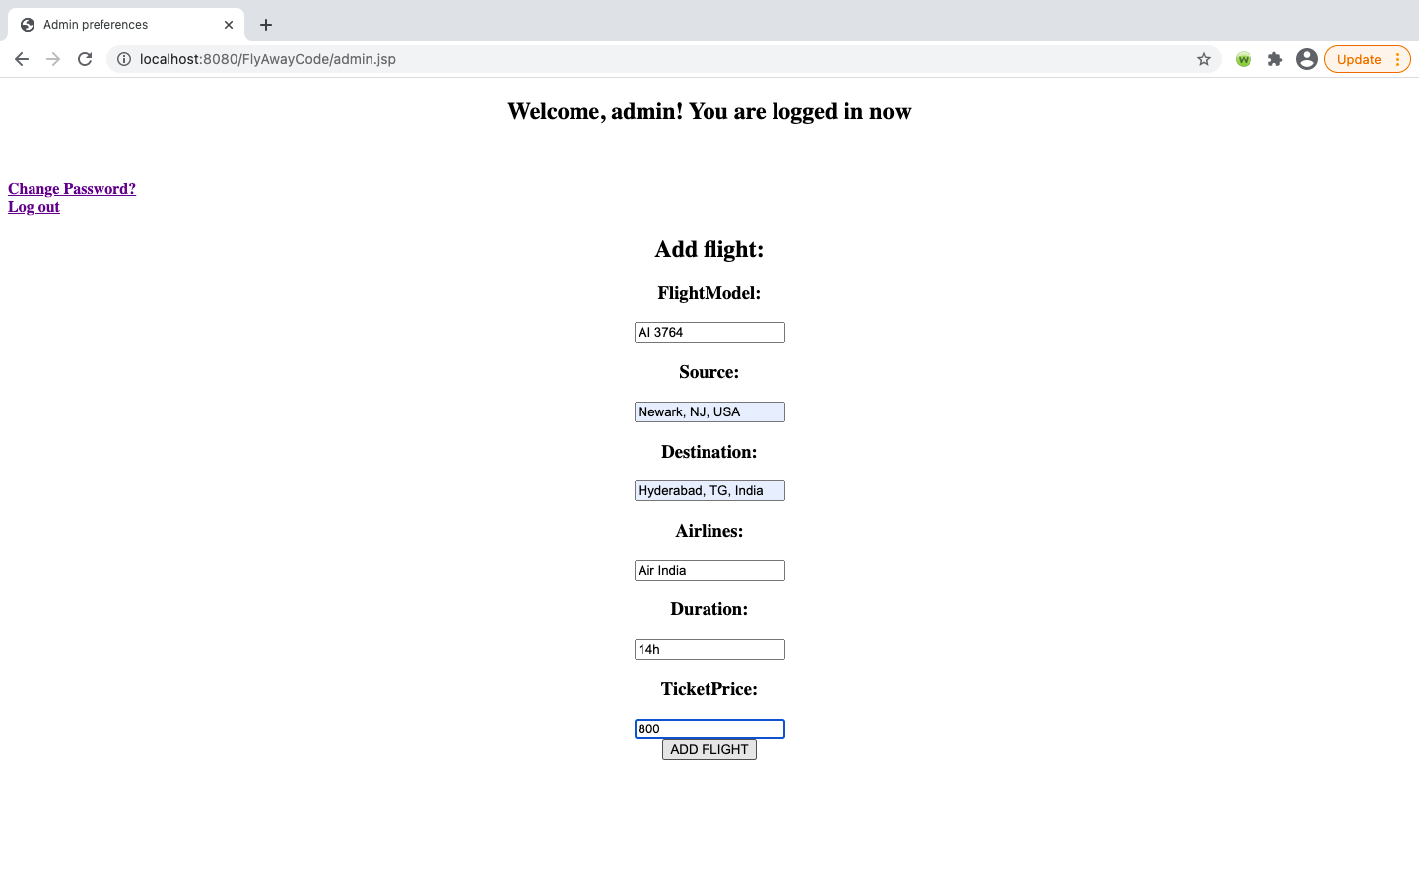

1. **Add Flight Success page –** Displays when the flight has been added to the database.

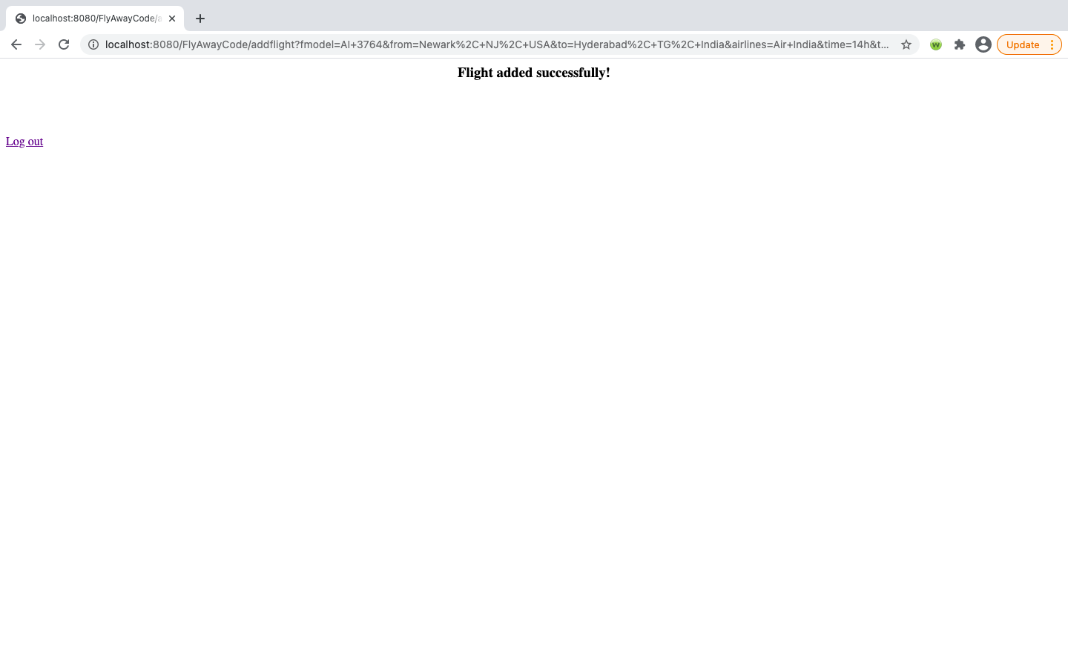

1. **Change Admin Password page**

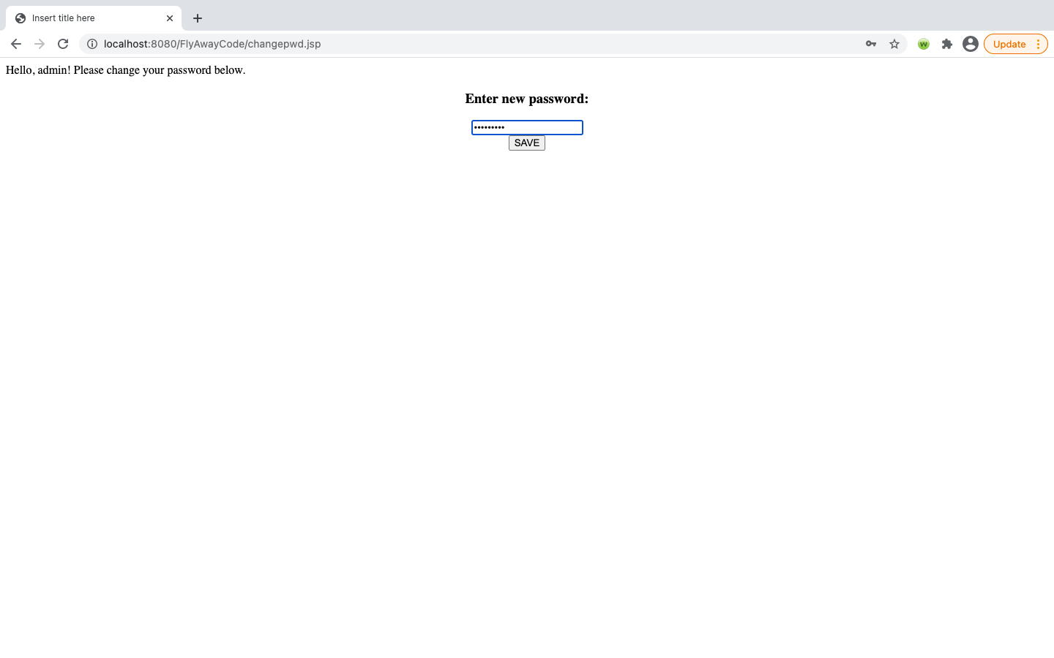

1. **Update Password Success page -** New password is saved in the database.

