**Phase-1 Assessment Java Code Document**

**Author: Prathyusha Kochuru**

**Date: 02/26/2021**

**Tool used: Eclipse**

**Project – LockedMe.com**

**GitHub Repository:** https://github.com/prathyushakochuru/SimplilearnPhase1Project

**Working Code:**

* **User Abstract class**

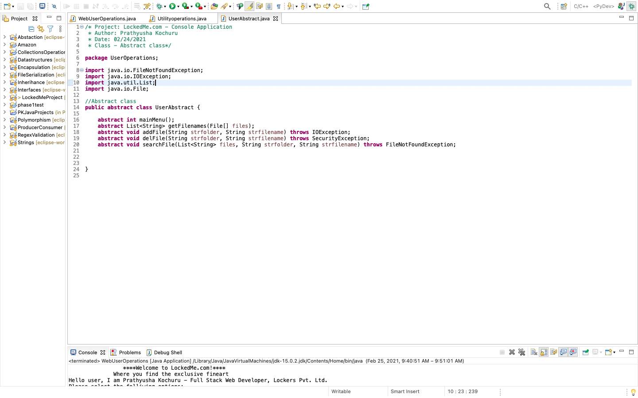

* **UtilityOperations class – where abstract class methods are implemented**

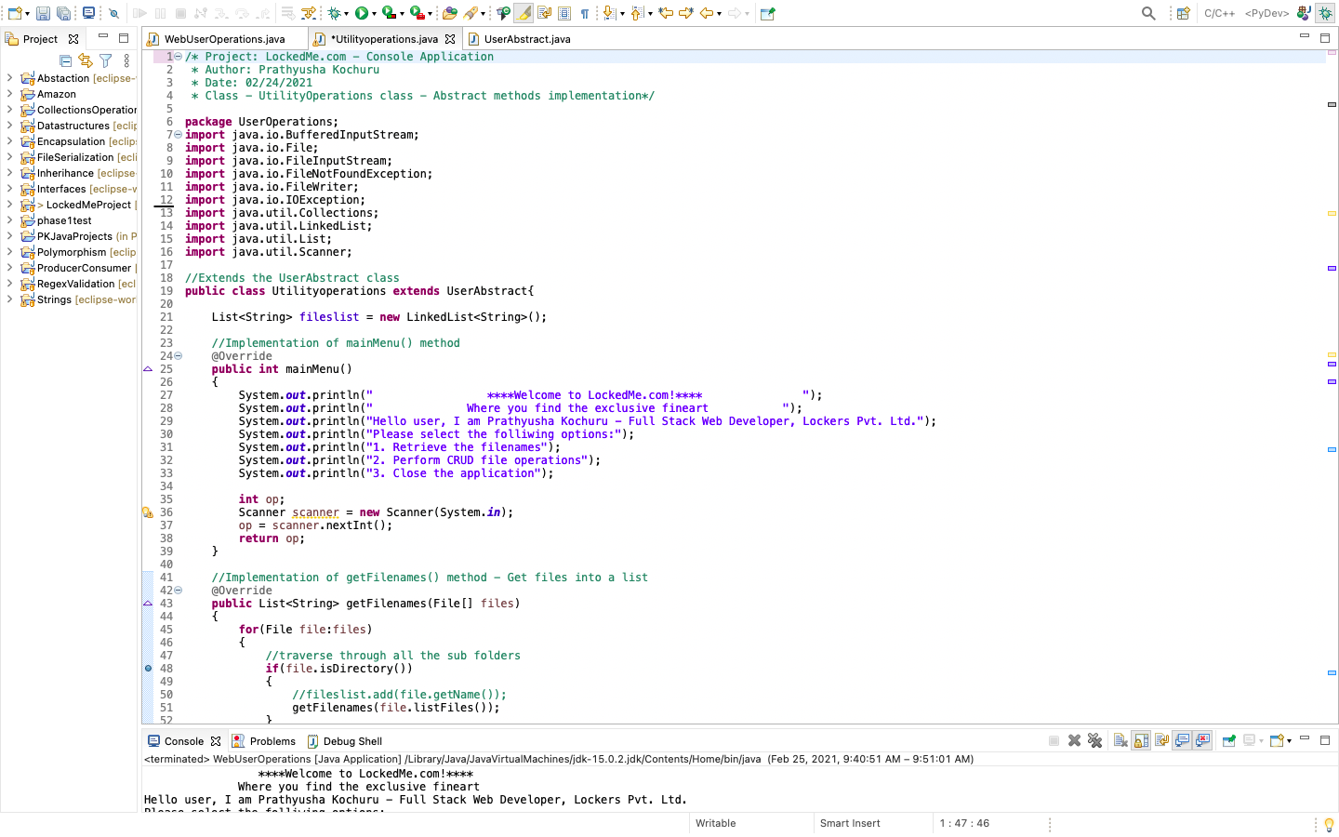

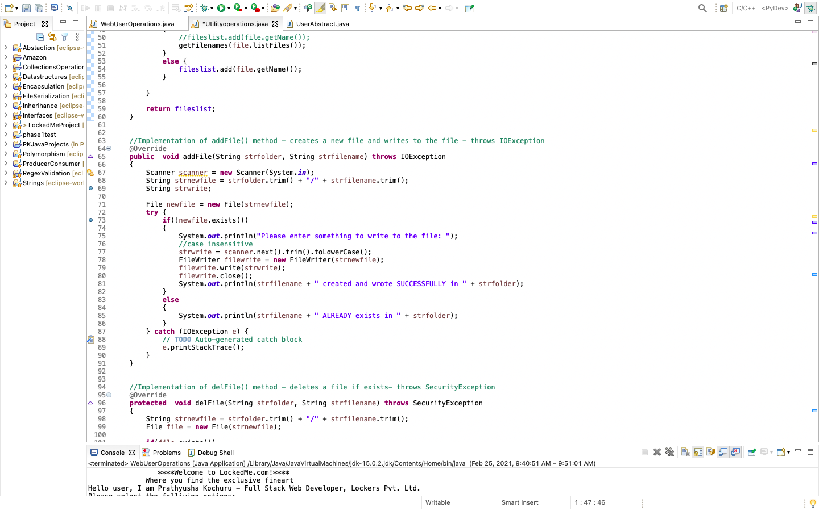

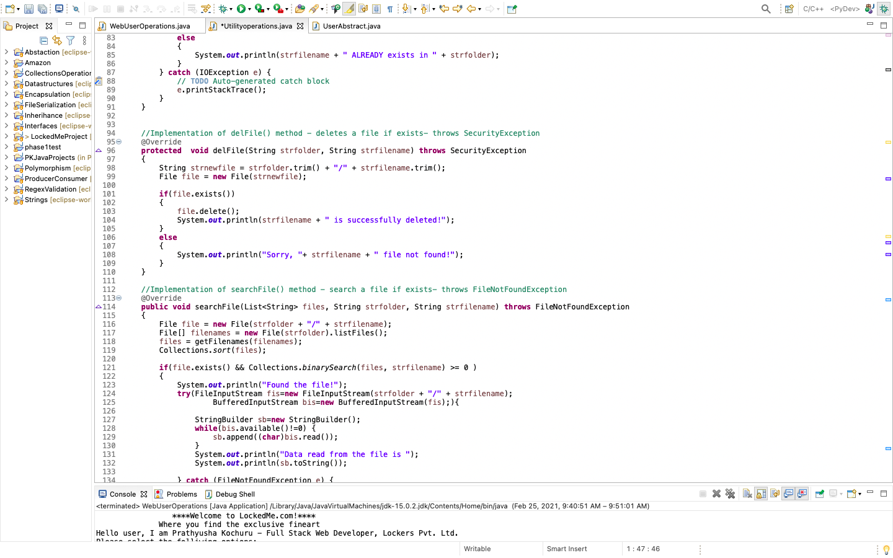

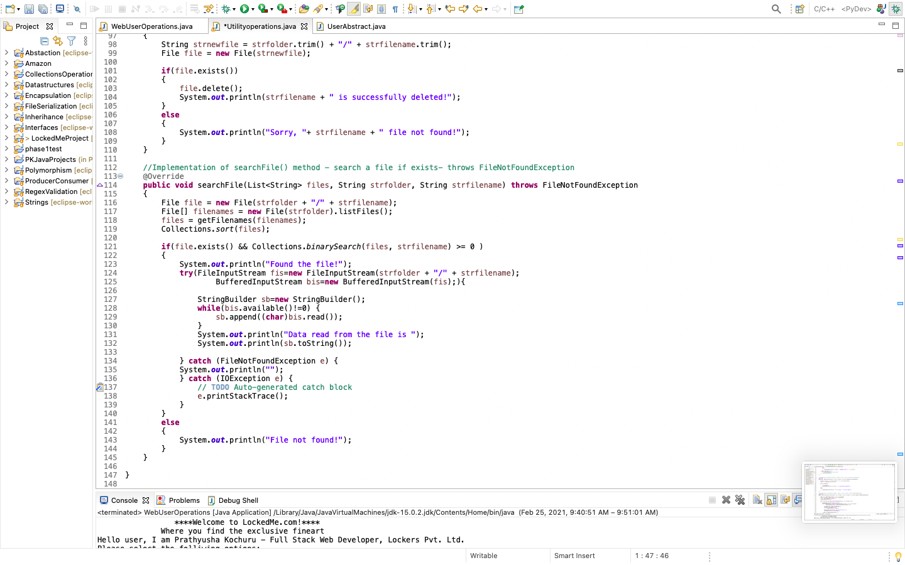

* **WebUserOperations – Main method**

