**CI/CD DEPLOYMENT FOR SPRINGBOOT APPLICATION**

**SCREENSHOTS DOCUMENT**

**Author: Prathyusha Kochuru**

**Date: 07/20/2021**

**Tools used: AWS, Eclipse, Spring Tools, Jenkins, GitHub**

**Technologies used: Maven, Java, Bootstrap, HTML, etc.,**

**What is Jenkins – A tool to perform Continuous Integration/ Continuous Deployment of the applications. Here, I have used the source code from GitHub repository**

1. **Source Code GitHub link – SpringBoot Web Application**

[**https://github.com/prathyushakochuru/SpringBootWebApplicationforJenkins**](https://github.com/prathyushakochuru/SpringBootWebApplicationforJenkins)

1. **AWS S3 – Uploaded and hosted the .jar file of the Springboot application to AWS S3 bucket**

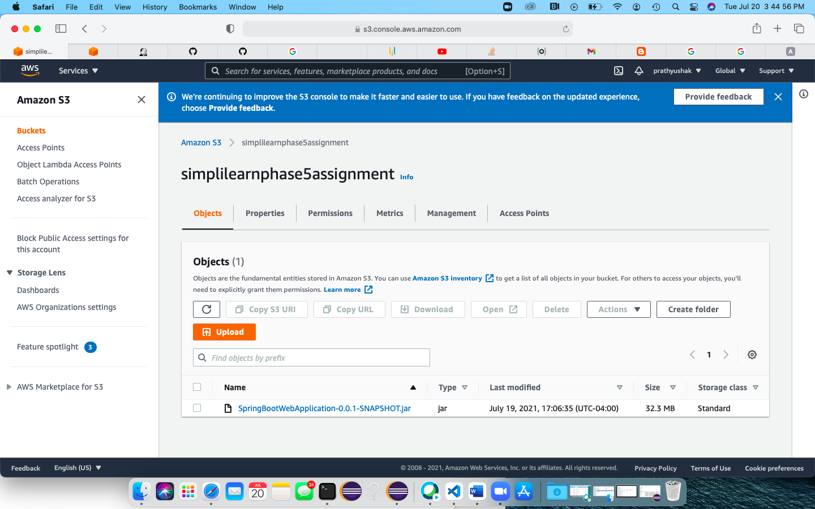

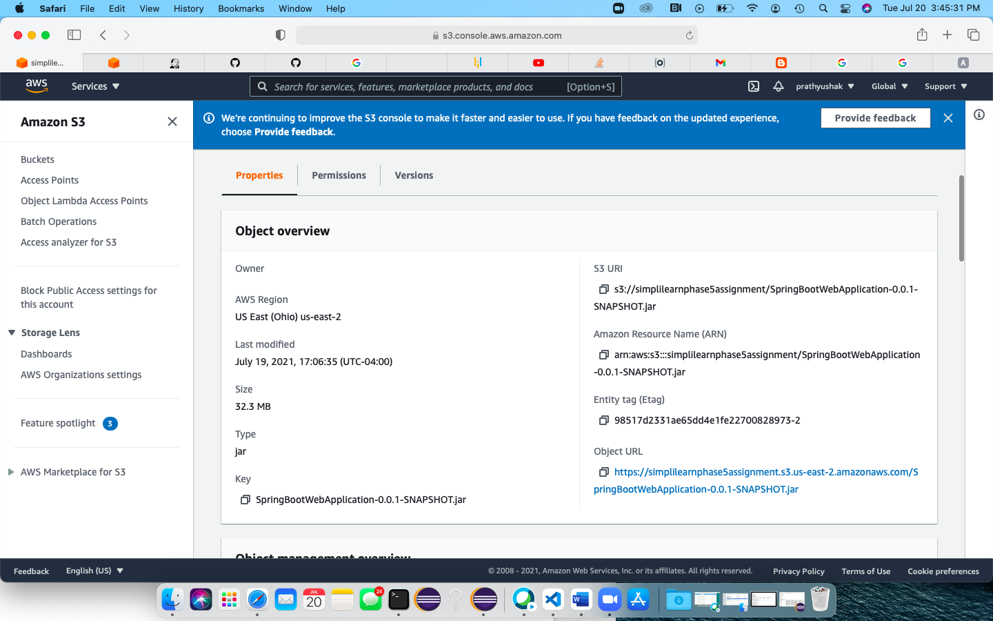

1. **AWS EC2 Instance – Created an Elastic Cloud (EC2) instance on AWS and installed Jenkins on TCP port 8080**

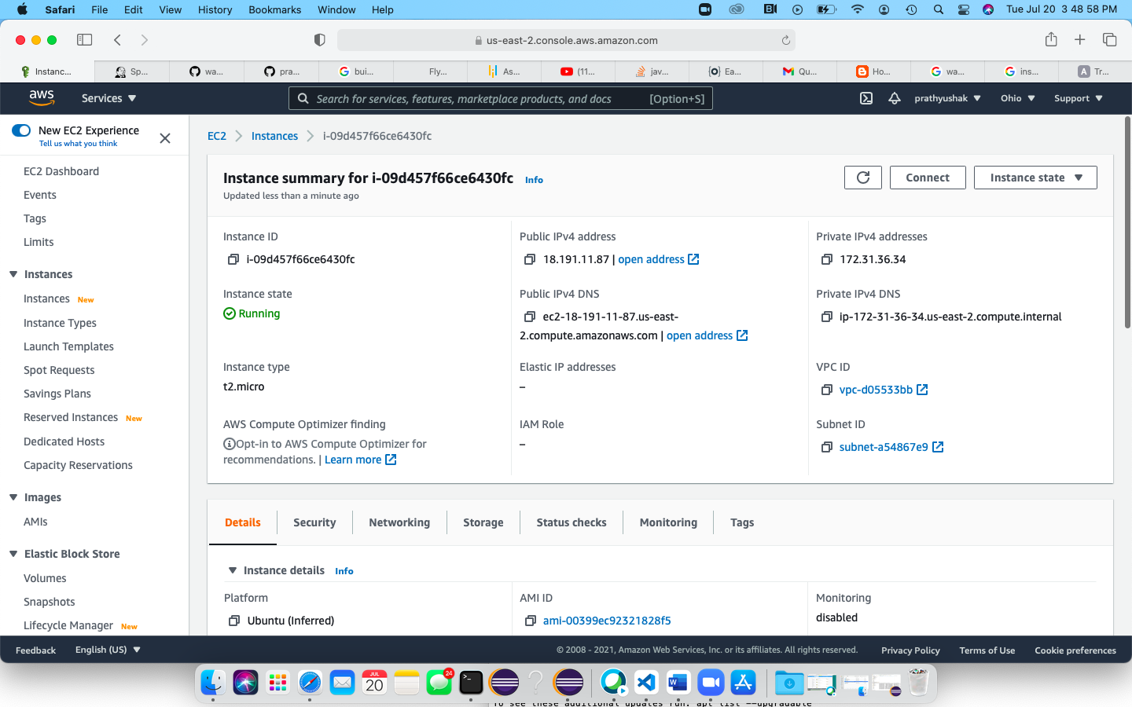

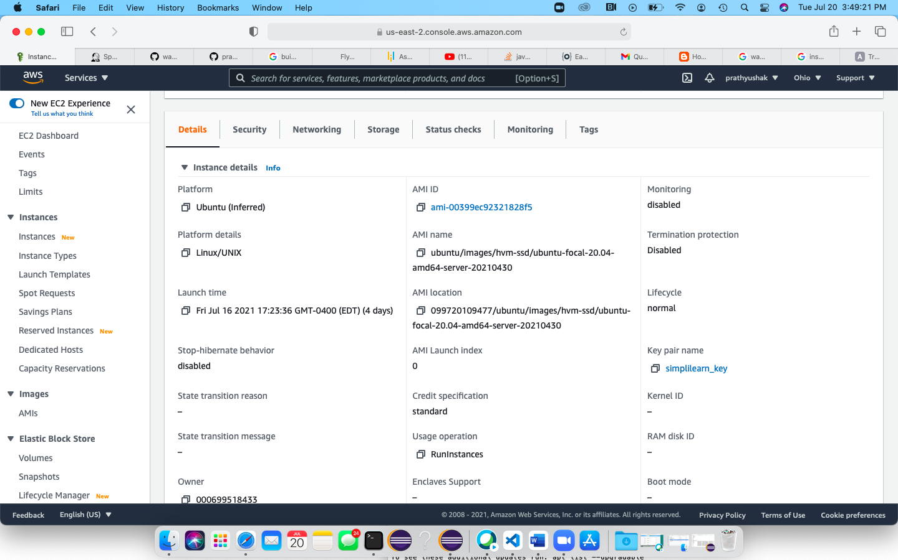

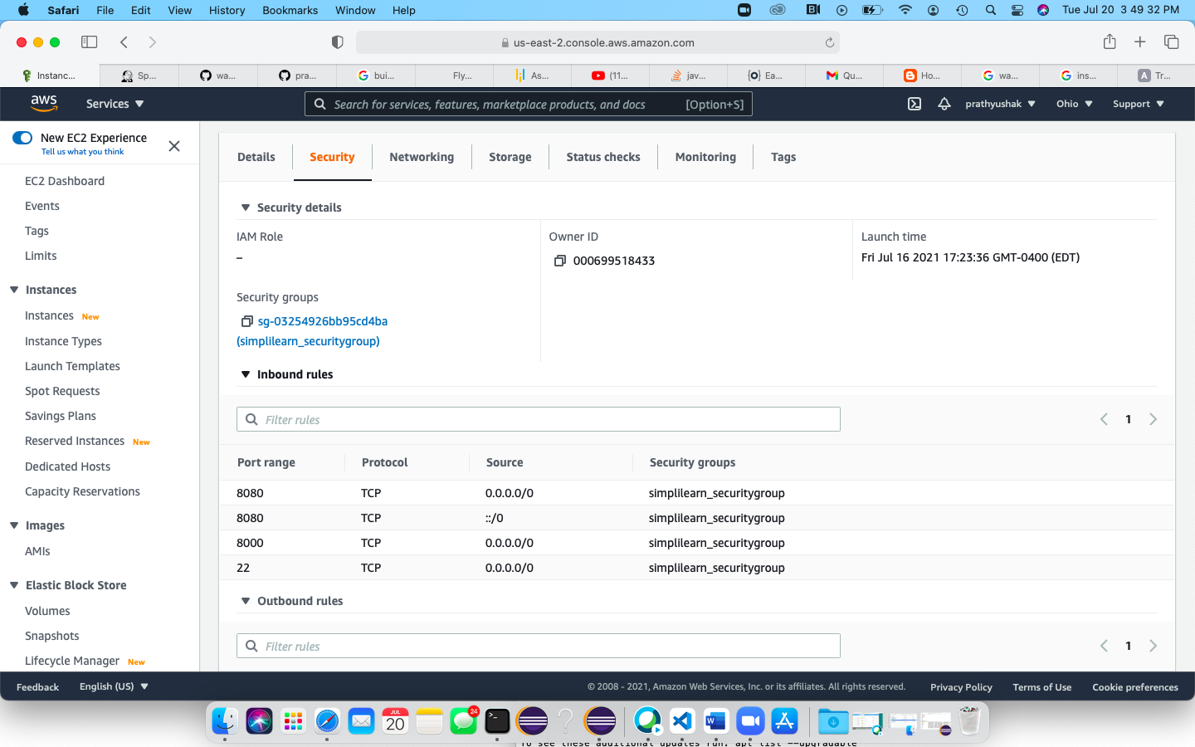

1. **Connect to EC2 from Terminal – Connect to the EC2 instance using SSH from terminal**

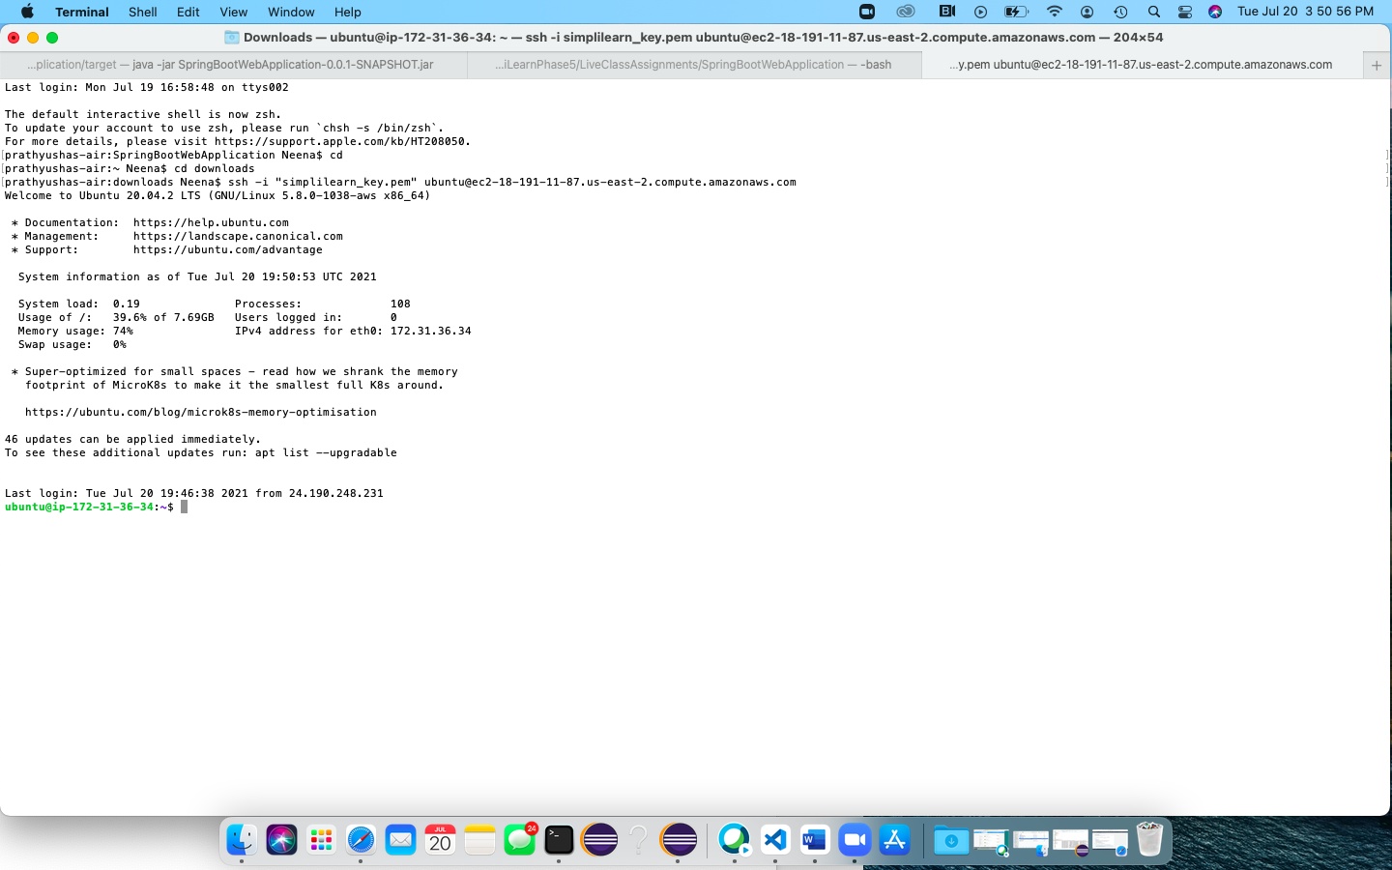

1. **Run the .jar file from AWS S3 bucket on EC2 instance on Terminal**

**Used command –**

**$** wget <https://simplilearnphase5assignment.s3.us-east-2.amazonaws.com/SpringBootWebApplication-0.0.1-SNAPSHOT.jar>

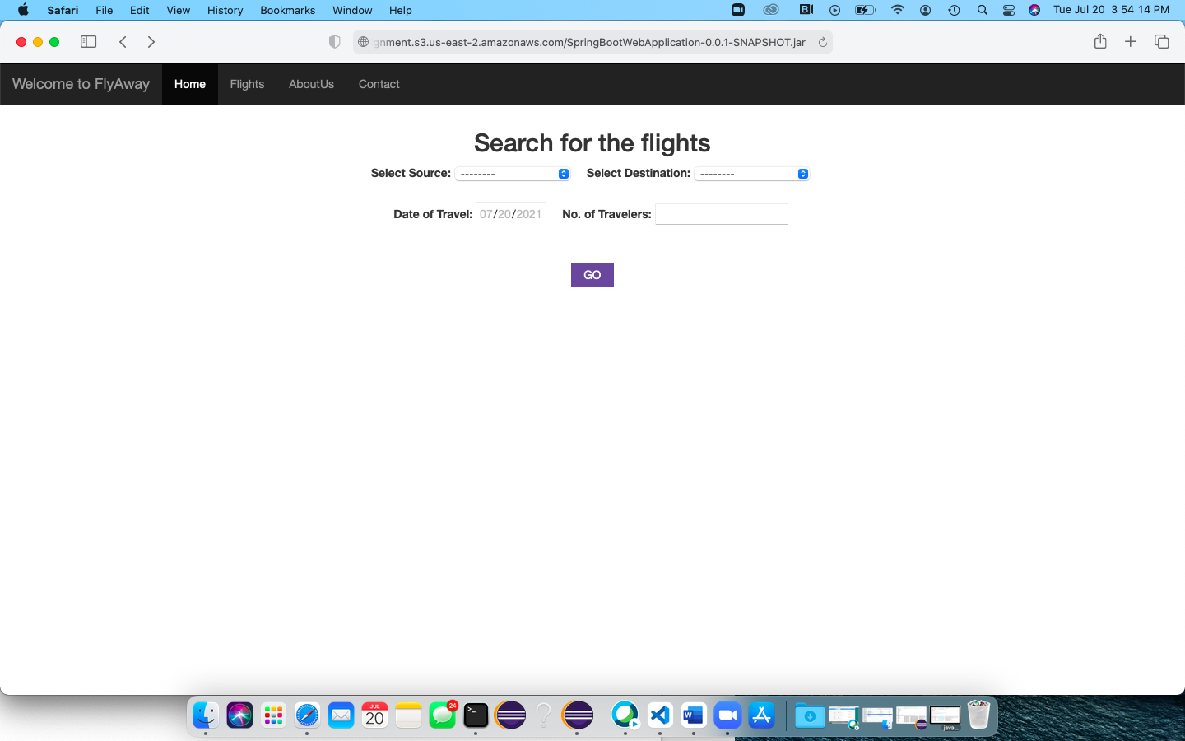

1. **Installed Jenkins on port 8080 on EC2 – Check Jenkins status on connected EC2 instance**

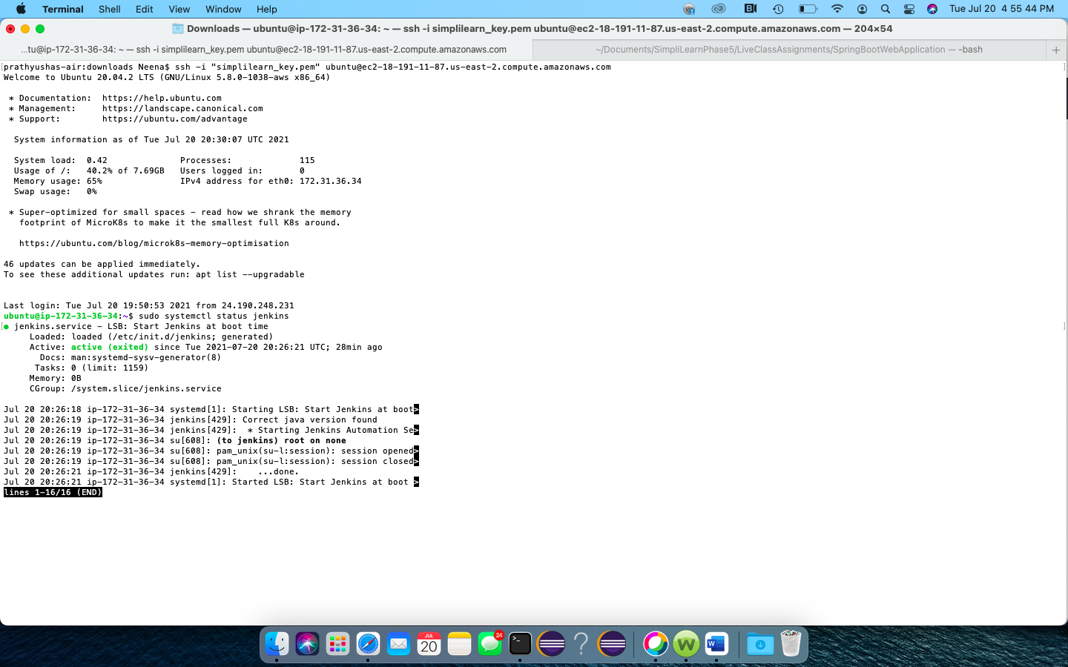

1. **Visit Jenkins and login – Visit on <ipaddr>:8080 and create a new item Jenkins Pipeline project to CI/CD our Springboot Web application**

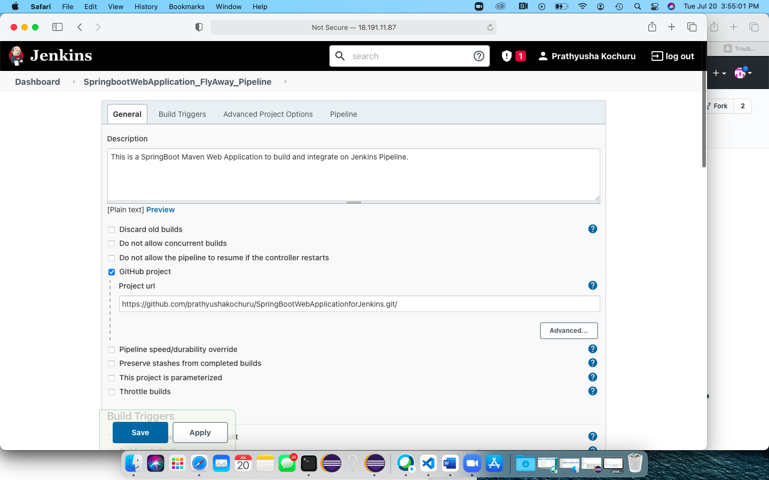

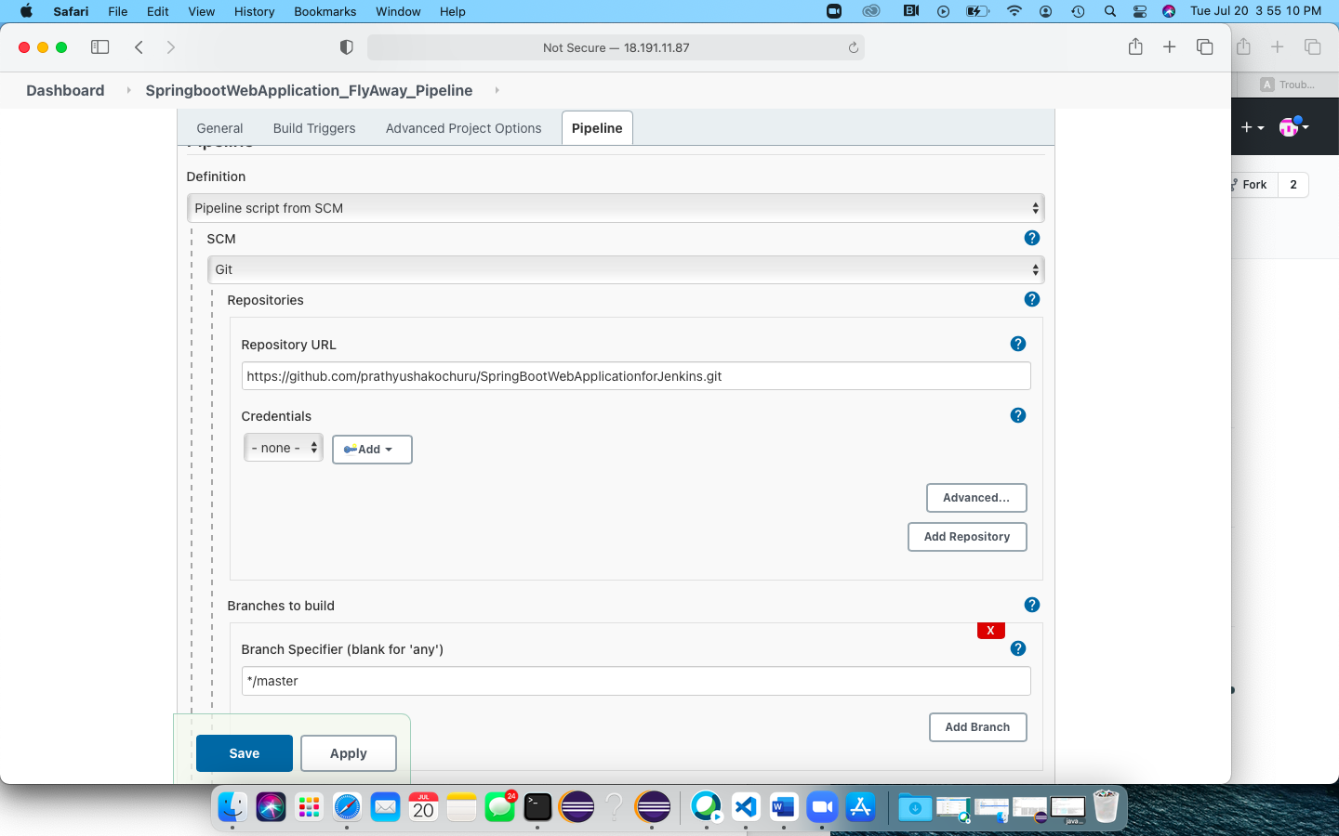

**Here, I am running the Jenkins Pipeline steps from the ‘Jenkins’ script file on GitHub repository source code.**

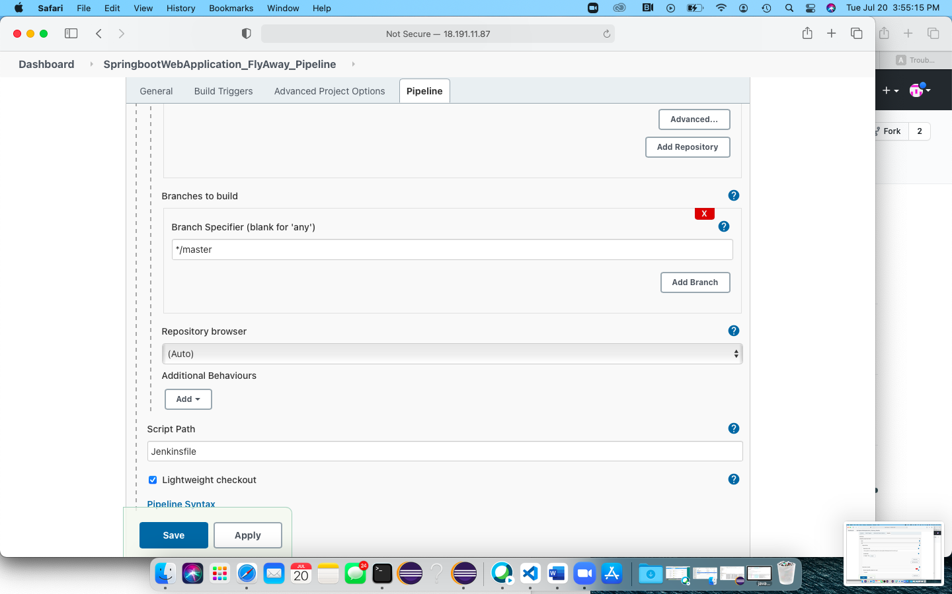

1. **Jenkins Pipeline Build – Have mentioned ‘Polle SCM’ as ‘* * * * *’ – means it happens once every hour**

