# Assignment 6 Part 1

***Run - imageSegmentation_image1.R***

***K = 2***

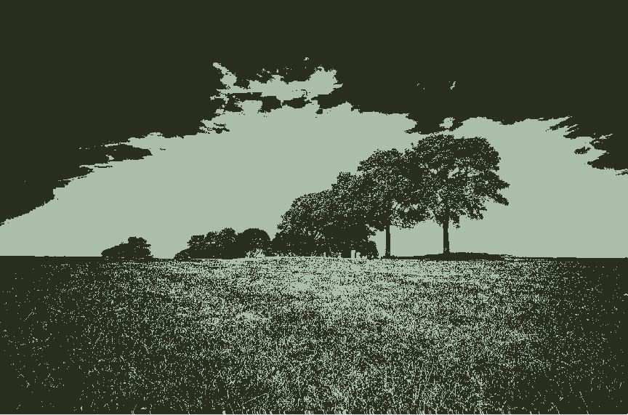

***Run - imageSegmentation_image2.R***

***K=3***

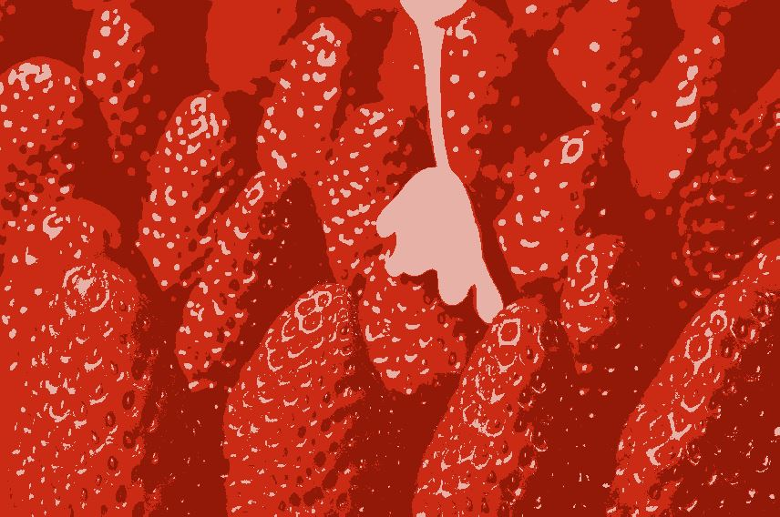

***Run - imageSegmentation_image3.R***

***K=4***

