WEB SERVER SENSING

Steps to run our development environment

1. Installing SQLite.
2.Create and Populating a Table in order to log DHT sensor measured data on the database.
3.Created sensorsData.db file to store sensors data in SQLite.
4.Developed a python script insertTableDHT.py to test a dummy data.
5. Connected the wired connection as below:
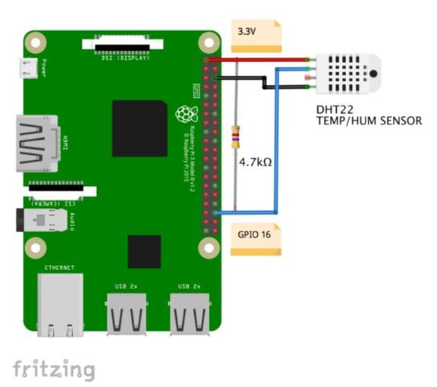

6.Installed DHT Library.
7.Developed a python script logDHT.py to capture the real data automatically.
8. Developed a python script queryTableDHT.py to display queries on the terminal.
9.Developed a python script lastLogDataTableDHT.py
to display the last data entered in a table.
10. Developed a python script appDhtWebHist.py to host our webpa ge.

Working of our project:
1.Run logDHT.py script in one terminal to capture real time data.
2. Open another terminal and run appDhtWebHist.py script to start the web-server.
3.Type Raspberry Pi IP address in browser to start the web-page.
4.To capture real time data, click refresh button.
5. Enter the number of queries you want to retrieve from the database, and variation of the data will be displayed in histogram.

