Software Engineering – Lab 3 Report
NAME: PRATHYUSH GOWDA
SRN: PES1UG24AM201
SEC:D
Component Modelling & Architectural Pattern Selection

Report Requirements
- Submit the Written Justification as a Word document with a maximum length of 1 page.
- The report must state the architectural style selected for the Self-Service Coffee Kiosk System.
- Give two specific reasons related to the scenario for choosing that architecture.
- Explain one security advantage of the chosen architecture.
- Explain one performance benefit of the chosen architecture.

Ready-to-Use Report
Architecture Selection: We chose Layered Architecture for the Self-Service Coffee Kiosk System.
Architectural Choice: Layered Architecture provides a clear separation between the presentation, business, and data responsibilities of the kiosk system.
Reason 1: The touch-screen interface can be separated from the order and payment processing logic.
This makes the system easier to understand and maintain.
Reason 2: Menu and pricing information can be maintained separately from order processing, while receipt printing can be handled through a dedicated component. This provides clear separation of concerns.
Security Advantage: Payment processing can be isolated in the Payment Service so that sensitive payment operations are separated from the user-interface and ordering components. Access between components can be controlled through defined interfaces.
Performance Benefit: Separating the user interface from data access and payment processing prevents the interface from handling unnecessary processing and allows menu information to be retrieved efficiently.

Output Screenshot
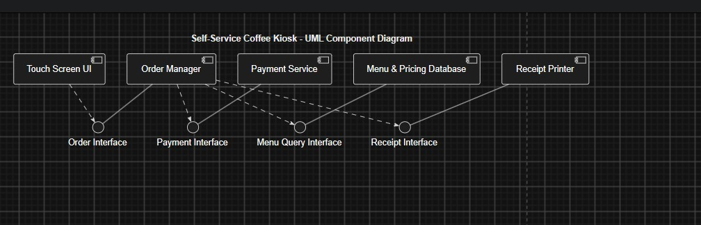
Screenshot of the component diagram output provided for the report.

