**Question #4:** Create a user persona for your project

**ANUSHKA SHRESTHA: Potential User of KUnotes**

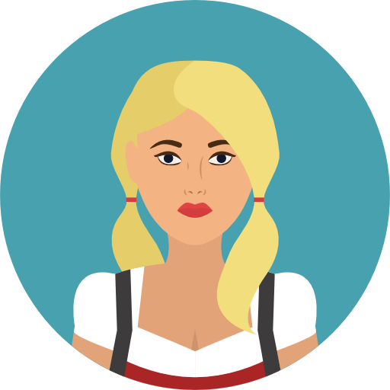

|  |
| --- |
| *“I want my study materials to be managed and available in one place.”* |

**DEMOGRAPHICS**

**Age:** 17-23

**Work:** Student

**College:** K.U. School of Engineering

**Location:** Samakhusi, Kathmandu

**TECHNICAL BACKGROUND:**

**Education:** +2 in science stream,

2nd yr student of BE. Computer

**Computer Skills:** Advanced

**Computer Tools Usage:**

Web surfing,

MS. Office Tools,

AutoCad,

Progamming tools

**Background:** Engineering

**ENVIRONMENT**

She is proficient and up-to-date with new technologies. She is always trying to find better ways to solve problems through various technologies that she has access to.

She has high speed internet connection at home and has constant internet access in college.

**BIOGRAPHY**

Anushka is an aspiring Computer Engineering Student at KU currently in 2nd yr. She is highly dedicated and wishes to be a successful back-end developer once she graduates. She is a brilliant student with above 3.7 GPA. She wishes to go through most of if not all the materials available for her course. She believes that no knowledge you gain is wasted.

**GOALS**

* Efficient management of study materials.
* Access all available study materials all through one place.
* Save time lost searching and organizing course materials.
* Get interactive with friends and lecturers and be able to share knowledge and ask questions.

**FRUSTATIONS**

* A lot of time and energy is spent searching for course materials.
* Difficulty getting answers to problems while not in college.
* Sometimes required course materials are just not available.

**MOTIVATIONS**

* Want to improve grades.
* Passionate about learning new things as motivating others towards learning.
* Be efficient and productive with available time and space.­­­