UKHO – Cloud/dev ops week2 – assignment 40F74BE9-6CCB-4CDC-DEEE-08D8EEB37A9E

1. Add new endpoint as below:

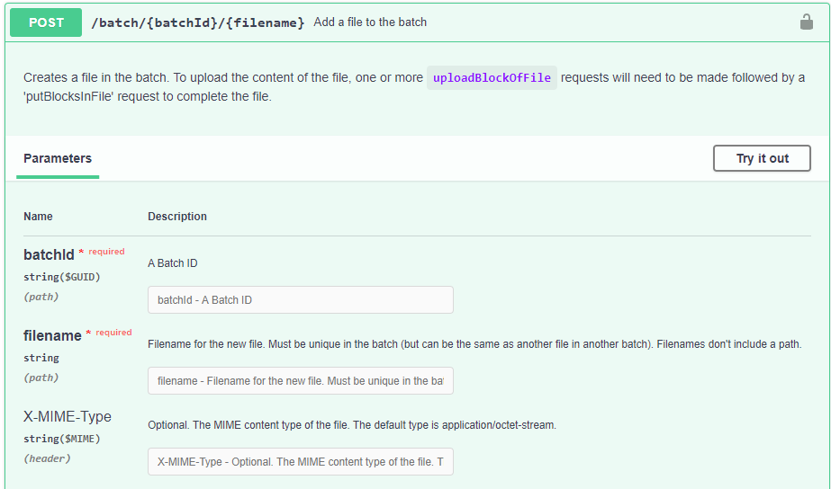



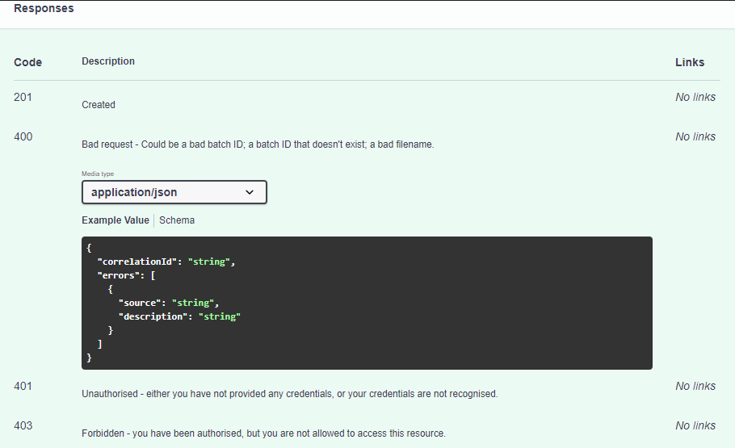

i. Files details i.e. meta data should be stored in database

ii. Keep one static file on your application which we are going to upload to azure storage account when this endpoint is called.

iii. End point should be same as given in above swagger doc.

Do the following changes in your application.

1. Add Keyvault support in your application for managing secrets like db connection string and storage account key.
2. Add Azure storage account support in your application and perform below tasks.
3. When batch is created application should create container in azure storage account
4. When you try add file endpoint the file stored in in application should be uploaded in container created during create batch
5. Move your current local database to Azure SQL Database
6. Use Azure Web App for running your web API