**BIG DATA ANALYTICS ASSIGNMENT-2**

**ICP2**

1.

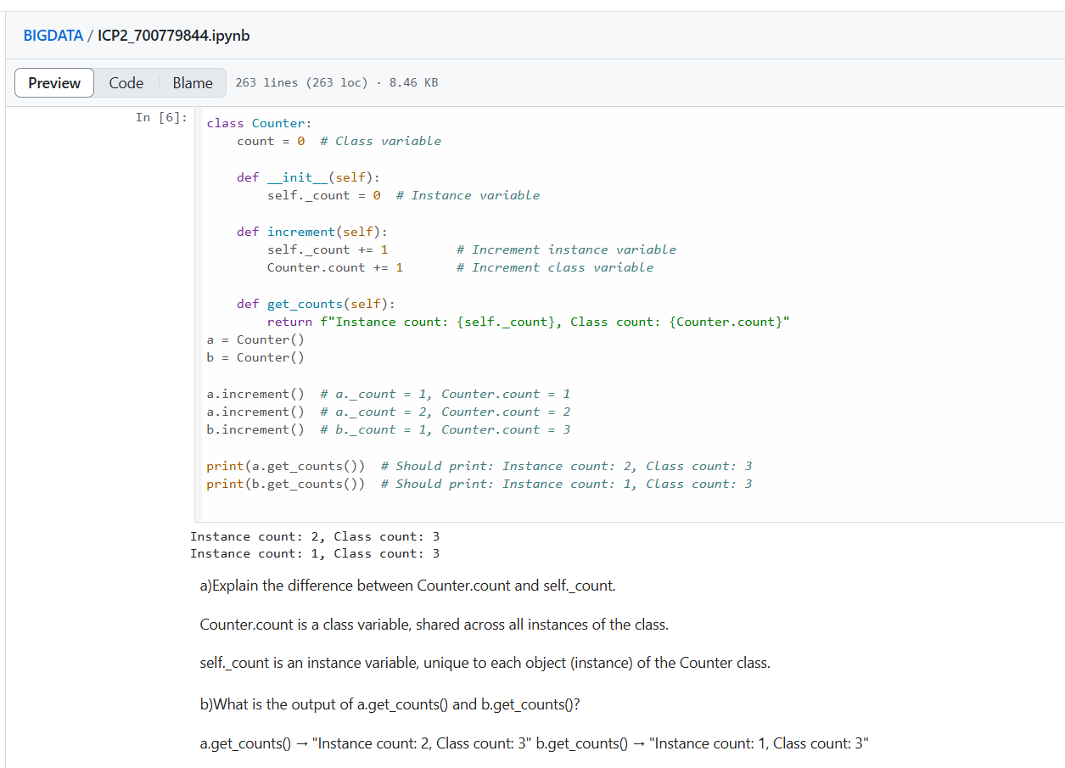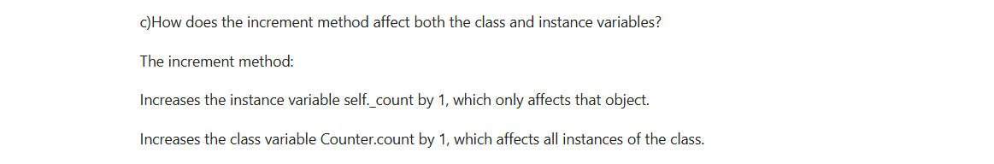

2.

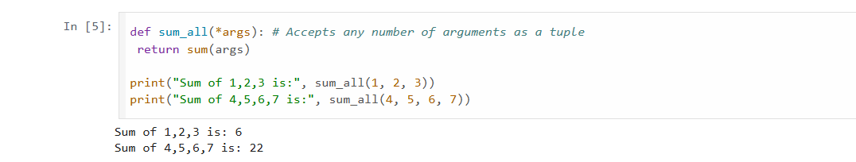3.

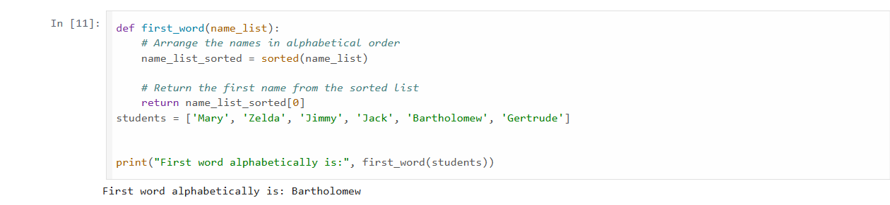

4.

