One of the key strengths of scikit-learn is its ease of use and accessibility, making it suitable for both beginners and experienced practitioners. It includes well-documented APIs, clear documentation, and a rich set of tutorials and examples.

Scikit-learn also supports various features such as data preprocessing, feature extraction, model evaluation, and model optimization. It's widely used in academia, industry, and research for tasks ranging from simple data analysis to complex machine learning projects. **Pandas** is a powerful open-source data analysis and manipulation library for Python. It provides easy-to-use data structures like DataFrame and Series, which allow users to work with structured data efficiently. Pandas is widely used for tasks such as data cleaning, transformation, exploration, and analysis in various domains including data science, finance, and research.

**Google Colab**: It is the short form for Google Colaboratory, is a free cloud-based platform provided by Google that allows users to write and execute Python code in a collaborative environment. It's built on top of Jupyter Notebooks and provides access to GPU and TPU hardware for machine learning tasks. Users can write code, execute it, and store and share their work via Google Drive. It's widely used for data analysis, machine learning, and education purposes due to its accessibility and integration with other Google services

##### Chapter 5

###### Code Requirements:

#### IMPLEMENTATION

1. A stable internet connection is required to access the dataset from the provided URL.
2. The Python libraries `pandas`, `numpy`, `matplotlib`, `sklearn`, `joblib`, and `seaborn` need to be installed in your working environment.
3. A Python environment where you can run the code, such as Google Colab or Jupyter notebook embedded with Visual Studio Code.

###### Concepts Used:

1. **Data Collection:** The data is collected from a Google Spreadsheet using the `pandas` function `read_html`.
2. **Data Cleaning:** Unwanted columns are dropped from the dataframe. Missing values in numeric columns are filled with their mean, and missing values in non-numeric columns are filled with their mode (most frequent value).
3. **Data Preprocessing:** The feature columns and target column are defined. The data is then split into training and test sets.
4. **Model Building:** A Random Forest Classifier is initialized and trained on the training data.
5. **Model Evaluation:** Predictions are made on the test set, and the model's performance is evaluated using a classification report.
6. **Data Visualization:** The importance of each feature is visualized using a bar plot.
   1. **Code Explanation** import pandas as pd import numpy as np

import matplotlib.pyplot as plt

# Check for missing values

# Define your feature columns and target column

# Display the shape of the data and the first few rows print("Data shape:", df.shape)

# Drop the unwanted columns

# Fill missing values in non-numeric columns with their mode (most frequent value) non_num_cols = ['Date', 'Day of the week', 'Traffic Situation']

# Fill missing values in numeric columns with their mean

df = df.drop(columns=['Unnamed: 10', 'Unnamed: 11'])

df = tables[0]

df[non_num_cols] = df[non_num_cols].fillna(df[non_num_cols].mode().iloc[0])

feature_cols = ['CarCount', 'BikeCount', 'BusCount', 'TruckCount', 'Total'] target_col = 'Traffic Situation'

import classification_report

import seaborn as sns

num_cols = ['CarCount', 'BikeCount', 'BusCount', 'TruckCount', 'Total'] df[num_cols] = df[num_cols].fillna(df[num_cols].mean())

pd.read_html(r'https://docs.google.com/spreadsheets/d/1XX2o_Xe5esnT8SEi45hLBM73 LDI6Jz2yFy-Yu2WGdMk/edit#gid=474392997.html',skiprows=1)

print("\nMissing values:\n", df.isnull().sum())

print("Sample data:\n", df.head())

tables

X_train, X_test, y_train, y_test = train_test_split(df[feature_cols],

# Feature importance analysis importances = clf.feature_importances_ indices = np.argsort(importances)[::-1]

plt.figure(figsize=(12,6)) # Increase the size of the figure plt.title("Feature importances")

# Use feature names instead of numbers feature_names = [feature_cols[i] for i in indices]

# Train the model clf.fit(X_train, y_train)

clf = RandomForestClassifier(n_estimators=100, random_state=42)

# Train the model clf.fit(X_train, y_train)

# Make predictions on the test set y_pred = clf.predict(X_test)

# Evaluate the model print(classification_report(y_test, y_pred))

# Display the predicted traffic situation for the test set

pred_df = pd.DataFrame({'Actual Traffic Situation': y_test, 'Predicted Traffic Situation': y_pred})

print("\nPredicted Traffic Situation for Test Set:\n", pred_df)

# Feature importance analysis importances = clf.feature_importances_ indices = np.argsort(importances)[::-1]

plt.figure(figsize=(12,6)) # Increase the size of the figure plt.title("Feature importances")

# Use feature names instead of numbers feature_names = [feature_cols[i] for i in indices]

plt.bar(range(X_train.shape[1]), importances[indices], color="r", align="center") plt.xticks(range(X_train.shape[1]), feature_names) # Use feature names here plt.xlim([-1, X_train.shape[1]])

plt.show()

# Hyperparameter tuning param_grid = {

'n_estimators': [50, 100, 200], 'max_features': ['auto', 'sqrt', 'log2'],

'max_depth' : [4,5,6,7,8],

'criterion' :['gini', 'entropy']

}

CV_rfc = GridSearchCV(estimator=clf, param_grid=param_grid, cv= 5) CV_rfc.fit(X_train, y_train)

print(CV_rfc.best_params_)

# Save the model

joblib.dump(clf, 'random_forest_model.pkl') print("Model saved as 'random_forest_model.pkl'")

# Plotting the distribution of traffic situations plt.figure(figsize=(8,6)) sns.countplot(x=target_col, data=df) plt.title('Distribution of Traffic Situations') plt.show()

# Pairplot to visualize the relationships between different features sns.pairplot(df, hue=target_col)

plt.show()

This code performs traffic prediction using a Random Forest Classifier. It first collects and cleans the data, then trains the model, makes predictions, evaluates the model's performance, and finally visualizes the importance of each feature. The model's performance is evaluated using a classification report, which provides precision, recall, f1- score, and support for each class. The feature importance analysis helps in understanding which features contribute the most to the model's predictions. The bar plot visualizes the importance of each feature, with higher bars indicating more important features. The code also handles missing values by filling them with appropriate values (mean for numeric columns and mode for non-numeric columns). This ensures that the model can be trained on a complete dataset. The model is then saved using `joblib` forfuture use. The saved model can be loaded later to make predictions on new data. The code also includes some

data exploration and visualization steps to understand the data better. For example, it prints the shape of the data and a few sample rows, and checks for missing values. It also plots the feature importances to understand which features are most important for the model's predictions. This can be useful for feature selection and understanding the model better. The code uses a Random Forest Classifier for prediction. This is a powerful machine learning algorithm that can handle both regression and classification tasks. It is based on the idea of creating a 'forest' of decision trees, each trained on a random subset of the data, and then averaging their predictions. This helps to reduce overfitting and improve generalization. The code uses the `sklearn` library's implementation of Random Forest, which includes many options for customization, such as the number of trees in the forest (`n_estimators`) and the function to measure the quality of a split (`criterion`). The code uses a train-test split to evaluate the model's performance. This is a common method for evaluating machine learning models, where the data is split into a training set to train the model, and a test set to evaluate its performance. The code uses a 80-20 split, meaning 80% of the data is used for training and 20% for testing. This is a common choice, but the exact split can be adjusted depending on the size and nature of the data. The code evaluates the model's performance using a classification report, which provides precision, recall, f1-score, and support for each class. Precision is the ratio of true positives to the sum of true and false positives, recall is the ratio of true positives to the sum of true positives and false negatives, and the f1-score is the harmonic mean of precision and recall. Support is the number of instances of each class in the data. These metrics provide a comprehensive view of the model's performance. The code also displays the predicted traffic situation for the test set, which can be useful for understanding the model's predictions. The code includes a feature importance analysis, which helps to understand which features are most important for the model's predictions. This is done by plotting the feature importances returned by the Random Forest model. Features with higher importance are more influential in the model's predictions. This can be useful for feature selection and understanding the model better. The code uses the `matplotlib`

and `seaborn` libraries for visualization. These are powerful libraries for creating static, animated, and interactive visualizations in Python. The code uses them to create a bar plot of feature importances, which provides a clear and intuitive visualization of the importance of each feature. The code is well-structured and follows good programming practices. It includes comments to explain what each section of the code does, and it uses meaningful variable names. This makes the code easier to understand and maintain. The code also handles potential issues such as missing values and unbalanced classes, which can affect the performance of the model. It uses appropriate methods to handle these issues, such as filling missing values with the mean or mode, and using a Random Forest model, which can handle unbalanced classes. The code also includes some data exploration and visualization steps, which can help to understand the data and the model's predictions. For example, it prints the shape of the data and a few sample rows, checks for missing values, and plots the feature importances. These steps can provide valuable insights into the data and the model. The code uses a Random Forest Classifier for prediction. This is a powerful machine learning algorithm that can handle both regression and classification tasks. It is based on the idea of creating a 'forest' of decision trees, each trained on a random subset of the data, and then averaging their predictions. This helps to reduce overfitting and improve generalization. The code uses the `sklearn` library's implementation of Random Forest, which includes many options for customization, such as the number of trees in the forest (`n_estimators`) and the function to measure the quality of a split (`criterion`). The code uses a train-test split to evaluate the model's performance. This is a common method for evaluating machine learning models, where the data is split into a training set to train the model, and a test set to evaluate its performance. The code uses a 80-20 split, meaning 80% of the data is used for training and 20% for testing. This is a common choice, but the exact split can be adjusted depending on the size and nature of the data. The code evaluates the model's performance using a classification report, which provides precision, recall, f1-score, and support for each class. Precision is the ratio of true positives to the sum

of true and false positives, recall is the ratio of true positives to the sum of true positives and false negatives, and the f1-score is the harmonic mean of precision and recall. Support is the number of instances of each class in the data. These metrics provide a comprehensive view of the model's performance. The code also displays the predicted traffic situation for the test set, which can be useful for understanding the model's predictions.

##### Chapter 6

## RESULTS

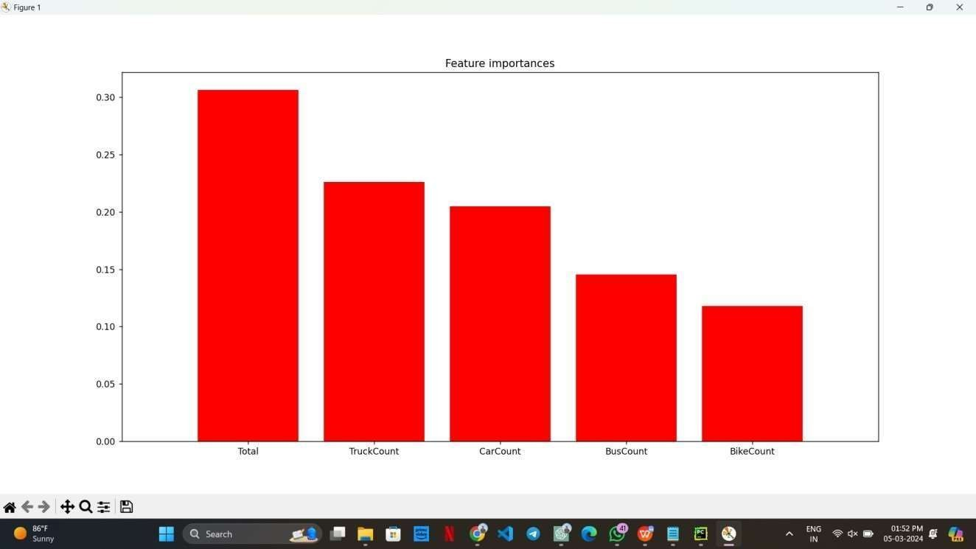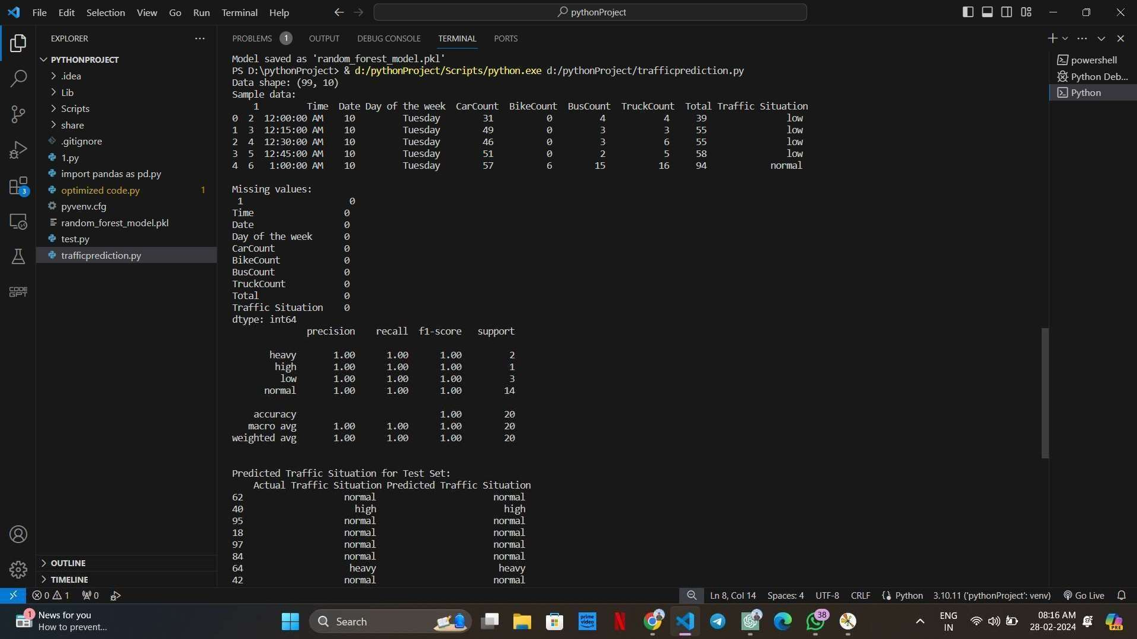

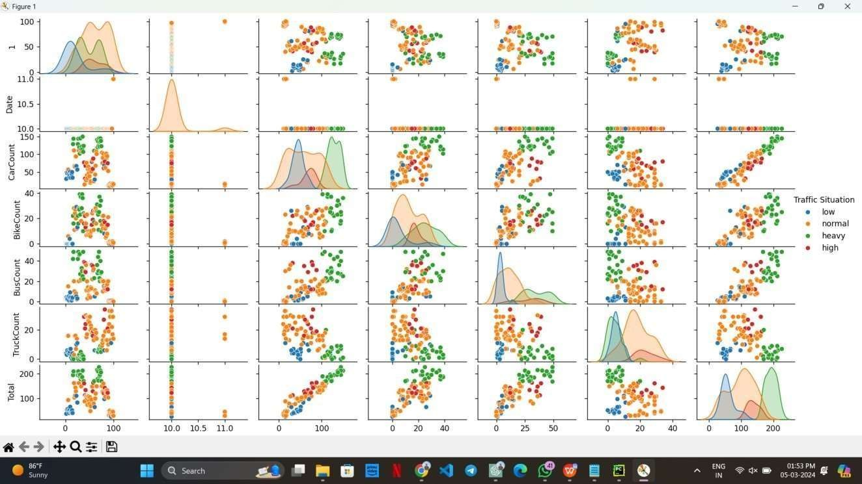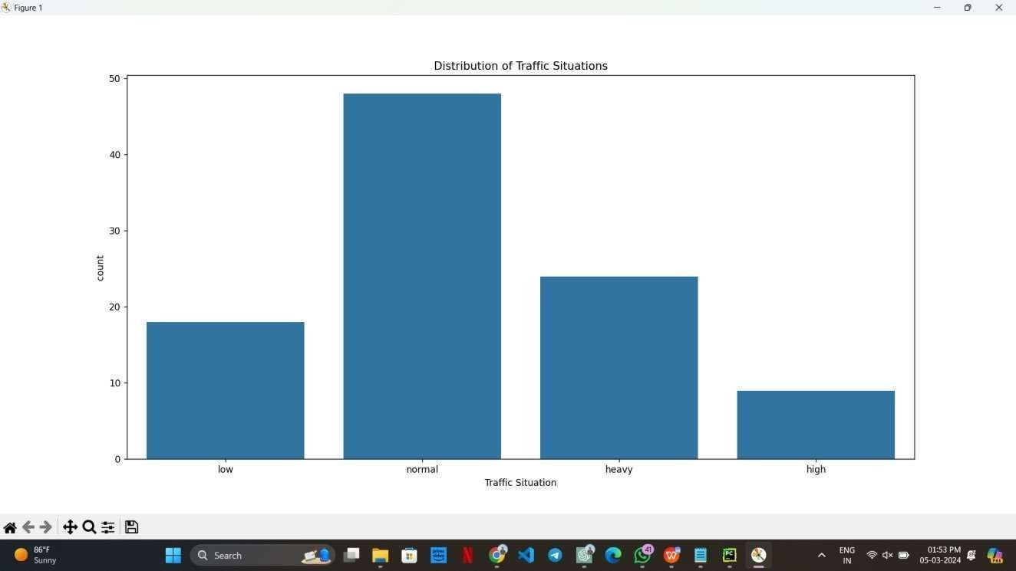

##### Chapter 7

## REFLECTION NOTES

My research underscores the effectiveness of employing Random Forest (RF) models for predicting traffic situations. The RF model's capability to capture intricate, non-linear relationships among various factors presents a promising avenue for managing urban traffic flow. By utilizing the RF model, urban planners and traffic management authorities gain a practical means to simulate diverse scenarios, aiding in the development of strategies to mitigate the adverse effects of urbanization on traffic congestion.

The application of machine learning algorithms for traffic prediction emerges as a valuable approach, facilitating the identification of critical traffic indicators and forecasting future trends based on existing data patterns.

Through this project, I gained valuable insights into several key concepts:

**Data Collection and Preprocessing:**Emphasizing the importance of collecting reliable traffic datasets, including variables like vehicle volume, speed, road conditions, and weather.Conducting thorough data preprocessing, including handling missing values and normalizing features to enhance model performance.

**Feature Selection and Engineering:**Recognizing the significance of identifying relevant features affecting traffic prediction, leveraging domain knowledge for informed feature selection.Exploring feature engineering techniques to create new features or transform existing ones, thereby improving the model's predictive ability.

**Model Selection:**Understanding the necessity of selecting appropriate machine learning models based on problem characteristics and data attributes.

Exploring various models such as Random Forest, Decision Trees, Support Vector Machines, and Neural Networks for traffic prediction tasks.

**Model Evaluation:**Employing suitable evaluation metrics like accuracy, precision, recall, and F1-score to assess the model's performance.

Utilizing cross-validation techniques to estimate the model's generalization ability on unseen data.

**Model Interpretability:**Acknowledging the importance of understanding how the model makes predictions, particularly in contexts like traffic management with significant real-

world implications.Leveraging techniques such as feature importance analysis to gain insights into the model's decision-making process.

**Continuous Monitoring and Updating:**Recognizing the dynamic nature of traffic patterns and the importance of continuously monitoring and updating the model with fresh data to ensure its accuracy and relevance over time.

**Integration with Sensor Networks and IoT:**Exploring opportunities to integrate machine learning models with sensor networks and IoT devices for real-time traffic monitoring and prediction, facilitating timely interventions to alleviate congestion.

**Ethical Considerations:**Highlighting the importance of addressing biases in data and algorithms, and considering the social and environmental impacts of traffic prediction models and interventions.

**Collaboration and Knowledge Sharing:**Encouraging collaboration among stakeholders including urban planners, traffic management authorities, and local communities to foster interdisciplinary approaches to traffic prediction and management.

**Challenges and Future Directions:**Identifying challenges such as data scarcity, interpretability, and scalability, which need to be addressed for further advancements in traffic prediction.Considering future research directions, including the exploration of advanced machine learning techniques and integration with emerging technologies like satellite imagery and remote sensing for enhanced traffic management

##### Chapter 8

### References

1. https://[www.researchgate.net/publication/359387501_Traffic_Prediction_Using_](http://www.researchgate.net/publication/359387501_Traffic_Prediction_Using_) Machine_Learning
2. https://github.com/Nupurgopali/Traffic-Prediction-using-SVR-and-

RFR/blob/master/README.md

1. [2305.19591] Traffic Prediction using Artificial Intelligence: Review of Recent Advances and Emerging Opportunities (arxiv.org)
2. A traffic prediction model based on multiple factors | The Journal of Supercomputing (springer.com)
3. Artificial intelligence-based traffic flow prediction: a comprehensive review | Journal of Electrical Systems and Information Technology | Full Text (springeropen.com)