Trader Performance vs. Bitcoin Market Sentiment
A data-driven analysis of Hyperliquid trading behavior across Fear & Greed regimes

1. Executive Summary
This analysis joins 211,224 trade-level records from 32 Hyperliquid accounts (May 2023 – May 2025) with the daily Bitcoin Fear & Greed Index to understand how market sentiment relates to trader behavior and profitability. All headline numbers below are reported on an equal-weighted (per-account) basis after a robustness check showed that pooled (trade-level) averages were distorted by a handful of high-volume accounts — see Section 3.5. Three findings stand out:
- Traders do best when sentiment is bullish, not neutral — Win rate and average profit-per-trade are both highest during Greed and Extreme Greed (win rate 84-85%, avg PnL $434-$518 per account) and lowest during Fear/Neutral (win rate 77-83%, avg PnL $155-$423) — the opposite of the 'calm markets are safest' intuition.
- The relationship is real — differences in Closed PnL across the five sentiment regimes are statistically significant (ANOVA F=7.74, p<0.0001, robust to outlier winsorizing at F=40.1), confirming sentiment is a meaningful factor in trading outcomes.
- A seemingly strong directional-bias signal did not hold up under a bias check — an initial pooled-data view suggested a strong contrarian Long/Short pattern (69% Long in Extreme Fear vs 45% in Extreme Greed); re-checked at the per-account level, this gap nearly disappears (54% vs 53%), and only 12 of 23 comparable accounts individually show the pattern. The apparent signal was mostly a high-volume-account artifact, not a broad trader behavior — see Section 3.5 for the full comparison.

2. Data & Methodology

2.1 Datasets
Dataset | Records | Key Fields | Coverage
Fear & Greed Index | 2,412 days | date, value (0-100), classification | Feb 2018 – May 2025
Hyperliquid Trades | 211,224 trades | account, coin, side, size, closedPnL, direction | May 2023 – May 2025 (32 accounts)

2.2 Approach
- Join: Each trade was tagged with that day's sentiment classification by matching on date (99.997% match rate).
- PnL filtering: Only trades with a non-zero Closed PnL were treated as realized, PnL-generating events (104,408 of 211,224 rows); all trades were used for position-size and directional analysis.
- Bias check: Daily totals were also computed to check that results weren't driven by one or two high-frequency accounts.
- Significance testing: A one-way ANOVA tested whether mean Closed PnL differs significantly across the five sentiment buckets.

3. Key Findings

3.1 Profitability by Sentiment Regime (Equal-Weighted)
To avoid a handful of high-volume accounts dominating the picture, profit and win-rate figures below are computed per account first, then averaged across accounts (see Section 3.5 for why this matters). Position size and trade count are shown pooled since they describe aggregate market activity, not individual skill.
Sentiment | Avg PnL/trade (per acct.) | Win Rate (per acct.) | Avg Trade Size (pooled) | Trade Count (pooled)
Extreme Fear | $280 | 77.2% | $5,350 | 21,400
Fear | $155 | 82.9% | $7,816 | 61,837
Neutral | $423 | 77.0% | $4,783 | 37,686
Greed | $434 | 84.8% | $5,737 | 50,303
Extreme Greed | $518 | 84.6% | $3,112 | 39,992

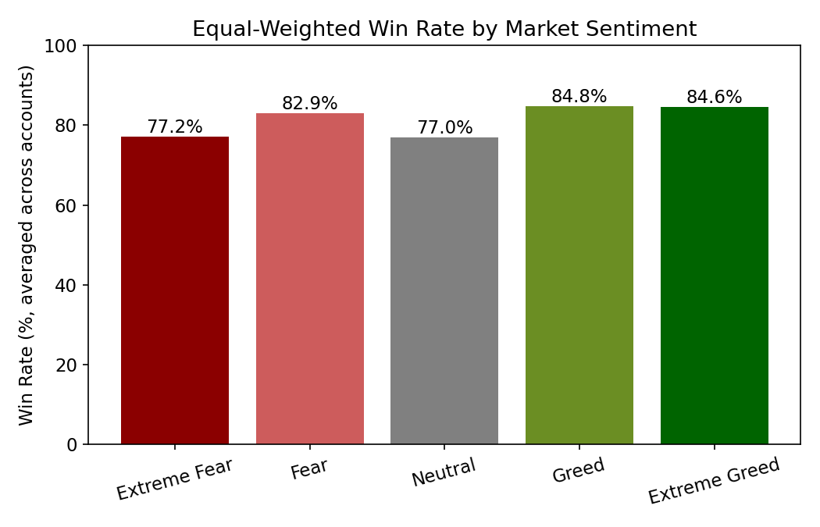
On a per-account basis, win rate and average PnL both trend upward from Fear/Neutral (77-83%, $155-$423) to Greed/Extreme Greed (85%, $434-$518). Extreme Fear sits in between on win rate (77%) but is the weakest regime for average profit ($280) after Fear. In short: this cohort's edge is strongest in bullish sentiment, not in calm or fearful conditions.
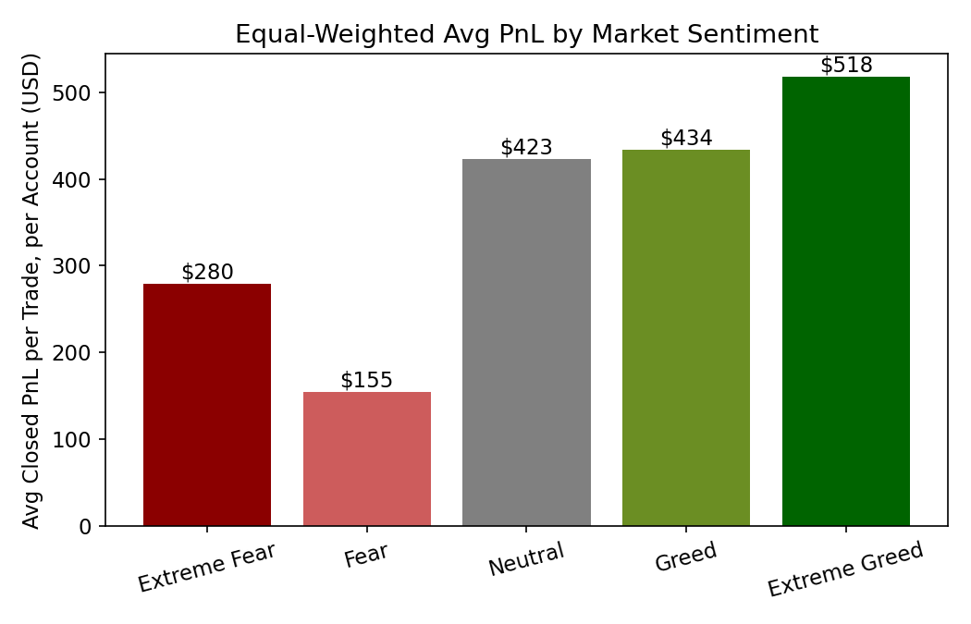

3.2 Position Sizing / Risk Appetite
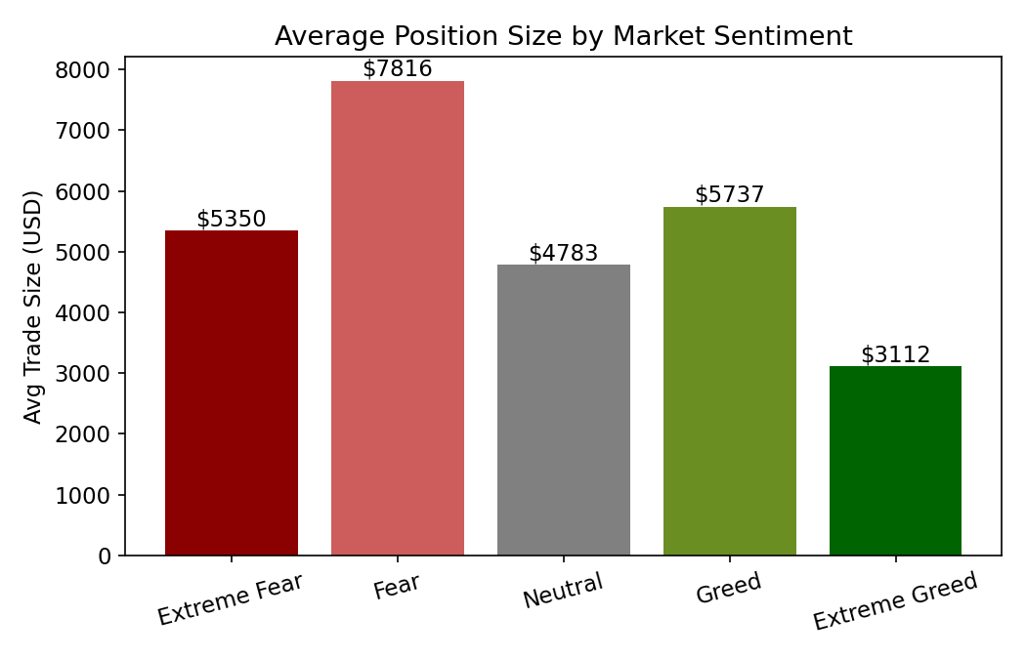
Average trade size (pooled across all trades) is largest during Fear ($7,816) and smallest during Extreme Greed ($3,112), while trade count is highest during Fear (61,837) as well. Traders commit more capital per trade, and trade more often, when sentiment is fearful but not extreme — then shift to smaller, more frequent trades during euphoric conditions.

3.3 Statistical Significance
A one-way ANOVA on Closed PnL across the five sentiment groups returned F = 7.74, p < 0.0001, meaning the differences in trading outcomes across sentiment regimes are very unlikely to be due to chance. This result strengthens under outlier-robust winsorizing (1st-99th percentile clip: F = 40.1, p < 0.0001). However, daily-level correlations between the raw sentiment score (0-100) and daily total PnL are weak (r = -0.08), indicating sentiment is one contributing factor among many, not a standalone predictor of daily returns.

3.4 Long vs. Short Positioning — A Signal That Didn't Survive Scrutiny
An initial pooled-data pass suggested a strong contrarian pattern: Long positions made up 69% of trades opened during Extreme Fear, falling to 45% during Extreme Greed.
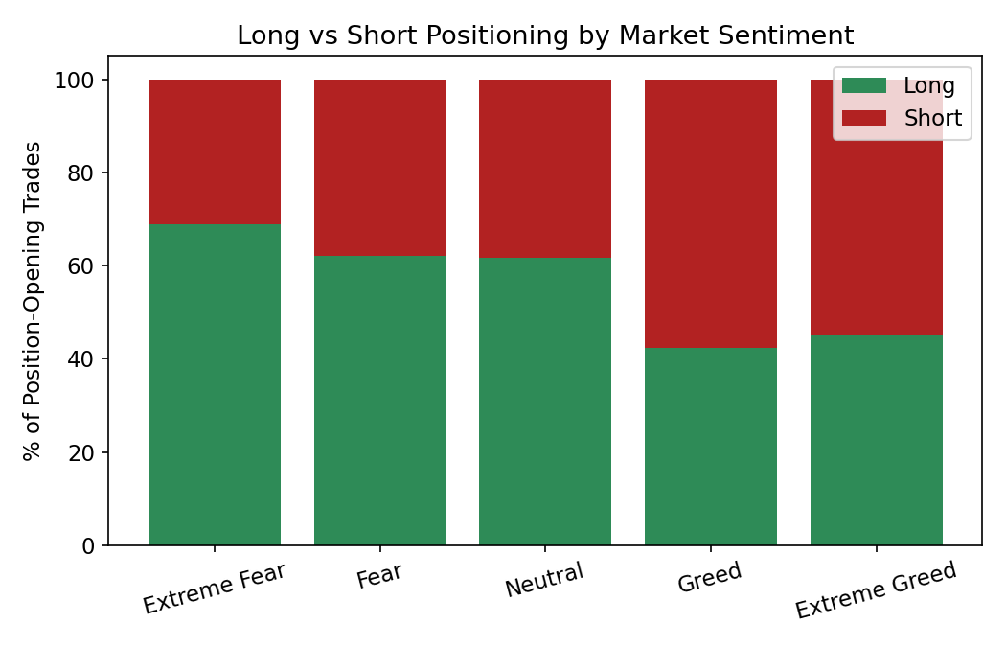
This looked like a clean 'buy the dip, fade the euphoria' signal. Re-checked on a per-account basis (each account's own %Long, then averaged), the gap nearly vanishes: 54% Long in Extreme Fear vs. 53% in Extreme Greed. Only 12 of 23 accounts with trades in both regimes individually show more Long bias in Fear than in Greed — close to a coin flip. The original pooled signal was driven largely by a few high-volume accounts whose own directional shifts got amplified by their trade counts. Conclusion: directional bias by sentiment is not a reliable pattern in this dataset once account-level weighting is applied.

3.5 Robustness Check: Why Equal-Weighting Matters
The single largest account by absolute Closed PnL accounts for 19.8% of the dataset's total, and the top 3 of 32 accounts together account for 43.2%. Because these accounts don't trade evenly across sentiment regimes, pooled (trade-level) averages can reflect a few accounts' behavior more than the group's. All Section 3.1-3.4 conclusions were re-derived on an equal-weighted basis specifically to correct for this, and are the figures relied on for the strategy implications below.

4. Trading Strategy Implications
- Regime-aware conviction: Greed and Extreme Greed show the strongest historical win rates and average per-account PnL — a sentiment-based filter could flag these as higher-conviction windows, rather than assuming calmer Neutral conditions are inherently safer.
- Fear regime warrants risk discipline: Fear shows the largest average trade size and highest trade count, but middling win rate/PnL — capital is being deployed aggressively in Fear without a matching edge, which is a flag for tighter risk controls during that regime specifically.
- Don't act on the unverified directional-bias signal: The pooled Long/Short split by sentiment did not replicate at the account level — a strategy should not be built on 'buy fear, short greed' directional timing based on this dataset alone.
- Sentiment is a secondary signal: With r ≈ -0.08 to 0.06 between the raw sentiment score and daily outcomes, sentiment should inform — not replace — technical/fundamental signals.
- Concentration risk in the sample itself: Because 3 accounts drive 43% of total PnL, any strategy derived from this dataset should be validated on a broader, more evenly distributed trader sample before being generalized.

5. Limitations
- 32 accounts is a small, possibly self-selected sample of active Hyperliquid traders, and PnL is concentrated in a few accounts — findings may not generalize to the broader market.
- Fear & Greed Index reflects overall crypto-market sentiment, not sentiment specific to each traded coin (246 coins were traded).
- Closed PnL does not account for unrealized positions held across sentiment-regime transitions, or for fees/funding costs beyond what's in the Fee column.
- A pattern that looks strong in pooled trade-level data can disappear at the account level (Section 3.4) — any further analysis of this data should default to equal-weighting unless trade-level aggregate activity is specifically what's being measured.

6. Conclusion
Market sentiment measurably relates to how this group of Hyperliquid traders performs — most reliably through win rate and average profit, which both trend higher in Greed/Extreme Greed regimes on a per-account basis (ANOVA p<0.0001, robust to outlier winsorizing). A seemingly clean directional (Long/Short) signal from the pooled data did not hold up once corrected for a few high-volume accounts, underscoring the value of checking pooled findings at the account level before drawing conclusions. Overall, sentiment is a real but moderate factor best used alongside other signals rather than as a standalone strategy input.

