- We are using fashion mnist dataset.
- 60000 are training and 10000 are testing dataset
- Two csv files (training and test) each consist of 784 columns(28x28 pixels).
- Classified into 10 classes(labels)
- A quick look at the training csv file and the images
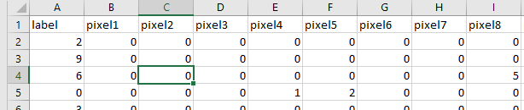…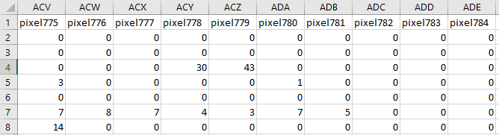

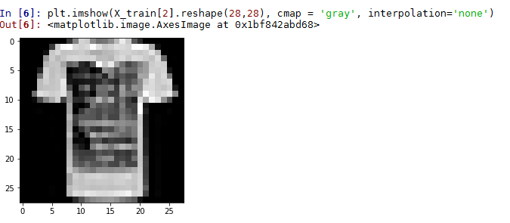

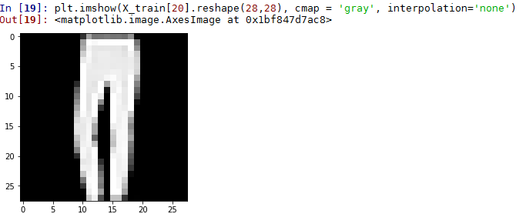

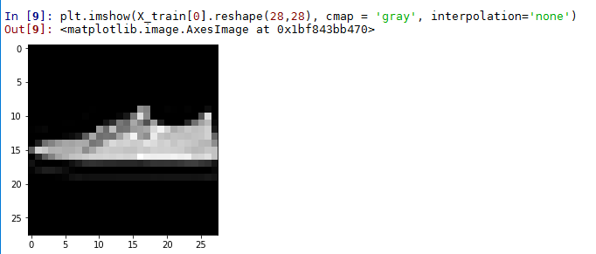

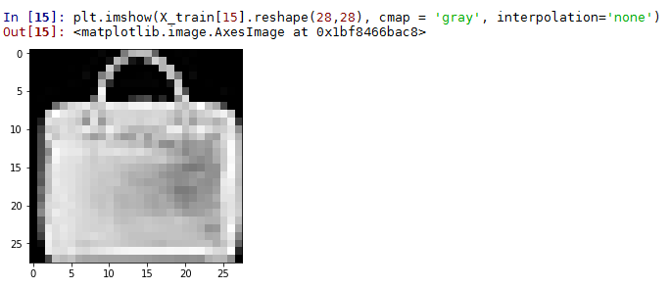

a. Default code:
- Took about an hour to complete
- Ran 50 epochs
- Used ‘relu’ as activation function, softmax in output layer, adam optimizer.
- 3 Convolution layers and 2 Maxpooling. Feature detector size = 3x3(check the conv2d) and Maxpooling size is 2x2.
- Below is how loss, accuracy and other parameters progressed during the training
Epoch 1/50
48000/48000 [==============================] - 76s 2ms/step - loss: 0.8949 - acc: 0.6685 - val_loss: 0.5369 - val_acc: 0.8127
:
Epoch 20/50
48000/48000 [==============================] - 86s 2ms/step - loss: 0.2481 - acc: 0.9075 - val_loss: 0.2387 - val_acc: 0.9118
:
Epoch 40/50
48000/48000 [==============================] - 103s 2ms/step - loss: 0.1950 - acc: 0.9262 - val_loss: 0.2201 - val_acc: 0.9189
:
Epoch 50/50
48000/48000 [==============================] - 85s 2ms/step - loss: 0.1853 - acc: 0.9305 - val_loss: 0.2195 - val_acc: 0.9208

b. Using relu activation, 3 conv layers with dropouts, kernel size 3x3. Optimizer = SGD(instead of Adam)(Efficiency drops!):

Epoch 1/50
48000/48000 [==============================] - 61s 1ms/step - loss: 1.8291 - acc: 0.3200 - val_loss: 1.2188 - val_acc: 0.5662
:
Epoch 25/50
48000/48000 [==============================] - 67s 1ms/step - loss: 0.5910 - acc: 0.7755 - val_loss: 0.5205 - val_acc: 0.8049
:
Epoch 50/50
48000/48000 [==============================] - 68s 1ms/step - loss: 0.4956 - acc: 0.8159 - val_loss: 0.4368 - val_acc: 0.8439

c. Using tanh activation function on default code(see a) causes little drop in training and test accuracies:

Epoch 1/50
48000/48000 [==============================] - 71s 1ms/step - loss: 0.7449 - acc: 0.7245 - val_loss: 0.5829 - val_acc: 0.7845
:
Epoch 35/50
48000/48000 [==============================] - 75s 2ms/step - loss: 0.2459 - acc: 0.9121 - val_loss: 0.2480 - val_acc: 0.9131
:
Epoch 50/50
48000/48000 [==============================] - 77s 2ms/step - loss: 0.2269 - acc: 0.9174 - val_loss: 0.2456 - val_acc: 0.9124
d. Using relu, 2 convolution layers with dropouts. Kernel size changed to 5,5 on both convolution layers( almost no effect on training or test accuracies):

Epoch 1/50
48000/48000 [==============================] - 83s 2ms/step - loss: 0.8006 - acc: 0.7117 - val_loss: 0.4575 - val_acc: 0.8340
:
Epoch 25/50
48000/48000 [==============================] - 67s 1ms/step - loss: 0.2055 - acc: 0.9225 - val_loss: 0.2339 - val_acc: 0.9129
:
Epoch 50/50
48000/48000 [==============================] - 67s 1ms/step - loss: 0.1575 - acc: 0.9395 - val_loss: 0.2281 - val_acc: 0.9209

Default code with epoch=25 and batch size=128(No significant difference):

Epoch 24/25
48000/48000 [==============================] - 69s 1ms/step - loss: 0.2253 - acc: 0.9164 - val_loss: 0.2301 - val_acc: 0.9152
Epoch 25/25
48000/48000 [==============================] - 73s 2ms/step - loss: 0.2192 - acc: 0.9175 - val_loss: 0.2279 - val_acc: 0.9135

Default code with epoch=25 and batch_size=1024(No significant difference):
Epoch 1/25
48000/48000 [==============================] - 72s 2ms/step - loss: 1.1966 - acc: 0.5637 - val_loss: 0.6653 - val_acc: 0.7531
:
Epoch 15/25
48000/48000 [==============================] - 72s 2ms/step - loss: 0.3245 - acc: 0.8812 - val_loss: 0.2871 - val_acc: 0.8937
:
Epoch 25/25
48000/48000 [==============================] - 73s 2ms/step - loss: 0.2715 - acc: 0.8993 - val_loss: 0.2497 - val_acc: 0.9060

