**Design of Microstrip Patch Antenna for wireless applications**

**Abstract**

A novel couple-fed dual-bands MIMO antenna is proposed for WLAN 2.4/5.2/5.8 GHz bands. The MIMO antenna system consists of two parallel folded branch monopoles with an edge-to-edge separation of 0.2 mm. The antenna elements are printed on an FR4 substrate and are located at the top edge of the ground plane. Size of the antenna is 20 mm (W) × 11 mm (L).

The isolation is achieved by introducing a round off-set structure at the end of the coupled feeding-line. Measured results show that antennas have good impedance matching and Port isolation. Since we have not introduced any isolation enhancing structure, the MIMO antenna appeared to have a built-in decoupling mechanism. When one end was fed, the Current distributions on the other feed line was reduced in magnitude by a self-generated counter current occur at the round off-set structure area. That is, the self-generated counter Current has contributed the needed isolation between the two antennas. The results suggest that the proposed novel simple, compact antenna structure has indeed attained good isolation Characteristics required for MIMO operations. Moreover, the antenna is easy to fabricate and suitable for applications at the 2.4/5.2/5.8-GHz bands.

**I. INTRODUCTION**

Planar multi-antennas structure and a small ground are very attractive for wireless local area network (WLAN) applications. On the other hands, the non-contact feeding such as proximity coupling and aperture coupling have become a popular type of solutions to broaden antenna band-width. In particular, proximity coupling is one of the most utilized methods in micro-strip antenna design. Recently, the use of multi-element antennas, such as multiple-input multiple-output (MIMO) antenna, was one of the effective ways to improve reliability and to increase the channel capacity of the communication systems .For multi-channel wireless communication systems, it is essential that the designed multi-antenna would have high isolation between the antenna ports. Several methods of improving antenna port isolation had been reported, including

incorporating a protruded ground plane between the antennas, inserting slits into the ground , arranging antenna shorting portions facing each other, manipulating radiation polarization of the antennas, using differential ground path, using strip resonator as a wave-strap, adding a decoupling neutralization line, and so on In this article, we proposed a built-in isolation/decoupling method to improve the performance (such as throughput) of two-antenna system for WLAN 2.4/5-GHz bands applications.



Figure1: Geometrics and photo of a constructed prototype of the antenna system.



Figure2: Detailed dimensions of the antenna system.

The proposed MIMO antenna consists of two parallel folded and couple-feed monopole antennas. The antenna occupies a small area of 11 mm (L) × 20 mm (W). The antenna and the ground are printed on the two-layered FR4 substrate with the dimensions 20 mm (W) × 56 mm (L). The antenna is excited

at dual radio frequency (RF) ports for 2400~2484/5150-5835 MHz bands operations. To improve the isolation characteristic, the isolation/decoupling mechanisms were studied and presented.

**1.5 WLAN**

WLAN, an [initialize](http://en.wikipedia.org/wiki/Initialism) of Wireless Local Area Network, is a standard for [wireless](http://en.wikipedia.org/wiki/Wireless) communication of high-speed data for data terminals. WLAN is work on (2400/5200/5800) MHz this frequencies. This technology will allow operators to achieve even higher peak throughputs and higher spectrum bandwidth.

A **wireless local area network** (**WLAN**) links two or more devices using some wireless distribution method (typically spread-spectrum or OFDM radio), and usually providing a connection through an access point to the wider Internet. This gives users the ability to move around within a local coverage area and still be connected to the network. Most modern WLANs are based on IEEE 802.11 standards, marketed under the Wi-Fi brand name.

Wireless LANs have become popular in the home due to ease of installation, and in commercial complexes offering wireless access to their customers; often for free. NEW York City, for instance, has begun a pilot program to provide city workers in all five boroughs of the city with wireless internet access.

**1.5.1 Key standard features of WLAN**

* Extension of mobility within an agency office building – users can connect to critical business information wherever they are to improve their productivity.
* Department or Agency internal wireless WLANs can also be made available at multiple locations where the states Wi-Fi system is deployed.
* Ability to share information with fellow employees
* Enhanced collaboration in meeting conference rooms
* Fully managed service that meets State CIO security standards and policies
* Design, implementation, and remote monitoring and management of a customer's WLAN infrastructure.
* All hardware and software components required to deliver the WLAN service

**1.5.2 Benefits for wireless LAN**

* People can access the network from where they want; they are no longer limited by the length of the cable
* Some cities have started to offer Wireless LANs. This means that people can access the internet even outside their normal work environment, for example when they ride the train home.
* Setting up a wireless LAN can be done with one box (called *Access point*). This box can handle a varying number of connections at the same time. Wired networks require cables to be laid. This can be difficult for certain places.
* Access points can serve a varying number of computers.

**1.8 Performance parameters**

**1.8.1 Isotropic antenna**

Antenna transmitting or receiving equal radiation in or from all directions. Isotropic antenna is a hypothetical idealized device that does not exist in reality. It is usually taken as a reference when measuring directivity of actual realizable antennas.

**1.8.2 Radiation pattern**

The [radiation pattern](http://en.wikipedia.org/wiki/Radiation_pattern) of an antenna is a plot of the relative field strength of the radio waves emitted by the antenna at different angles. The antenna pattern is a graphical representation in three dimensional of the radiation of the antenna as the function of direction. It is a plot of the power radiated from an antenna per unit solid angle which gives the intensity of radiations from the antenna.

**1.8.3 Gain**

[Gain](http://en.wikipedia.org/wiki/Antenna_gain) is a parameter which measures the degree of directivity of the antenna's radiation pattern. Antenna gain is a measure of directivity properties and the efficiency of the antenna. Antenna gain is the ratio of maximum radiation intensity at the peak of main Beam to the radiation intensity in the same direction which would be produced by an isotropic radiator having the same input power.

**1.8.4 Directivity**

The directivity of an antenna is the maximum value of its directive gain. Directive gain is represented as D(\theta,\phi). An antenna's directivity is a component of its [gain](http://en.wikipedia.org/wiki/Antenna_gain); the other component is its (electrical) [efficiency](http://en.wikipedia.org/wiki/Antenna_efficiency). If a three dimensional antenna pattern is measured, the ratio of normalized power density at the peak of the main beam to the average power density is called the directivity.

**1.8.5 Bandwidth**

Antenna bandwidth is the frequency range within which the antenna performance meet specifications. The bandwidth can be the range of frequencies on either side of the center frequency where the antenna characteristics like input impedance, radiation pattern, beam width, polarization, side lobe level or gain, are close to those values which have been obtained at the center frequency.

**1.8.6 Return loss**

It is a measure of the reflected energy from a transmitted signal. It is commonly expressed in positive dB's. The larger the value, the less energy that is reflected. Return loss or reflection loss is the reflection of signal power from the insertion of a device in a transmission line or optical fiber.

The return loss is given by:

RL in dB = 10

Where, Pi is the power supplied by the source and Pr is the power reflected.

If Vi is the amplitude of the incident wave and Vr that of the reflected wave, then the return loss can be expressed in terms of the reflection coefficient г as:

RL = -20log|г|

and the reflection coefficient can be expressed as

Г=

**1.8.7 VSWR**

A standing wave in a transmission line is a wave in which the distribution of current, voltage or field strength is formed by the superimposition of two waves of same frequency propagating in opposite direction. Then the voltage along the line produces a series of nodes and antinodes at fixed positions.

VZ =V+ e-jZ +V- e+j

The voltage standing wave ratio can be defined as the ratio of maximum voltage to minimum voltage in standing wave pattern.

VSWR = VmaxVmin



**1.8.8 Efficiency**

The antenna efficiency is the ratio of directivity to gain. It takes into consideration all the power lost before radiation. The losses may be due to mismatch at the input terminals, conduction losses, dielectric losses and spillover losses.

**1.8.9 Antenna polarization**

Polarization is the orientation of the electric field vector component of the electromagnetic field. In line-of-sight communications it is important that transmitting and receiving antennas have the same polarization (either horizontal, vertical or circular). In non-line-of-sight the received signal undergoes multiple reflections which change the wave polarization randomly.

**1.8.10 Beam width**

Directional antennas have a radiation intensity peak in the particular direction. Beam width is the angular distance between the points on two opposite sides of the peak direction where the radiation intensity drops to the half of the peak intensity.

**1.8.11 Front to back ratio**

Another parameter measuring antenna directivity defined as the ratio of the peak radiation intensity in the "front" direction to the radiation intensity at 180 degrees behind the point ("back" direction).

**1.2 Problem Statement**

The main problem in MIMO antenna is Mutual Coupling between radiating elements which degrades the quality of antenna. Due to mutual coupling effect, Antenna give considerably low gain and shows less efficiency at different frequency bands.

**1.3 Thesis Objectives**

* Reduce Mutual Coupling effect by enhancing the isolation between patch.
* Improving the gain of the antenna at different bands of frequencies, making it better efficient.

**II. ANTENNA CONFIGURATION**

Figure 1 shows the geometry and photo of a constructed prototype for the proposed two-monopole-antenna system, which includes two branch folded coupled monopoles etched

on the front layer and two direct-excited monopole etched on the bottom layer of a 0.8-mm-thick FR4 substrate with dimensions 20 mm (W) × 56 mm (L). More details of the two monopoles are given in figure 2. The antennas are fed by two50-ohm micro-strip lines of width 1.5 mm on the bottom FR4 substrate, which is suitable for a general USB dongle. The coupled feeds have different structure, that has a round off-set coupled feed at the end of the feeding-line. The two

monopoles are printed on the top layer of the ground plane and designed in a clearance area (no grounding layout and electric components therein) of size 20 mm (W) × 11 mm (L).The two monopole are also identical in size and symmetrically placed with respect to the PCB center line.

Accordingly, it is expected that the performance of each monopole should be the same.



Figure 3: Measured reflection coefficients (S11 for

monopole 1 ) and isolation (S21) between the two



Figure 4: Measured envelope correlation coefficients for the antenna system, (a) for 2.4 GHz band, (b) for

5 GHz bands.

In this design, the dual-frequency operations obtained by loading a meandered branch wire, which are densely meandered to achieve a compact configuration and a very low profile. One end of the strip is nearby the coupled feeding line, and the other end, the branch strip is folded

internal of the monopole. The total length of branch 1 and 2 (point A to C and point B to D) are about 34 mm, whereas that of branch 3 and 4 (point A to E and point B to F) are about 32 mm for the designs, respectively. It is observed from experiments that, the branch antennas are verified, the lower band at about 2440 MHz can be excited with impedance electric components therein) of size 20 mm (W) × 11 mm (L). The two monopole are also identical in size and Symmetrically placed with respect to the PCB center line. Accordingly, it is expected that the performance of each monopole should be the same. In this design, the dual-frequency operations obtained by loading a meandered branch wire, which are densely meandered to achieve a compact configuration and a very low profile. One end of the strip is nearby the coupled feeding

Line, and the other end, the branch strip is folded internal of the monopole. The total length of branch 1 and 2(point A to C and point B to D) are about 34 mm, whereas that of branch 3 and 4 (point A to E and point B to F) are about 32 mm for the designs, respectively. It is observed from

Experiments that, the branch antennas are verified, the lower band at about 2440 MHz can be excited with impedance matching over the 2400 ~ 2484 MHz band, the upper band at

About 5550 MHz can be excited with good impedance matching over the 5150 ~ 5835 MHz bands. In addition, a capacitive coupling feed is proposed to assist bandwidth to easily cover the 2.4/5 GHz bands operation. The capacitive feed is basically composed of a round section

Figure 3 shows the measured reflection coefficients (S11

for monopole 1) and the isolation (S21) between the two

monopoles. The isolation is only presented by the curves of

S21 due to the symmetrical structure of the proposed design.

Generally, the measured S11 of the proposed antennas over

the 2.4/5-GHz (2400-2484/5150-5835 MHz) bands are below

-7.5dB (about VSWR of 2.5), which meets the demanded

bandwidth specifications for WLAN (2.4/5.2/5.8 GHz bands)

operations.

Figure 4 plots the measured envelope correlation *􀈡*e

between the two monopoles operating in the 2.4/5 GHz bands,

respectively. The correlation coefficients were measured

through the Bluetest reverberation chamber. The correlation

coefficient *􀈡*e between two ports can therefore be calculated as the normalized coupling between the corresponding

embedded element radiation field functions, which was

derived in [14].

The isolation behavior is dependent on the current

distributions of the feeding lines which were also observed in

figure 5. Furthermore, the mutual coupling in this study is

mitigated by introducing the counter currents excited by the

same feeding strip. For example, when strip 1 is excited with

the currents entering the feeding strip and the round section,

the opposite currents are offset in the adjacent portion

towards the opposite of strip 2. Likewise, the current flowing

from strip 2 is eliminated towards the two opposite currents.

These two surface currents are out of phase with a good

isolation located on the strip 1 and 2, respectively. If they are

excited at the same time, it can explain good isolation for the

proposed antenna.

Connecting the feeding-line, the feeding capacitor is formed from a truncated micro-strip transmission line with the round section and all its open edges by terminal or edge capacitances. The Total length of the feeding strip is chosen to be 4.18 mm on the top side of the bottom FR4 substrate. The distance between the two feeding portions is set to 0.2 mm for good impedance and isolation matching. In this design, the feeding strip excites two different surface current

paths and thus two opposite surface current can be suppressed by each other, which may have contributed the needed isolation between the antennas.



Figure 5: The current distributions of the feeding strip.

Figure 6 shows the far-field, 2-D radiation patterns at

2440 MHz and 5250 MHz, the center frequency of the 2.4

GHz bands and 5.2 GHz bands, in E􀈙 and E􀄳 fields for

monopole 1 and 2, respectively. For brevity, the patterns are

only extended at the center frequencies of the two operating

bands. In addition, both the two monopoles show very

adequate polarization properties, the radiation patterns are inclined at an angle of -17

o

in x-y plane at 2440 MHz, and

have similar conical-patterns in the x-y plane at 5250 MHz.

Figure 7 shows the peak antenna gain and the radiation

efficiency against frequency for the two monopoles. The peak

gain measured in the 2.4 and 5-GHz bands for the two

antennas is varies from 2 to 3 dBi in 2.4-GHz band and 1 to 2

dBi in 5-GHz bands, and the radiation efficiency is larger

than about 57 % in 2.4-GHz band and 56% in 5-GHz bands.





Figure 6: measured 2-D radiation patterns at 2440

MHz and 5250 MHz for (a) excited by strip-1, and

(b) excited by strip-2.

**Chapter 5 - Summary and Conclusions**

**5.1 Summary**

At the initial stage of our project we decided to implement a MIMO patch for various frequency applications such as Wi-MAX , WLAN, GSM, and LTE. At the first stage we designed with the dimensions of 15mm*55mm with the width of 1.6mm at 2.05-2.7 GHz operating frequency. After simulation we got results of reflection coefficients less than -10dB for the frequency band of 2.05-2.7GHz.

In this patch we modified the neutral line and also made changes in the ground plane by introducing a parasitic line. As per the defective ground technique if we change the dimension of ground plane then the bandwidth of the antenna changes that to results in the efficiency parameter. In the middle phase we made changes in the front side by extending T-element and also we increased the frequency band from 2-4GHz.Inspite of this instead of keeping a complete ground plane we restricted the ground plane as a parasitic line and hence we got the desired results for gain and directivity.



At the end we got the results for the patch which includes dimensions of 15mm*55mm with the width of 1.6mm at 2-4GHz operating frequency. Obtained results S11 at 2.51GHz & 3.85 GHz below -10 dB, S12 below -15 dB, S21 below -15 dB, S22 below -10 dB at 2.51GHz & 3.85GHz, VSWR in between 1-2, gain at 2.4dB and directivity 1.6dB.

**5.2 Conclusions**

A PIFA type MIMO antenna for USB dongle applications operating at WLAN band is proposed. The S11 and S22 based on -10 dB for WLAN are resonated by the two PIFAs. The S21 between the PIFAs, which is achieved by a T shaped element and a neutral line, is less than -15 dB to ensure good isolation. The radiation patterns of the two antennas having reversed shapes are owing to their reverse structure. Base on the antenna performances and compact dimension, the proposed design can be applied to WLAN dongle device.

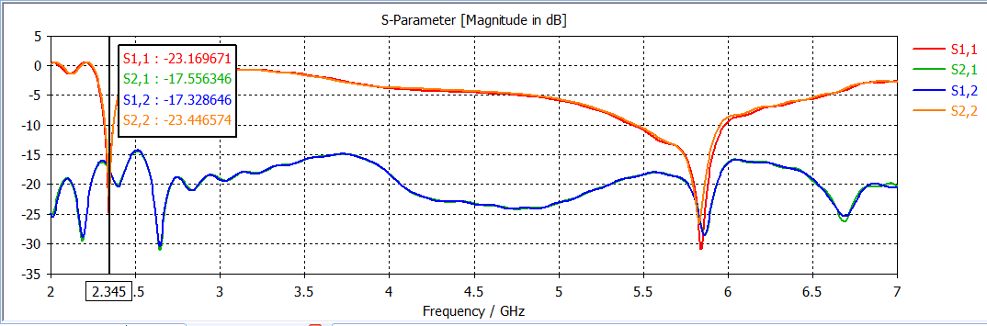

|  |  |
| --- | --- |
| **Parameters** | **Specifications** |
| Dielectric Substrate | FR4 |
| Dielectric constant | 4.4 |
| Substrate Height | 1.6 mm |
| Substrate Length | 55 mm |
| Substrate Breadth | 15 mm |
| Feed Radius | 0.1 mm |
| Frequency Range | 2GHz To 4GHz |
| Gain | 2.4dB |
| Directivity | 1.68dB |

**5.3 Antenna specifications**

**Table 5.1 Antenna Specifications**

**4.2 : Final Patch Results**

**4.2.1 : MIMO antenna Patch :**

* Print antenna simulated in CST SOFTWARE

This is the patch we have designed in software name CADFEKO 5.5. Fig.4.2.1.1 shows the design of the patch in the CADFEKO which includes dimensions of 55mm*15mm with the width of 1.6mm at 2 to 4GHz operating frequency band.

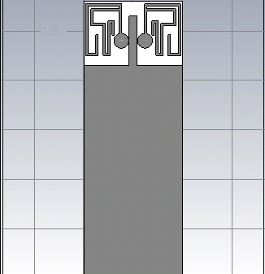 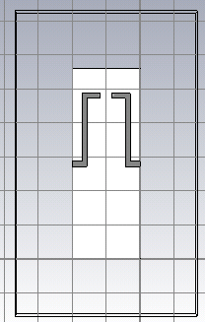

Front side ( units in mm) Back side

Patch Ground

Fig 4.2.1.Final Patch

**4.2.2 : S-Parameters:**

**4.2.2.1: S11 parameter**

As we can see in the following fig. (4.2.2.1) we are getting the expected results for S11 for 2.51GHz and 3.85GHZ operating frequency. Here we are getting the value of S11 less than -10 dB. So this is the correct result which we are getting from the above patch.

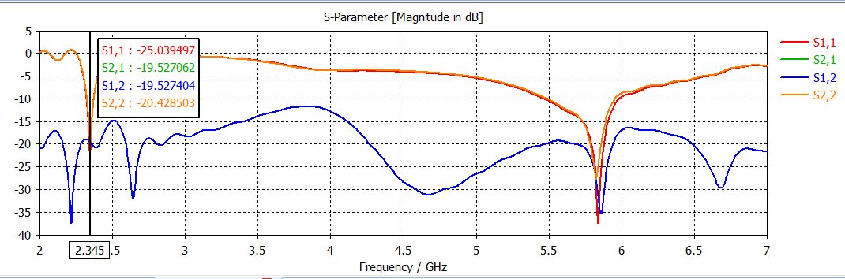

Fig 4.2.2.1 : S11 parameter

**4.2.2.2: S22 parameter**

As we can see in the following fig. (4.2.2.2) we are getting the expected results for S22 for 2.51GHz and 3.85GHz operating frequency. Here we are getting the value of S22 less than -10 dB. So this is the correct result which we are getting from the above patch.

Fig 4.2.2.2 : S22 parameter

**4.2.2.3: S12 parameter**

As we can see in the following fig. (4.2.2.3) we are getting the proper results for S12 for 2.51GHz and 3.85GHz operating frequency. Here we are getting the value of S12 less than -15dB.

Fig 4.2.2.3 : S12 parameter

**4.2.2.4: S21 parameter**

As we can see in the following fig. (4.2.2.4) we are getting the proper results for S21 for 2.51GHz and 3.85GHz operating frequency. Here we are getting the value of S21 less than -15dB.

Fig 4.2.2.4 : S21 parameter

**4.2.3: Gain**

As we can see in the following fig. (4.2.3.1) we are getting the proper results for gain for 2 to 4GHz operating band. Gain should be as large as possible for this operating frequency but we are getting it as 2.4dB . But in future if we adjust the antenna dimensions then we can get improved results and we are working on it.

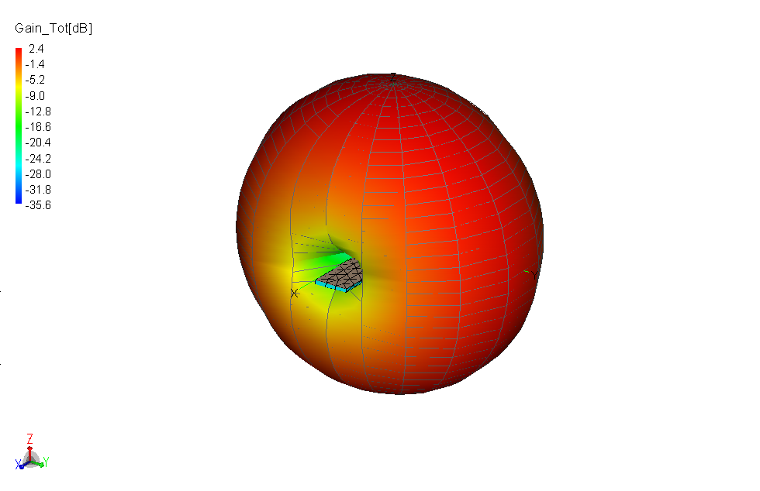

Fig 4.2.3.1 : Gain

**4.2.4: Directivity**

As we can see in the following fig. (4.2.4.1) we are getting the proper results for directivity for 2-4GHz operating frequency band. We are getting it as 2.5dB.

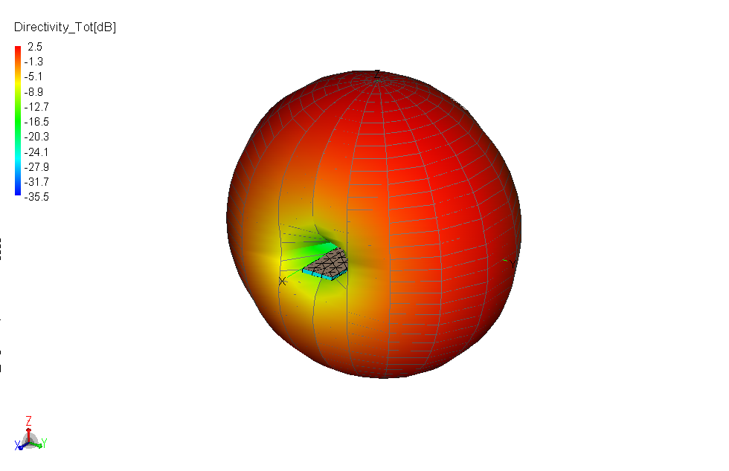

Fig 4.2.4.1: Directivity

**4.2.5: VSWR**

As we can see in the following fig. (4.2.5.1) we are getting the expected results for VSWR for 2-4GHz operating frequency band. Here we are getting the value of VSWR in between 1-2dB.

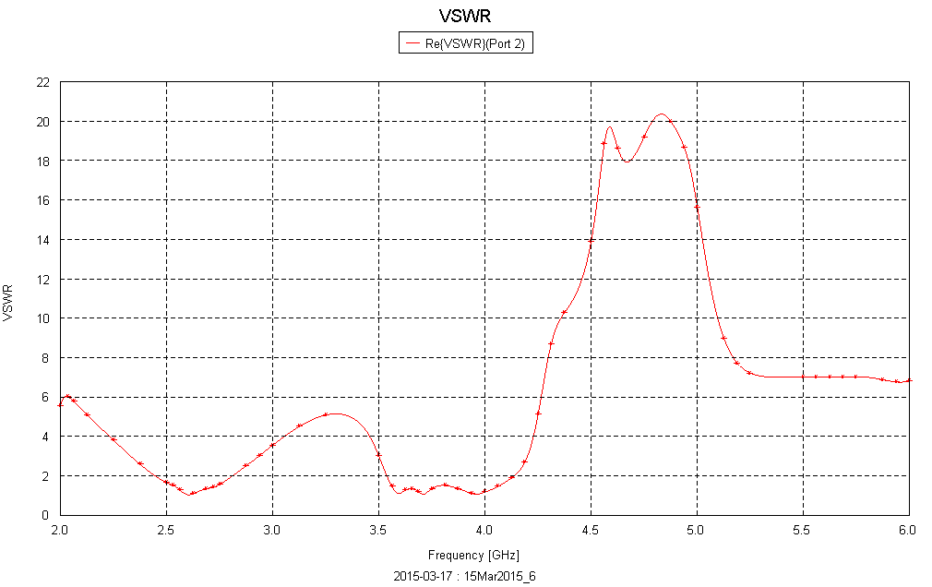

Fig 4.2.5.1: VSWR

|  |  |  |
| --- | --- | --- |
|  | **FREQUENCY 1**  **2.44 GHz** | **FREQUENCY 2**  **5.25 GHz** |
| Return Loss S11 | -25dB | -35dB |
| S22 | -10.93dB | -24.90dB |
| S21 | -15 dB | -20dB |
| S12 | --3.51dB | -12.12dB |
| VSWR | 2.5dB | 1dB |
| Gain | 0.549dB | 1.48dB |
| Directivity | 2.97dB | 5.23dB |
| Impedance | 50 ohm | 50 ohm |

**5.1 Summary**

At the initial stage of our project we decided to implement a MIMO patch for various frequency applications such as Wi-MAX , WLAN, GSM, and LTE. At the first stage we designed with the dimensions of 15mm*55mm with the width of 1.6mm at 2.05-2.7 GHz operating frequency. After simulation we got results of reflection coefficients less than -10dB for the frequency band of 2.05-2.7GHz.

In this patch we modified the neutral line and also made changes in the ground plane by introducing a parasitic line. As per the defective ground technique if we change the dimension of ground plane then the bandwidth of the antenna changes that to results in the efficiency parameter. In the middle phase we made changes in the front side by extending T-element and also we increased the frequency band from 2-4GHz.Inspite of this instead of keeping a complete ground plane we restricted the ground plane as a parasitic line and hence we got the desired results for gain and directivity.

At the end we got the results for the patch which includes dimensions of 15mm*55mm with the width of 1.6mm at 2-4GHz operating frequency. Obtained results S11 at 2.51GHz & 3.85 GHz below -10 dB, S12 below -15 dB, S21 below -15 dB, S22 below -10 dB at 2.51GHz & 3.85GHz, VSWR in between 1-2, gain at 2.4dB and directivity 1.6dB.

**5.2 Conclusions**

A PIFA type MIMO antenna for USB dongle applications operating at WLAN band is proposed. The S11 and S22 based on -10 dB for WLAN are resonated by the two PIFAs. The S21 between the PIFAs, which is achieved by a T shaped element and a neutral line, is less than -15 dB to ensure good isolation. The radiation patterns of the two antennas having reversed shapes are owing to their reverse structure. Base on the antenna performances and compact dimension, the proposed design can be applied to WLAN dongle device.

**5.4 Future Scope**

1. Based on the concept of multi-antenna arrays deployed at both transmitter and receiver locations, MIMO takes advantage of a traditional weakness of wireless technology. It harnesses the once-unusable multi-path propagation that occurs in a single antenna transmission and uses it to create additional transmission channels within the same frequency.
2. MIMO already is part of the latest version of Wi-Fi, known as 802.11n, which is designed to extend the speed and range of Wi-Fi to allow Ethernet-like wireless services that span several office floors, with less infrastructure and maintenance costs.
3. By modifying feeding techniques like coupled feed, inset feed, apertures feed, it gives change in input impedance, current is low at the ends, increase in magnitude.
4. By adding sleet and slot on the surface of antenna will improve the matching levels of antennas.

**References**

1. Wen-Shan Chen , Ke-Ming Lin“MIMO Antenna with Enhanced Isolation Elements for USB Dongle Applications “, 2012 Cross Strait Quad-Regional Radio Science and Wireless Technology Conference pp.48-51,2012
2. I.J. Gupta, J.A. Ulrey and E. H. Newman, “Antenna Element Bandwidth and Adaptive Array Performance,” *Proc. 2005 IEEE AP-S*,pp.295-298, 2005.
3. T. Katajamaki, “A compact dual-band phased array antenna for outdoor WLAN,” IEEE *Vehicular Technology Conference.* pp. 59-63,2004.
4. Z. Li, Z. Du and K. Gong, “A dual-slot diversity antenna with isolation enhancement using parasitic elements for mobile handsets,” *Proc. 2009 Asia-Pacific Microwave Conf.*, pp. 1821-1824.
5. F. G. Zhu, J. D. Xu and Q. Xu, “Reduction of mutual coupling between closely-packed antenna elements using defected ground structure,” *Electron. Lett.*, vol. 45, No. 12, pp. 601-602, June 2009.
6. Diallo, C. Luxey, P. L. Thuc, R. Staraj and G. Kossiavas, “Study and reduction of the mutual coupling between two mobile phone PIFAs operatin in the DCS1800 and UMTS bands,” *IEEE Trans. On Antennas and Propagat.*, vol. 54, no. 11, pp. 3063-3074, November 2006.