S. S. JAIN SUBODH PG AUTONOMOUS COLLEGE
Rajasthan University
Department of Generative AI
An Internship Project Report on
“SALARY PREDICTION USING ENSEMBLE LEARNING”
Submitted in partial fulfilment of the requirements of the
IBM NASSCOM Internship Programme, Academic Session 2025–2026
Submitted by
Pratibha Rathore
Roll Number: 2434015
Internship Duration: 18 May – 18 June 2026
Organisation: IBM NASSCOM

Certificate
This is to certify that the Internship Project Report entitled “Salary Prediction Using Ensemble Learning” is a bona fide record of work carried out by Pratibha Rathore (Roll Number: 2434015), a student of S. S. Jain Subodh PG Autonomous College, Rajasthan University, during the IBM NASSCOM Internship Programme conducted from 18 May to 18 June 2026, under the Department of Generative AI.
The work presented in this report has been carried out under my supervision and guidance and, to the best of my knowledge, has not been submitted elsewhere for the award of any other degree, diploma, or certificate.
I wish her every success in her future academic and professional endeavours.
Internship Mentor / Faculty Coordinator
Department of Generative AI
S. S. Jain Subodh PG Autonomous College

Declaration
I, Pratibha Rathore, Roll Number 2434015, hereby declare that the Internship Project Report entitled “Salary Prediction Using Ensemble Learning”, submitted to the Department of Generative AI, S. S. Jain Subodh PG Autonomous College, Rajasthan University, in partial fulfilment of the requirements of the IBM NASSCOM Internship Programme, is an original piece of work carried out by me under the guidance of my internship mentor.
I further declare that this report, or any part of it, has not been submitted previously to any other institution or university for the award of any degree or diploma. All sources of information used in the preparation of this report have been duly acknowledged.
Pratibha Rathore
Roll Number: 2434015
Date: 18 June 2026

Acknowledgement
I would like to express my sincere gratitude to IBM and NASSCOM for providing me the opportunity to undertake this internship and gain valuable exposure to real-world applications of Machine Learning and Artificial Intelligence.
I am deeply thankful to my internship mentor and the faculty of the Department of Generative AI, S. S. Jain Subodh PG Autonomous College, for their constant guidance, encouragement, and constructive feedback throughout the duration of this project. Their insights greatly helped me in understanding the practical aspects of Ensemble Learning and regression modelling.
I would also like to thank the Principal and management of my college for providing the necessary infrastructure and a conducive learning environment. My heartfelt thanks go to my parents and friends for their unwavering support and motivation throughout this internship.
Finally, I acknowledge the IBM SkillsBuild platform and the open-source Python community, whose learning resources and libraries formed the technical backbone of this project.
Pratibha Rathore

Preface
This report presents the work undertaken during a one-month internship under the IBM NASSCOM Internship Programme, focused on the domain of Generative AI and Machine Learning. The chosen project, “Salary Prediction Using Ensemble Learning,” was designed to provide hands-on experience with the complete Machine Learning workflow — from data collection and preprocessing to model building, evaluation, and interpretation of results.
The report is organised into nine chapters, beginning with an introduction to the problem domain and progressing through literature review, dataset description, exploratory data analysis, methodology, model implementation, results and discussion, conclusion, and future scope. Each chapter has been prepared with the intention of not only documenting the technical work carried out, but also reflecting the learning journey undertaken during the internship.
It is hoped that this report will serve as a useful reference for readers interested in regression-based Machine Learning problems and Ensemble Learning techniques, particularly Decision Tree and Random Forest Regressors.

Abstract
Predicting employee salaries based on relevant features is a classical and widely studied problem in the field of Machine Learning, with significant applications in Human Resource Management, workforce planning, and organisational budgeting. This project, titled “Salary Prediction Using Ensemble Learning,” aims to build and compare regression models capable of predicting an employee’s salary based on their years of professional experience.
The dataset used in this study, Salary_Data.csv, contains 30 records with two attributes: Years of Experience and Salary. The dataset was found to be clean, with no missing or duplicate values, making it suitable for direct application of regression algorithms. Two models were implemented and compared: a Decision Tree Regressor and a Random Forest Regressor, the latter being an Ensemble Learning technique that combines the predictions of multiple decision trees to improve accuracy and reduce overfitting.
The dataset was split into training and testing sets in an 80:20 ratio. Both models were trained on the training set and evaluated on the unseen test set using standard regression metrics — Mean Absolute Error (MAE), Mean Squared Error (MSE), Root Mean Squared Error (RMSE), and R² Score. The experimental results show that the Random Forest Regressor achieved an R² Score of 0.8753, outperforming the Decision Tree Regressor, which achieved an R² Score of 0.8022. Similarly, the Random Forest model recorded a lower RMSE of ₹7,983 compared to ₹10,052 for the Decision Tree model.
These findings confirm that Ensemble Learning methods, by aggregating multiple weak learners, generally produce more robust and generalisable predictions than a single Decision Tree, particularly on datasets prone to overfitting. The project concludes with a discussion of the practical implications of these findings and outlines directions for future work, including the incorporation of additional features and deployment of the model as a web application.

Keywords
Machine Learning, Ensemble Learning, Decision Tree Regressor, Random Forest Regressor, Salary Prediction, Regression Analysis, Scikit-learn, Python.

Table of Contents

List of Figures
Figure No. | Title | Page
1 | Scatter Plot of Years of Experience vs Salary | —
2 | Histogram of Salary Distribution | —
3 | Box Plot of Salary | —
4 | Machine Learning Workflow Adopted in the Project | —
5 | Decision Tree Regressor – Prediction Curve | —
6 | Random Forest Regressor – Prediction Curve | —
7 | Actual vs Predicted Salary on the Test Set | —
8 | Model Comparison – MAE and RMSE | —
9 | Model Comparison – R² Score | —

List of Tables
Table No. | Title | Page
1 | Dataset Description | —
2 | Dataset Statistics | —
3 | Software Requirements | —
4 | Tools and Technologies Used in the Project | —
5 | Train-Test Split Summary | —
6 | Comparison of Evaluation Metrics | —
7 | Sample Prediction Table (Test Set) | —

List of Abbreviations
Abbreviation | Full Form
ML | Machine Learning
AI | Artificial Intelligence
EDA | Exploratory Data Analysis
MAE | Mean Absolute Error
MSE | Mean Squared Error
RMSE | Root Mean Squared Error
R² | Coefficient of Determination
CSV | Comma Separated Values
DT | Decision Tree
RF | Random Forest
IBM | International Business Machines
NASSCOM | National Association of Software and Service Companies

Chapter 1: Introduction

1.1 Background
Salary determination is one of the most important yet complex aspects of Human Resource Management. Organisations must decide fair and competitive compensation for employees based on multiple factors such as experience, education, job role, skills, and location. Traditionally, such decisions have relied heavily on manual benchmarking, industry surveys, and subjective judgement. With the rapid growth of data-driven decision-making, Machine Learning offers a systematic and objective approach to predicting salaries based on historical data, thereby assisting organisations in making informed compensation decisions.
Machine Learning, a subset of Artificial Intelligence, enables systems to learn patterns from historical data and make predictions on new, unseen data without being explicitly programmed for every scenario. Among the many categories of Machine Learning problems, Regression is specifically used when the target variable to be predicted is continuous in nature — salary being a classic example of such a variable.

1.2 Motivation
The motivation behind this project stems from the observation that a strong, well-documented positive relationship generally exists between an employee’s years of professional experience and their salary. While this relationship appears linear at first glance, real-world salary structures often include non-linear jumps corresponding to promotions, seniority bands, and role changes. This makes the salary prediction problem an excellent candidate for exploring both simple models (such as a Decision Tree) and more sophisticated Ensemble Learning models (such as Random Forest), which are capable of capturing non-linear relationships more effectively.
This project was undertaken as part of the IBM NASSCOM Internship Programme under the Department of Generative AI, with the objective of gaining practical, hands-on experience in applying Machine Learning algorithms to a real-world style regression problem, while also learning the complete end-to-end workflow of a Machine Learning project — from data acquisition to model deployment considerations.

1.3 Problem Statement
Given a dataset containing employees’ years of experience and their corresponding salaries, the objective is to build a Machine Learning model that can accurately predict the salary of an employee based on their years of experience. The project further aims to compare the performance of a single Decision Tree Regressor against an Ensemble Learning based Random Forest Regressor, in order to determine which approach yields more accurate and generalisable predictions.

1.4 Objectives of the Project
- To study and understand the fundamentals of Regression-based Machine Learning.
- To perform data preprocessing and Exploratory Data Analysis (EDA) on the Salary_Data.csv dataset.
- To implement a Decision Tree Regressor for salary prediction.
- To implement a Random Forest Regressor, an Ensemble Learning technique, for salary prediction.
- To evaluate and compare both models using standard regression evaluation metrics.
- To identify the better-performing model and justify the result using the principles of Ensemble Learning.
- To document the entire workflow in a professional, university-level project report.

1.5 Scope of the Project
The scope of this project is limited to a single-feature regression problem using a small, clean, educational dataset consisting of 30 records. While the current implementation uses only Years of Experience as the independent variable, the methodology and workflow developed in this project are designed to be extensible to multi-feature datasets that include additional attributes such as education level, job role, skill set, and geographic location, as discussed further in Chapter 9 (Future Scope).

1.6 Organisation of the Report
The remainder of this report is organised as follows: Chapter 2 presents a review of relevant literature and prior work in the area of salary prediction and Ensemble Learning. Chapter 3 describes the dataset used in this project. Chapter 4 presents the Exploratory Data Analysis carried out on the dataset. Chapter 5 discusses the methodology adopted for model building. Chapter 6 details the implementation of the Decision Tree and Random Forest models. Chapter 7 presents and discusses the results obtained. Chapter 8 concludes the report, and Chapter 9 outlines directions for future work.

Chapter 2: Literature Review

2.1 Overview
Salary prediction and, more broadly, wage estimation based on demographic and professional attributes has been a subject of study within both economics and computer science literature for several decades. Traditional statistical approaches such as Linear Regression have long been used to model the relationship between experience and compensation, given their simplicity and interpretability. However, with the increasing availability of computational power and larger datasets, Machine Learning based approaches have gained substantial traction due to their ability to model complex, non-linear relationships.

2.2 Decision Tree Regression
A Decision Tree is a non-parametric supervised learning algorithm that partitions the feature space into a series of rectangular regions and fits a simple prediction model (typically the mean of the target values) within each region. Decision Trees are attractive because they are easy to interpret and visualise; however, a single Decision Tree is prone to overfitting, particularly when trained on small datasets, as it can create overly specific splits that fail to generalise well to unseen data.

2.3 Ensemble Learning and Random Forests
Ensemble Learning refers to a family of techniques that combine the predictions of multiple base learners in order to produce a more accurate and robust prediction than any single model could achieve alone. The Random Forest algorithm, introduced by Leo Breiman in 2001, is one of the most widely used Ensemble Learning techniques. It constructs a large number of Decision Trees during training, each trained on a bootstrap-sampled subset of the training data, and aggregates their predictions (via averaging, in the case of regression) to produce the final output. This process, known as Bagging (Bootstrap Aggregating), significantly reduces the variance of the model and mitigates the overfitting problem commonly associated with individual Decision Trees.

2.4 Related Work
Numerous studies in the Machine Learning literature have applied Ensemble Learning methods to regression problems in domains such as house price prediction, stock price forecasting, and employee attrition analysis, consistently reporting that Ensemble methods such as Random Forest, Gradient Boosting, and XGBoost outperform single-model approaches such as Linear Regression and standalone Decision Trees. These findings from the broader literature motivated the choice of Decision Tree and Random Forest Regressors as the two models to be compared in this project.

2.5 Research Gap
While extensive literature exists on salary and wage prediction using multi-feature datasets, relatively few educational studies focus specifically on isolating the relationship between years of experience and salary using Ensemble Learning techniques, while also providing a clear, step-by-step comparative analysis suitable for learning purposes. This project attempts to fill that gap by providing a focused, well-documented comparison between a Decision Tree Regressor and a Random Forest Regressor on a clean, single-feature salary dataset.

Chapter 3: Dataset Description

3.1 Source of Dataset
The dataset used for this project, Salary_Data.csv, is a widely used educational dataset for demonstrating regression techniques. It contains a simple, clean mapping between an employee’s years of professional experience and their corresponding annual salary, making it well suited for illustrating the core concepts of Regression and Ensemble Learning without the added complexity of feature engineering.

3.2 Dataset Overview
Table 1: Dataset Description
Attribute | Description
Dataset Name | Salary_Data.csv
Number of Records | 30
Number of Attributes | 2 (YearsExperience, Salary)
Missing Values | 0
Duplicate Records | 0
File Format | CSV (Comma Separated Values)
Problem Type | Supervised Machine Learning – Regression
Target Variable | Salary
Independent Variable | YearsExperience

3.3 Statistical Summary
Table 2 presents the descriptive statistics of the dataset, including the mean, standard deviation, minimum, maximum, and quartile values for both attributes. The average years of experience across the dataset is approximately 5.3 years, with a corresponding average salary of approximately ₹76,003, reflecting a wide range of experience levels from entry-level to senior professionals.
Table 2: Dataset Statistics
Statistic | YearsExperience | Salary (₹)
Count | 30 | 30
Mean | 5.31 | 76,003
Std. Deviation | 2.84 | 27,414
Minimum | 1.10 | 37,731
25th Percentile | 3.20 | 56,721
Median (50%) | 4.70 | 65,237
75th Percentile | 7.70 | 1,00,545
Maximum | 10.50 | 1,22,391

3.4 Data Quality Assessment
Before proceeding with model building, the dataset was assessed for data quality issues, specifically missing values and duplicate records. As shown in Table 1, the dataset contains no missing values and no duplicate records, confirming that it is already clean and does not require imputation or deduplication. This is a common characteristic of curated educational datasets and allowed the project to focus primarily on model building, evaluation, and comparison rather than extensive data cleaning.

Chapter 4: Exploratory Data Analysis

4.1 Introduction to EDA
Exploratory Data Analysis (EDA) is a critical step in any Machine Learning pipeline, as it allows the practitioner to understand the underlying structure, distribution, and relationships within the dataset before proceeding to model building. For this project, EDA was carried out using dataset preview (df.head()), dataset information (df.info()), statistical summary (df.describe()), missing value analysis, and visualisation techniques including scatter plots, histograms, and box plots.

4.2 Scatter Plot Analysis
The scatter plot in Figure 1 visualises the relationship between Years of Experience (independent variable) and Salary (target variable). A clear positive correlation is observed: as years of experience increase, salary also tends to increase. However, the relationship is not perfectly linear — there are visible jumps and plateaus in salary at certain experience levels, which is typical of real-world compensation structures involving promotions and seniority bands. This non-linearity provides strong justification for exploring tree-based models such as Decision Tree and Random Forest, which do not assume a linear relationship between variables.
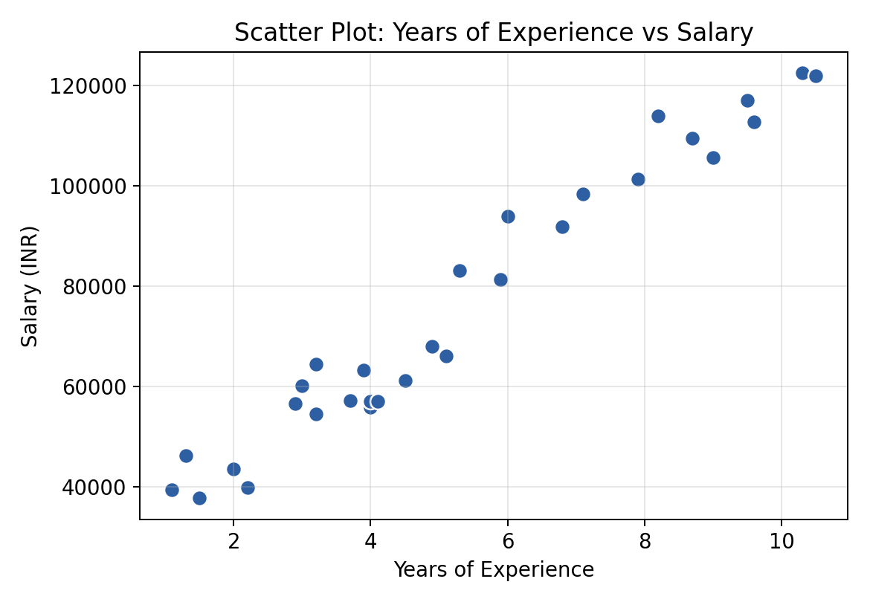
Figure 1: Scatter Plot of Years of Experience vs Salary

4.3 Histogram Analysis
Figure 2 shows the histogram of the Salary attribute, illustrating its distribution across the dataset. The distribution is right-skewed, with a higher concentration of employees in the lower-to-mid salary range and fewer employees in the highest salary brackets, which corresponds to the smaller number of highly experienced employees in the dataset.
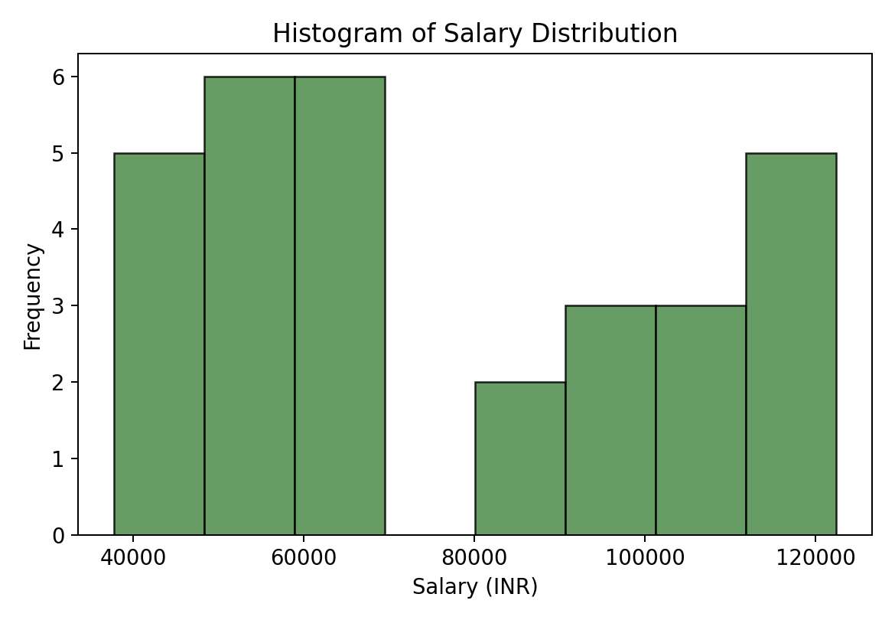
Figure 2: Histogram of Salary Distribution

4.4 Box Plot Analysis
Figure 3 presents a box plot of the Salary attribute, used to visually assess the spread, central tendency, and presence of any outliers in the data. The box plot confirms that the Salary attribute does not contain significant outliers, and the interquartile range aligns with the statistical summary presented in Chapter 3, further validating the quality and consistency of the dataset.
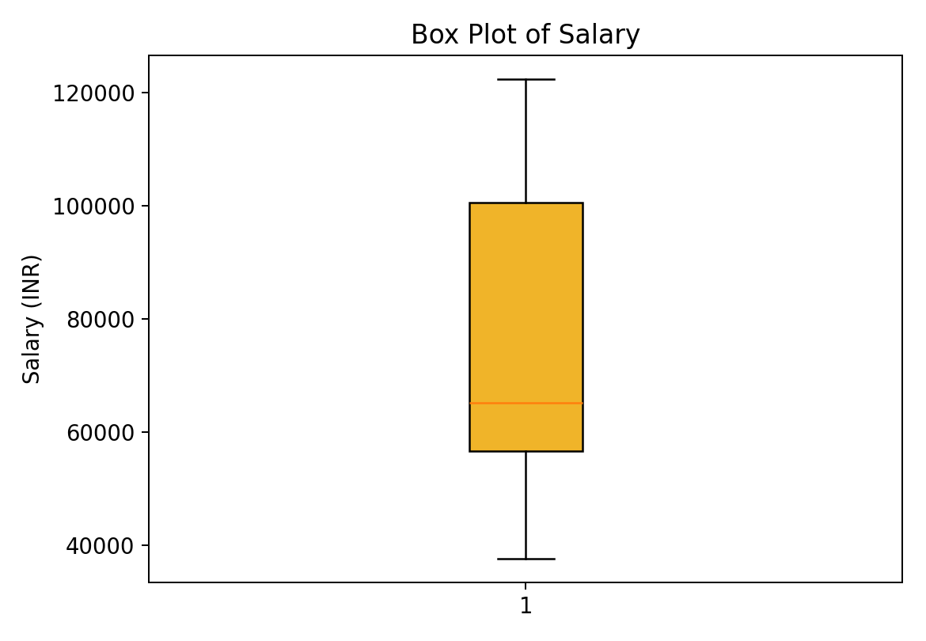
Figure 3: Box Plot of Salary

4.5 Observations from EDA
- A strong positive correlation exists between Years of Experience and Salary.
- The relationship between the two variables shows mild non-linear characteristics.
- The Salary distribution is right-skewed, with fewer high-salary records.
- No significant outliers were detected in the dataset.
- The dataset is clean and well-suited for direct application of regression models without further preprocessing.

Chapter 5: Methodology

5.1 Overview of the Approach
The methodology adopted in this project follows the standard Machine Learning pipeline, beginning with data collection and preprocessing, followed by Exploratory Data Analysis, feature selection, train-test splitting, model training, model evaluation, and finally, salary prediction. Figure 4 illustrates the complete workflow followed in this project.
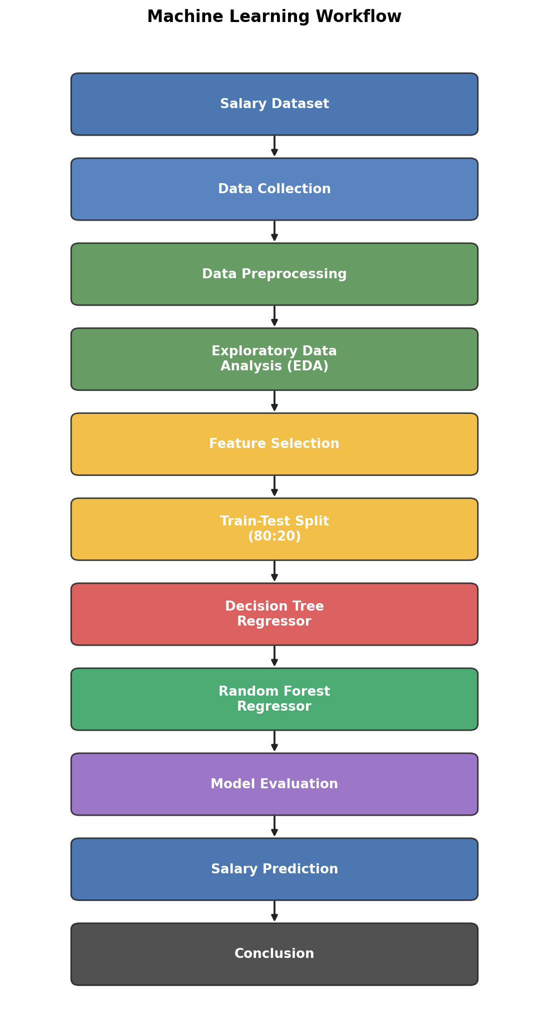
Figure 4: Machine Learning Workflow Adopted in the Project

5.2 Feature Selection
Since the dataset contains only two attributes, feature selection in this project was straightforward: Years of Experience (YearsExperience) was selected as the independent variable (X), and Salary was selected as the dependent or target variable (y). No feature engineering was required, as the dataset was already clean and directly usable.

5.3 Train-Test Split
The dataset was split into training and testing subsets using an 80:20 ratio, a widely accepted convention in Machine Learning that ensures sufficient data is available for model training while reserving a representative portion for unbiased evaluation. Out of the 30 total records, 24 records were allocated to the training set and 6 records were reserved for the testing set. A fixed random state was used during the split to ensure the reproducibility of results.

5.4 Model Selection
Two regression models were selected for this project: the Decision Tree Regressor, serving as the baseline model, and the Random Forest Regressor, an Ensemble Learning technique that combines the predictions of 100 individual Decision Trees trained on bootstrap samples of the training data. The Random Forest model was configured with 100 estimators (n_estimators = 100), a commonly used default that balances predictive performance with computational efficiency.

5.5 Evaluation Strategy
Model performance was evaluated on the held-out test set using four standard regression metrics: Mean Absolute Error (MAE), Mean Squared Error (MSE), Root Mean Squared Error (RMSE), and the R² Score (Coefficient of Determination). Lower values of MAE, MSE, and RMSE indicate better model performance, while an R² Score closer to 1 indicates a better fit between the predicted and actual values.

5.6 Software and Hardware Requirements
Table 3: Software Requirements
Requirement | Specification
Software | Python 3.x, Jupyter Notebook / Google Colab, scikit-learn, pandas, numpy, matplotlib
Hardware | Processor: Intel Core i5 or above; RAM: 8 GB or above; Storage: 5 GB free space

5.7 Tools and Technologies Used
Table 4: Tools and Technologies Used in the Project
Component | Details
Programming Language | Python 3
Core Libraries | pandas, numpy, matplotlib, scikit-learn
Development Environment | Jupyter Notebook
Operating System | Windows 10 / 11
Hardware | Intel Core i5 processor, 8 GB RAM (minimum recommended)

Chapter 6: Model Implementation

6.1 Importing Required Libraries
The implementation begins with importing the necessary Python libraries: pandas and numpy for data handling and numerical computation, matplotlib for visualisation, and the relevant modules from scikit-learn — train_test_split for splitting the data, DecisionTreeRegressor and RandomForestRegressor for model building, and mean_absolute_error, mean_squared_error, and r2_score for model evaluation.

6.2 Loading and Inspecting the Dataset
The dataset was loaded into a pandas DataFrame using pd.read_csv(). Initial inspection was carried out using df.head() to preview the first few records, df.info() to examine data types and non-null counts, and df.describe() to obtain the statistical summary discussed in Chapter 3. This inspection confirmed that the dataset required no further cleaning.

6.3 Splitting the Dataset
The dataset was split into training and testing subsets using scikit-learn’s train_test_split() function with a test_size of 0.2 (20%) and a fixed random_state for reproducibility, as summarised in Table 5.
Table 5: Train-Test Split Summary
Subset | Number of Records | Percentage
Training Set | 24 | 80%
Testing Set | 6 | 20%
Total | 30 | 100%

6.4 Training the Decision Tree Regressor
The Decision Tree Regressor was instantiated using DecisionTreeRegressor() from scikit-learn and trained on the training data using the fit() method. The Decision Tree algorithm works by recursively splitting the feature space at points that minimise the variance of the target variable within each resulting region, continuing until a stopping criterion is met.
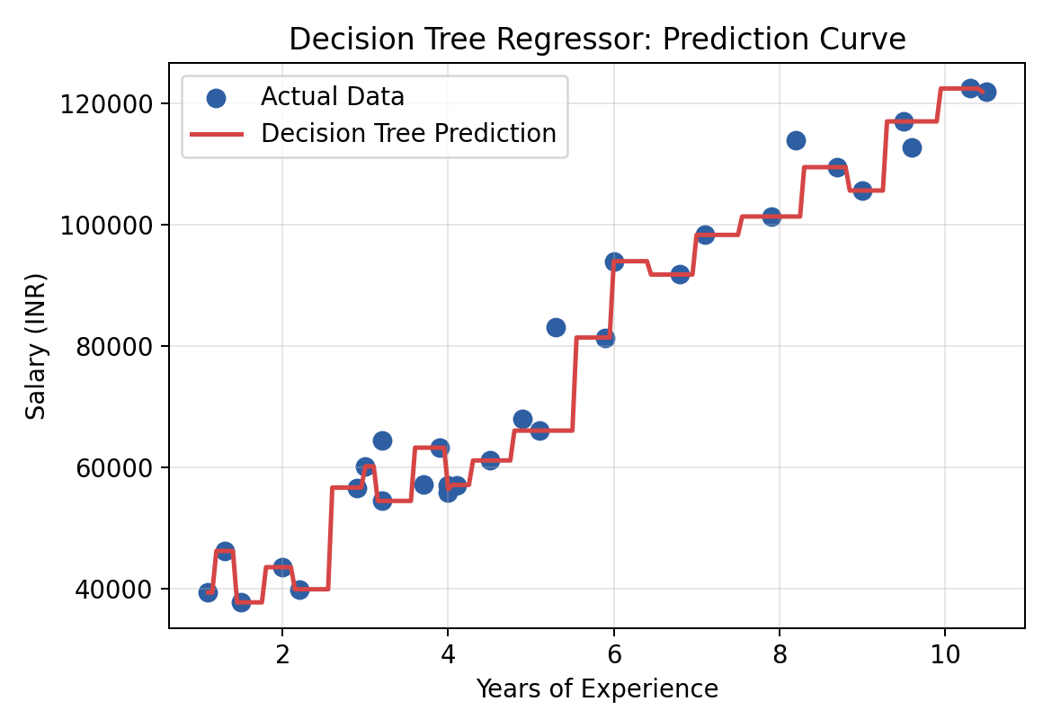
Figure 5: Decision Tree Regressor – Prediction Curve
As shown in Figure 5, the Decision Tree Regressor produces a step-like, piecewise-constant prediction curve. While this allows the model to fit the training data very closely, it also makes the model susceptible to overfitting, particularly on a dataset as small as the one used in this project, since the tree can create very specific splits that do not generalise well to new, unseen values of experience.

6.5 Training the Random Forest Regressor
The Random Forest Regressor was instantiated using RandomForestRegressor(n_estimators=100, random_state=42) and trained on the same training data. Internally, the Random Forest algorithm builds 100 individual Decision Trees, each trained on a different bootstrap sample of the training data, and aggregates their individual predictions by averaging to produce the final output.
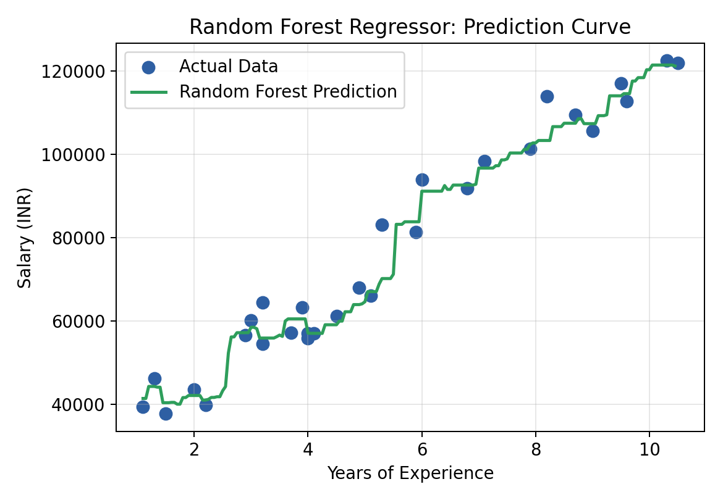
Figure 6: Random Forest Regressor – Prediction Curve
As shown in Figure 6, the prediction curve produced by the Random Forest Regressor is noticeably smoother than that of the single Decision Tree, since the averaging process across multiple trees reduces the variance and smooths out the sharp, overfit steps seen in Figure 5. This smoother curve is expected to generalise better to unseen data.

6.6 Generating Predictions
Once trained, both models were used to generate salary predictions on the test set using the predict() method. These predictions were then compared against the actual salary values to compute the evaluation metrics discussed in Chapter 7.

Chapter 7: Results and Discussion

7.1 Evaluation Metrics Obtained
Table 6 summarises the evaluation metrics obtained for both the Decision Tree Regressor and the Random Forest Regressor on the test dataset. All metrics were computed using the actual scikit-learn implementations of mean_absolute_error, mean_squared_error, and r2_score.
Table 6: Comparison of Evaluation Metrics
Evaluation Metric | Decision Tree Regressor | Random Forest Regressor
Mean Absolute Error (MAE) | ₹8,640 | ₹6,872
Mean Squared Error (MSE) | 10,10,47,710 | 6,37,21,130
Root Mean Squared Error (RMSE) | ₹10,052 | ₹7,983
R² Score | 0.8022 | 0.8753

7.2 Actual vs Predicted Salary
Table 7 presents a sample of actual versus predicted salary values from the test set for both models, providing a direct, record-level comparison of prediction accuracy.
Table 7: Sample Prediction Table (Test Set)
Years of Experience | Actual Salary (₹) | Decision Tree Predicted (₹) | Random Forest Predicted (₹)
9.6 | 1,12,635 | 1,16,969 | 1,14,508
4.9 | 67,938 | 66,029 | 63,907
8.2 | 1,13,812 | 1,01,302 | 1,03,274
5.3 | 83,088 | 66,029 | 70,152
3.2 | 64,445 | 54,445 | 55,880
3.7 | 57,189 | 63,218 | 60,478
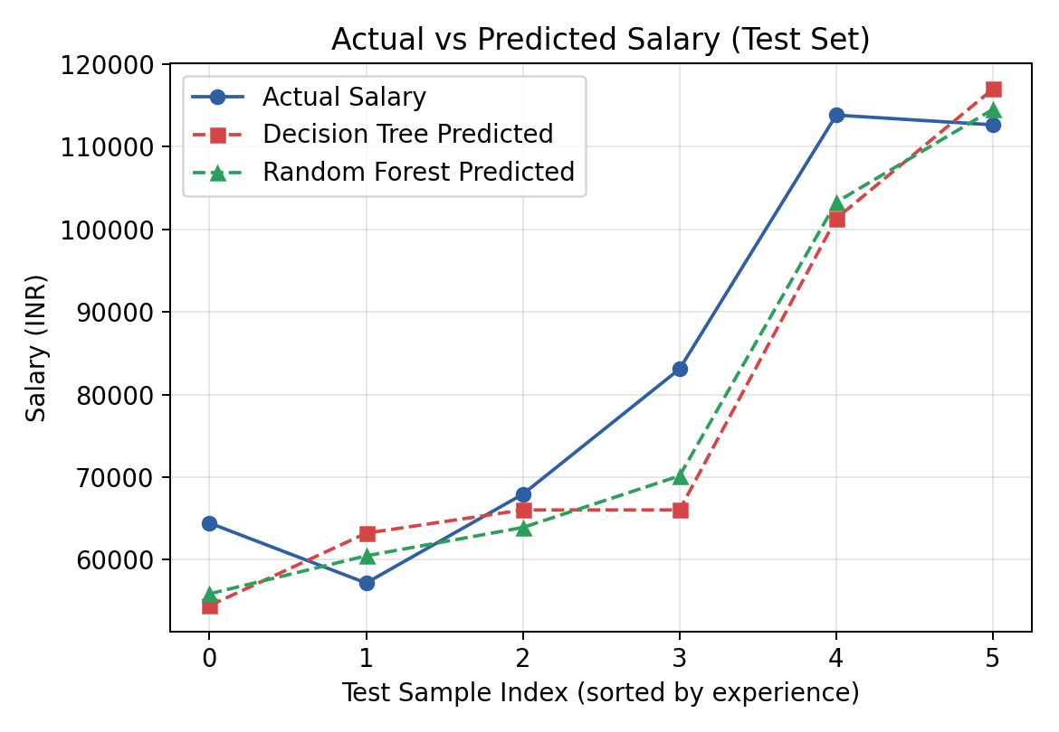
Figure 7: Actual vs Predicted Salary on the Test Set

7.3 Model Comparison
As evident from Table 6 and Figure 8, the Random Forest Regressor achieved a lower Mean Absolute Error, lower Root Mean Squared Error, and a higher R² Score compared to the Decision Tree Regressor. Specifically, the Random Forest model achieved an R² Score of 0.8753, compared to 0.8022 for the Decision Tree model, indicating that the Random Forest model explains a greater proportion of the variance in salary based on years of experience.
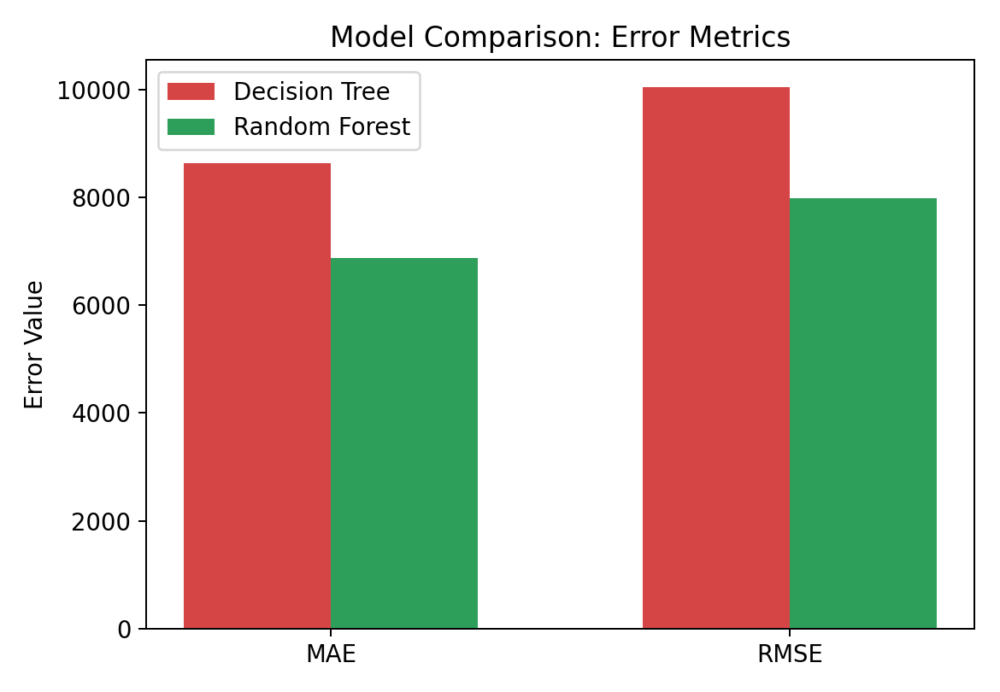
Figure 8: Model Comparison – MAE and RMSE
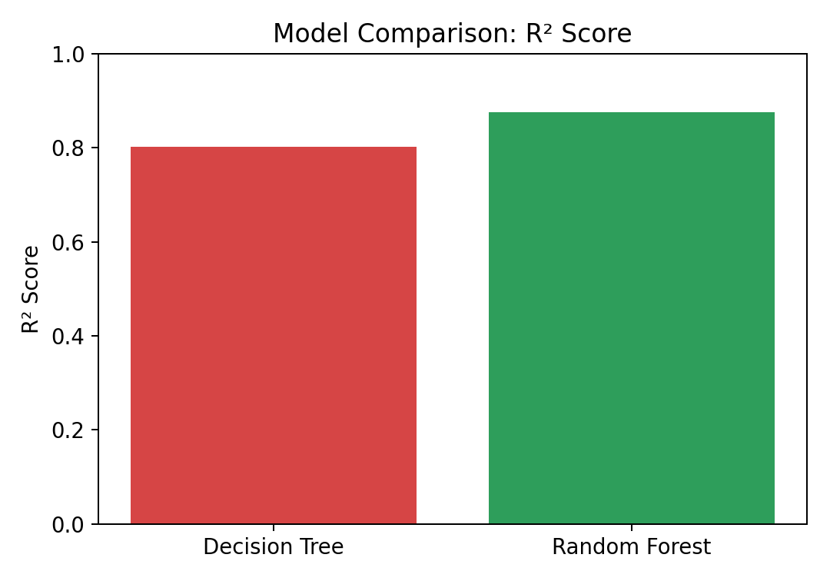
Figure 9: Model Comparison – R² Score

7.4 Discussion
The superior performance of the Random Forest Regressor can be attributed to the fundamental principle of Ensemble Learning: by training multiple Decision Trees on different bootstrap samples of the data and averaging their predictions, the Random Forest algorithm reduces the variance associated with any single tree, thereby producing predictions that generalise better to unseen data. In contrast, the single Decision Tree Regressor, while capable of fitting the training data very closely, is more prone to overfitting — particularly on a small dataset such as the one used in this project, where a single tree can create highly specific splits that do not reflect the true underlying trend.
It is also worth noting that both models performed reasonably well given the small size of the dataset (30 records), which is a limiting factor for any Machine Learning model. Nevertheless, the consistent improvement shown by the Random Forest model across all four evaluation metrics provides strong empirical support for the use of Ensemble Learning techniques in salary prediction tasks.

Chapter 8: Conclusion

8.1 Summary of Work Done
This project successfully implemented and compared two regression models — a Decision Tree Regressor and a Random Forest Regressor — for the task of predicting employee salary based on years of professional experience. The complete Machine Learning workflow was followed, including data collection, preprocessing, Exploratory Data Analysis, feature selection, train-test splitting, model training, and evaluation using standard regression metrics.

8.2 Key Findings
The experimental results demonstrated that the Random Forest Regressor outperformed the Decision Tree Regressor across all evaluation metrics considered, achieving a lower Mean Absolute Error, lower Root Mean Squared Error, and a higher R² Score of 0.8753 compared to 0.8022 for the Decision Tree model. This confirms the central hypothesis of the project: that Ensemble Learning techniques, by combining the predictions of multiple Decision Trees, reduce overfitting and produce more accurate and generalisable predictions than a single Decision Tree model.

8.3 Learning Outcomes
Beyond the technical results, this internship project provided valuable hands-on experience in applying the end-to-end Machine Learning pipeline to a real-world style problem. Key learning outcomes include a practical understanding of data preprocessing and Exploratory Data Analysis techniques, the working principles of Decision Tree and Random Forest algorithms, the importance of train-test splitting and cross-validation in preventing overfitting, and the correct interpretation of regression evaluation metrics such as MAE, MSE, RMSE, and R² Score.

8.4 Concluding Remarks
In conclusion, this project reaffirms the value of Ensemble Learning as a powerful technique for improving the accuracy and robustness of Machine Learning models, particularly in regression tasks involving noisy or non-linear relationships. The Random Forest Regressor, by virtue of its ensemble nature, proved to be the more suitable model for the salary prediction task addressed in this project.

Chapter 9: Future Scope

9.1 Incorporating Additional Features
The current model relies solely on Years of Experience as the predictor variable. Future iterations of this project could significantly improve prediction accuracy by incorporating additional features such as Education Level, Job Role, Skill Set, Industry, and Geographic Location, all of which are known to influence salary in real-world scenarios.
- Education — highest qualification attained by the employee.
- Job Role — designation or position held within the organisation.
- Skills — specific technical or domain-specific skills possessed by the employee.
- Location — geographic region or city, which significantly affects cost-of-living-adjusted salaries.

9.2 Deployment as a Web Application
To make the model accessible to end users such as HR professionals and job seekers, it could be deployed as an interactive web application using frameworks such as Flask or Streamlit, allowing users to input their experience (and other features) and receive an instant, real-time salary prediction.

9.3 Using a Larger and More Diverse Dataset
The current dataset, while clean and suitable for educational purposes, is limited to 30 records. Future work should involve collecting or sourcing a larger, more diverse, real-world salary dataset spanning multiple industries and job roles, which would allow the model to generalise more effectively and produce more reliable predictions in practical settings.

9.4 Exploring Advanced Ensemble Techniques
Beyond Random Forest, future work could explore more advanced Ensemble Learning and Boosting techniques such as Gradient Boosting and XGBoost (Extreme Gradient Boosting), both of which have demonstrated state-of-the-art performance on structured, tabular datasets in numerous Machine Learning competitions and real-world applications. A comparative study involving Random Forest, Gradient Boosting, and XGBoost would provide deeper insights into the most effective Ensemble Learning approach for salary prediction tasks.

References
[1] Aurélien Géron, Hands-On Machine Learning with Scikit-Learn, Keras & TensorFlow, O’Reilly Media.
[2] Christopher M. Bishop, Pattern Recognition and Machine Learning, Springer.
[3] Scikit-learn Developers, Scikit-learn Documentation — Machine Learning in Python.
[4] pandas Development Team, Pandas Documentation.
[5] NumPy Developers, NumPy Documentation.
[6] Matplotlib Development Team, Matplotlib Documentation.
[7] IBM SkillsBuild, Learning Resources on Machine Learning and Artificial Intelligence.
[8] Breiman, L., Random Forests, Machine Learning, Vol. 45, pp. 5–32.

Appendix

A.1 Complete Python Code Listing
The following section lists the core Python code used in this project for data loading, preprocessing, model training, and evaluation.
import pandas as pd
import numpy as np
import matplotlib.pyplot as plt
from sklearn.model_selection import train_test_split
from sklearn.tree import DecisionTreeRegressor
from sklearn.ensemble import RandomForestRegressor
from sklearn.metrics import mean_absolute_error, mean_squared_error, r2_score
# Load dataset
df = pd.read_csv('Salary_Data.csv')
print(df.head())
print(df.info())
print(df.describe())
print(df.isnull().sum())
# Feature selection
X = df[['YearsExperience']]
y = df['Salary']
# Train-test split (80:20)
X_train, X_test, y_train, y_test = train_test_split(
X, y, test_size=0.2, random_state=42)
# Decision Tree Regressor
dt = DecisionTreeRegressor(random_state=42)
dt.fit(X_train, y_train)
dt_pred = dt.predict(X_test)
# Random Forest Regressor
rf = RandomForestRegressor(n_estimators=100, random_state=42)
rf.fit(X_train, y_train)
rf_pred = rf.predict(X_test)
# Evaluation
for name, pred in [('Decision Tree', dt_pred), ('Random Forest', rf_pred)]:
mae = mean_absolute_error(y_test, pred)
mse = mean_squared_error(y_test, pred)
rmse = np.sqrt(mse)
r2 = r2_score(y_test, pred)
print(name, 'MAE:', mae, 'RMSE:', rmse, 'R2:', r2)

A.2 List of Abbreviations Used in Code
- df — DataFrame
- X — Independent variable(s) / Features
- y — Dependent variable / Target
- dt — Decision Tree model object
- rf — Random Forest model object

Viva Questions
Q1. What is the difference between a Decision Tree and a Random Forest?
Ans: A Decision Tree is a single tree-based model that splits data based on feature values, whereas a Random Forest is an Ensemble of many Decision Trees whose predictions are averaged to improve accuracy and reduce overfitting.
Q2. Why did the Random Forest model perform better than the Decision Tree model in this project?
Ans: The Random Forest model performed better because it aggregates predictions from multiple Decision Trees trained on different bootstrap samples, which reduces variance and overfitting compared to a single Decision Tree.
Q3. What is Ensemble Learning?
Ans: Ensemble Learning is a technique that combines predictions from multiple base models to produce a more accurate and robust overall prediction than any individual model.
Q4. Why was the dataset split into training and testing sets?
Ans: The dataset was split to allow the model to be trained on one portion of the data and evaluated on a separate, unseen portion, providing an unbiased estimate of the model’s generalisation performance.
Q5. What does the R² Score represent?
Ans: The R² Score, or coefficient of determination, represents the proportion of variance in the target variable that is explained by the model; a value closer to 1 indicates a better fit.
Q6. What is overfitting, and how does Random Forest help reduce it?
Ans: Overfitting occurs when a model learns the training data too closely, including its noise, and fails to generalise to new data. Random Forest reduces overfitting by averaging predictions across many trees, which smooths out individual trees’ errors.
Q7. Why is Mean Absolute Error (MAE) useful as an evaluation metric?
Ans: MAE measures the average magnitude of prediction errors in the same units as the target variable, making it easy to interpret and less sensitive to outliers than MSE.
Q8. What is bootstrap sampling in the context of Random Forest?
Ans: Bootstrap sampling is the process of randomly sampling the training data with replacement to create multiple different training subsets, each used to train an individual tree in the Random Forest.
Q9. What are the limitations of this project?
Ans: The primary limitation is the small dataset size (30 records) and the use of only a single feature (Years of Experience), which may not fully capture the real-world complexity of salary determination.
Q10. How could this project be extended in the future?
Ans: The project could be extended by incorporating additional features such as education, job role, and location, using a larger dataset, and exploring advanced Ensemble techniques such as Gradient Boosting or XGBoost.

