

A Project Report On

**Online Shopping Cart Application**

**By**

**Mrunali Newareakr**

**Swapnali Kore**

**Pratibha Walunj**

**Batch:** 2020 – 5733

**Center: Pune**

Under the Guidance of,

**Jayanth V.**

**Technical Trainer**

**EduBridge**

(School of coding)

## Introduction:

Online shopping is a form of electronic commerce which allows consumers to directly buy goods or services from a seller over the Internet using a web browser. Consumers find a product of interest by visiting the website of the retailer directly or by searching among alternative vendors using a shopping search engine, which displays the same product's availability and pricing at different e-retailers. Our Project Include **Modules:-**

* Admin Module
* Customer Module
* Cart Module

We have developed this Application in **Java, JSP, Servlets, MySQL, and Bootstrap**

The main feature of the project is to make shopping easier. You can access this website from anywhere and everywhere.

In Admin module, admin can add the Category and Products in the specific category. He can also view the total number of users at present in the website. And category and product details also. Admin can only see the admin page and cart if he wants to order something.

In Customer module, user can access the website and buy products and products to cart by category. New customer can register and login after that to shop. In Cart, admin and user both can access, they can add the products to the cart.

**Software Requirements:**

**Front end:** Java/J2EE technologies (Servlet, JSP), Bootstrap.

**Back end**: MySQL workbench 6.2CE.

**Middleware/Server:** Apache Tomcat v8.5. IDE: Eclipse IDE for Java EE Developers

**Browser:** Best result on Google Chrome

**Operating System:** Window 10.

# Data Dictionary:

* Create Database

ShoppingCartApplication

* show tables;

DROP TABLE IF EXISTS `product_orders`;

CREATE TABLE `product_orders` (

`oid` int(11) NOT NULL auto_increment,

`product_name` varchar(100) default NULL,

`purchase_quantity` int(45) default NULL,

`total_price` int(45) default NULL,

`uname` varchar(45) default NULL,

PRIMARY KEY (`oid`)

) ENGINE=InnoDB DEFAULT CHARSET=latin1;

# Screenshots:-

## Home Page:

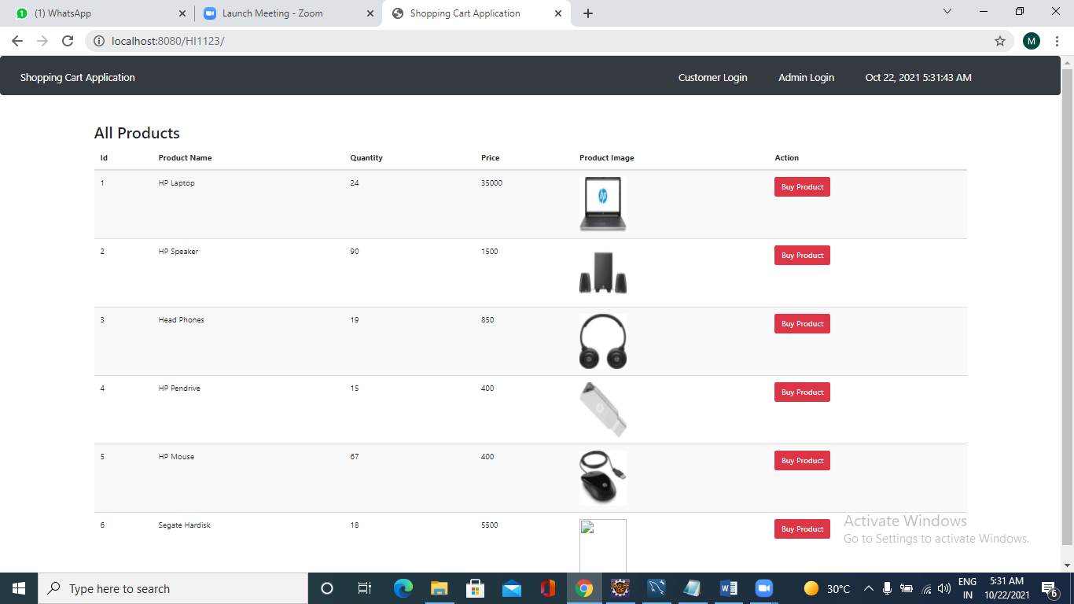

Customer Login Page

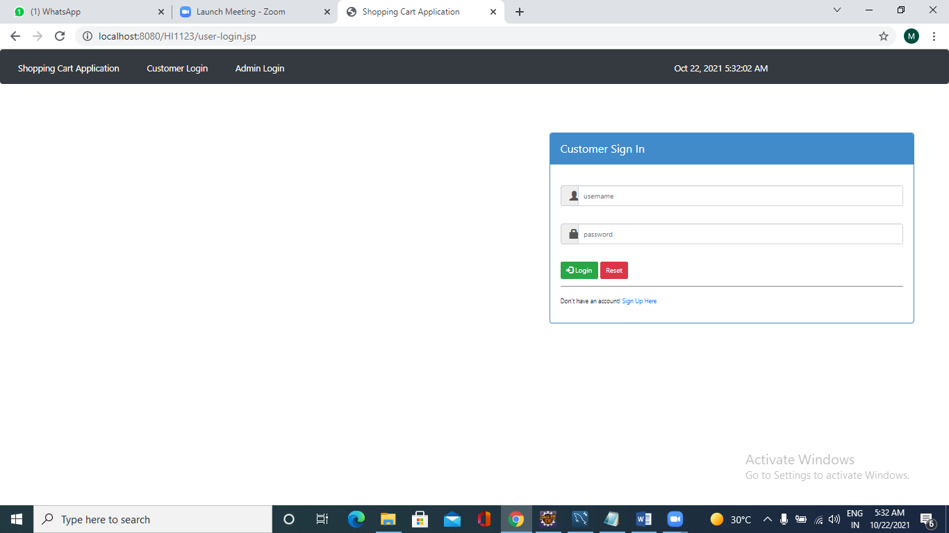

**Customer Sign-up Page:**

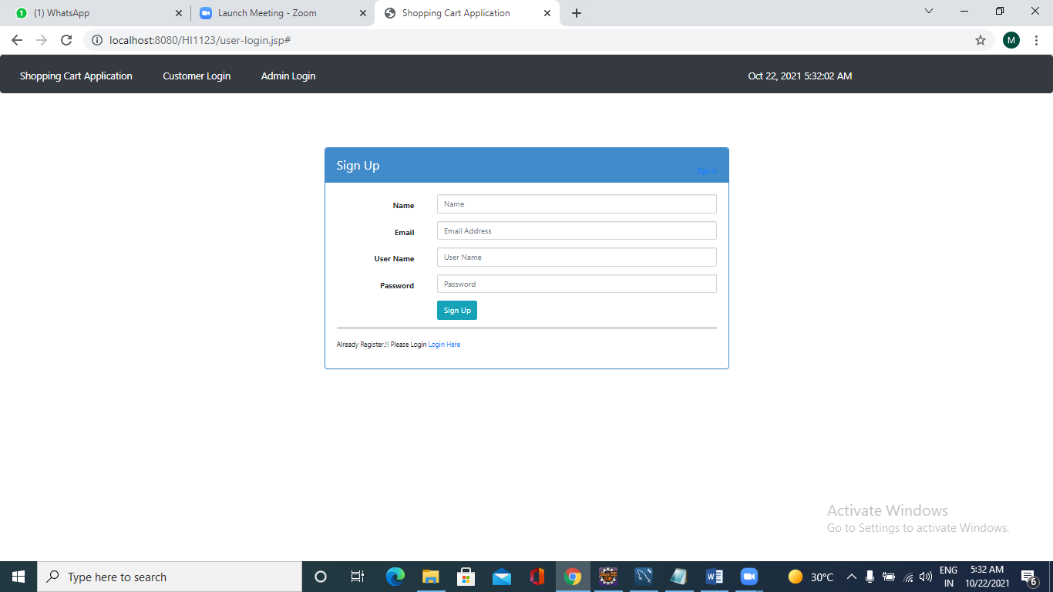

**Admin Login Page:**

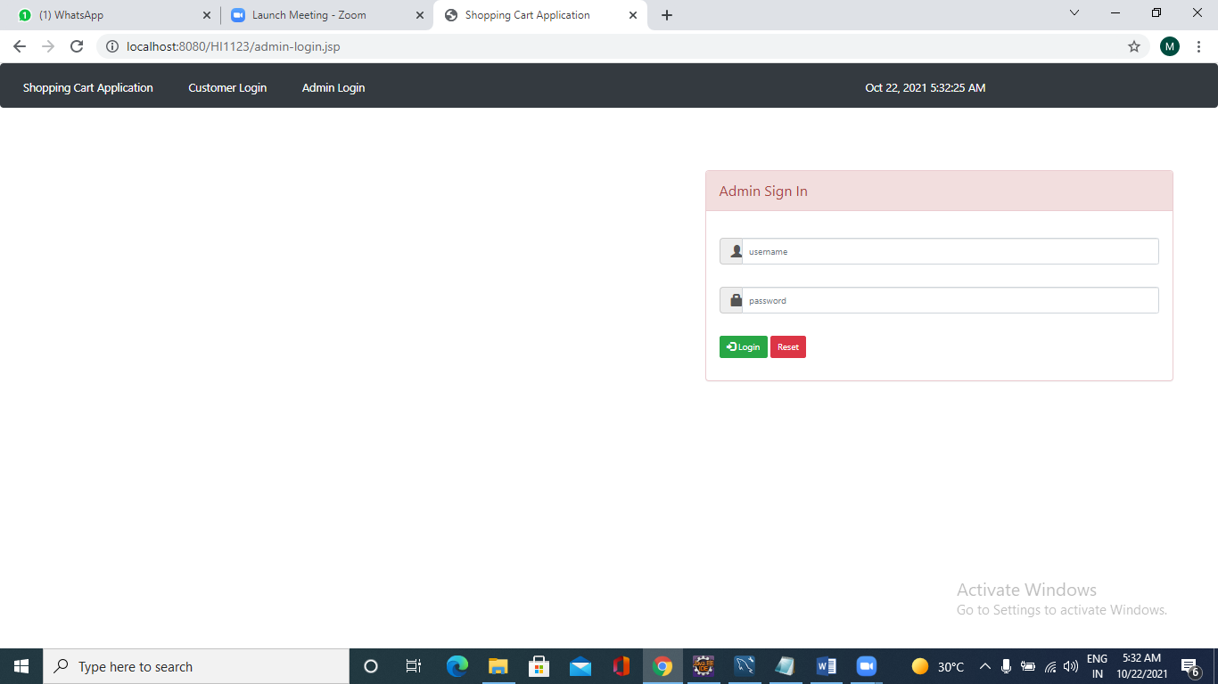

**Admin Dashboard Page:**

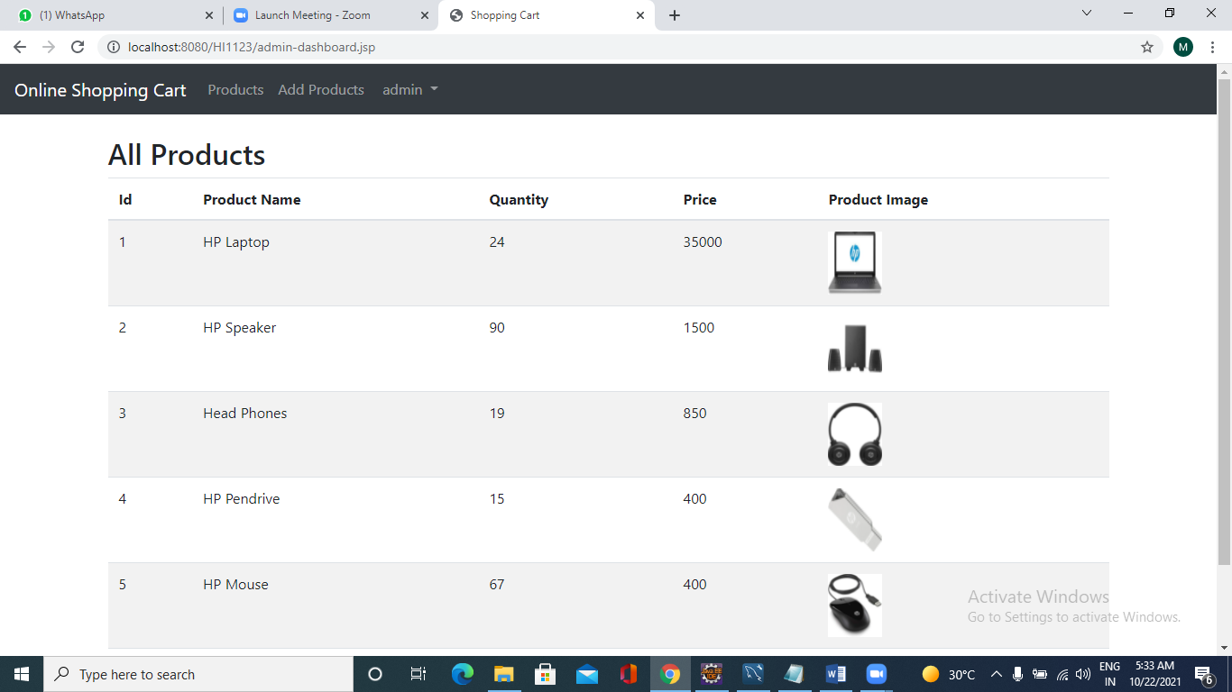

**Product Page:**

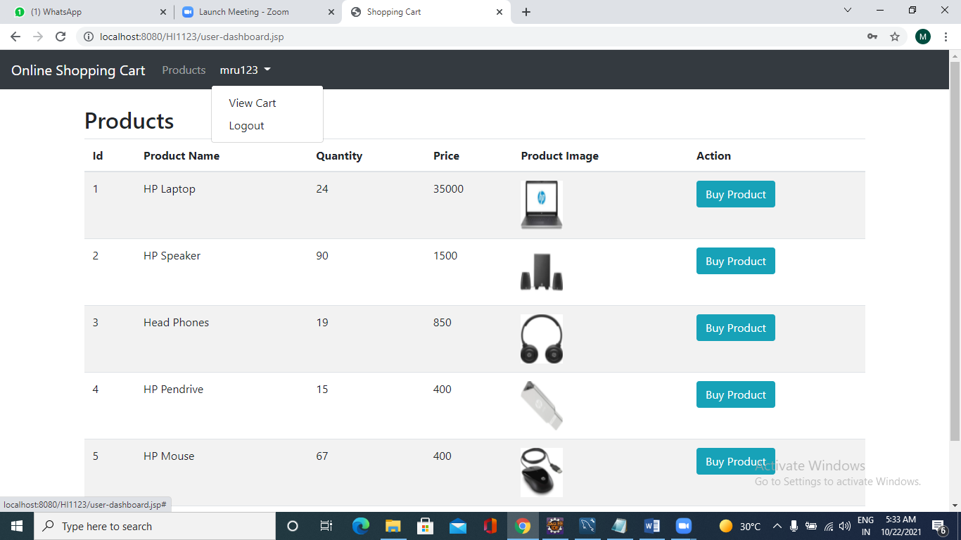

**Data Added in Database SuccessFully:**

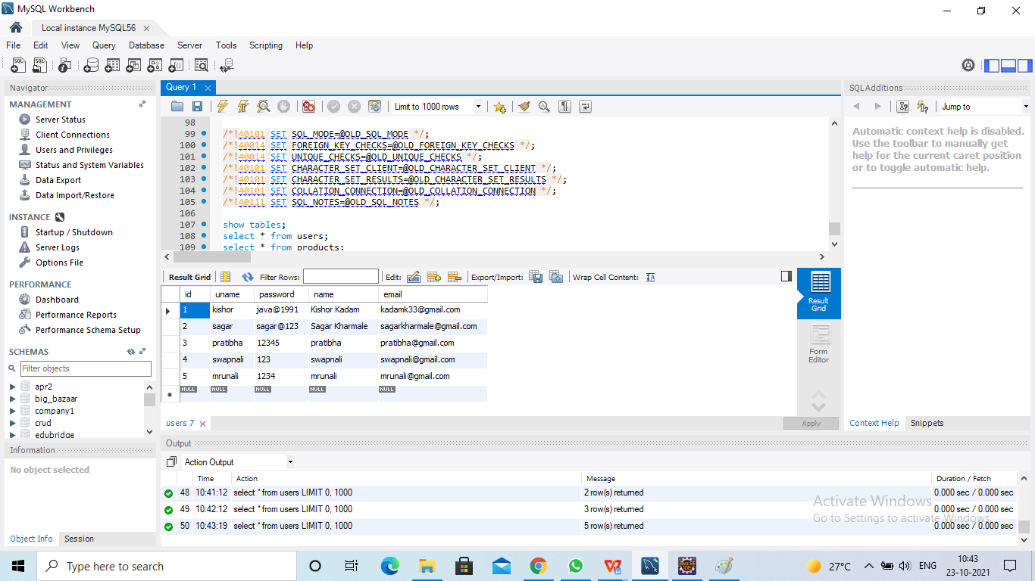

**Login with UserID:**

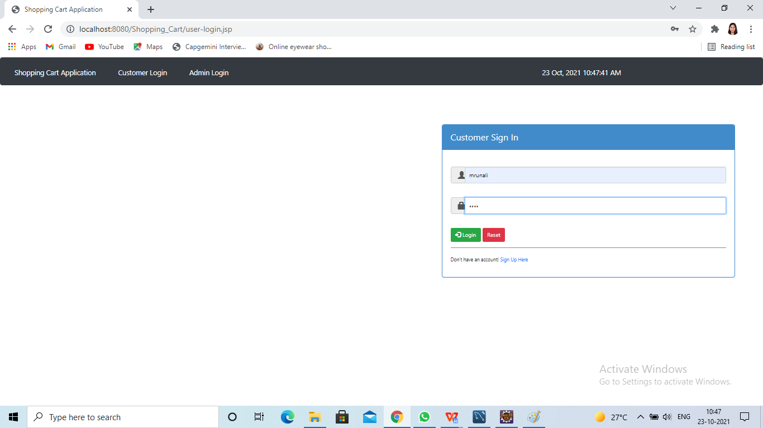

**Add to cart Tab:**

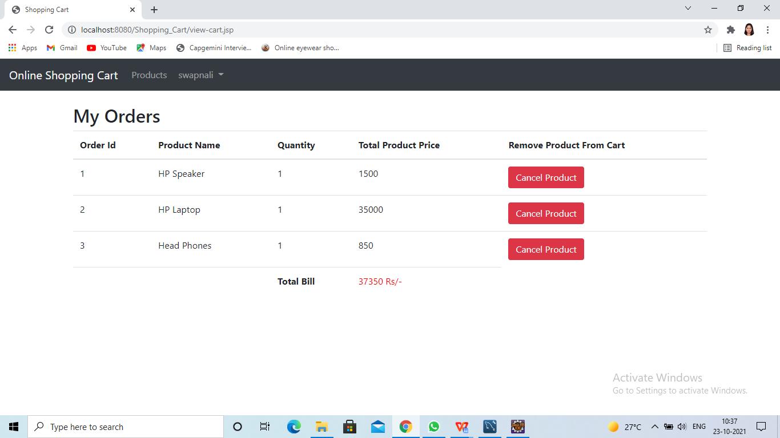

**About Us:**

**Thank you**