|  |  |
| --- | --- |
| logo.jpg | **Omega Mobile Store** 9486451238 samadwelgate@gmail.com Main Road Gudalur, The Nilgiris, Tamilnadu 33ASWPA0523E1Z7:33ASWPA0523E1Z7 |

**Invoice  
INV1527806326321  
01-06-2018**

Bill To  
**Akash**24, Hoodi, Bangalore.  
1234567890

|  |  |  |  |  |  |
| --- | --- | --- | --- | --- | --- |
| **No.** | **Product** | **Qty.** | **Rate** | **Discount** | **Amount** |
| 1 | Google Pixel 1 | 2 | 50000.0 | 5000.0 | 95000.0 |
|  |  |  | Item code |  | Rs. 95000.0 |
|  | Good Once sold will not be taken up or exchange |  | Total |  | Rs. 95000.0 |
|  | warranty/services available only on brand service centres, please contact your nearest brand service center for any manufacture defects. |  | (-)Paid |  | Rs. 95000.0 |

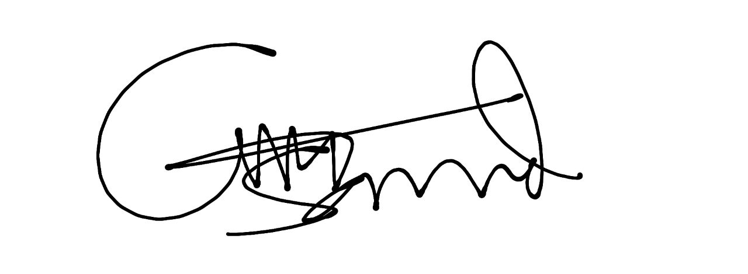  
Omega Mobile Shop  
Signature