|  |  |
| --- | --- |
| logo.jpg | **Omega Mobile Store** 9486451238 samadwelgate@gmail.com Main Road Gudalur, The Nilgiris, Tamilnadu 33ASWPA0523E1Z7:33ASWPA0523E1Z7 |

**Invoice  
INV1528175305183  
05-06-2018**

Bill To

|  |  |  |  |  |  |
| --- | --- | --- | --- | --- | --- |
| **No.** | **Product** | **Qty.** | **Rate** | **Discount** | **Amount** |
| 1 | 22 22 | 19 | 22.0 | 0.0 | 418.0 |
| 2 | 33 33 | 1 | 999.0 | 0.0 | 999.0 |
|  |  |  | Item code |  | Rs. 1246.96 |
|  | Good Once sold will not be taken up or exchange |  | Total |  | Rs. 1246.96 |
|  | warranty/services available only on brand service centres, please contact your nearest brand service center for any manufacture defects. |  | (+) CGST (+) SGST (-) Unpaid  Paid |  | (6.0%) Rs.6.0 (6.0%) Rs.6.0 RS. 0.0 Rs. 1417.0 |

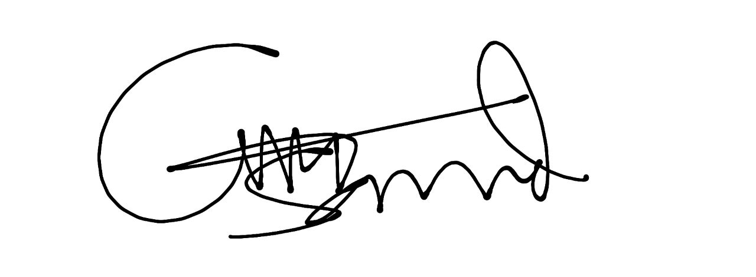  
Omega Mobile Shop  
Signature