“**WEB APPLICATION TO SOLVE LINEAR EQUATION IN TWO VARIABLE”**

Submitted in 49TH Jawaharlal Nehru National Science, Mathematics and

Environment Exhibition for Children — 2022

**JAWAHAR NAVODAYA VIDYALAYA, SARANG DIST. DHENKANAL**



**Submitted by: Guided by:**

Ma. Pratik Khuntia Kamal Kumar Asiwal

Class : XI Science PGT(CS), JNV Sarang

Dist. Dhenkanal

**ABSTRACT :**

SOFTWARE AND APPS HAVE BECAME AN INTEGRAL PART OF OUR LIFE . WEB APPLICATIONS , APPLICATION SOFTWARES MADE OUR LIFE VERY EASY .

HERE IS A WEB APPLICATION BASED ON SIMPLE LANGUAGES LIKE HTML, CSS , JAVA SCRIPT . ITS AIM IS TO SHOW HOW WE CAN DO SPECIAL MATHEMATICAL CALCULATOR FOR SPECIAL SECTIONS APART FROM THE ORDINARY CALCULATOR.

IT IS SIMPLE TO USE, OPEN SOURCE, IT WILL MOTIVATE STUDENTS WHO ARE STUDING IN HIGH SCHOOL **TO INTEGRATE THEIR COMMON STUDY WITH COMPUTER ALGORITHMS**  **.**

**SOURCE OF CONTENTS :**

* INTRODUCTION.
* OBJECTIVE OF THE PROJECT.
* SOFTWARE AND HARDWARE REQUIREMENTS.
* WORKING PRINCIPLE.
* SOURCE CODE ANALYSIS
* HOW TO OPERATE
* DISTRIBUTION OF THIS WEB APPLICATION
* REFERENCE SITES

**INTRODUCTION :**

**Computer software** is the set of instructions and data that tells a computer what to do and how to do it. Software provides instructions to your computer’s hardware. Without it, your PC or Mac would be little more than a large paperweight. But software actually comes in three main types: [system software](https://www.techopedia.com/definition/5476/system-software), [programming software](https://www.techopedia.com/definition/450/middleware) and application software. System software includes all the stuff that makes up a computer's [operating system](https://www.techopedia.com/definition/3515/operating-system-os) (OS), including [device drivers](https://www.techopedia.com/definition/6824/device-driver), [configuration files](https://www.techopedia.com/definition/3339/configuration-file-config-file) and other key system components. This is the software that tells the computer’s hardware what to do and provides a foundation for the system. Programming software, or middleware, works much like the plumbing in your home by invisibly keeping things running behind the scenes. **Application software**, however, is the most important type for computer users **because it is used to achieve many of the tasks that make us turn to our computers in the first place**, such as word processing, web browsing and data crunching.[Numerical analysis](https://en.wikipedia.org/wiki/Numerical_analysis) and [symbolic computation](https://en.wikipedia.org/wiki/Symbolic_computation) had been in most important place of the subject, but other kind of them is also growing now. A useful mathematical knowledge of such as [algorism](https://en.wikipedia.org/wiki/Algorism) which exist before the [invention](https://en.wikipedia.org/wiki/Invention) of [electronic computer](https://en.wikipedia.org/wiki/Computer), helped to mathematical software developing. On the other hand, by the growth of [computing power](https://en.wikipedia.org/wiki/Computing_power) (such as seeing on [Moore's law](https://en.wikipedia.org/wiki/Moore%27s_law)), the new treatment (for example, a new kind of technique such as [data assimilation](https://en.wikipedia.org/wiki/Data_assimilation) which combined numerical analysis and [statistics](https://en.wikipedia.org/wiki/Statistics)) needing conversely the progress of the [mathematical science](https://en.wikipedia.org/wiki/Mathematical_science) or [applied mathematics](https://en.wikipedia.org/wiki/Applied_mathematics).  
The progress of mathematical information presentation such as [TeX](https://en.wikipedia.org/wiki/TeX) or [MathML](https://en.wikipedia.org/wiki/MathML)[[2]](https://en.wikipedia.org/wiki/Mathematical_software#cite_note-2) will demand to evolution form *formula manipulation language* to true *mathematics manipulation language* (notwithstanding the problem that whether [mathematical theory is inconsistent](https://en.wikipedia.org/wiki/G%C3%B6del%27s_incompleteness_theorems) or not). And popularization of general purpose mathematical software, special purpose mathematical software[[3]](https://en.wikipedia.org/wiki/Mathematical_software#cite_note-3) so called *one purpose software* which used special subject will alive with adapting for environment progress at normalization of platform. So the diversity of mathematical software will be kept.

**OBJECTIVE OF THE PROJECT**

**This project is a mathematical software** . It calculates the values of variables involved in linear equation in two variable . This software will use the coefficient of the variables in linear equation in two variable to calculate the values of the variables. . It is helpful for students,teachers and it’s a perfect example of **integration of computer science and mathematics.** It uses markup language like HTML . Scripting language like JAVASCRIPT, style language like CSS.

**SOFTWARE/ HARDWARE REQUIREMENTS :**

* Computer with windows or mac OS
* Browser to run HTML file.
* Android version 10 or above

**WORKING PRINCIPLE :**

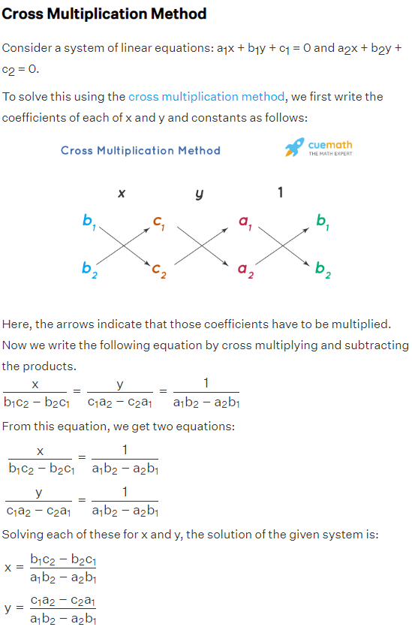

**SOURCE CODE ANALYSIS :**

1. index.html file is created with title : SLE CALCULATOR

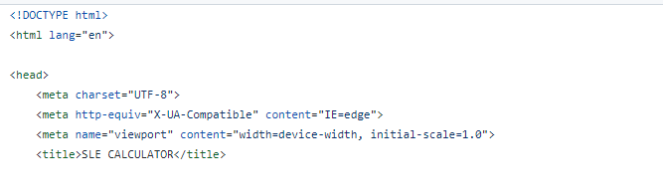

**Out put :**

**Screenshot 2022-09-10 131157.png**

1. within <body> </body> tag the code for calculator is coaded. 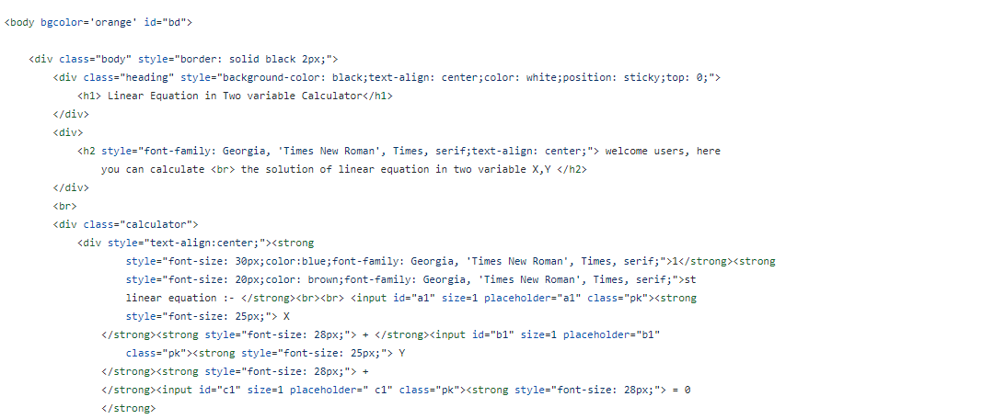
2. The calaculation is done by the help of java script with <script > </script> tag

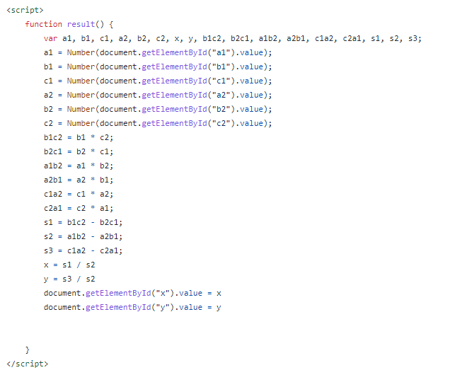

**HOW TO OPERATE :**

Here the variable **a1 , a2,b1,b2,c1,c2** stores the **NUM** value which it receives through input fields from the user.

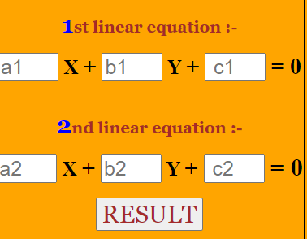

Then according to the matrics and determinant method cross of different coefficient is done and strored as

**b1c2, b1c1, a1b2, a2b1, c1a2, c2a1. B1c2 –b2c1 is strored in var s1 .**

**b1c2 – b2c1 = s1**

**a1b2- a2b1 = s2**

**c1a2 – c2a1 = s3**

**finally**

**x = s1/s2**

**y = s3/s2**

1. 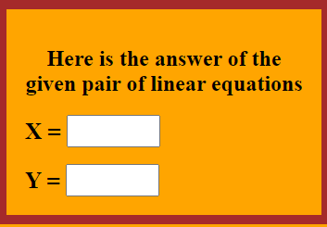At the end the value is returned and displayed in the result section
2. To start another click on refresh it will make the values NULL to start fresh with new coefficients.

**Screenshot 2022-09-10 170035.png**

**DISTRIBUTION OF THIS WEB APPLICATION :**

**We** can distribute it as an INDEX.HTML file or hoist it in various hoisting sites for global access. Here is a demo of uploading it to the famous open source hub GITHUB.

1. Create a new repository give it a name 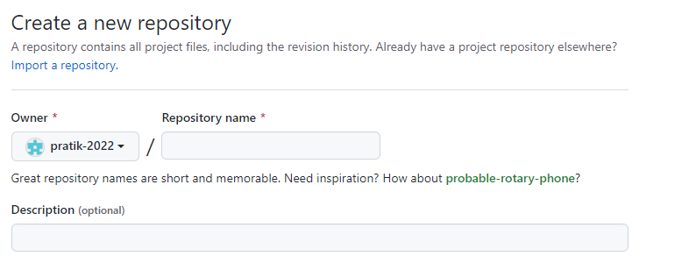
2. Add your html file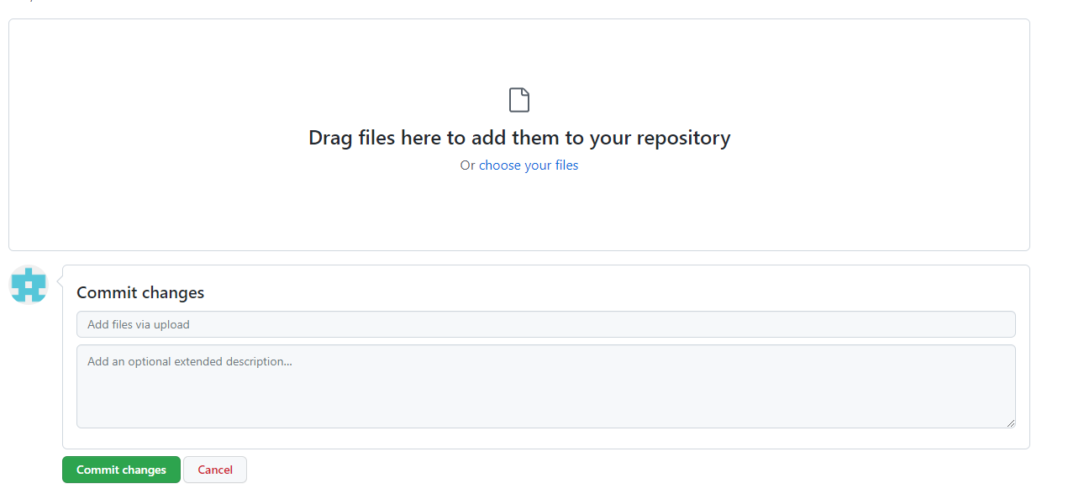
3. At last deploy it in github page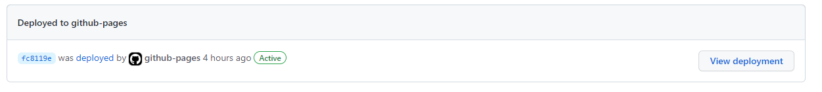

Now world can access this webapplication.

**REFERENCE SITES :**

* [**https://www.geeksforgeeks.org/**](https://www.geeksforgeeks.org/)
* [**https://codepen.io/**](https://codepen.io/)
* [**https://www.freecodecamp.org/news/how-to-use-codepen/**](https://www.freecodecamp.org/news/how-to-use-codepen/)
* [**https://www.crunchbase.com/organization/codepen**](https://www.crunchbase.com/organization/codepen)
* [**https://github.com/join**](https://github.com/join)