**Voting Machine**

*Software Architecture Design*

***CS 460 Software Engineering***

**Table of Contents**

1 Introduction 3

2 Design Overview 3

3 Component Specifications 6

3.1 Voting Manager – Procedure, runs on main thread 6

3.2 Admin Manager – Internal Thread 6

3.3 Voting – Internal Thread 6

3.4 Vote Process 6

3.5 Active Ballot - Ballot 6

3.6 Vote Recording 6

3.7 Monitor – Internal Thread 6

3.8 Card Reader 6

3.9 Latch Driver 7

3.10 Screen Driver 7

3.11 SD Card 1 – SD Card Driver 7

3.12 SD Card 2 & 3 – SD Card Driver 7

3.13 Printer Driver 7

# Introduction

The purpose of this document is to outline the design of the voting machine system’s software architecture. This document serves as a guide to the structure and functionality of the system, detailing how the software interacts with the physical components.

In the Design Overview, the design diagram provides an overview of the software architecture. This diagram visually represents the flow of the software, demonstrating how passive and active objects interact, how tasks are executed, and how packages contribute to the overall system logic.

In the Component Specification section, it lists each object along with its methods. This provides a simple explanation of how each part is managed in the overall system.

# Design Overview

The software is designed with a passive procedure called Voting Manager, which acts as the central unit managing several components and functions of the voting machine. The Voting Manager manages active object and passive object, this is broken down into 4 parts. Card Holder manages the Card Reader Driver. The Voting object creates a thread to manage the voting objects, this includes the processes of the ballots and updating them to reflect changes made by voter. Admin Manager is another thread that sets up the process and ensures latch is on. Lastly the Monitor thread constantly checks the status of all security, drivers, screen function, and tamper detection to confirm no issues.

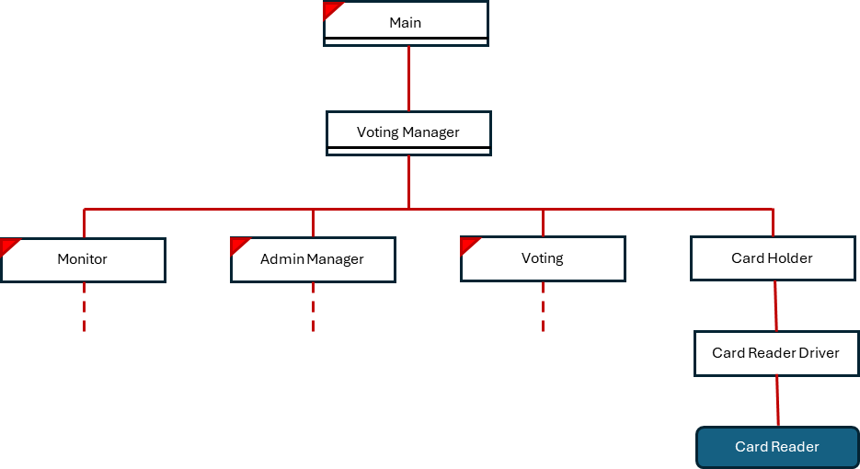

Figure 1. Card Holder

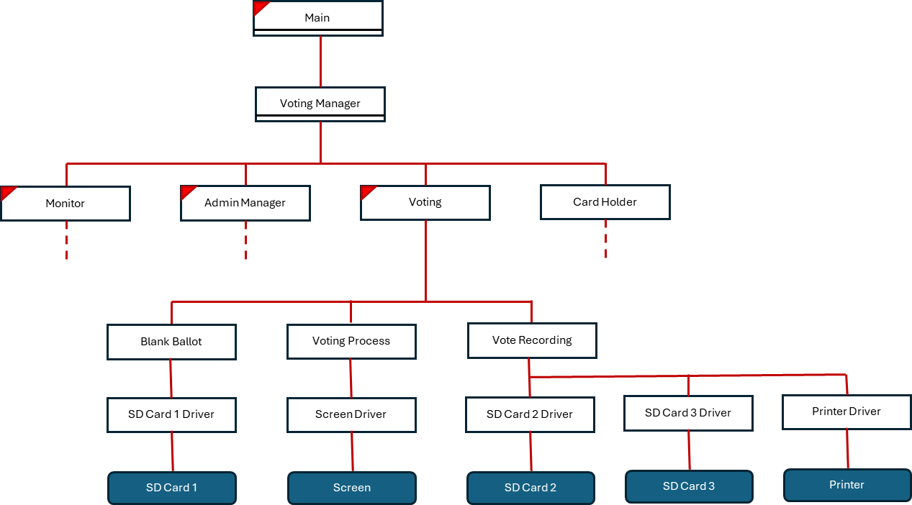

Figure 2. Voting

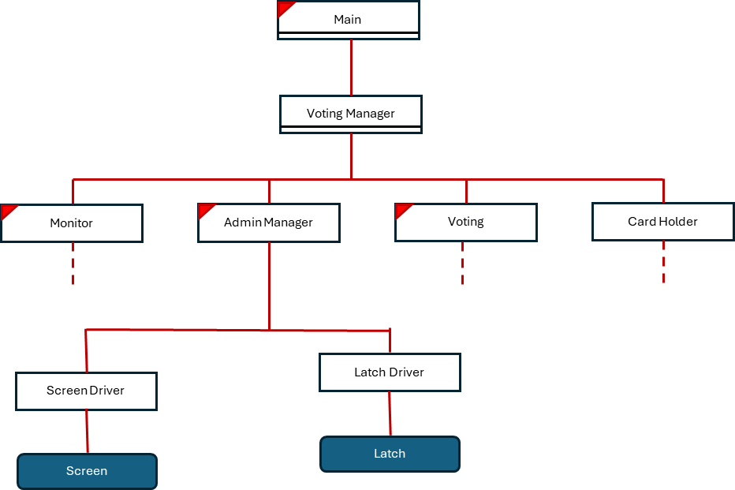

Figure 3. Admin Manager

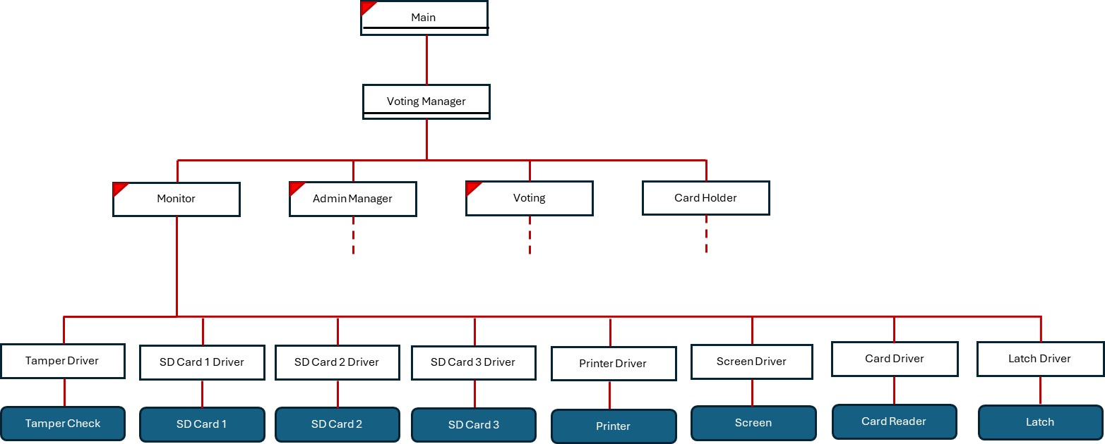

Figure 4. Monitor

# Component Specifications

## Voting Manager – Procedure, runs on main thread

* votingManager()

## Admin Manager – Internal Thread

* void newAdmin(int ID)
* boolean adminDone()
* boolean isVotingOpen()
* boolean isVotingClosed()
* void failureDetected()

## Voting – Internal Thread

* void newVoter(int ID)
* boolean votingDone()
* void endThread()
* void failureDetected()

## Vote Process

* boolean startVote(template)
* Ballot completeVote()
* Boolean timeOut()

## Vote Recording

* boolean submitVote(currentBallot submittedBallot)

## Monitor – Internal Thread

* boolean systemFailed()

## Card Reader

* String readCard()
* boolean cardPresent()
* int getCardType()
* String getCardNumber()
* void eraseEjectCard()
* void ejectCard()
* boolean checkFail()

## Latch Driver

* void lock()
* void unlock()
* boolean isLocked()
* boolean checkFail()

## Screen Driver

* Void displayScreen(template newScreen)
* boolean checkFail()

## SD Card 1 – SD Card Driver

* String readFile()
* boolean checkFail()

## SD Card 2 & 3 – SD Card Driver

* String writeFile(String newVote)
* boolean checkFail()

## Printer Driver

* void print(String newVote)
* boolean checkFail()