ANALYSIS VISUALISATIONS AND TABLES

SEDS DATASET ANALYSIS

rows | states | msns | years | sub_datasets
0 | 5215338 | 54 | 920 | 1960–2023 | co2, complete, consumption_btu, consumption_ph...

 | dataset | rows | states | msns | Years
0 | co2 | 109888 | 52 | 34 | 1960–2023
1 | complete | 2366854 | 54 | 920 | 1960–2023
2 | consumption_btu | 1065472 | 52 | 328 | 1960–2023
3 | consumption_phy | 819200 | 52 | 254 | 1960–2023
4 | indicators | 242944 | 52 | 73 | 1960–2023
5 | prices | 497124 | 52 | 179 | 1970–2023
6 | production | 113856 | 54 | 34 | 1960–2023

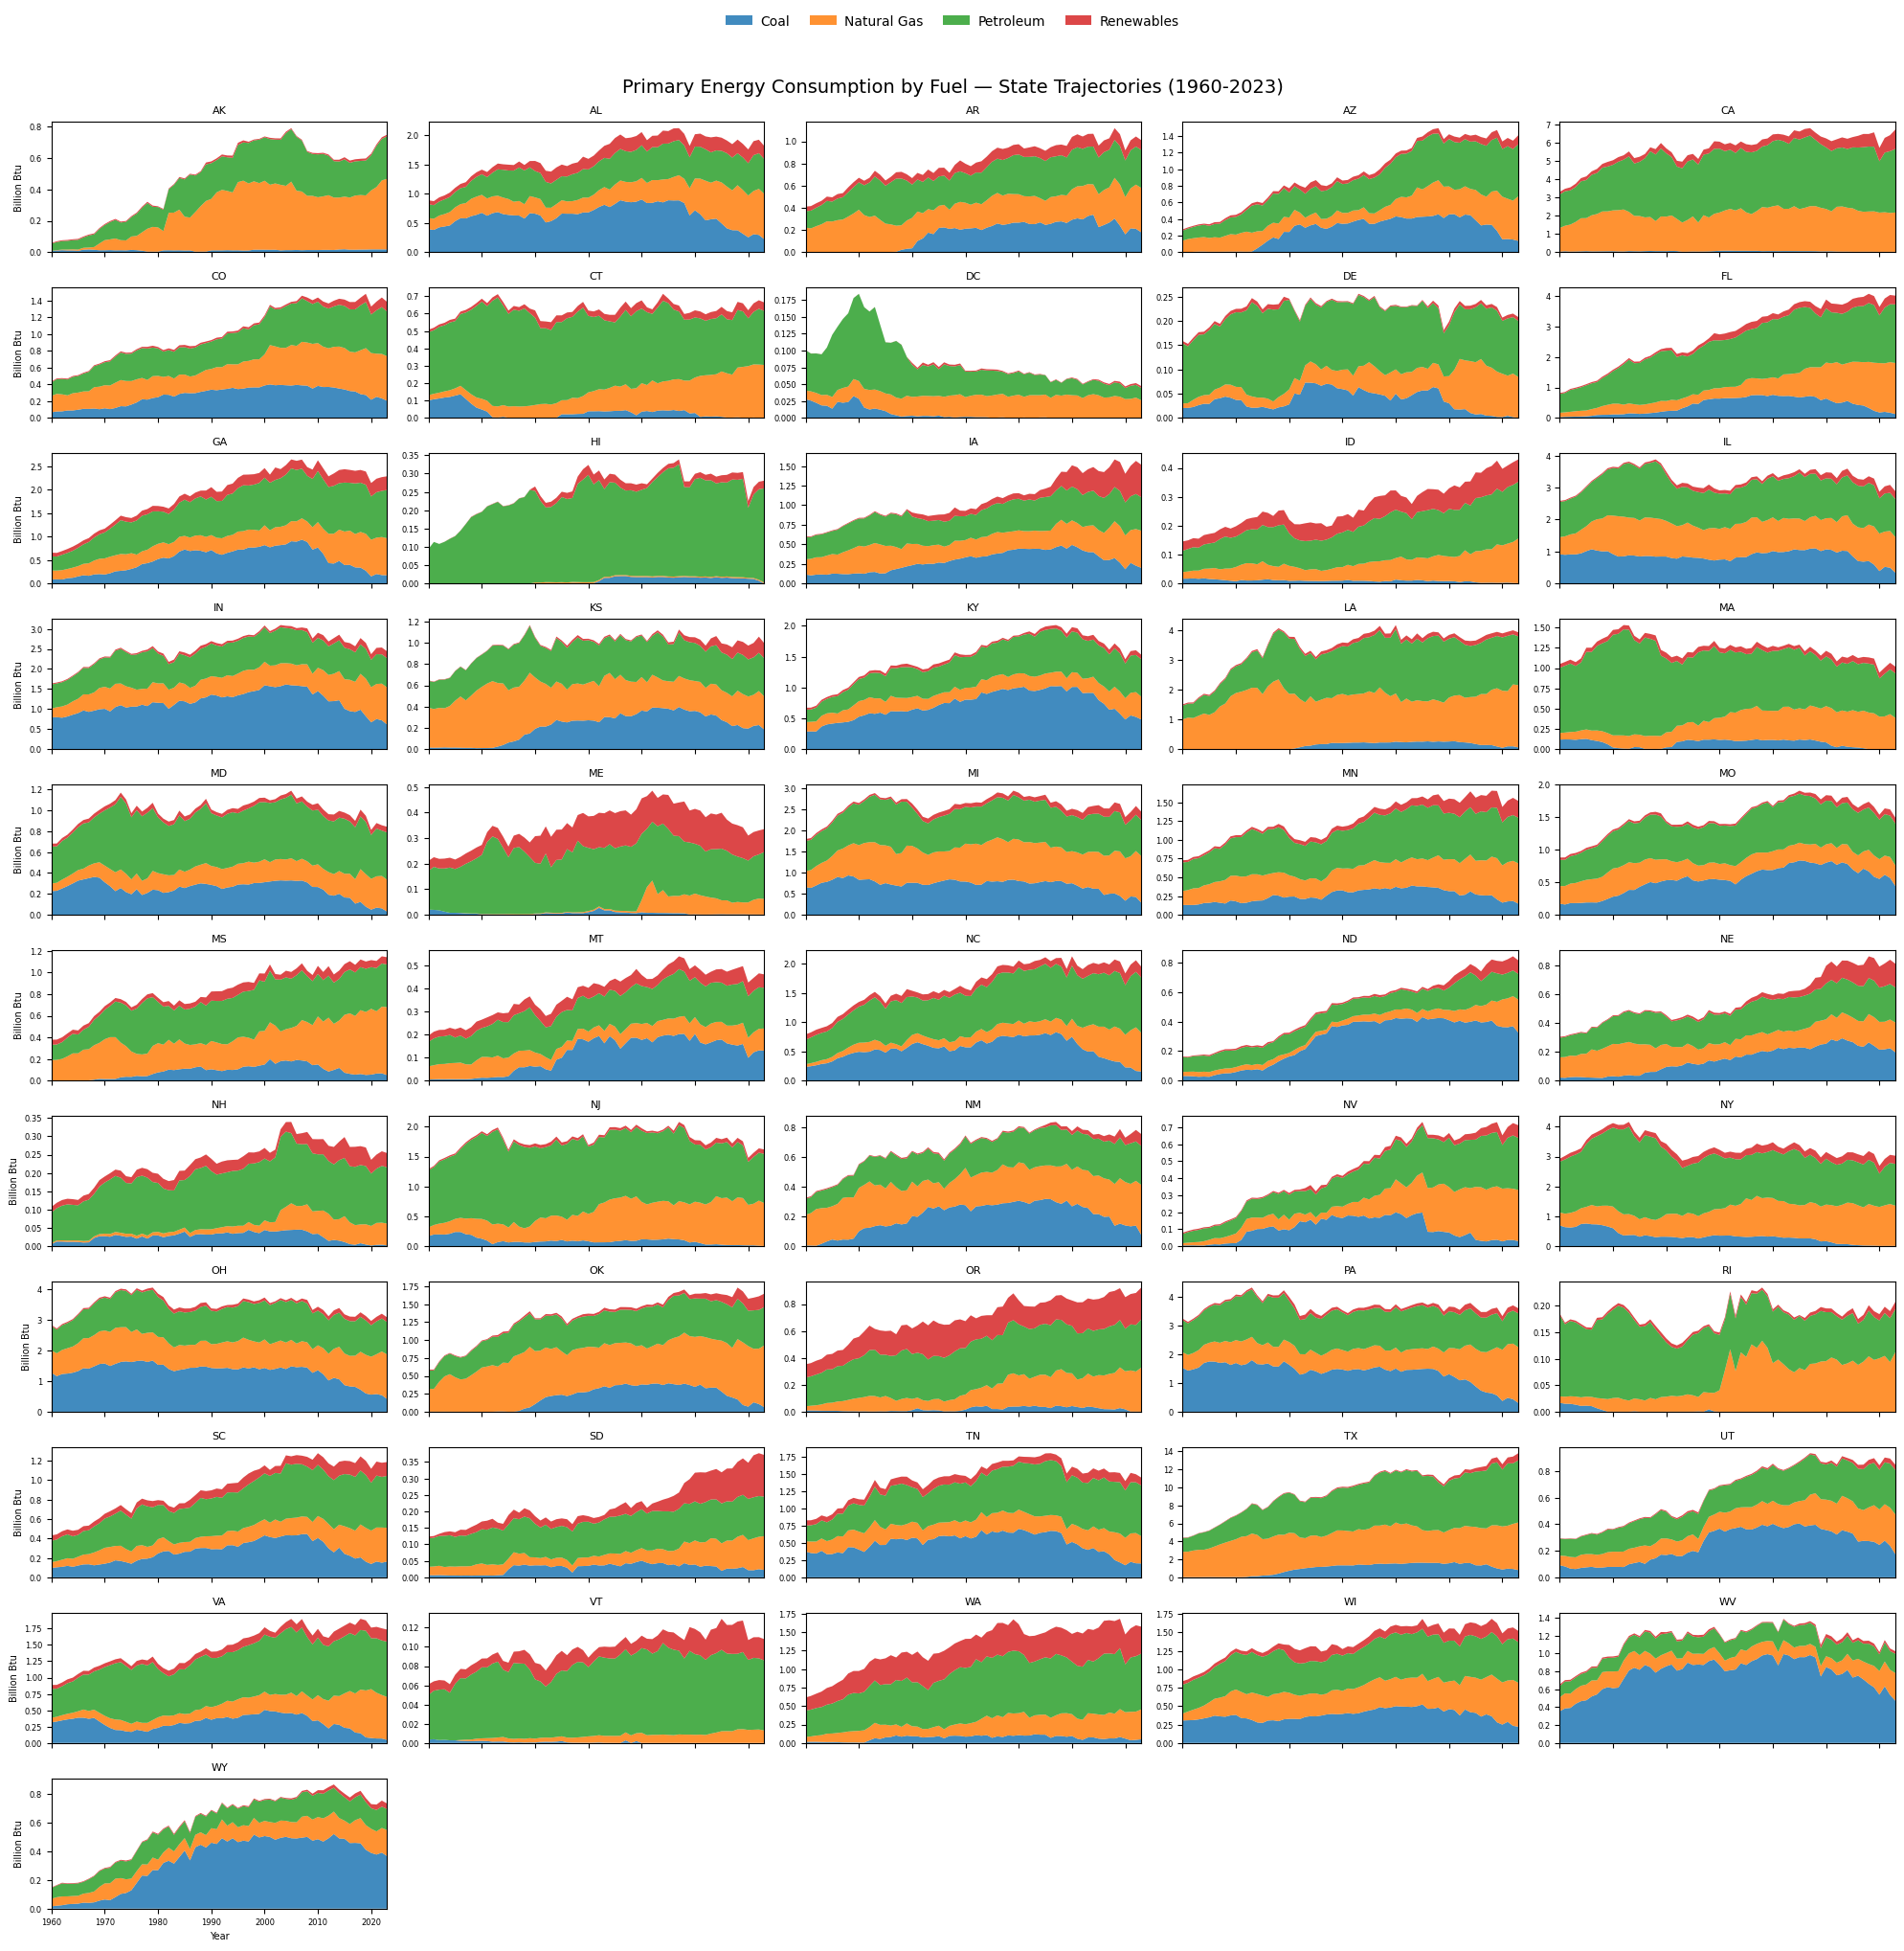
Fig 1.1 US electricity by state, 1960–2023 (SEDS baseline)

Year | Tech milestone | Electricity (Billion Btu) | % Δ vs previous milestone | % Δ vs 1975
0 | 1975 | Mainframe (pre-Internet) | 5,961,073 | +nan % | +0.0 %
1 | 1985 | Commercial Internet | 7,929,399 | +33.0 % | +33.0 %
2 | 1995 | World-Wide Web | 10,281,334 | +29.7 % | +72.5 %
3 | 2005 | Cloud storage / farms | 12,491,225 | +21.5 % | +109.5 %
4 | 2017 | GPU step-change | 12,704,091 | +1.7 % | +113.1 %
5 | 2023 | Latest data | 13,218,952 | +4.1 % | +121.8 %

Top-5 states by % growth in electricity (ESTCB) 1995 → 2023
 | State | Year | Tech milestone | Electricity (Billion Btu) | % Δ vs previous milestone | % Δ vs 1995
0 | ND | 1975 | Mainframe (pre-Internet) | 12667.0 | NaN | -52.90
1 | ND | 1985 | Commercial Internet | 23972.0 | 89.25 | -10.87
2 | ND | 1995 | World-Wide Web | 26896.0 | 12.20 | 0.00
3 | ND | 2005 | Cloud storage / farms | 36986.0 | 37.51 | 37.51
4 | ND | 2017 | GPU step-change | 68719.0 | 85.80 | 155.50
5 | ND | 2023 | Latest data | 96226.0 | 40.03 | 257.77
6 | NV | 1975 | Mainframe (pre-Internet) | 26078.0 | NaN | -63.00
7 | NV | 1985 | Commercial Internet | 38696.0 | 48.39 | -45.10
8 | NV | 1995 | World-Wide Web | 70490.0 | 82.16 | 0.00
9 | NV | 2005 | Cloud storage / farms | 110892.0 | 57.32 | 57.32
10 | NV | 2017 | GPU step-change | 125076.0 | 12.79 | 77.44
11 | NV | 2023 | Latest data | 130507.0 | 4.34 | 85.14
12 | SD | 1975 | Mainframe (pre-Internet) | 13841.0 | NaN | -45.28
13 | SD | 1985 | Commercial Internet | 19279.0 | 39.29 | -23.78
14 | SD | 1995 | World-Wide Web | 25295.0 | 31.20 | 0.00
15 | SD | 2005 | Cloud storage / farms | 33475.0 | 32.34 | 32.34
16 | SD | 2017 | GPU step-change | 42014.0 | 25.51 | 66.10
17 | SD | 2023 | Latest data | 46082.0 | 9.68 | 82.18
18 | TX | 1975 | Mainframe (pre-Internet) | 441813.0 | NaN | -50.82
19 | TX | 1985 | Commercial Internet | 727183.0 | 64.59 | -19.05
20 | TX | 1995 | World-Wide Web | 898307.0 | 23.53 | 0.00
21 | TX | 2005 | Cloud storage / farms | 1140489.0 | 26.96 | 26.96
22 | TX | 2017 | GPU step-change | 1371216.0 | 20.23 | 52.64
23 | TX | 2023 | Latest data | 1681503.0 | 22.63 | 87.19
24 | UT | 1975 | Mainframe (pre-Internet) | 27092.0 | NaN | -56.99
25 | UT | 1985 | Commercial Internet | 44486.0 | 64.20 | -29.37
26 | UT | 1995 | World-Wide Web | 62986.0 | 41.59 | 0.00
27 | UT | 2005 | Cloud storage / farms | 85302.0 | 35.43 | 35.43
28 | UT | 2017 | GPU step-change | 104370.0 | 22.35 | 65.70
29 | UT | 2023 | Latest data | 113768.0 | 9.00 | 80.62

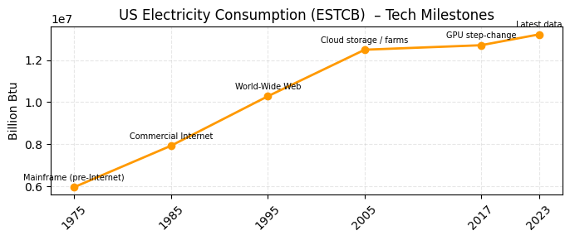
Fig 1.2
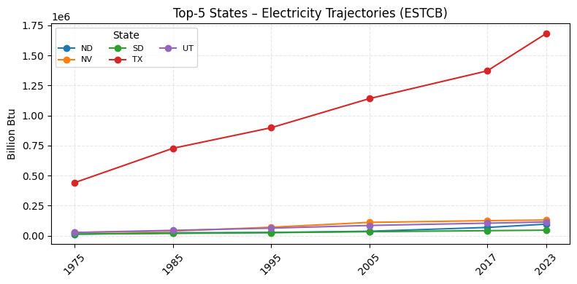
Fig 1.3
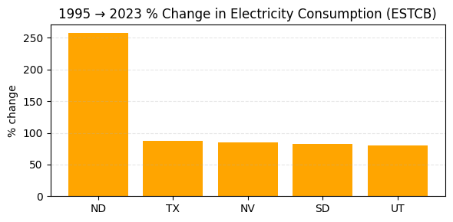
Fig 1.4

DC COUNT PER CAPITA

Gini (DCs per-million): 0.812
Hoover (Robin-Hood) : 0.659
 | country | dc_count | iso3 | population | dc_per_million
100 | Monaco | 2 | MCO | 38,631 | 51.77
86 | Liechtenstein | 2 | LIE | 40,197 | 49.75
88 | Luxembourg | 23 | LUX | 677,717 | 33.94
3 | Andorra | 2 | AND | 81,938 | 24.41
108 | Netherlands | 298 | NLD | 17,994,237 | 16.56
137 | Singapore | 99 | SGP | 6,036,860 | 16.40
163 | United States | 5,427 | USA | 340,110,988 | 15.96
109 | New Zealand | 83 | NZL | 5,338,500 | 15.55
67 | Iceland | 6 | ISL | 404,610 | 14.83
81 | Latvia | 27 | LVA | 1,862,441 | 14.50
Bottom 10 countries (with ≥1 DC)
 | country | dc_count | iso3 | population | dc_per_million
2 | Algeria | 1 | DZA | 46,814,308 | 0.02
0 | Afghanistan | 1 | AFG | 42,647,492 | 0.02
89 | Madagascar | 1 | MDG | 31,964,956 | 0.03
28 | Cameroon | 1 | CMR | 29,123,744 | 0.03
159 | Uganda | 2 | UGA | 50,015,092 | 0.04
12 | Bangladesh | 7 | BGD | 173,562,364 | 0.04
116 | Pakistan | 11 | PAK | 251,269,164 | 0.04
112 | Nigeria | 11 | NGA | 232,679,478 | 0.05
4 | Angola | 3 | AGO | 37,885,849 | 0.08
150 | Tanzania | 6 | TZA | 68,560,157 | 0.09

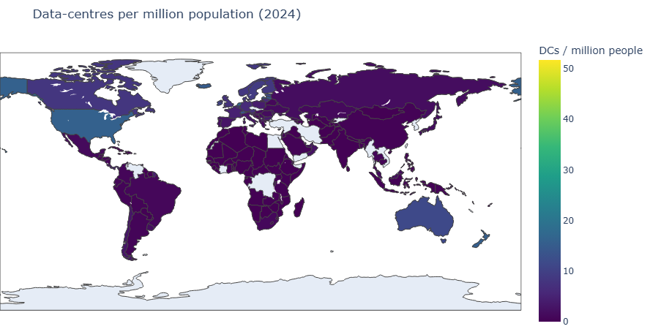
Fig. 2.1 — Global data-centre count per million people (choropleth)
UKPN
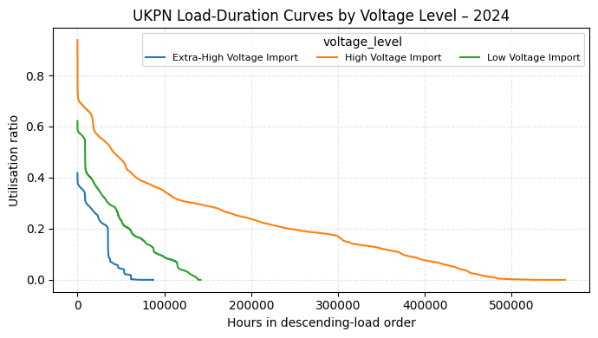
Fig. 3.1 — UKPN service coverage vs estimated DC clusters (schematic/map)
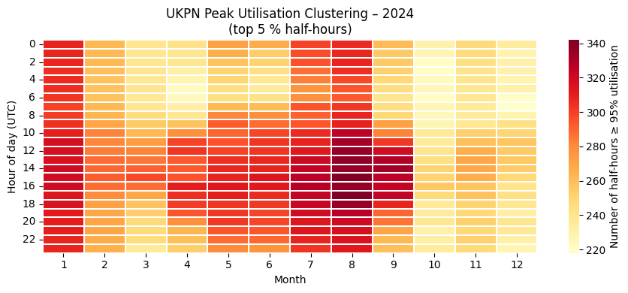
Fig. 3.2 — Load-duration / workload-hours per resident (2024)

UK total DCs : 523
UK population (2024) : 69,226,000
Population ‘covered’ by UKPN 83 sites: 10,986,153

Total equivalent full-load hours (all sites, 2024) : 152,231.2 h
Workload-hours per affected resident : 0.0139 h

SERVER WORKSTATION
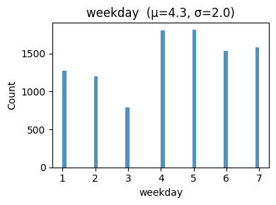
Fig 4.1
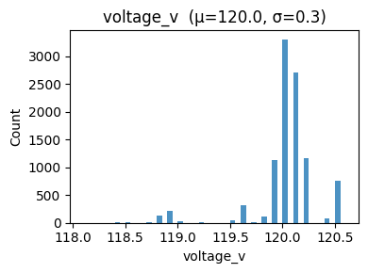
Fig 4.2
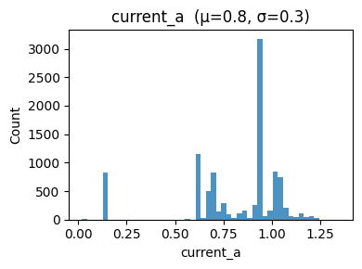
Fig 4.3
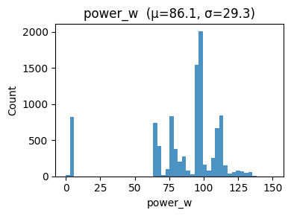
Fig 4.4
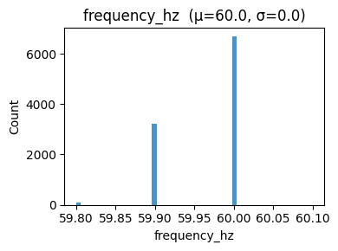
Fig 4.4

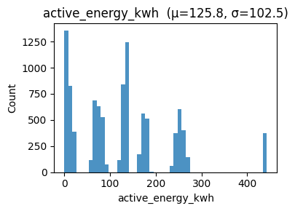
Fig 4.5

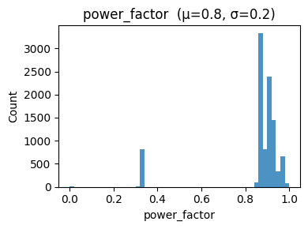
Fig 4.6
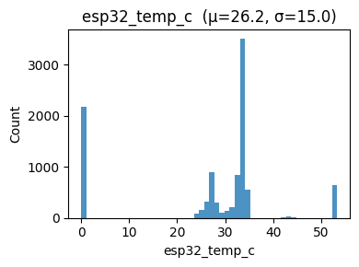
Fig 4.7
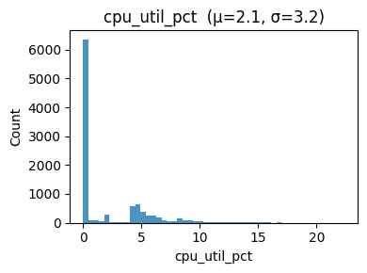
Fig 4.8
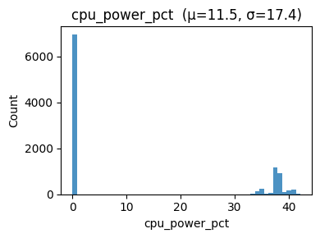
Fig. 4.9 — CPU utilisation distribution (full run)

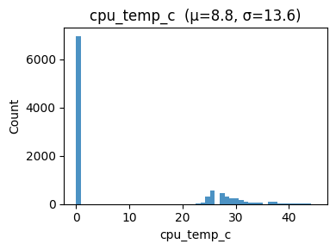
Fig 4.10 - CPU temp
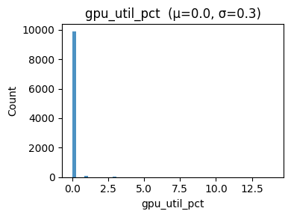
Fig. 4.10 — GPU utilisation distribution (full run)
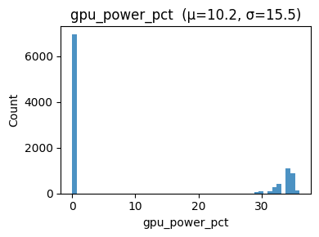
Fig 4.12 – GPU utilisation distribution (full run)
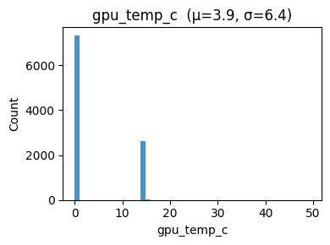
Fig 4.13 - GPU temp

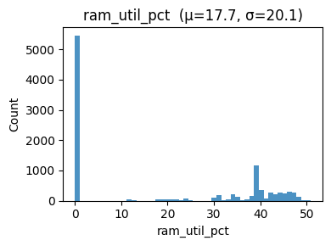
Fig 4.14 - Ram Utilisation distribution (full run)
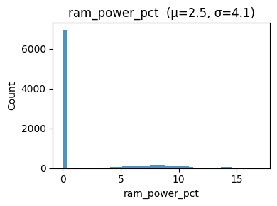
Fig 4.15
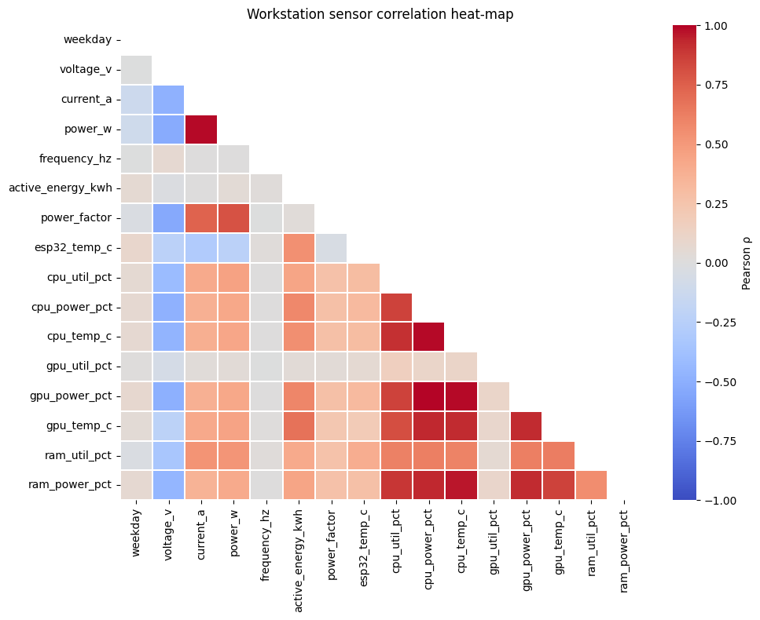
Fig. 5.1 — Feature correlation matrix (Pearson ρ)
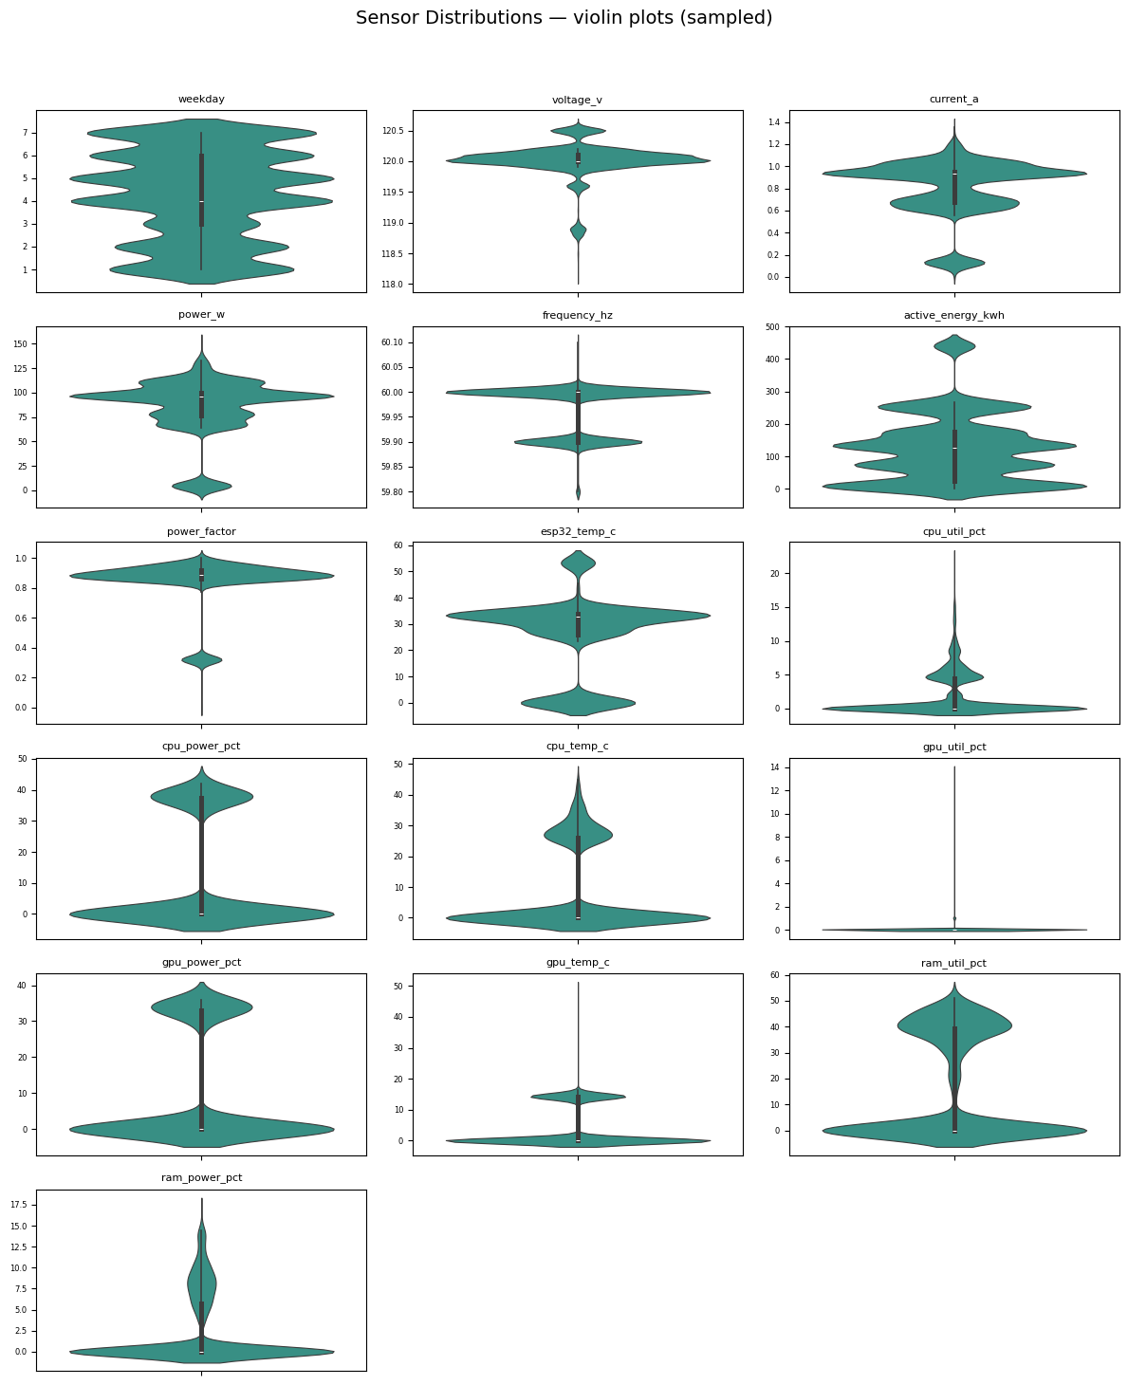
Fig. 5.2 —
Pairs with |ρ| ≥ 0.9:

 | feat_A | feat_B | rho
75 | gpu_power_pct | cpu_power_pct | +1.00
5 | power_w | current_a | +0.99
54 | cpu_temp_c | cpu_power_pct | +0.99
76 | gpu_power_pct | cpu_temp_c | +0.98
115 | ram_power_pct | cpu_temp_c | +0.97
114 | ram_power_pct | cpu_power_pct | +0.93
87 | gpu_temp_c | cpu_power_pct | +0.93
117 | ram_power_pct | gpu_power_pct | +0.93
90 | gpu_temp_c | gpu_power_pct | +0.93
88 | gpu_temp_c | cpu_temp_c | +0.93
53 | cpu_temp_c | cpu_util_pct | +0.91

Table 5.1 — Highly collinear pairs (|ρ| ≥ 0.9) (table panel, not a plot)

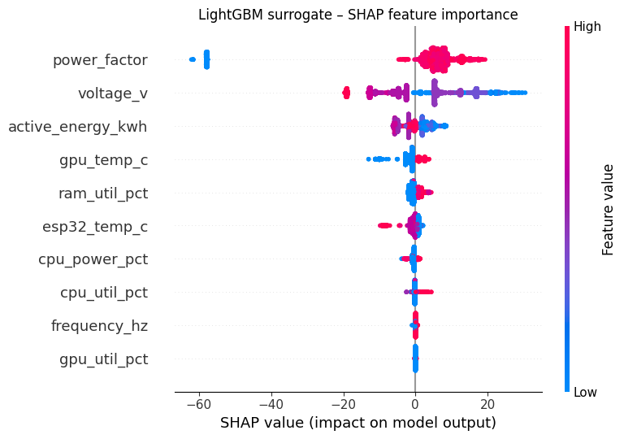
Fig. 6.1 — LightGBM surrogate – Shap feature importance plot

Best CV RMSE : 1.25 (params below)
{'num_leaves': np.int64(80), 'n_estimators': 900, 'min_child_samples': 10, 'max_depth': -1, 'learning_rate': np.float64(0.16), 'lambda_l2': 0.1, 'feature_fraction': np.float64(0.8), 'bagging_freq': 10, 'bagging_fraction': np.float64(1.0)}

SENTIMENT ANALYSIS

year avg_tone
2015 0.221211
2016 0.706310
2017 0.711807
2018 1.087847
2019 1.358316,
year sentiment prop source
2015 negative 0.372881 news
2015 neutral 0.059322 news
2015 positive 0.567797 news
2016 negative 0.296667 news
2016 neutral 0.090000 news
Table 7.1 — Average news tone over time (GDELT V2Tone, 2015–2019)

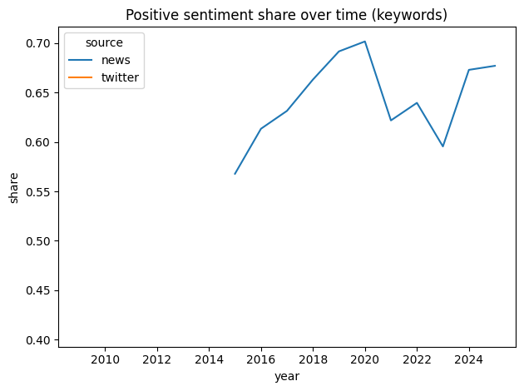Fig. 7.2 — News sentiment shares (neg/neu/pos, yearly)
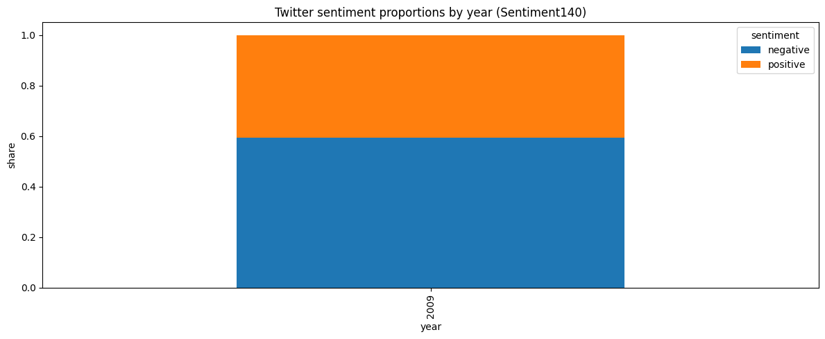
Fig. 7.3 — Twitter (Sentiment140) sentiment shares

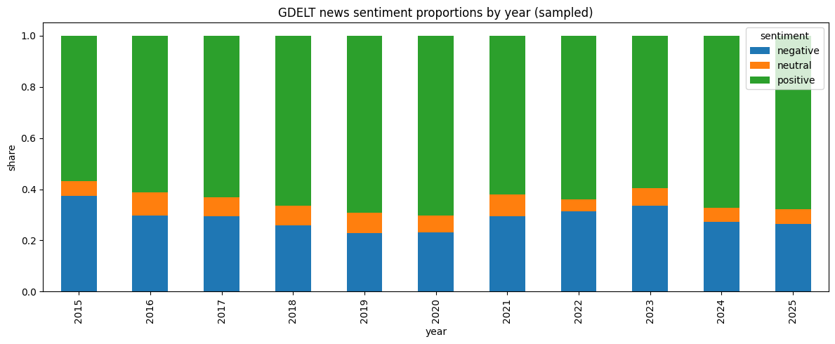
Fig. 7.4

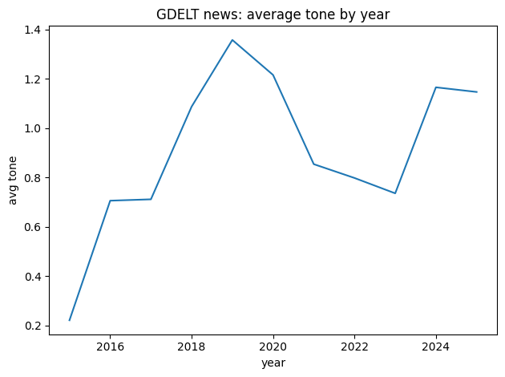
Fig 7.5

Figure | Assigned descriptive title | Use in Results & Analysis?
Table 1 | SEDS datasets used: coverage and structure (1960–2023) – summary of rows, states, MSN codes and year spans for each sub-dataset. | Yes
Fig 1.1 | State-level primary energy consumption by fuel (1960–2023) – 50 small multiples of coal/gas/petroleum/renewable trajectories. | No (appendix).
Fig 1.2 | U.S. electricity consumption aligned to major digital milestones (1975–2023) – line chart marking the mainframe, commercial internet, web, cloud farm and GPU eras. | Yes
Fig 1.3 | Top-five states electricity trajectories – consumption paths for ND, NV, SD, TX, UT. | No (appendix).
Fig 1.4 | Percentage change in electricity consumption (1995–2023) by top-five states – bar plot. | No.
Fig 2.1 | Global distribution of data-centres per million population (2024) – static choropleth map. | Yes
Fig 3.1 | UKPN load-duration curves by voltage level (2024) – curves for extra-high, high and low voltage imports. | No.
Fig 3.2 | UKPN peak-utilisation clustering – heatmap of high-load half-hours by month and hour; includes summary metrics (523 DCs in UK, covered population 10.99 M, 152 k load-hours, workload-hours per resident 0.0139 h). | Use the metrics only (presented as Table 2).
Table 2 | UK data-centre metrics (2024) – number of UK DCs, UK population, UKPN-covered population, equivalent full-load hours and workload-hours per affected resident. | Yes
Figs 4.1–4.15 | Server/workstation sensor distributions – histograms for weekday, voltage, current, power, frequency, energy, power factor, CPU/GPU utilisation/power/temperature and RAM metrics. | No; only needed for appendix; we’ll cite overall distribution patterns in text.
Fig 5.1 | Feature correlation heatmap (workstation sensors) – triangular matrix showing Pearson correlations among all sensor variables. | Yes
Fig 5.2 | Sensor distributions – violin plots – violin plots for all variables and a listing of pairs with | ρ
Table 3 | *Highly collinear feature pairs ( | ρ
Fig 6.1 | LightGBM model validation: SHAP feature importance and best cross-validation performance – SHAP scatter plot and hyper-parameters (best CV RMSE = 1.25). | Yes
Fig 7.1 | Twitter sentiment proportions by year (Sentiment140) – stacked bar plot. | No (appendix).
Fig 7.2 | GDELT news sentiment composition by year – stacked bars of negative, neutral and positive proportions. | Yes (used as Figure 9 in your chapter).
Fig 7.3 | GDELT news average tone by year – line plot of mean tone (2015–2019). | Yes (used as Figure 8).
Fig 7.4 | Positive sentiment share over time (keywords) – line plot for search-keyword sentiment (2015–2025). | No (appendix).

