1. **Creating teams, assigning roles and responsibilities**

* Our Team:
* Nimish Agarwal (01)
* Yash Aher (04)
* Arya Badwe (08)
* Chetan Dabbe (19)
* Shreekrushna Dongare (22)

**Mentored By- Prof. A.V. Taware**

**2. Brain storming, Ideation and setting actionable and goal statements**

“To enhance travel ease, create a top-tier luggage transport service that caters to the seamless transfer of baggage from airports to various destination locations."

First, we identified the problem or opportunity that our project aimed to address. We noticed that many travelers struggle with transporting their luggage from airports to hotels, especially when they have multiple bags or limited time.

Next, we generated as many ideas as possible to solve the problem or seize the opportunity. We used different brainstorming techniques, such as mind mapping or basic brainstorming. We used a mind map to visualize different aspects of the luggage delivery service, such as the target market, the pricing model, the delivery methods, and the potential challenges.

Then, we evaluated and selected the best ideas from our brainstorming session. We used criteria such as feasibility, originality, impact, and cost-effectiveness. We chose the idea of creating a mobile app that connects travelers with local drivers who can pick up and drop off their luggage at their desired locations. To optimize the overall travel experience, we recognize the significance of seamless integration with airlines. By collaborating with major carriers, we aim to provide travellers with a unified booking and tracking experience. This integration eliminates the need for multiple interactions with different service providers, simplifying the logistics and enhancing customer satisfaction.

Our overarching goal is to achieve a customer satisfaction rating of 95% within the first year of operation. This will be accomplished by providing reliable, on-time luggage delivery and exceptional tracking capabilities. By continuously refining and enhancing our services based on customer feedback, we aim to deliver an outstanding that meets and exceeds traveller’s expectations.

**3. Identify stakeholders, people/organization, problems and opportunities, prepare questionnaire and discuss with Stakeholders**

Stakeholders for CarryOnGo can Include:

**Travellers(user):**

Travelers are our primary customers who are going to avail our service, because they are the ones who face the problem of transporting their luggage from airports to hotels. Our service offers them a convenient and affordable solution that saves them time and hassle. Our service caters to different types of travellers, such as business travelers, leisure travelers, solo travelers, or family travelers.

**Airports(benificary):**

At the airports we are going to setup our kiosks from where we are going to collect luggage. Revenue will be partly shared for providing us space.

**Logistics(benificary):**

Logistics is going to be important part for transporting the luggage to final destination or get the luggage from the user and transport it to airport.

**4. Field visits / Survey**

**Survey to identify problem**

**1. Users(Traveller):**

* How often do you travel long distances with luggage?
* What types of items do you typically pack in your luggage?
* How important is it for you to have your luggage delivered on time?
* How do you typically communicate with the luggage transport service provider?
* Have you ever experienced lost or damaged luggage when using a luggage transport service? If so, how was the issue resolved?
* How satisfied are you with the current luggage transport services available to you?

**2. Airports and logistics:**

* How often do you receive luggage from luggage transport services on behalf of guests?
* How do you ensure that the correct luggage is delivered to the correct guest?
* How important is timely delivery of luggage for guest satisfaction?
* Have you ever experienced lost or damaged luggage when receiving luggage on behalf of guests? If so, how was the issue resolved?
* Will it be helpful to return lost items?

**6. Survey analysis for problem validation**

1.

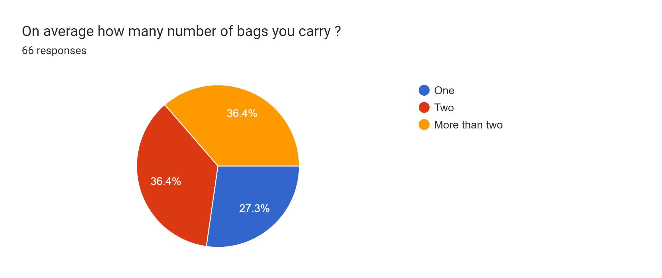

2.

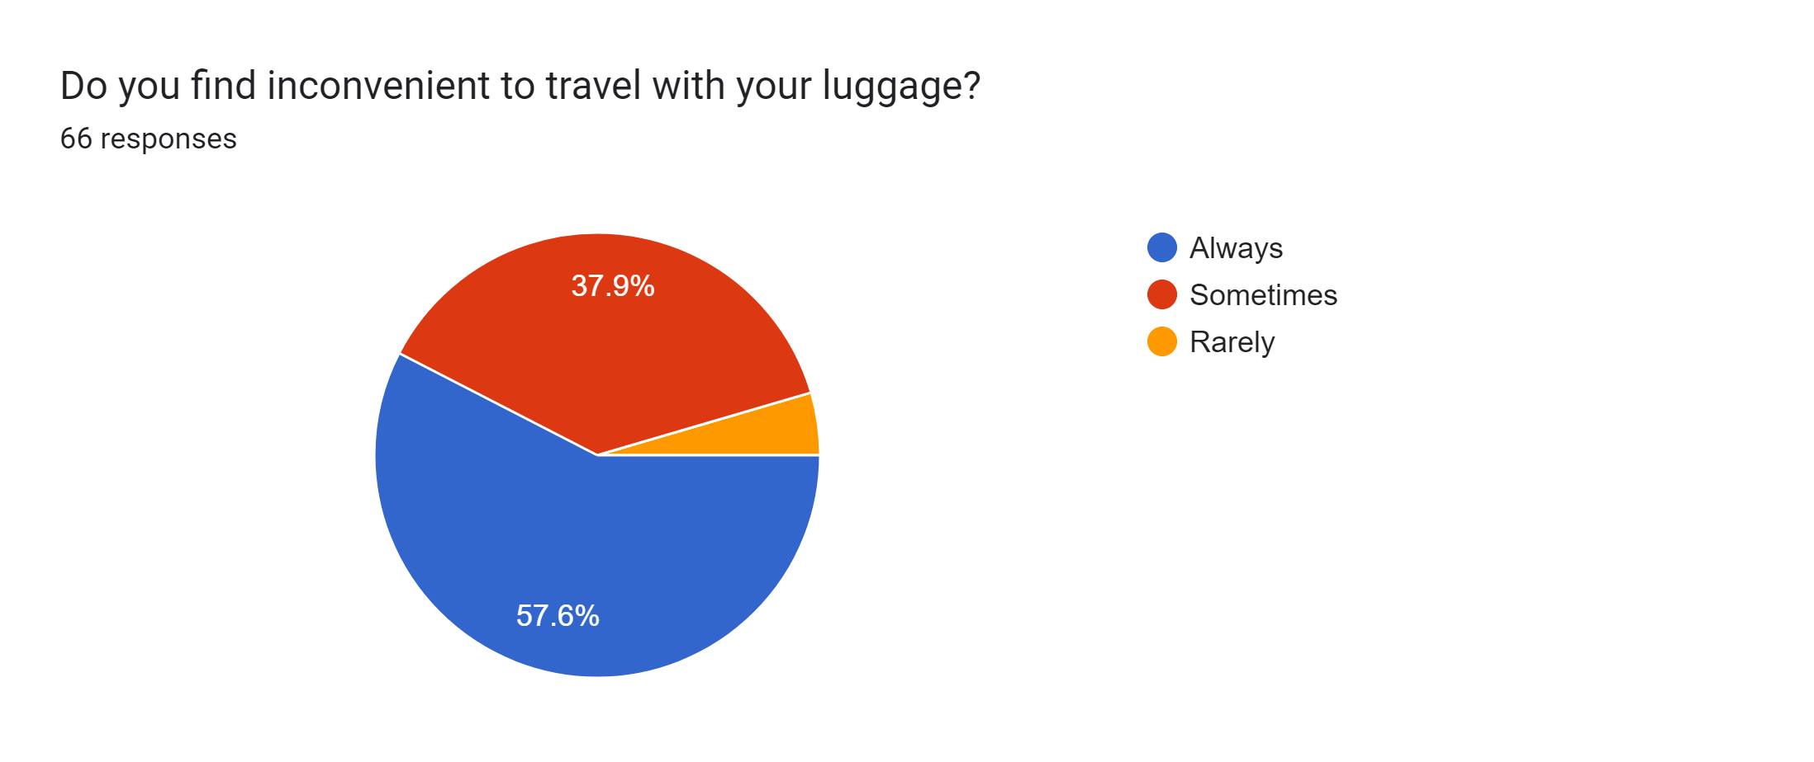

3.

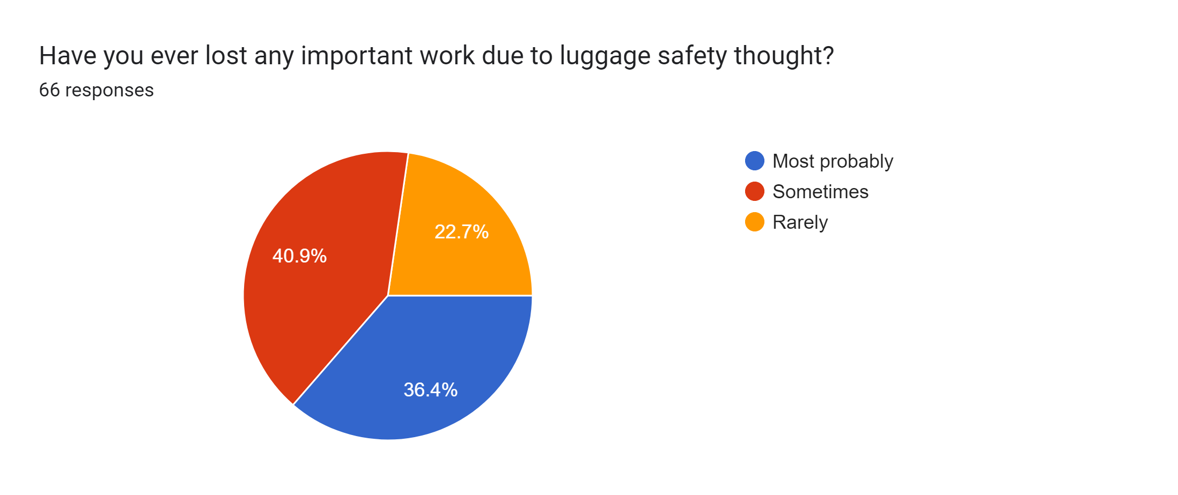

4.

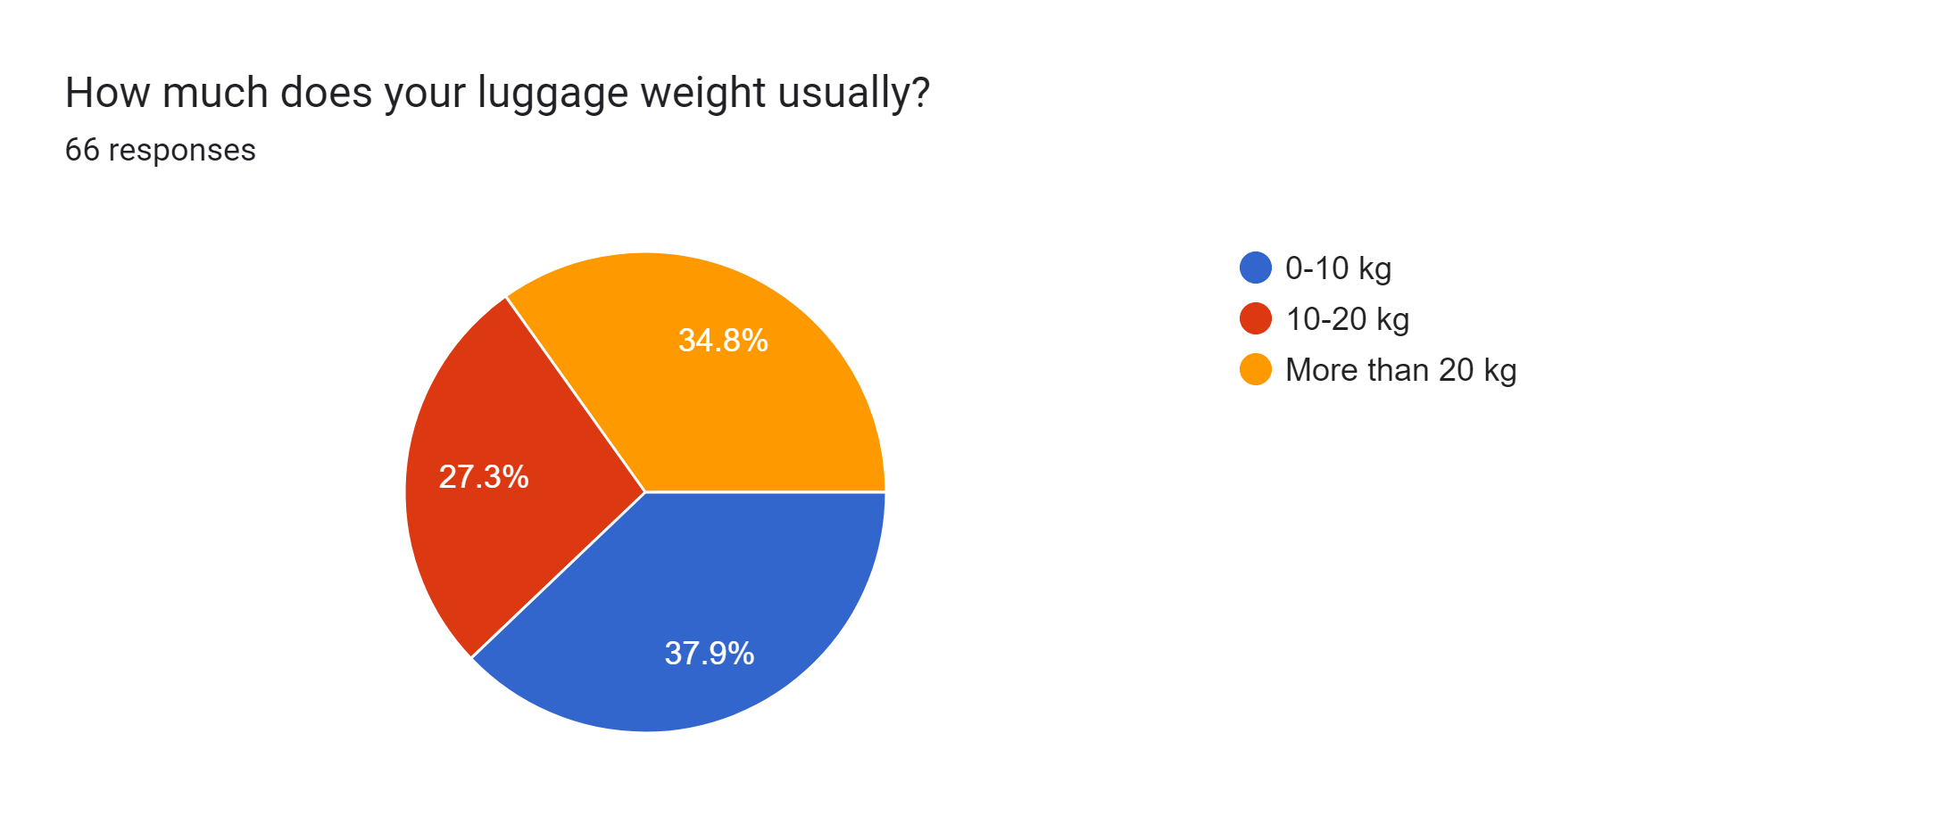

5.

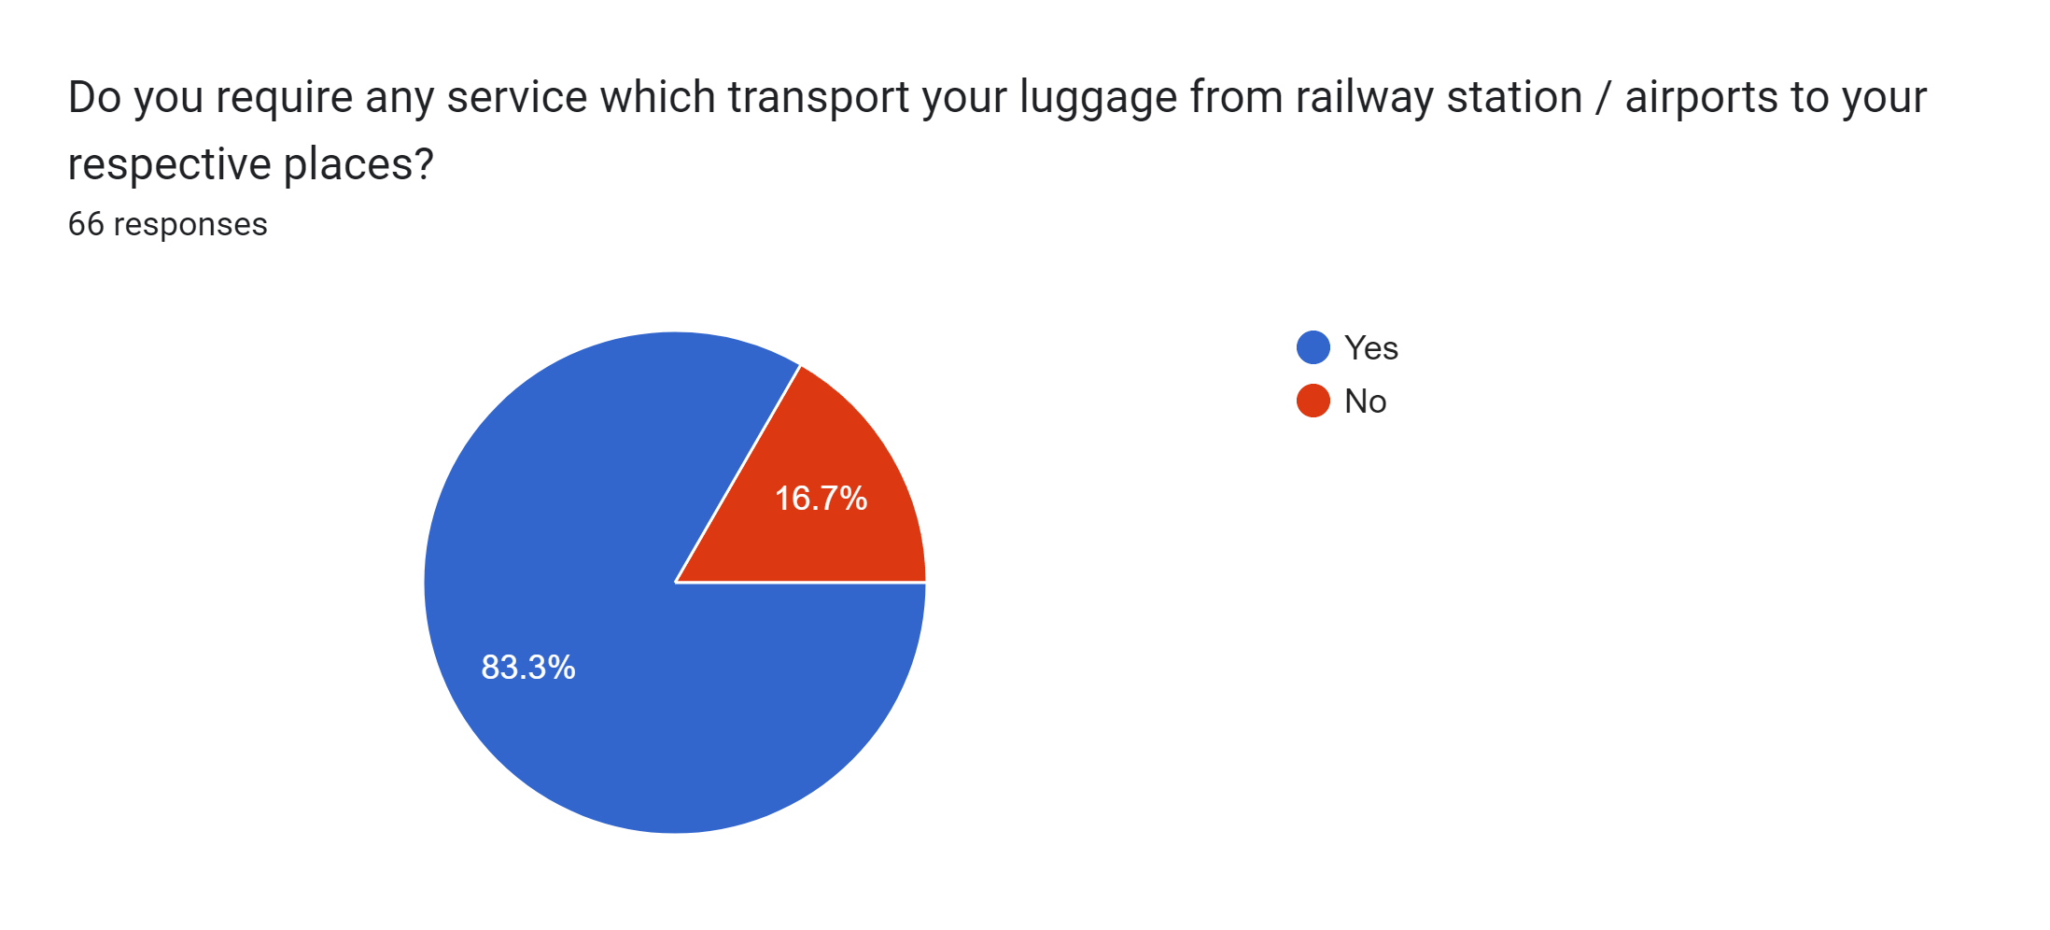

**Analysis:**

* 1. Majority of the people carry two or more luggage while travelling
  2. More than 70% of travellers luggage weight 20Kg or more
  3. More than 85% people find it difficult to carry luggage while travelling
  4. About 75% people have lost some of their items while travelling
  5. Almost all the people feel the need for a service which transports their luggage to their hotel from the airport.

**7.Requirement analysis and Use case diagram**

**Problem analysis (requirement gathering):**

1. Inefficient Baggage Handling: Existing baggage handling processes at airports may be inefficient, leading to delays, mishandling, or loss of luggage. Bags may be improperly sorted, loaded, or unloaded, resulting in inconvenience and frustration for passengers.

2. Lack of Tracking and Communication: Passengers often lack visibility and real-time updates on the status and location of their luggage during transportation. This can cause anxiety and uncertainty, especially when baggage is delayed or misplaced.

3. Security Concerns: Instances of baggage theft or unauthorized access can occur during transportation, compromising the safety and integrity of passengers' belongings. Inadequate security measures may result in lost or damaged luggage, leading to financial loss and inconvenience for passengers.

4. Complex Booking and Scheduling: Booking and scheduling processes may be cumbersome or lack flexibility, making it challenging for passengers to arrange and modify luggage transport services according to their travel plans and preferences.

5. Data Security and Privacy: Concerns related to the security and privacy of passenger data during luggage transport arise due to potential breaches, unauthorized access, or misuse of personal information. Ensuring robust data protection measures is crucial for maintaining customer trust.

6. Cost Considerations: The cost of luggage transport services may be prohibitive for some passengers, limiting accessibility and affordability. Transparent pricing structures, competitive rates, and value-added services should be considered to address this issue.

By identifying and analyzing these problems, service providers can develop strategies and solutions to address them, improve the overall customer experience, and optimize luggage transport services.

**Use Case Diagram:**

**8.Identifying Skills and techniques required to solve the listed problem**

**Software Development Skills:**

1. P**rogramming languages:** Proficiency in languages such as Python, Java, or JavaScript is important for developing the backend and frontend components of the software.
2. **Web development:** Knowledge of HTML, CSS, and JavaScript frameworks like React or Angular for building user interfaces and creating responsive web applications.
3. **Mobile app development:** Familiarity with mobile app development frameworks like React Native or Flutter for creating iOS and Android applications.
4. **Database management:** Experience in working with relational databases (e.g., MySQL, PostgreSQL) or NoSQL databases (e.g., MongoDB) for data storage and retrieval.
5. **API integration**: Understanding how to integrate with third-party services, payment gateways, mapping APIs, or other external APIs to enhance functionality.
6. **Version control:** Proficiency in using version control systems like Git to manage source code and collaborate with a development team.
7. **Testing and debugging:** Knowledge of testing frameworks and techniques to ensure the software is functional, reliable, and free from bugs.
8. **Logistics and supply chain management:** Knowledge of logistics operations, transportation, inventory management, and scheduling will contribute to the efficient functioning of the software.
9. **Customer experience and service delivery:** An understanding of customer expectations, service customization, and effective communication channels is crucial for developing a user-friendly software solution.

**Security and data protection:**

* Awareness of data security practices, encryption methods, and compliance with relevant regulations (e.g., GDPR) is essential to ensure the protection of user data.

**Communication and Collaboration:**

1. **Effective communication skills:** The ability to understand client requirements, collaborate with stakeholders, and work in a team is vital for successful software development.
2. **Requirement gathering and analysis:** Skills in conducting interviews, workshops, and surveys to elicit and document user requirements accurately.
3. **Agile methodology:** Familiarity with Agile practices, such as Scrum or Kanban, for iterative development, frequent feedback, and adaptability.
4. **Problem-solving and Analytical Thinking:** Strong analytical and problem-solving skills to identify and address technical and functional challenges during the development process.

**9. Create design Template**

**10. Possible Solutions**

* Baggage Delivery App: Develop a user-friendly mobile app that allows passengers to schedule and track the delivery of their luggage from the airport to their designated location, providing convenience and real-time updates.
* Luggage Transfer Kiosks: Install self-service kiosks at airports where passengers can securely drop off their luggage for transport, streamlining the process and reducing wait times.
* Group Luggage Transfers: Introduce a group transfer option for passengers traveling together, where their luggage is consolidated and transported as a single shipment, optimizing efficiency and cost-effectiveness.
* Regional Luggage Hubs: Establish regional luggage hubs in strategic locations to facilitate efficient and timely transfers, reducing transit times and optimizing logistics.
* Sustainable Transport Solutions: Introduce eco-friendly transport options, such as electric vehicles or bicycles, for luggage delivery, promoting sustainability and reducing carbon emissions.

These solutions aim to enhance the overall luggage transport experience, providing convenience, security, and efficiency for travellers traveling from airports to their destination locations.