# INDEX

|  |  |  |  |
| --- | --- | --- | --- |
| **Practical Units.** | **Name of Practical** | **Date** | **Sign** |
| 1 | 1. Perform Geometric transformations 2. Perform Image Stitching 3. Perform Camera Calibration |  |  |
| 2 | 1. Face detection 2. Object detection 3. Pedestrian detection 4. Face recognition 5. Construct 3D model from images 6. Implement object detection and tracking from video |  |  |
| 3 | 1. Perform Feature extraction using RANSAC 2. Perform Colorization |  |  |
| 4 | 1. Perform Text detection and recognition 2. Perform Image matting   and Composting |  |  |

## Practical 1

##### Perform Geometric Transformations

import numpy as np import cv2

def translate(image, x, y):

M = np.float32([[1, 0, x], [0, 1, y]])

translated_image = cv2.warpAffine(image, M, (image.shape[1], image.shape[0]))

return translated_image

def rotate(image, angle, center=None, scale=1.0): (h, w) = image.shape[:2]

if center is None:

center = (w // 2, h // 2)

M = cv2.getRotationMatrix2D(center, angle, scale) rotated_image = cv2.warpAffine(image, M, (w, h)) return rotated_image

def scale(image, scale_x, scale_y):

scaled_image = cv2.resize(image, None, fx=scale_x, fy=scale_y) return scaled_image

def shear(image, shear_x, shear_y):

M = np.float32([[1, shear_x, 0], [shear_y, 1, 0]]) sheared_image = cv2.warpAffine(image, M, (image.shape[1],

image.shape[0])) return sheared_image

image = cv2.imread('img.jpg') translated_image = translate(image, 100, 100) rotated_image = rotate(image, 45)

scaled_image = scale(image, 0.5, 0.5)

sheared_image = shear(image, 0.2, 0.3) cv2.imshow('Original',image) cv2.imshow('translated_image',translated_image) cv2.imshow('rotated_image',rotated_image) cv2.imshow('scaled_image',scaled_image) cv2.imshow('sheared_image',sheared_image) **Output:**

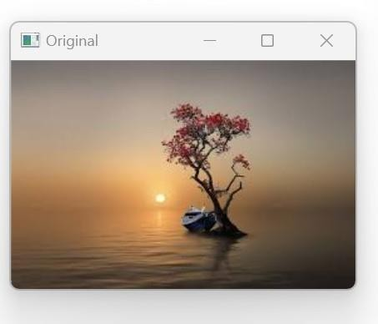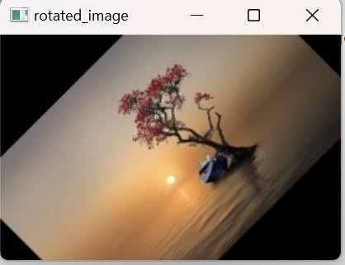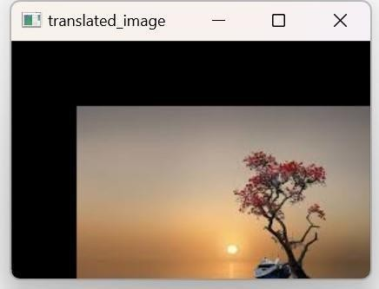

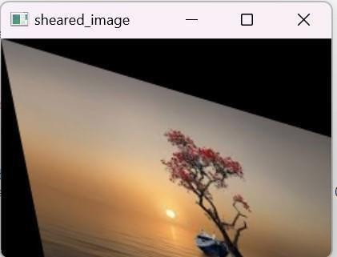

##### Perform Image Stitching

from imutils import paths import numpy as np import argparse

import imutils import cv2

imagePaths = sorted(list(paths.list_images('p2'))) #p2 is folder containing images

images=[]

for imagePath in imagePaths:

image = cv2.imread(imagePath) images.append(image)

print("[INFO] stitching images...")

stitcher = cv2.createStitcher() if imutils.is_cv3() else cv2.Stitcher_create() (status, stitched) = stitcher.stitch(images)

if status == 0:

# write the output stitched image to disk cv2.imwrite("p2output.jpg", stitched)

# display the output stitched image to our screen cv2.imshow("Stitched", stitched) cv2.waitKey(0)

else:

print("[INFO] image stitching failed ({})".format(status))

**Output:**

[INFO] stitching images…

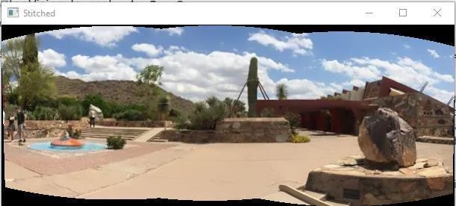

##### Perform Camera Caliberation

import cv2

import numpy as np import os

import glob chb = (6, 9)

criteria = (cv2.TERM_CRITERIA_EPS + cv2.TERM_CRITERIA_MAX_ITER, 30, 0.001)

threedpoints = [] twodpoints = []

objectp3d = np.zeros((1, chb[0] * chb[1], 3), np.float32) objectp3d[0, :, :2] = np.mgrid[0:chb[0], 0:chb[1]].T.reshape(-1, 2) prev_img_shape = None

images = glob.glob('*.jpg') for filename in images:

image = cv2.imread(filename)

grayColor = cv2.cvtColor(image, cv2.COLOR_BGR2GRAY) ret, corners = cv2.findChessboardCorners(grayColor, chb,

cv2.CALIB_CB_ADAPTIVE_THRESH

+ cv2.CALIB_CB_FAST_CHECK + cv2.CALIB_CB_NORMALIZE_IMAGE)

if ret == True:

threedpoints.append(objectp3d) corners2 = cv2.cornerSubPix(

grayColor, corners, (11, 11), (-1, -1), criteria) twodpoints.append(corners2)

image = cv2.drawChessboardCorners(image, chb, corners2, ret) cv2.imshow('img', image)

cv2.waitKey(0) cv2.destroyAllWindows() h, w = image.shape[:2]

ret, matrix, distortion, r_vecs, t_vecs = cv2.calibrateCamera( threedpoints, twodpoints, grayColor.shape[::-1], None, None)

print(" Camera matrix:") print(matrix)

print("\n Distortion coefficient:") print(distortion)

print("\n Rotation Vectors:") print(r_vecs)

print("\n Translation Vectors:") print(t_vecs)

**Output:**

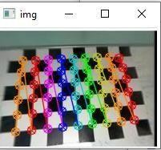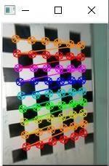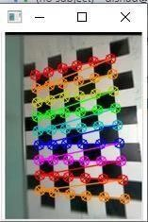

Camera matrix:

[[40.8618761 0. 83.80597971]

[ 0. 41.29134045 94.37718569]

[ 0. 0. 1. ]]

Distortion coefficient:

[[ 0.00051989 -0.00105068 -0.00512204 -0.00037702 0.00015534]]

Rotation Vectors:

(array([[-0.09670096], [ 0.06446519],

[ 1.50927077]]), array([[-0.15910316],

[-0.0178901 ],

[ 3.07539003]]), array([[-0.03866621],

[ 0.09626499],

[-0.07417175]]))

Translation Vectors:

(array([[ 4.65717678],

[-3.68545603],

[ 2.75350073]]), array([[2.34304791],

[4.05578132],

[2.76539468]]), array([[-3.12854143],

[-3.38972333],

[ 2.83149017]]))

## Practical 2

##### Face Detection

import cv2

img = cv2.imread('input1.jpg')

gray_image = cv2.cvtColor(img, cv2.COLOR_BGR2GRAY) face_classifier = cv2.CascadeClassifier(

cv2.data.haarcascades + "haarcascade_frontalface_default.xml") face = face_classifier.detectMultiScale(

gray_image, scaleFactor=1.1, minNeighbors=5, minSize=(40, 40)) for (x, y, w, h) in face:

cv2.rectangle(img, (x, y), (x + w, y + h), (0, 255, 0), 4) img_rgb = cv2.cvtColor(img, cv2.COLOR_BGR2RGB) cv2.imshow('i',img_rgb)

**Output:**

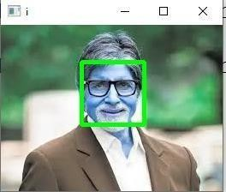

Changing another image : img = cv2.imread('input3.jpg')

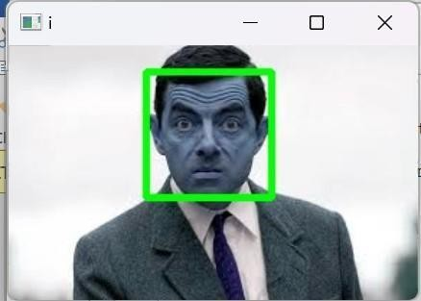

##### Object detection

import cv2

# Opening image

img = cv2.imread("stop.png")

img_gray = cv2.cvtColor(img, cv2.COLOR_BGR2GRAY) img_rgb = cv2.cvtColor(img, cv2.COLOR_BGR2RGB) stop_data = cv2.CascadeClassifier('stop_data.xml')

found = stop_data.detectMultiScale(img_gray,minSize =(20, 20)) amount_found = len(found)

if amount_found != 0:

for (x, y, width, height) in found:

cv2.rectangle(img_rgb, (x, y),(x + height, y + width),(0, 255, 0), 5) cv2.imshow('imgobject',img_rgb)

**Output:**

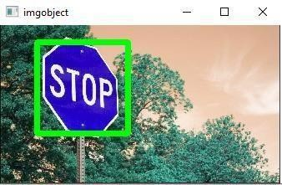

##### Pedestrain Detection

import cv2 import imutils

hog = cv2.HOGDescriptor() hog.setSVMDetector(cv2.HOGDescriptor_getDefaultPeopleDetector()) image = cv2.imread('pedestrian1.png')

image = imutils.resize(image,width=min(400, image.shape[1]))

(regions, _) = hog.detectMultiScale(image,winStride=(4, 4),padding=(4, 4),scale=1.05)

for (x, y, w, h) in regions:

cv2.rectangle(image,(x, y),(x + w, y + h),(0, 0, 255), 2) cv2.imshow("Image", image)

cv2.waitKey(0)

cv2.destroyAllWindows()

**Output :**

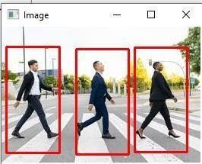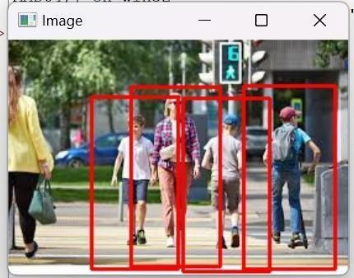

##### Face Recognition

Write command in Command Prompt:

pip install dlib-19.24.99-cp312-cp312-win_amd64.whl (need the file to be downloaded)

pip install cmake

pip install face_recognition pip install setuptools

Coding:

import cv2

import face_recognition

imgmain = face_recognition.load_image_file('random11.jpg') imgmain = cv2.cvtColor(imgmain, cv2.COLOR_BGR2RGB) imgTest = face_recognition.load_image_file('random12.jpg') imgTest = cv2.cvtColor(imgTest, cv2.COLOR_BGR2RGB) faceLoc = face_recognition.face_locations(imgmain)[0] encodeElon = face_recognition.face_encodings(imgmain)[0]

cv2.rectangle(imgmain,(faceLoc[3],faceLoc[0]),(faceLoc[1],faceLoc[2]),(255, 0, 255), 2)

faceLocTest = face_recognition.face_locations(imgTest)[0] encodeTest = face_recognition.face_encodings(imgTest)[0]

cv2.rectangle(imgTest, (faceLocTest[3],faceLocTest[0]),(faceLocTest[1],faceLocTest[2]),

(255, 0, 255), 2)

results = face_recognition.compare_faces([encodeElon],encodeTest) faceDis = face_recognition.face_distance([encodeElon],encodeTest) print(results, faceDis)

cv2.putText(imgTest, f'{results} {round(faceDis[0], 2)}', (20, 20),

cv2.FONT_HERSHEY_COMPLEX, 1, (0, 0, 255), 2)

cv2.imshow('Main Image', imgmain) cv2.imshow('Test Image', imgTest) cv2.waitKey(0)

**Output:**

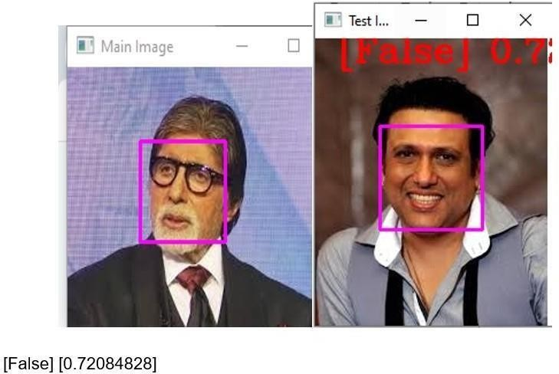

Changes

imgmain = face_recognition.load_image_file('random11.jpg') imgmain = cv2.cvtColor(imgmain, cv2.COLOR_BGR2RGB) imgTest = face_recognition.load_image_file('random2.jpg') imgTest = cv2.cvtColor(imgTest, cv2.COLOR_BGR2RGB)

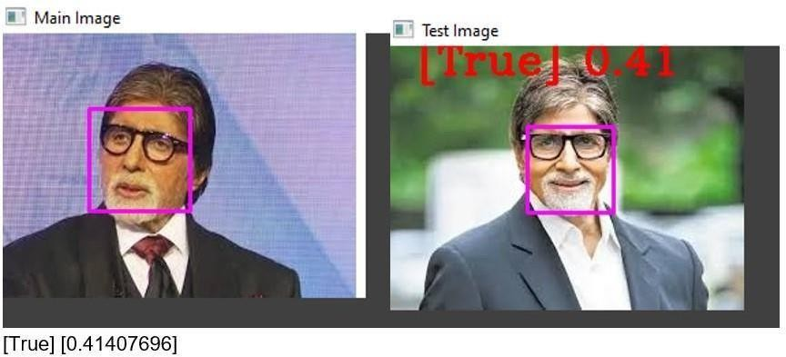

##### Construct 3D model from images

from PIL import Image import numpy as np

def shift_image(img, depth_img, shift_amount=10): img = img.convert("RGBA")

data = np.array(img)

depth_img = depth_img.convert("L") depth_data = np.array(depth_img)

deltas = ((depth_data / 255.0) * float(shift_amount)).astype(int) shifted_data = np.zeros_like(data)

height, width, _ = data.shape for y, row in enumerate(deltas):

for x, dx in enumerate(row):

if x + dx < width and x + dx >= 0: shifted_data[y, x + dx] = data[y, x]

shifted_image = Image.fromarray(shifted_data.astype(np.uint8)) return shifted_image

img = Image.open("cube1.jpeg") depth_img = Image.open("cube2.jpeg")

shifted_img = shift_image(img, depth_img, shift_amount=10) shifted_img.show()

**Output:**

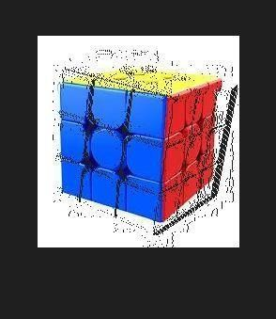

##### Object detection from video

import cv2

face_classifier = cv2.CascadeClassifier(

cv2.data.haarcascades + "haarcascade_frontalface_default.xml") video_capture = cv2.VideoCapture('a.mp4')

def detect_bounding_box(vid):

gray_image = cv2.cvtColor(vid, cv2.COLOR_BGR2GRAY)

faces = face_classifier.detectMultiScale(gray_image, 1.1, 5, minSize=(40,

40))

for (x, y, w, h) in faces:

cv2.rectangle(vid, (x, y), (x+w+100, y+h+100), (0,0,255), 4) return faces

while True:

result, video_frame = video_capture.read() if result is False:

break

faces = detect_bounding_box(video_frame) cv2.imshow("My Object Detection Project", video_frame) if cv2.waitKey(1) & 0xFF == ord("q"):

break video_capture.release() cv2.destroyAllWindows()

**Output:**

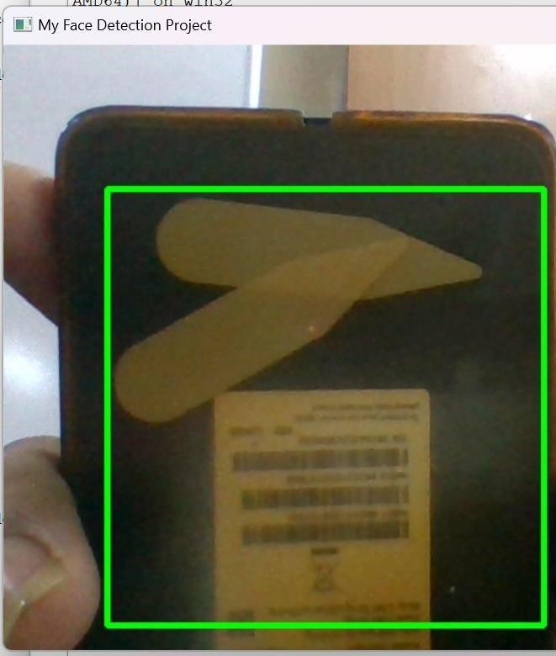

## Practical 3

##### RANSAC Implementation

**linearleastsqaure.py**

import numpy as np

class LinearLeastSqaureModel: def fit(self, A, Y):

A_transpose = A.transpose() ATA = A_transpose.dot(A) ATY = A_transpose.dot(Y)

model = (np.linalg.inv(ATA)).dot(ATY) return model

**ransac.py:**

import numpy as np import math

class RansacModel:

def init (self, curve_fitting_model): self.curve_fitting_model = curve_fitting_model

def fit(self, A, Y, num_sample, threshold): num_iterations = math.inf iterations_done = 0

num_sample = 3

max_inlier_count = 0 best_model = None prob_outlier = 0.5

desired_prob = 0.95

total_data = np.column_stack((A, Y)) ## [ A | Y] data_size = len(total_data)

while num_iterations > iterations_done: np.random.shuffle(total_data) sample_data = total_data[:num_sample, :]

estimated_model = self.curve_fitting_model.fit(sample_data[:,:-1],

sample_data[:, -1:]) y_cap = A.dot(estimated_model)

err = np.abs(Y - y_cap.T)

inlier_count = np.count_nonzero(err < threshold) if inlier_count > max_inlier_count:

max_inlier_count = inlier_count best_model = estimated_model

prob_outlier = 1 - inlier_count/data_size print('# inliers:', inlier_count)

print('# prob_outlier:', prob_outlier)

num_iterations = math.log(1 - desired_prob)/math.log(1 - (1 - prob_outlier)**num_sample)

iterations_done = iterations_done + 1 print('# s:', iterations_done)

print('# n:', num_iterations)

print('# max_inlier_count: ', max_inlier_count) return best_model

**Modelfitting.py:**

**Ransac Implementation Coding:**

import numpy as np import math

import pandas as pd

from matplotlib import pyplot as plt from ransac import RansacModel

from linearleastsquare import LinearLeastSqaureModel def fit_curve(data):

x_values = np.array(data['x']) y_values = np.array(data['y']) x_sq = np.power(x_values, 2)

A = np.stack((x_sq, x_values, np.ones((len(x_values)), dtype = int)), axis = 1) threshold = np.std(y_values)/2

linear_ls_model = LinearLeastSqaureModel() linear_ls_model_estimate = linear_ls_model.fit(A, y_values) linear_model_y = A.dot(linear_ls_model_estimate) ransac_model = RansacModel(linear_ls_model)

ransac_model_estimate = ransac_model.fit(A, y_values, 3, threshold) ransac_model_y = A.dot(ransac_model_estimate)

return linear_model_y, ransac_model_y if name == ' main ':

df1 = pd.read_csv('data_1.csv') df2 = pd.read_csv('data_2.csv')

ls_model_y1, ransac_model_y1 = fit_curve(df1) ls_model_y2, ransac_model_y2 = fit_curve(df2) fig, (ax1, ax2) = plt.subplots(1, 2) ax1.set_title('Dataset-1')

ax1.scatter(df1['x'], df1['y'], marker='o', color = (0,1,0), label='data points') ax1.plot(df1['x'], ls_model_y1, color = 'red', label='Least sqaure model')

ax1.plot(df1['x'], ransac_model_y1, color = 'blue', label='Ransac model') ax1.set(xlabel='x-axis', ylabel='y-axis')

ax1.legend() ax2.set_title('Dataset-2')

ax2.scatter(df2['x'], df2['y'], marker='o', color = (0,1,0), label='data points') ax2.plot(df2['x'], ls_model_y2, color = 'red', label='Least sqaure model') ax2.plot(df2['x'], ransac_model_y2, color = 'blue', label='Ransac model') ax2.set(xlabel='x-axis', ylabel='y-axis')

ax2.legend() plt.show()

**Output:**

# inliers: 117

# prob_outlier: 0.532

# s: 1

# n: 27.700875935823316

# max_inlier_count: 117

# inliers: 175

# prob_outlier: 0.30000000000000004

# s: 2

# n: 7.131485905524426

# max_inlier_count: 175

# inliers: 76

# prob_outlier: 0.696

# s: 3

# n: 105.1257167640639

# max_inlier_count: 175

# inliers: 134

# prob_outlier: 0.46399999999999997

# s: 4

# n: 17.91439390915469

# max_inlier_count: 175

# inliers: 187

# prob_outlier: 0.252

# s: 5

# n: 5.525552495791251

# max_inlier_count: 187

# inliers: 68

# prob_outlier: 0.728

# s: 6

# n: 147.36332180032895

# max_inlier_count: 187

# inliers: 64

# prob_outlier: 0.744

# s: 7

# n: 177.05746802114584

# max_inlier_count: 187

# inliers: 87

# prob_outlier: 0.652

# s: 8

# n: 69.57430607360442

# max_inlier_count: 187

# inliers: 72

# prob_outlier: 0.712

# s: 9

# n: 123.90418270340892

# max_inlier_count: 187

# inliers: 145

# prob_outlier: 0.42000000000000004

# s: 10

# n: 13.801901471212751

# max_inlier_count: 187

# inliers: 58

# prob_outlier: 0.768

# s: 11

# n: 238.4038555094377

# max_inlier_count: 187

# inliers: 118

# prob_outlier: 0.528

# s: 12

# n: 26.963389844145

# max_inlier_count: 187

# inliers: 63

# prob_outlier: 0.748

# s: 13

# n: 185.69618036762273

# max_inlier_count: 187

# inliers: 168

# prob_outlier: 0.32799999999999996

# s: 14

# n: 8.283822964377974

# max_inlier_count: 187

# inliers: 204

# prob_outlier: 0.18400000000000005

# s: 1

# n: 3.821999420219228

# max_inlier_count: 204

# inliers: 115

# prob_outlier: 0.54

# s: 2

# n: 29.25380161992817

# max_inlier_count: 204

# inliers: 143

# prob_outlier: 0.42800000000000005

# s: 3

# n: 14.457625659547233

# max_inlier_count: 204

# inliers: 91

# prob_outlier: 0.636

# s: 4

# n: 60.60513156707005

# max_inlier_count: 204

# inliers: 120

# prob_outlier: 0.52

# s: 5

# n: 25.561028720085947

# max_inlier_count: 204

# inliers: 184

# prob_outlier: 0.264

# s: 6

# n: 5.889670195389181

# max_inlier_count: 204

**Graph:**

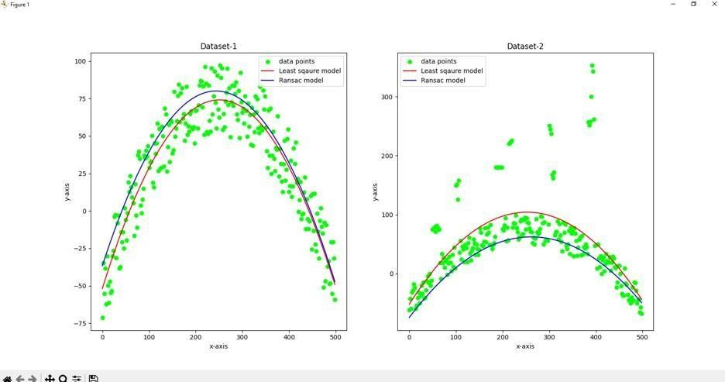

##### Colorization

import argparse

import matplotlib.pyplot as plt

from colorizers import * #local package c1 = eccv16(pretrained=True).eval()

c2 = siggraph17(pretrained=True).eval() img = load_img('testbw1.jpg')

(orig,rs) = preprocess_img(img, HW=(256,256))

img_bw = postprocess_tens(orig, torch.cat((0*orig,0*orig),dim=1)) img1 = postprocess_tens(orig, c1(rs).cpu())

img2 = postprocess_tens(orig, c2(rs).cpu()) plt.imsave('s1.png', img1) plt.imsave('s2.png', img2) plt.figure(figsize=(12,8))

plt.subplot(2,2,1) plt.imshow(img) plt.title('Original Image') plt.axis('off') plt.subplot(2,2,2) plt.imshow(img_bw)

plt.title('Input Black and White') plt.axis('off')

plt.subplot(2,2,3)

plt.imshow(img1) plt.title('Colored Image 1') plt.axis('off') plt.subplot(2,2,4)

plt.imshow(img2) plt.title('Colored Image 2') plt.axis('off')

plt.show()

**Output:**

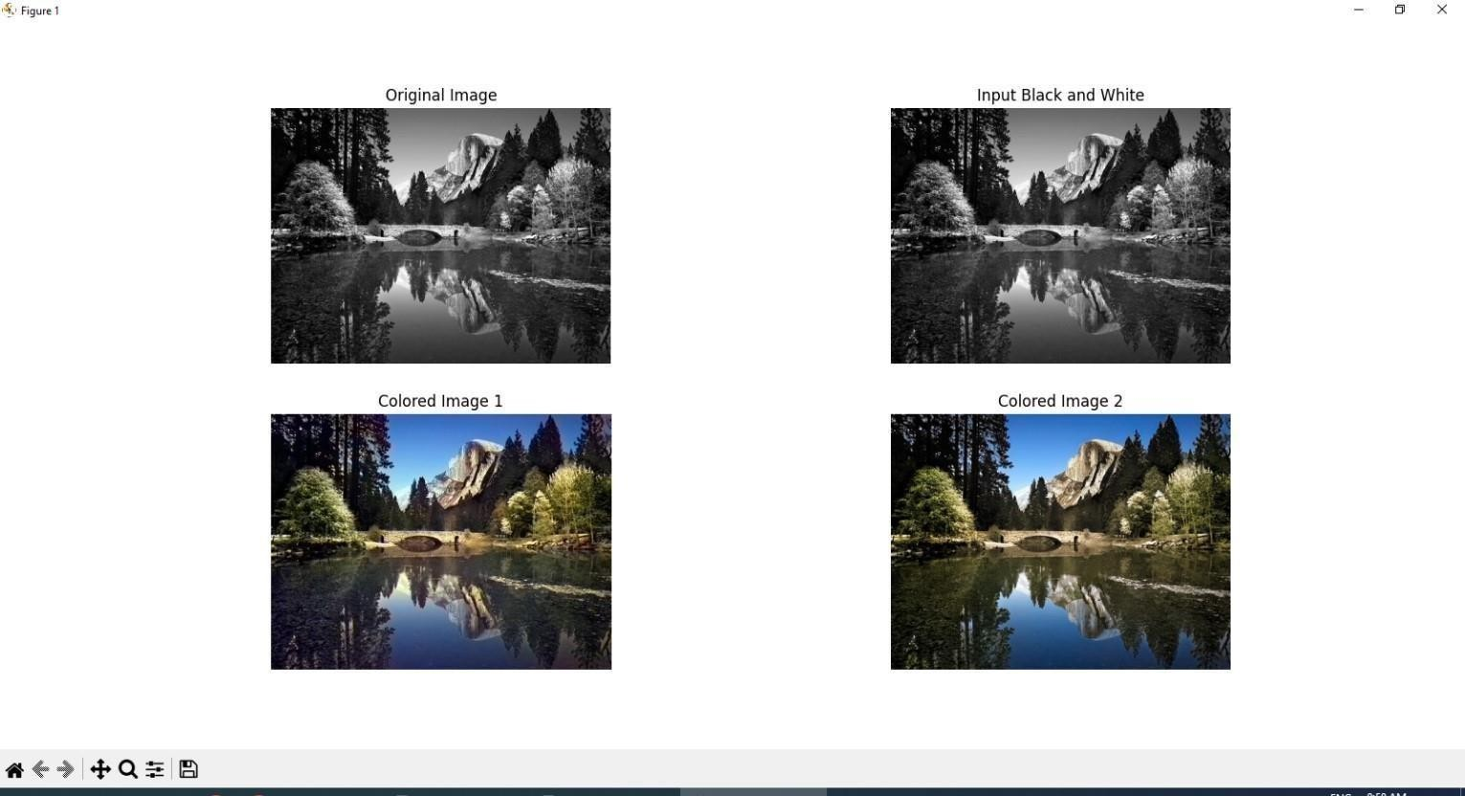

## Practical 4

##### Text Detection And Recognition from Image

import cv2

import pytesseract

pytesseract.pytesseract.tesseract_cmd = r'C:\Program Files\Tesseract- OCR\tesseract.exe'

img = cv2.imread("imgtest1.jpg")

gray = cv2.cvtColor(img, cv2.COLOR_BGR2GRAY)

ret, thresh1 = cv2.threshold(gray, 0, 255, cv2.THRESH_OTSU | cv2.THRESH_BINARY_INV)

rect_kernel = cv2.getStructuringElement(cv2.MORPH_RECT, (20, 20)) dilation = cv2.dilate(thresh1, rect_kernel, iterations = 1)

contours, hierarchy = cv2.findContours(dilation, cv2.RETR_EXTERNAL,cv2.CHAIN_APPROX_NONE)

im2 = img.copy() for cnt in contours:

x, y, w, h = cv2.boundingRect(cnt)

rect = cv2.rectangle(im2, (x, y), (x + w, y + h), (0, 255, 0), 2) cropped = im2[y:y + h, x:x + w]

text = pytesseract.image_to_string(cropped) print(text)

**Output:**

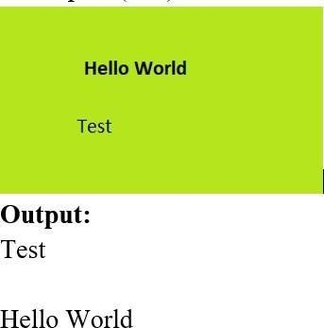

1. **Perform Image matting and Composting**

from pymatting import * import numpy as np import cv2

scale = 1.0

image = load_image("4b1.png", "RGB", scale, "box") trimap = load_image("4b2.png", "GRAY", scale, "nearest") alpha = estimate_alpha_cf(image, trimap) new_background = np.zeros(image.shape) new_background[:, :] = [0.5, 0.5, 0.5]

foreground, background = estimate_foreground_ml(image, alpha, return_background=True)

save_image("output1.png", alpha) save_image("output2.png", foreground) save_image("output3.png", background) cutout = stack_images(foreground, alpha) save_image("output4.png", cutout)

cutout = cv2.imread('output4.png', cv2.IMREAD_UNCHANGED) new_background = cv2.imread('4b3.png')

foreground = cutout[:, :, :3] am = cutout[:, :, 3] / 255.0

newbg_resized = cv2.resize(new_background, (foreground.shape[1], foreground.shape[0]))

composite = np.zeros_like(foreground, dtype=np.uint8) for c in range(3):

composite[:, :, c]=foreground[:,:,c]*am+newbg_resized[:,:,c]*(1-am) cv2.imwrite('composite_image.png', composite)

**Output:**

