1. **Introduction**

In number theory and computer science, the partition problem, or number partitioning, is the task of deciding whether a given multiset ‘S’ of positive integers can be partitioned into two subsets S1 and S2 such that the sum of the numbers in S1 equals the sum of the numbers in S2. In this project, the same task is done using the HLS. An IP overlay is created using Vivado HLS and is implemented in Xilinx PYNQ. An array size is 25 for this project which means it can partition the set of 25 numbers. The execution time for this project has been obtained as around 8.05 seconds which in contrast it is 1000 seconds if implemented only using Python. Thus, this way the execution time of the problem is accelerated.

***Note: To make this tutorial short, the detail algorithm of the partition problem is not described in this tutorial.***

1. **Importing the overlay into Python**

Just like there are software libraries, there are hardware libraries which can be reconfigured, and they are called overlays. The required overlay for this project is provided inside the GitHub repository [here](https://github.com/pratik-stha/PartitionProblemUsingFPGA/blob/master/PartitionHLS.cpp).

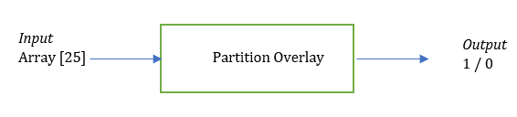

Power up the PYNQ board with USB and connect it with the machine through ethernet. Boot up the PYNQ board. When the LEDS flash blue, it indicates that the board has been successfully booted and is ready to work. Refer to [the official tutorial](https://pynq.readthedocs.io/en/v2.0/getting_started.html) if there is any problem connecting the board.

We are interested in two files. One is *.BIT file and other is *.HWH file. Dowbload the “**CheckPartition.hwh**” and “**CheckPartition.bit**” files from the repository and store it somewhere safe. Now navigate to \\pynq\xilinx\jupyter_notebooks and copy both of these files and paste it here. Please make sure you can successfully access the PYNQ board first.

Follow the steps below to import the overlay and use it.

1. Open the Jupyter Notebook through PYNQ remote access using the IP address.
2. Create a python 3 file (click on **New** > **Python 3**) at same location where we have copied the two files.
3. Write down the following codes as shown in image below then Run it.

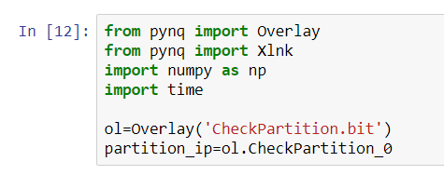

1. After successful execution, create one more cell underneath this cell and write down the following code. Then Run it.

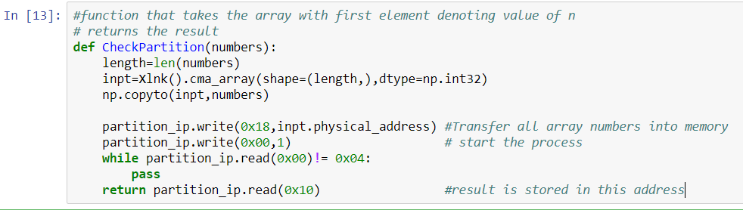

1. Create one more cell underneath this cell and write down the following code which calls the previous function and sends the parameter. We are now testing if our overlay actually worked or not.

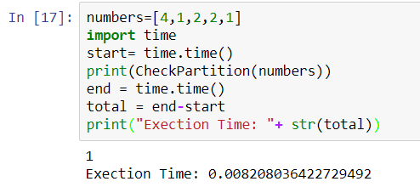

1. Here, the variable ‘**numbers**’ is the array of which the first element ‘**4**’ denotes there are altogether 4 numbers that needs to be partitioned. All the numbers are the first element are the actual numbers that needs to be partitioned. After execution of this cell, the function should return the value of 1 indicating that the given set can be partitioned with the total execution time. If it returns 0 then it means the given set cannot be partitioned.
2. Go ahead and try to change the number as shown in figure and see what happens.

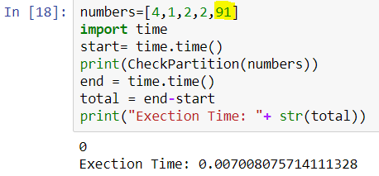

Congratulations !! we have successfully implemented the overlay and executed this program.