**Database Split Tool**

Title  Database Split

**Description**

This tool takes a larger geodatabase along with a polygon feature class that will be used to clip the the geodatabase. It has options of whether or not to delete empty feature classes from output geodatabases. Also if the user wants the output geodatabases to be in a certain Coordinate Reference System, a .prj file for that CRS can be provided as input. This .prj file is optional. If no such file is provided or if the file is invalid, the feature datasets output geodatabases will follow the CRS of corresponding feature datasets from input geodatabase. It works only for feature datasets and Point, Line, Polygon and Annotation files.

**Usage**

It is very useful for extracting a small subset of large geodatabase or when the database is to be split into multiple smaller geodatabases. This can come handy for distributing, updating, managing and cleaning of geodatabases.

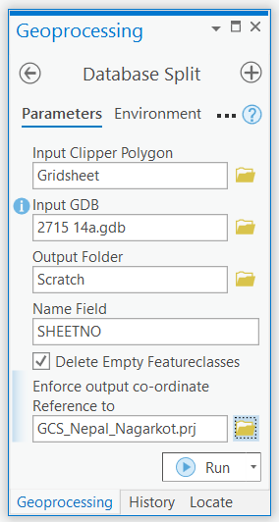

Figure 1: Tool with Inputs

**Syntax**

DatabaseSplit (input_clip_polygon, input_GDB, output_folder, name_field, DIE, {user_defined_CRS})

|  |  |  |
| --- | --- | --- |
| **Parameter** | **Explanation** | **Data Type** |
| input_clip_polygon | Dialog Reference  It is a polygon feature class. If multiple polygons are present, the input gdb will be split to that many gdbs. It should have at least one unique name field that can be used to name output databases. It is encouraged to have input clip polygon in same datum as the input gdb.    Python Reference  input_clip_polygon = r'C:\Users\Lab\Databases\2715 14a.gdb\POLYGON\Gridsheet' | Feature Class |
| input_GDB | Dialog Reference  It is the geodatabase which needs to be clipped. It can contain multiple feature datasets with multiple feature classes.    Python Reference  input_GDB = r'C:\Users\Lab\Databases\2715 14a.gdb' | Workspace |
| output_folder | Dialog Reference  This is the folder where outputs will be stored.    Python Reference  output_folder = r'C:\Users\Lab\Outputs' | Workspace |
| name_field | Dialog Reference  This is the name of a string field of input clipper polygon feature class. It should have unique values in each row. Those values will be used to name the output clipped geodatabases.  Python Reference  name_field = 'SHEETNO' | String |
| DIE | Dialog Reference  DIE is a Boolean. If checked, if means that from output geodatabases, empty feature classes will be deleted. If unchecked, those won’t be deleted.  Python Reference  DIE = True | Boolean |
| user_defined_CRS (Optional) | Dialog Reference  It is a .prj file for the CRS user wants for the output geodatabases. It is optional. If user does not provide any or a valid .prj file, the CRS of input feature datasets will be used for corresponding output feature datasets. Otherwise, the output feature datasets will have user defined CRS. For that, first the geodatabase is to be projected to user defined CRS before beginning the split operation, thus execution time will increase. Moreover, extra memory is also required for that projected geodatabase.    Python Reference  user_defined_CRS = r'C:\Users\Lab\CRS\GCS_Nepal_Nagarkot.prj' | Projection File |

**Code Samples**

General Use

There is no description for this code sample.

input_clip_polygon = r'C:\Users\Lab\Databases\2715 14a.gdb\POLYGON\Gridsheet'

user_defined_CRS = r'C:\Users\Lab\CRS\GCS_Nepal_Nagarkot.prj'

input_GDB = r'C:\Users\Lab\Databases\2715 14a.gdb'

output_folder = r'C:\Users\Lab\Outputs'

name_field = 'SHEETNO'

DIE = True

toolpath = '''path of tool upto .tbx'''

arcpy.ImportToolbox(toolpath)

#Run the tool by calling arcpy followed by dot followed by toolbox alias

#followed by dot followed by toolname followed by list of parameters

#inside parenthesis.

arcpy.NewToolbox.DatabaseSplit(input_clip_polygon, input_GDB, output_folder, name_field, DIE , user_defined_CRS)

**Tags**

Database split; Database Clip, Feature Class Clip; Feature Dataset Split; Data management

**Credits**

Created by: Pratik Dhungana (pdhungana@crimson.ua.edu)

As part of GY 539 (GIS Programming) Class Project

(Built with ArcGIS pro 2.8.0

Python version 3.4.3)

**Use limitations**

This tool is dependent on ArcGIS. Though this tool is free to use, you should have valid ArcGIS License.

**Tutorial**

The following figure shows the folder structure of all the files contained in the *DatabaseSplitTool* folder. The red lines and labels indicate the inputs to be provided to the tool. Please note that not all files listed below can be seen from ArcCatalog.

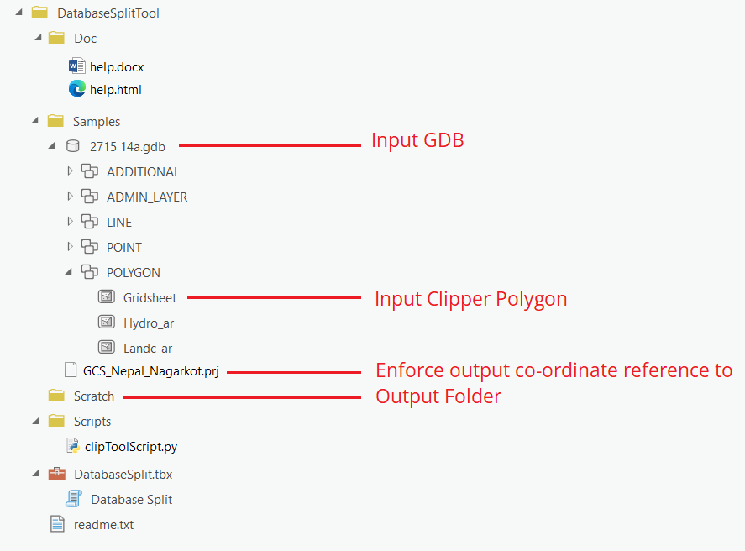

Figure 2: Folder and file organization with labels to tool input.

Step 1: Double click the tool ‘Database Split’ to open it. The following window will open.

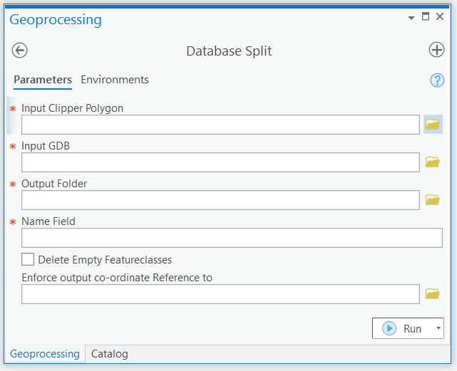

Figure 3: Tool interface asking input parameters.

Step 2: In each input field fill the files that correspond to the labels in figure 2.

The last parameter is optional.

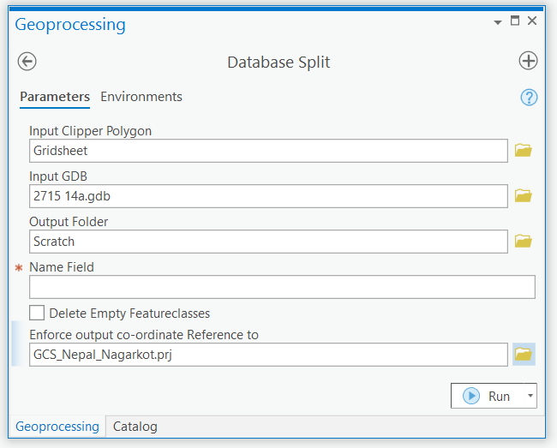

Figure 4: Tool inputs from the provided *Samples* folder

Step 3: Open attribute table of the *Gridsheet* polygon.

Note a string field that has unique values for each row. In this case, it is the field *SHEETNO*.

Step 4: Provide Name Field Parameter. Simply type SHEETNO in the box below Name Field.

If you want to delete any empty featureclasses from output geodatabases, check the

*Delete Empty Featureclasses* option.

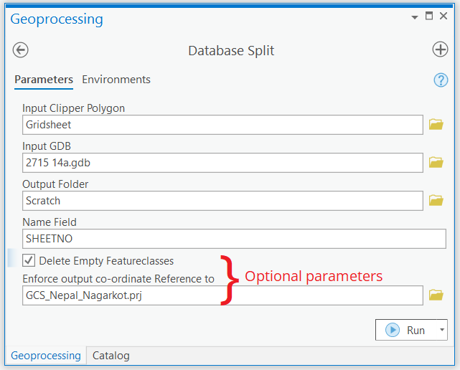

Figure 5: All inputs provided

Step 5: Click Run.

You can inspect the progress with Messages of the tool. For this click view details.

A new window will pop-up. Go to Messages tab.

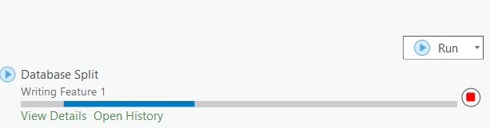

Figure 6: Tool execution status

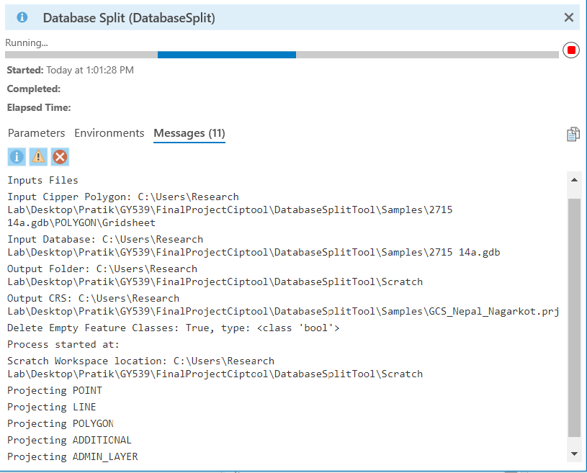

Figure 7: Tool messages

Step 6: After the tool runs successfully, please navigate to the *Scratch* folder.

Here a log of tool execution can be found.

Also, as it was provided as output folder, the output splited gdbs can be found here.

Here you will also see a *scratch.gdb.* It was created by projecting the input gdb to user defined crs. If a .prj file is not provided, scratch.gdb is not created.

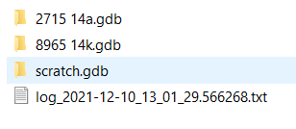

Figure 8: Output after tool execution completes

Step 7: The tool execution succeeded. Now close the ArcGIS pro.

Delete the *scratch.gdb* before running this tool with different data.