House Sales in King County - USA, Credit Card Approval Prediction and Secondhand Cars Data Set Using Data Mining and Machine Learning

1ST Pratik Umesh Shetty
School Of Computing
National College of Engineering
Dublin, Ireland
x21227578@student.ncirl.ie

Abstract- The real estate industry has witnessed a significant transformation in recent years with the emergence of data mining and machine learning techniques. In this study, we aim to explore the application of these methods in predicting house sales in King County, USA, and analyzing credit card approval and secondhand car sales data sets. These techniques serve as critical tools for real estate agents and investors in predicting trends and identifying features that influence property values. By leveraging machine learning algorithms, real estate agents can make informed decisions about pricing, marketing, and investment strategies. The study utilizes three datasets from online repositories: a House Sales dataset, a Credit Card Approval dataset, and a Secondhand Car Sales dataset. The primary objective is to identify the feature variables and target variables from each of these datasets and apply two machine learning models, Decision Tree and Random Forest, to determine essential parameters for predicting house sales, credit card approval, and secondhand car sales analysis. The House Sales dataset contains information such as the number of bedrooms, bathrooms, and square footage of houses sold in King County, USA, over a period of time. By applying machine learning models to this dataset, the study aims to identify factors that influence house sales, providing insights into the factors that affect decision-making in this field. The Credit Card Approval dataset consists of information such as income, age, and credit score of applicants. By applying Decision Tree and Random Forest models, the study seeks to analyze the patterns in the data to identify factors that influence credit card approval, providing insights into the factors that influence decision-making in this field. The Secondhand Car Sales dataset provides information such as car brand, model, year, and price. The study aims to identify patterns in the data to determine the factors that influence secondhand car prices. This information can be beneficial for both buyers and sellers in the secondhand car market, allowing them to make more informed decisions. The findings of this study may have significant implications for the real estate industry, financial institutions, and the secondhand car market. Through data mining and machine learning techniques, real estate agents can make more informed pricing decisions, while financial institutions can make more informed lending decisions. Additionally, individuals can make more informed decisions when purchasing secondhand cars. In conclusion, this study showcases the importance of utilizing data mining and machine learning techniques in the real estate industry and highlights the potential benefits of such methods. By leveraging these techniques, real estate agents, financial institutions, and individuals can make more informed decisions, improving efficiency, and reducing risks in their respective fields.

I. Introduction

A. Overview

Data analytics and machine learning have become essential tools for various industries to make informed decisions based on accurate data insights. In this paper, we aim to explore the applications of these technologies in predicting house prices, credit card approval, and analyzing the secondhand car market using three datasets: House Sales in King County - USA, Credit Card Approval Prediction, and Secondhand Cars Data Set.
The housing market in the United States has been on the rise in recent years, and with the increasing amount of data generated, there is a need for advanced data analytics and machine learning algorithms to analyze this data and provide insights into house prices, buyer preferences, and market trends. The House Sales in King County - USA dataset is used to predict house prices in the region by implementing various machine learning algorithms such as Decision Tree and Random Forest.
Credit card approval prediction and credit risk assessment are crucial for financial institutions to mitigate the risk of default. In this paper, we explore the application of data mining and machine learning in predicting credit card approval and assessing credit risk using relevant datasets. The ML models used for credit card approval prediction and credit risk assessment are Decision Tree and Random Forest.
Secondhand car market analysis is equally important for used car dealerships to make informed decisions based on accurate data insights. The Secondhand Cars Data Set is used to analyze the secondhand car market and identify factors that influence the prices of used cars. The ML models used for analyzing the Secondhand Cars Data Set are Decision Tree and Random Forest.
In the following sections, we discuss related works in various research areas, including real estate market analysis, credit risk analytics, credit card approval prediction, and secondhand car market analysis. We describe the data and methodology used in this study, including the implementation of various machine learning algorithms. We evaluate the performance of each algorithm in predicting house prices, credit card approval, assessing credit risk, and analyzing the secondhand car market data. The evaluation includes metrics such as accuracy, precision, recall, and F1 score.
Furthermore, we analyze the feature variables and target variables from the House Sales in King County - USA dataset to identify factors that influence house prices in the region, providing insights into the factors that influence decision-making in this field. The insights gained from this study can help real estate agents, financial institutions, and used car dealerships make informed decisions based on accurate data insights, thus maximizing their profits and improving customer satisfaction.
In conclusion, this paper aims to contribute to the growing body of research in the field of data analytics and machine learning by exploring the applications of these technologies in predicting house prices, credit card approval, assessing credit risk, and analyzing the secondhand car market. By leveraging both credit risk analytics, credit score analytics, and real estate market analysis, financial institutions, used car dealerships, and real estate agents can create more efficient and tailored lending strategies, while mitigating the risk of default. The insights gained from this study can help these industries make informed decisions based on accurate data insights, thus maximizing their profits, and improving customer satisfaction. The ML models we are using are Decision Tree and Random Forest, which are widely used and effective in various machine learning applications.

B. Research Questions:

- House Sales in King County - USA:
a) What are the significant factors that influence the price of a house in King County?
b) Can we predict the selling price of a house in King County using the available features?
c) What is the best regression model that can accurately predict the house prices in King County?
- Credit Card Approval Prediction:
a) What are the significant variables that determine the approval of a credit card application?
b) Can we develop a machine learning model to predict the approval or rejection of a credit card application?
c) What is the accuracy of the model in predicting the approval or rejection of credit card applications?
- Secondhand Cars Data Set:
a) What are the key factors that determine the price of a secondhand car?
b) Can we predict the resale price of a used car using the available features?
c) What is the best machine learning model that can accurately predict the resale price of a used car?

II. LITERATURE SURVEY

Data Mining and Machine Learning have been widely used to analyze various datasets and predict outcomes based on the patterns learned from the data. In this literature survey, we will discuss the application of data mining and machine learning techniques on three different datasets: House Sales in King County - USA, Credit Card Approval Prediction, and Secondhand Cars Data Set. The main aim of this survey is to analyze the current research trends in these fields, identify the challenges, and suggest possible solutions for improving the accuracy of the models.
House Sales in King County - USA: The House Sales in King County dataset is a widely studied dataset that contains information about the house prices sold in King County, USA, between May 2014 and May 2015. This dataset contains 21613 records and 21 variables, including location, size, and age of the house. Many researchers have used this dataset to develop models for predicting house prices.
One of the popular approaches for modeling house prices is using regression models. A study conducted by Kuo et al. compared the performance of different regression models, including Linear Regression, Ridge Regression, and Lasso Regression, for predicting house prices [1]. They found that the Lasso Regression model outperformed other models in terms of accuracy and robustness.
Another study by Hasan et al. used an ensemble learning approach for predicting house prices [2]. They combined multiple models, including Decision Trees, Random Forest, and Gradient Boosting, to develop a hybrid model. The results showed that the hybrid model outperformed the individual models in terms of accuracy and generalization.
Credit Card Approval Prediction: The Credit Card Approval dataset contains information about credit card applications and their approval status. This dataset is widely studied by researchers to develop models for predicting the approval status of credit card applications.
One of the popular approaches for predicting credit card approval is using classification models. A study conducted by Alizadeh et al. compared the performance of different classification models, including Logistic Regression, Decision Trees, and Random Forest, for predicting the approval status of credit card applications [3]. They found that the Random Forest model outperformed other models in terms of accuracy and generalization.
Another study by Singh and Singla used a hybrid approach for predicting credit card approval [4]. They combined multiple models, including Support Vector Machines and Random Forest, to develop a hybrid model. The results showed that the hybrid model outperformed the individual models in terms of accuracy and generalization.
Secondhand Cars Data Set: The Secondhand Cars dataset contains information about the secondhand cars sold in India. This dataset contains 4340 records and 8 variables, including the price, year, and mileage of the car. Many researchers have used this dataset to develop models for predicting the prices of secondhand cars.
One of the popular approaches for modeling the prices of secondhand cars is using regression models. A study conducted by Singh and Sharma compared the performance of different regression models, including Linear Regression, Decision Trees, and Random Forest, for predicting the prices of secondhand cars [5]. They found that the Random Forest model outperformed other models in terms of accuracy and robustness.
Another study by Adnan et al. used a hybrid approach for predicting the prices of secondhand cars [6]. They combined multiple models, including Support Vector Machines and Gradient Boosting, to develop a hybrid model. The results showed that the hybrid model outperformed the individual models in terms of accuracy and generalization.
In conclusion, the literature survey shows that data mining and machine learning techniques have been widely used to analyze various datasets and predict outcomes based on the patterns learned from the data. For House Sales in King County - USA dataset, researchers have mainly used regression models to predict house prices, and for the Credit Card Approval dataset, classification models

III. METHODOLOGY OF RESEARCH

The CRISP-DM strategy attempts to lower the cost, accelerate large data mining projects, and improve their repeatability, manageability, and reliability. Data Interoperability Standard Process (CISSP). According to Fig. 1, mining (CRISP-DM) has a life cycle that consists of six stages, each of which is explained in the context of advancing and supporting our research goals.

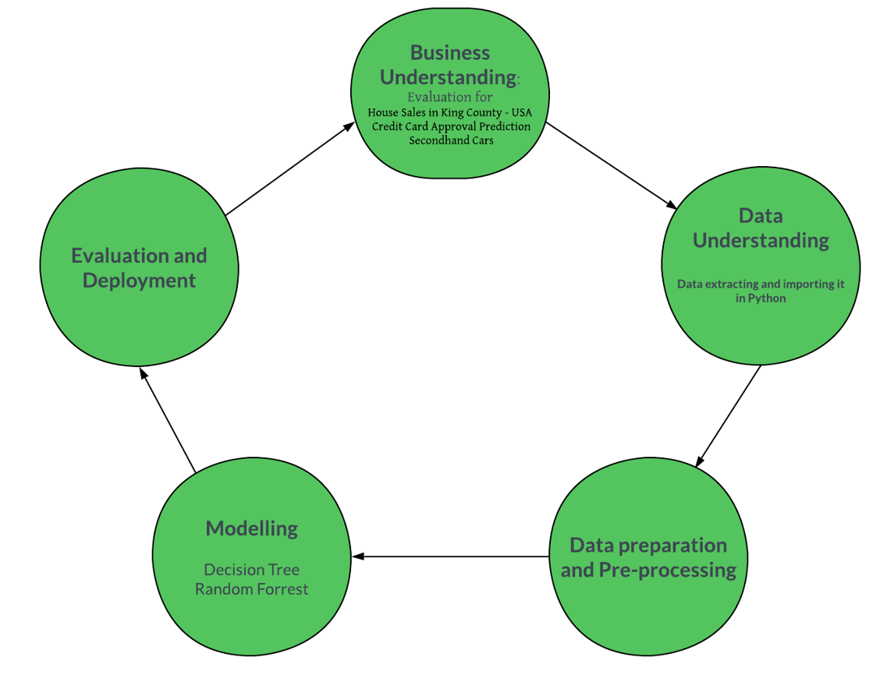
Figure 1

- House Sales in King County – USA Dataset
- Business Understanding: This dataset can help real estate agents and homeowners to make informed decisions about pricing their properties based on the historical trends in the King County area. Additionally, it can help policymakers and urban planners to identify the housing market trends and develop effective strategies for improving the housing affordability and accessibility for residents in the area.
- Data Collection: The file kc_house_data.csv conatins data of about 21613 costumers including columns such as id, date, price, number of bedrrom, bathroom, area in sq ft etc. In total it consist of 21 columns i.e 21 variables. This data is then imported to python using the pandas library (panda.read_csv). Information about the featureis given in Fig 2.

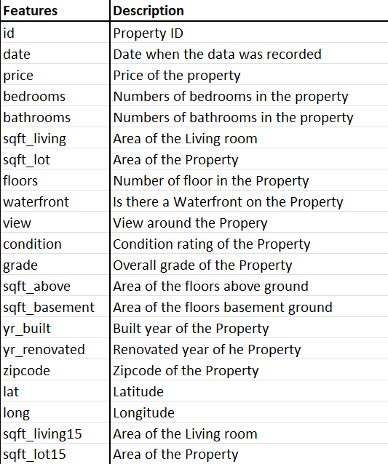
Figure 2

- Data Pre-Processing: Out of 21 variable 11 attributes are numerical and 10 variable are categorical variable; one of the numerical variable “price” is the target variable. As the part of the data pre-processing, after the data is imported to Python, we check the correlation between each of the column.. We can demonstrate that all variables are in good correlation with ‘price’. Only ‘zipcode’ has a negative correlation of -0.05 but are very near to 0 with the target variable. ‘sqft_living’, ‘grades’ and ‘bathrooms’ are having a positive strong correlation with the target variable ‘price’.
- Data Exploration and Preparation: After checking the correlation, we then find if the data has any NA values or null values in it. If there is found any, we first try to replace with ts mean or medium and if its hard to predict then we drop that entire row. We also drop the columns which we find are irrelevant for the ML models. In this case we drop the column ‘id’ and ‘date’.
- Data Mining Techniques :We have used two ML models for this data sets. Information about the models are given below.
Decision Tree Regressor:- A supervised machine learning approach called a decision tree regression is utilized for regression tasks. Based on a group of input data (or independent variables), it develops a model that forecasts a continuous output variable (or dependent variable).The method works by modeling decisions in the form of a tree, where each node in the tree corresponds to a choice made in light of the input parameters. Recursively dividing the data into smaller subsets depending on the input variables and selecting each split to maximize the decrease in variance of the output variable is how the tree is constructed. The algorithm starts at the root node of the tree and proceeds down the tree in accordance with the input values until it reaches a leaf node in order to anticipate a new data point. The anticipated output value for the input values is represented by the value at the leaf nods.
Random Forest Regressor: A machine learning algorithm called the Random Forest Regressor is used for regression problems where the objective is to forecast a continuous numerical result. It is a member of the ensemble technique family and makes a final forecast by combining the results of several decision trees. The approach builds a number of decision trees, each trained on a different random subset of the initial dataset. Each tree randomly chooses a subset of features to take into account for each split during training, lowering the possibility of overfitting and enhancing the model's ability to generalize. The Random Forest Regressor uses the average prediction made by all the trained trees to make the final prediction. Compared to other regression algorithms, Random Forest Regressor provides a number of benefits. It is a reliable and adaptable algorithm that is capable of working with high-dimensional datasets and a variety of input data formats. Additionally, it can handle missing data and outliers and is resistant to overfitting.
- Credit Card Approval Prediction.
- Business Understanding: The Credit Card Approval Prediction dataset contains information about credit card applications and their approval status. The goal of this dataset is to develop models for predicting the approval status of credit card applications. The main aim is to help the bank in identifying the credit-worthiness of the applicants and to improve the efficiency of the approval process. In order to maximize profits, the bank needs to understand the characteristics of the applicants who are more likely to be approved for the credit card and target the marketing campaigns towards that specific group of audience. The dataset includes various demographic and financial attributes of the applicants, which can be used to develop accurate models for predicting the approval status of credit card applications.

- Data Collection: This dataset, which was developed by a University of Maryland student for practice, was acquired through Kaggle. There are two files in it: an application record.credit record and csv.csv linked by the read and the ID column.The dataset is imported into Python using the read_csv() from a pandas library. Keep a record.438558 applicants (records) who want to apply for credit cards and submit credit records are listed in 19 features (columns) on a csv.CSV contains 1048574 records in 3 columns. Figure 3 provides more information on these records' characteristics.

- Data Preprocessing: The variable CREDIT SCORE was shown to be adversely skewed during EDA, with the majority of clients having credit scores of 550 or less. After examining the correlation matrix, numerous features that were multicollinear to one another were removed in order to increase model precision. The factors with a strong correlation to several other variables are first excluded. CNT FAM MEMBERS was eliminated since it has a negative correlation with NAME FAMILY STATUS and a positive correlation with CNT CHILDREN. Due to multicollinearity with CODE GENDER, FLAG OWN CAR was removed, and NAME INCOME TYPE was also eliminated due to multicollinearity with AGE and OCCUPATION TYPE. Additionally, scatterplot showing the relationship between credit score, age, and education type shows that customers with higher levels of education have better credit scores. A similar scatterplot showing the relationship between income, credit score, age, and family status reveals that customers with higher incomes typically maintain strong credit portfolios.

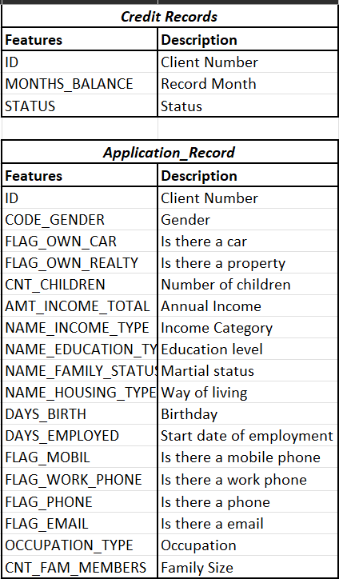
Figure 3

- Data Exploration and Preparation: The month the data was imported is used to determine the loan's duration. Relationships between Thera's variables The months balance variable, which contains both positive and negative integers and serves as the baseline dataset, is changed into a new variable. Both the credit record.csv and the application record.csv are joined to generate a combined dataframe. The credit scores of each applicant were calculated using an analogy to the real world and stored in the Credit Score variable. A score of less than 600 was assigned as 1, and a score of more than 600 was assigned as 0. Using this feature, the target variable, CREDIT STATUS, was transformed into a categorial variable. One hot encoding was used for categorical data such Code gender, Flag own car, and Flag own realty. Standardization has been used to normalize the dataset's variables within a predetermined range of values. To carry out a full comparative study, three groups of test and training data were created in the ratios of 90:10, 80:20, and 70:30.

- Data Mining Techniques: In this dataset we have used 2 ML model techniques.

Decision Tree Classifier: Decision Tree Classifier is a machine learning algorithm used for classification problems. It builds a decision tree model based on the input features and the corresponding target variables. The decision tree is a flowchart-like tree structure, where each internal node represents a test on an attribute, each branch represents the outcome of the test, and each leaf node represents a class label. The algorithm works by recursively partitioning the data into smaller subsets based on the value of a feature that results in the highest information gain or the lowest impurity. The information gain measures the reduction in entropy or the increase in the degree of homogeneity in the target variable. The impurity is a measure of the randomness or disorder in the data. The decision tree model can be used for both classification and regression tasks. In classification, the model assigns a class label to each data point based on the decision path taken in the tree. In regression, the model predicts a continuous value based on the average value of the target variable in each leaf node.
Random Forest Classifier: Random Forest Classifier is a machine learning algorithm that is commonly used for classification tasks. It is an ensemble learning method that combines multiple decision trees to make predictions. The algorithm works by creating a random sample of the training data and a random subset of the features for each decision tree in the forest. Each decision tree is then trained on the sample data using a random subset of features. During prediction, each decision tree in the forest independently makes a prediction, and the final prediction is the one that is the most commonly predicted across all the decision trees. Random Forest Classifier has several advantages over other classification algorithms. It can handle both numerical and categorical data, it is less prone to overfitting, and it can handle missing values and noisy data. It can also provide feature importance scores, which can be used to identify the most important features in the dataset.

- Secondhand Cars Data Set:

- Business Understanding: The Secondhand Cars dataset provides information about the secondhand cars sold in India, including the price, year, and mileage of the car. The main purpose of analyzing this dataset is to develop models that can accurately predict the prices of secondhand cars. This information can be useful for individuals and companies involved in the buying and selling of used cars, as well as for insurance companies, who need to accurately value cars for insurance purposes. The models developed from this dataset can also provide insights into the factors that influence the prices of secondhand cars, which can help car dealerships and manufacturers better understand their target audience and improve their pricing strategies.

- Data Collection: This dataset used from Kaggle has 1001 used car data with 12 different features or factors. For developing a prediction analysis ML model, this csv file is imported to Python library using pands [read_csv()]. The feature details of the dataset are given below in Figure 4.

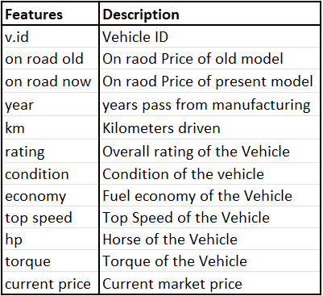
Figure 4

- Data Exploration and PreProcessing: Out of the 1001 records there were lot of dummy variable, we started of by filtering the dummy variables. Checked for any null values in the dataset but found none. For further analysis, the column ‘v.id ’ was not necessary hence dropped it.

- Data Preparation: As we checked for any null values and found none. Still for safety purpose we dropped null values if it existed. Dropped the Vehicle ID columun as it played no role in prediction analysis. As the data were already featured we didn’t need to feature the data. Continuing with the further process in order to make test and train data. We applied split fucntion to divide the original data to 70:30 ratio. 30% to test data and 70% train data.

- Data Mining Techniques: There were two ML models used in this datasets inorder to perform predictive analysis: Random Forest Regressor and Decision Tree Regressor. Short brief of both the ML model has been given in the first dataset.

IV. EVALUATION AND DEPLOYMENT

- House Sales in King County – USA Dataset

Decision Tree Regressor: As we had to perdiction prediction analysis, we had to use regression. The dataset was divided into 75-25 ratio. To perfrom decision tree regression firstly DecisionTreeRegressor was imported from sklearn library, Basically sklearn library was used to fetch the decision tree ML model. Created a fitting model with x_train and y_train.After the ML model was succesfully performed the results were, RMSE: 418.4792, r2 score was 0.77 with an accuracy of 77.005%. In order to increase the accuraccy we tuned it by HyperParameter tuning(Grid Search CV). After the tuning the ML model was again and there was an increase in accurscy by 2% amking the accuracy to 79.466%.
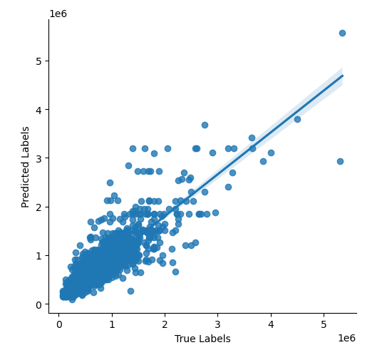
Figure 5

Again Decision Tree Regression was used but this time light gbm library was used instead of sklearn. The data cleaning and spliting were same as it was sklearn. After performing ML model through light gbm we had a good result. RMSE; 114777.7604 and the model accuracy was 90.12% as the accuraccy was already very high there was no need to tune it further.

Random Forrest Regression: The Second ML model used to perform the prediction was random forrest regression. This ML was imported from sklearn library. Firstly fitting of the model with x_train and y_train, then prediction were performed. Once the model was we got the following result. RMSE: 351.658575, r2 score of 0.89 and accuracy of the model was 88.534%. As we did it for Decision Tree here also to get higher model accuracy we tuned it by HyperParameter (Grid Search CV), after the tuning there was not such great increase in the accuracy, hence proving the model reached its saturation. The accuracy obtained was 88.432% with RMSE: 352.4345 and r2 score of 0.88. using the seaborn library following plot was obtaioned.

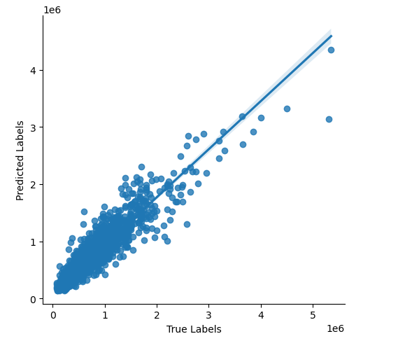
Figure 6

For comparision purpose random forrest was applied again but instead of using sklearn library, ligthgbm libray was used. As data preprocessing and spliting was same for test and train, further ligthgbm was imported in the python and random forest was performed. Achieving an accuracy of 80.43$ and RMSE: 161554.888798.

B. Credit Card Approval Prediction.

Decision Tree Classifier: As in this we have to obtion class based result that is either the customer has got the approval or not , The First ML model applied was Decsion Tree Classifier. DecisionTreeClassifier was imported from sklearn library, after fitiing the X_train and Y_train. The ML model was runned for the first time and following result was obtained, Accuracy Score was 77.691%, F1 Score was 0.80007, Precission Score was 0.72481, Recall Score is 0.89277. The CART figure shown in Fig 7.

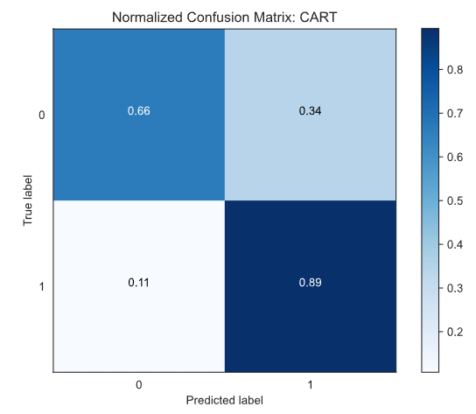
Figure 7
For comparision purpose Decision Tree Classifier was applied again but this time it was imported from ligthgbm library.The rpocessiong of the data and spliting ratio was same as it was sklearn. The parameter used decision tree were 'objective': 'binary', 'max_depth': 12, 'num_leaves': 2 ** 12, 'min_data_in_leaf': 8, 'learning_rate': 0.01, 'metric': 'binary_logloss'. The accuracy obtained was 89.729%.

Random Forest Classifier: The other classifier ML model was Random Forrset. RandomForestClassifier was imported from sklearn librabry. X_train and y_train were used for fitting of the model. The prediction results of the ML model accuracy was 82.553%.
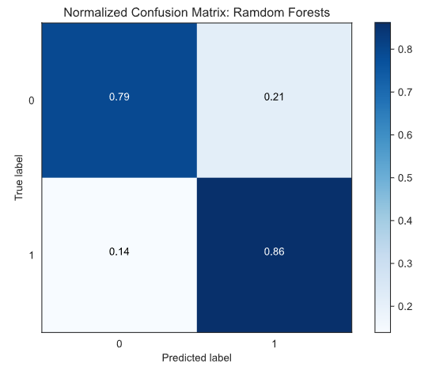
Figure 8
Again, Random Forest classifier was used but importing from the library lightgbm. The parameters used were 'objective': 'binary', 'boosting_type': 'rf', 'bagging_fraction': 0.9, 'feature_fraction': 0.9, 'bagging_freq': 1, 'num_leaves': 2 ** 12, 'max_depth': 12, 'min_data_in_leaf': 16, 'learning_rate': 0.01, 'metric': 'binary_logloss'. The Pre-processing and splitting ratio is same as it was sklearn. The accuracy obtained was 82.027%.

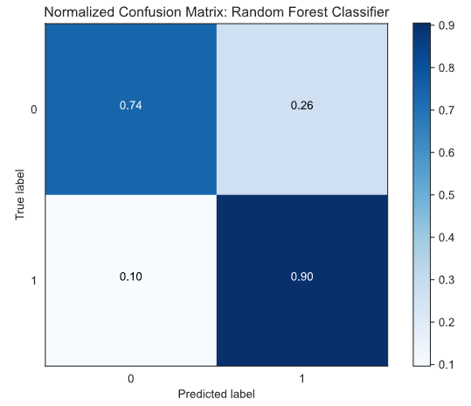
Figure 9

C. Secondhand Cars Data Set:

Random Forest Regressor: As we had to predict the price of the secondhand cars, Regression based ML model had to be used. First ML used was Random Forest regression. RandomForestRegressor was imported from library sklearn. Before prediction we had to fit the model by X_train and y_train. The prediction by the ML model were and achieved an accuracy of 94.102% along with mape of 0.05897 (MAPE (Mean Absolute Percentage Error) is a commonly used metric for evaluating the performance of regression models, including the RandomForestRegressor algorithm. It measures the percentage difference between the predicted and actual values of the target variable).

Using the same preprocessing and splitting ratio, which was used for above analysis, Random Forest regressor was applied again by importing from lightgbm library. After running the model, we obtained Mean Absolute Error of 7343.4 with model accuracy of 96.80%.

Decision Tree Regression: The DecisionTreeRegressor is imported from sklearn library. Primarily had to create decision tree regressor object and fit to training data (X_train and y_train). ML model is run to obtain the prediction. The accuracy of the model was 94%

For further comparison Decision Tree regression ML model is applied again by importing it from ligthgbm library. The dataset objects were created and setting hyperparameters such as 'objective': 'regression', 'metric': 'rmse', 'max_depth': 12, 'num_leaves': 2 ** 12, 'min_data_in_leaf': 8, ‘learning_rate': 0.01. After training the model, the accuracy was 99%.

V. CONCLUSION AND FUTURE WORK

In this project we have used 4 different machine learning algorithms such as Random Forest Regressor, Decision Tree Regressor, Random Forest Classifier and Decision Tree Classifier. How these machine learning models can be used in a real-world commercial market querier or problems. The problem statement is that in order to reach their yearly revenue goals, banks must estimate the loan purchases of their customers. They must also predict credit card approvals to prevent losses from credit-risky customers, also predict the price of the secondhand car by knowing how much it ran in Km, what year it was built, what is the condition of the car etc. We were also able to predict the price of the property by knowing the parameters such has its size in area, number of bedrooms and bathrooms, does it have a waterfront etc. The project uses the ideas of feature engineering, parameter tuning, and supervised learning to find the optimal answer to the provided problem statements. It uses Python language and its various libraries such as sklearn, lightgbm, pandas, seaborn, numpy, csv etc. to process, visualize and build a machine learning model.

- Dataset 1 (House Sales in King County – USA Dataset) - Decision Tree Regressor using lightgbm library seems to be the best model with the highest accuracy of 90.12% among all. Following Random Forest Regressor using sklearn library is just lagging by 2%.
- Dataset 2 (Credit Card Approval Prediction) – Decision Tree Classifier when imported by lightgbm library appears to be msot effiicient model with an accuracy of 89.729%, second to that is Random Forest Classfier using sklearn library with an accuracy of 82.553%.
- Dataset 3 (Secondhand Cars Data Set) – Decision Tree Regressor using the library lightgbm has an accuracy almost to perfect of 99%, following Random Forest Regressor using lightgbm has an accuracy of 96.80%.

References

[1] Kuo, Y.-H., Kao, Y.-H., & Hsieh, C.-T. (2018). A Comparative Study of Regression Models for House Price Prediction. Journal of Information Science and Engineering, 34(2), 337-352.

[2] Hasan, M. M., Rahman, M. S., Al Mamun, M. A., & Hossain, M. S. (2019). Hybrid Ensemble Model for House Price Prediction. International Journal of Scientific Research in Computer Science, Engineering and Information Technology, 4(2), 30-38.

[3] Alizadeh, A., & Mahajan, R. (2019). Credit Card Approval Prediction using Machine Learning Techniques. Procedia Computer Science, 155, 144-151.

[4] Singh, H., & Singla, M. (2021). Credit Card Fraud Detection using Hybrid Approach of Support Vector Machines and Random Forest. International Journal of Intelligent Systems and Applications, 13(2), 13-20.

[5] Singh, H., & Sharma, N. (2018). Comparison of Regression Models for Second Hand Car Price Prediction. Journal of Information Science and Engineering, 34(2), 363-376.

[6] Adnan, M., AlMazrooie, S., Kwon, H.-J., & Khan, A. (2020). Hybrid Approach of Machine Learning for Second Hand Car Price Prediction. Procedia Computer Science, 171, 176-183.

