**Module 3 Assignment: Combinational Circuits**

Hi Student,

We have discussed combinational circuit design in this module. Let us apply the knowledge gained in this module and design a simple combinational system that converts thermometer code to binary code. A thermometer code is a special binary code in which the values are 1s on the LSB side and 0s on the MSB side. The number of 1s increase like the mercury level in a thermometer. If there are 7 bits, then 8 different codes can be generated. For example, 0000000, 0000001, 0000011, 0000111, 0001111, 0011111, 0111111, and 1111111. We have to convert these codes into binary numbers.

Problem Statement

The block diagram for a Thermometer to binary converter is given below. First, design a full adder using any coding style and then use 4 different full adders to design the complete system using the module instantiation technique.

Write a Verilog code that will have 7-bit input and 3-bit output. Check the simulation test cases for all input cases.

Approach:

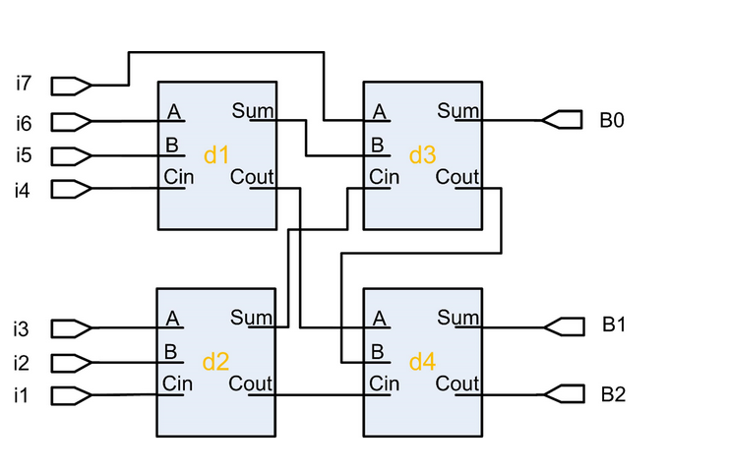

The Verilog code for Full adder is

module FA_data(

input a,

input b,

input c,

output s,

output cout

);

assign s = a ^ b ^ c;

assign cout = (a&b)|(a&c)|(b&c);

endmodule

The code for the thermometer to binary code converter is

module Thermo_binary(

input [6:0] i,

output [2:0] b

);

wire s1, s2, s3, s4, s5;

FA_data d1(i[5], i[4], i[3], s1, s2);

FA_data d2(i[2], i[1], i[0], s3, s4);

FA_data d3(i[6], s1, s3, b[0], s5);

FA_data d4(s5, s2, s4, b[1], b[2]);

endmodule

Simulation waveforms

Set the input as binary numbers, 0000000, 0000001, 0000011, 0000111, 0001111, 0011111, 0111111, and 1111111 one by one and check if you get the accurate outputs for each case.

Evaluation:

Self-evaluate the assignment. You should be able to write the Verilog code with module instantiation technique and generate the simulation waveforms.