**Introduction:**

In modern web development, the choice of rendering patterns is a critical decision that significantly influences the performance, user experience, and maintainability of web applications. This report delves into various rendering patterns, such as Static Websites, Single Page Applications (SPAs), Server Side Rendering (SSR), Static Site Generation (SSG), Incremental Static Regeneration (ISR), Islands, and Streaming SSR. Each pattern has distinct characteristics, benefits, and trade-offs, making them suitable for different use cases.

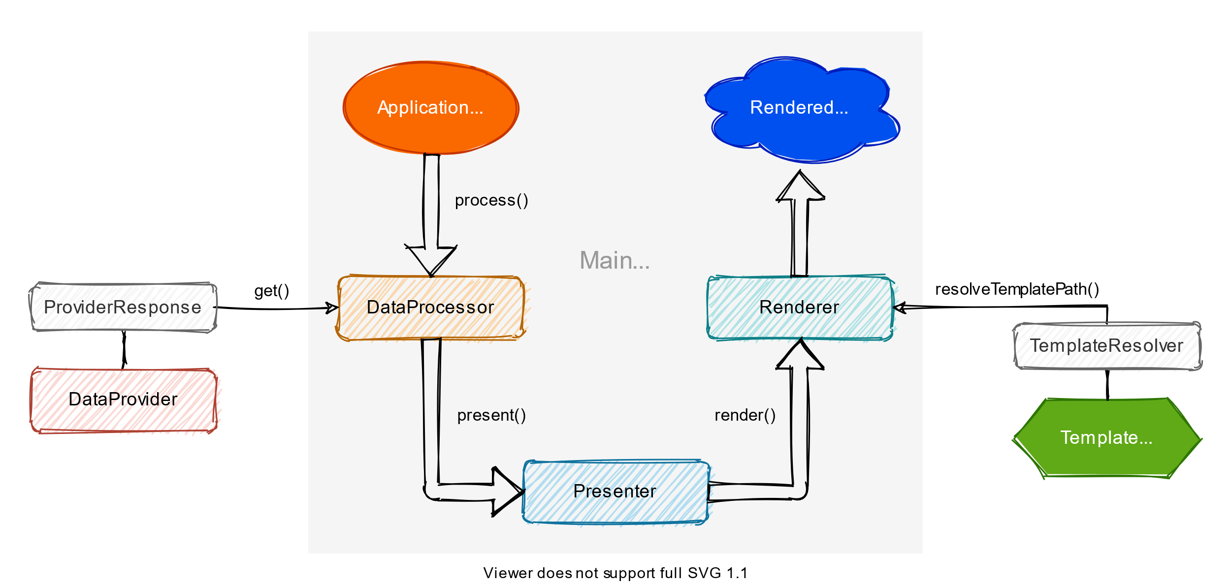

**Overview of Rendering Patterns:**

Static Websites:

* Characteristics: Pre-built static files served directly to the client.
* Pros: Exceptional speed, simplicity, and security.
* Cons: Limited interactivity, suitable for content-centric sites.
* Best for: Small to medium-sized websites with minimal dynamic content.

Single Page Applications (SPAs):

* Characteristics: Dynamically renders content client-side through JavaScript.
* Pros: High interactivity, suitable for complex, data-driven applications.
* Cons: Slower initial load times, SEO challenges.
* Best for: Applications with frequent content updates and rich interactivity.

Server Side Rendering (SSR):

* Characteristics: Server generates complete HTML sent to the client.
* Pros: Improved SEO, better initial performance, accessibility.
* Cons: Higher server load, reduced interactivity.
* Best for: Applications with frequently changing content.

Static Site Generation (SSG):

* Characteristics: Pre-built static files generated at build time.
* Pros: Fast loading times, improved security, scalability.
* Cons: Limited dynamic content, additional client-side JS for interactivity.
* Best for: Content-centric sites with limited interactivity.

Incremental Static Regeneration (ISR):

* Characteristics: Hybrid approach with periodic or on-demand content regeneration.
* Pros: Fast initial load times, dynamic content with static benefits.
* Cons: Limited dynamic content, complex caching requirements.
* Situations: Content that changes frequently with some latency tolerance.

Islands:

* Characteristics: Parts rendered on the server, others on the client-side.
* Pros: Faster initial load, suitable for mixed rendering approaches.
* Cons: Setup complexity, potential content inconsistencies.
* Best for: Applications with dynamic content requiring both server and client rendering.

Streaming SSR:

* Characteristics: Server sends HTML in chunks for progressive rendering.
* Pros: Improved time-to-content, better user experience.
* Cons: Complex setup, potential ordering challenges.
* Best for: Large pages or media requiring a smooth user experience

**Recommendations and Considerations:**

1. For content-centric sites with minimal interactivity, Static Websites offer unparalleled speed and simplicity.
2. For dynamic applications with frequent content updates, Single Page Applications (SPAs) provide high interactivity despite slower initial load times.
3. To enhance SEO and initial performance, especially for content-rich applications, Server Side Rendering (SSR) is a valuable choice.
4. If interactivity is essential but with limited dynamic content, Static Site Generation (SSG) is efficient, ensuring fast loading times.
5. For applications with a mix of dynamic and static content, Incremental Static Regeneration (ISR) strikes a balance, allowing dynamic updates with static benefits.
6. The Islands pattern is suitable for applications needing a combination of server and client-side rendering for specific components.
7. For large pages or media requiring a smooth user experience, Streaming SSR provides progressive rendering, improving time-to-content.

**Conclusion:**

Choosing the right rendering pattern is crucial in achieving the desired balance between performance, interactivity, and maintainability. Each pattern has its strengths and weaknesses, making it essential to align the choice with the specific needs and characteristics of the web application. As technology evolves, developers must stay informed about these rendering patterns to make informed decisions for optimal web development.