# PRATIKOSTWAL

Full Stack Developer/Web Developer/Web Designer

Sr. No-58/7, Gokul Nagar, Katraj, ---------------Pune(411046).

 pratikostwa1985@gmail.com

8796889625

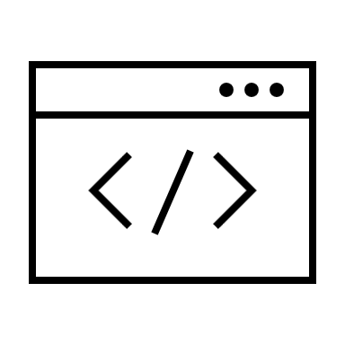www. .com

# PROFILE

An experienced and motivated MERN Stack Developer with 3+ years of experience in developing web applications that are both user-friendly and secure. Skilled in developing efficient and effective applications using MongoDB, Express, Reactjs, and Nodejs. Ability to work in an Agile environment. Designed and developed REST fulweb services. Developed and maintained.

# SKILLS

|  |  |
| --- | --- |
| * HTML5 * CSS3 * BOOTSTRAP * JAVASCRIPT * REACTJS * REACTNATIVE * NODEJS * EXPRESSJS * MOGODB * FIREBASE |  |
|  |  |

## EDUCATION

Bachelor of Computer Applications (BCA)

vishwakarma institute of Information technology (VIlT), Pune University

2018 - 2021

Higher Secondary School

Certificate (HSC)

Vishwakarma College of Arts

Commerce and Science (VCACS)

2017 - 2018

Secondary School Certificate

(SSC)

Sahyadri national school

have a steady source of motivation that drives me to do my best.

## EXPERIENCE

**Software** **Engineer**

From 2022 | Aligned Automation

Working in this company dedicating the best responsibility, is the -----area that corresponds, delivering the best results for the ---------- company and improving productivity.

**Intern**

From 2021 to 2022 | Aligned Automation

Working in this company dedicating the best responsibility is the ----- area that corresponds, to delivering the best results for the ---------- company and improving productivity.

**WordPress** **Developer**

From 2021 to 2021 | Sands Tech solution

Working in this company dedicating the best responsibility is the area ----that corresponds, to delivering the best results for the company and ------improving productivity.

## LANGUAGES

 English Hindi --Marathi Marwadi

# INTERESTS

Music Travel

Read Fitness

PROJECTS

**Business Dashboard for Sales and Purchase Analysis**

• Developed a business dashboard to visualize sales and purchase data across different regions/country using React.js and HighCharts library.

• Implemented various charts to display data trends and insights, enhancing business decision-making.

• Tested APIs for fetch data from Database.

• Integrated continuous testing with Jest to ensure code quality and reliability.

• Collaborated with team members using Git for version control and efficient workflow management.

## CERTIFICATES

**ReactJs** (2022)

Completed a comprehensive course on React.js, convering the creation dynamic andinteractive components, state management and component lifecycle methods.

**VueJs** (2022)

Gained in-depth knowledge of Vue.js, focusing on building scalable and maintainable single-page applications, including Vue CLI, Vue Router, and Vuex management.

**TypeScript** (2021)

Learned TypeScript fundamentals, including type annotations, interfaces, and advancedtypes, to enhance JavaScript code quality and maintainability.

**JavaScript** (2021)

Completed a course on modern JavaScript, covering ES6+ features, asynchronous programming with promises and async/await, and functional programming concepts.