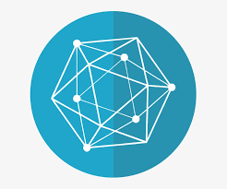

|  |  |
| --- | --- |
| Mohammad Jamshed Qureshi | mohammadjamshed.qureshi@georgebrown.ca |
| Shilpa Kaushik | shilpa.kaushik@georgebrown.ca |
| Pratik Patil | pratik.patil@georgebrown.ca |
| Andrew Starling | andrew.starling@georgebrown.ca |

Traceability in the Food Supply Chain

A Hyperledger Fabric Solution

# Project Business Case

Traceability is essential in the food supply system. In the current system, determining provenance of produce is a time-consuming task, with tracking done in separate databases, or via paper records in many cases.

When applied to the food sector, blockchain technology can be used to store information about a given product: where it comes from, and the methods used to produce it. All stakeholders along the food supply chain are enabled to generate and securely share data, creating an accountable and traceable system. Data collection at critical points provides a real-time record of a food item’s path, from farm to table. In the process, a blockchain solution’s transparency and immutability helps eliminate supply chain bottlenecks, helps forecast the shelf life of products moving through the supply chain, and determines precise origin of products in case of a recall. The provenance of a product can be established in seconds rather than days. In the case of the food supply chain, this quick turnaround results in considerable cost savings, but more importantly, can actually save lives.

Consumers want more transparency and assurances regarding the products that they purchase. Also, producers and retailers need to create relationships based on trust with consumers. The food blockchain meets these requirements. By scanning the QR code on a product's label, consumers can access product information on their smartphone in a web-based interface.

The blockchain enables supply chain transparency and provides access to data that was previously difficult or impossible to attain. It is a database which contains a record of all data exchanged between producers, processors and distributors since the network was created.

## CHALLENGES IN THE FOOD SUPPLY CHAIN

* Complex product path (ingredients can be combined to create new products).
* Food is a perishable commodity.
* Foodborne diseases threaten public health.
* Need to track and control inventories along every link in the chain, validating the authenticity of goods at each step, and preventing fraud.

## TRACEABILITY BENEFITS FOR BUSINESSES

* Supply chain time efficiencies.
* Cost savings.
* Product recalls and its financial impact. According to a 2011 Grocery Manufacturers Association report, most companies that go through a Class One recall, when the public health impact has the potential to be most severe, can expect a financial impact of $10 million or more. Nearly one in four companies report a financial impact in excess of $30 million for a single recall.
* Achieving product premiums.
* Reduction in insurance premiums. Blockchain solutions could also change the terms of insurance policies currently required in transactions and global shipping as well as how liability and indemnification are identified in supply chain management.
* Fraud reduction.
* Customer satisfaction – brand loyalty.

# Solution Design

## GOVERNANCE MODEL

* Consortium Blockchain.
* Accessible by multiple private permissioned organizations.
* Participants are pre-approved and permissioned, with known identities.
* Consensus is voting-based in an environment of partial trust. When a majority of nodes validates a transaction or block, consensus is reached and finality occurs. Because voting-based algorithms require nodes to transfer messages to each of the other nodes on the network, it takes longer to reach consensus the more nodes there are. This results in a trade-off between scalability and speed. In this particular food supply chain network, the number of nodes is limited and transaction speed would be improved.

## SYSTEM REQUIREMENTS

A food supply chain system design must satisfy the following requirements:

* Tracking and tracing of products through the supply chain. In this particular case we are tracking apples from a farmer/supplier’s apple orchard. The apples are packaged in boxes onto a palette. Each palette would have a unique identification code. (The tracking granularity is at the palette level for this project).
* The shipment of apples is received at a manufacturer where the apples are processed and made into apple sauce. Payment for the apples is made to the supplier. The apple sauce is put into jars which are then put in boxes. The boxes are placed on a palette. This palette would also have a unique identification code. The palette is shipped to a warehouse.
* The palette of apple sauce is unloaded at the warehouse. The ID is scanned to record the shipment received. This triggers payment for the shipment to the manufacturer. The goods would likely be taken from the palette and boxes placed on shelves.
* A palette of products is shipped to the retailer. This palette would most likely consist of different products in a real-world application, however for this project it is assumed that a palette consists of one product only. It is also assumed that only the owner of a palette can ship and receive the palette. The palette would have a unique identification number. Payment is made from the Retailer to the Warehouse.
* All stakeholders must have access to relevant data. Knowing the farm and batch identification would be useful in the event of a problem down the line. For example, if there is a health concern regarding the apples, the manufacturer would be able to pinpoint the problem. Similarly, if there is an issue with the batch of applesauce, the retailer would know which palette the jars of applesauce came from, and this identification would link backwards in the chain.

## DIAGRAM - SYSTEM OVERVIEW

## FARMER ONBOARDING REQUIREMENTS

Farmers must meet the following criteria as part of the onboarding process.

* Product is legal to sell.
* Food Safety Plan is in place.
* A water test showing a safe water supply for growing and washing harvested produce.
* Supplier has product liability insurance.
* Certification backing up any claims regarding the product (e.g., organic certification for organically grown produce).

## FUTURE CONTINGENCIES

The system in its current form is simplified. Finer granularity could be introduced to provide a more robust ecosystem. Future development may include the following:

* Recording the identification data according to GS1 Standards.
* IoT Sensors: Environmental conditions, humidity, temperature, shock – tracks data and generates alerts (bruised apples to make cider, good apples to make sauce, hash stored on chain)
* Other Inputs: Seed Purchasing, Fertilizer Purchasing, Financing/Banks
* Aggregation: Farmer Organizations/Coops, Small Traders
* Retailing: Traditional Markets, Supermarkets, Restaurants

# NETWORK ARCHITECTURE

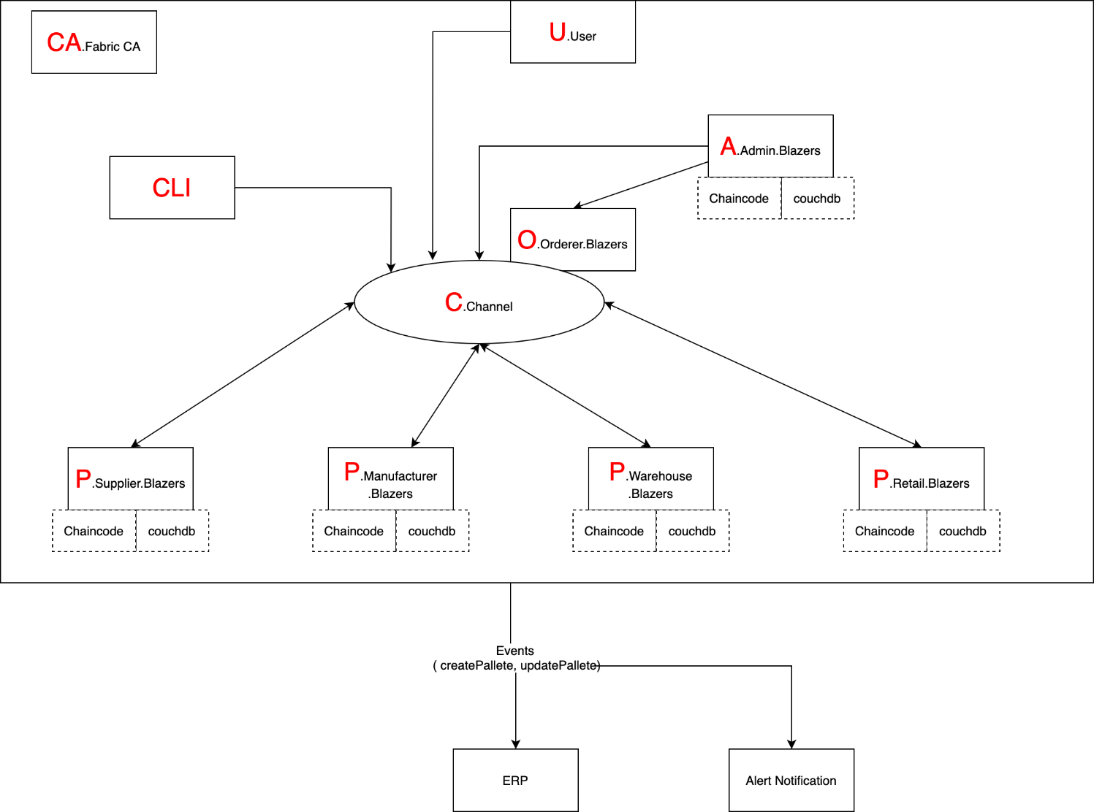

# CHAINCODE

This asset is created by a farmer/supplier to list the product.

Transactions:

* PalletContract.create
* PalletContract.purchase
* PalletContract.ship
* PalletContract.receive

# DATA DICTIONARY

|  |  |
| --- | --- |
| GROWER/SUPPLIER | |
| Field | Description |
| GTIN | Global Trade Item Number |
| LOT | Batch/Lot Number |
| DATETIME | Date and Time Stamp |
| GLN_FARM | Global Location Number (physical location of farm) |
| * Global Trade Item Numbers + Lot Numbers are used to identify raw produce. * Global Serial Shipping Container Codes are used for products distributed from the farms with batch/lot information.   Each physical location is identified with a Global Location Number. | |

|  |  |
| --- | --- |
| MANUFACTURER | |
| INPUT | |
| Field | Description |
| GTIN | Global Trade Item Number of Raw Materials |
| DATETIME_RECEIVED | Date and Time Shipment Received |
| GLN_FACTORY | Global Location Number of Factory |
| OUTPUT | |
| SSCC | Serial Shipping Container Code |
| DATETIME_PRODUCED | Date and Time Product Produced |
| DATETIME_PACKED | Date Product Packed |
| * Internal traceability is maintained in the key processes: receiving, transformation of raw materials to semi-finished or finished goods, storage and distribution. * GTINs and production data (batch/lot & expiry date) are printed on products to be despatched. * Links between goods received and despatch of final product are always maintained through the GTINs and batch/lot numbers. | |

|  |  |
| --- | --- |
| WAREHOUSE | |
| INPUT | |
| Field | Description |
| SSCC | Serial Shipping Container Code |
| GLN | Global Location Number of Warehouse |
| DATETIME_RECEIVED | Date and Time Received |
| OUTPUT | |
| SSCC | Serial Shipping Container Code |
| GLN | Global Location Number of Warehouse |
| DATETIME_SHIPPED | Date and Time Shipped |
| * Internal traceability is maintained in the processes of receiving, storage and distribution. * Global Trade Item Numbers + batch/lot or expiry date is used to assure accuracy of products when aggregated and disaggregated. These cases are linked and tracked with a pallet using the Serial Shipping Container Code. * Despatch Advice containing Global Trade Item Numbers, Serial Shipping Container Code and Global Location Numbers are sent to customers. | |

|  |  |
| --- | --- |
| RETAILER | |
| INPUT | |
| Field | Description |
| GTIN | Global Trade Item Number of Carton/Case |
| GLN | Global Location Number of Retail Store |
| DATETIME_RECEIVED | Date and Time Received |
| OUTPUT | |
| GTIN | Global Trade Item Number of Carton/Case |
| DATETIME_UNPACKED | Date and Time Unpacked and put on Shelves |
| DATETIME_SOLD | Date + Time Sold to Customer |
| * Retailers provide product information to their customers at Point of Sale. * Master data and event data (for traceability purposes) can be provided to consumers on product labels or through scanning of barcodes. | |

# INTERFACE

Input media provides information to the system. Examples of input devices in a food supply chain system include, data entry screens, optical character readers, and bar scanners. IoT oracles would also be used to ensure acceptable environmental conditions such as, humidity, temperature, shock – tracks data and generates alerts (bruised apples to make cider, good apples to make sauce, hash stored on chain).

# SYSTEM INTEGRITY

The Hyperledger Fabric network is a private permissioned blockchain where all stakeholders are required to register with membership services to obtain an identity, in order to access and initiate transactions on the network. During network setup, validators can determine the appropriate permission levels for various stakeholders.

The development of a food supply chain system entails the capturing and use of sensitive data. As a result, internal security is required to restrict access of critical data items to only those access types with permission, and verification processes must be in place for additions, deletions, or updates of critical data.

# References

Accenture Report: Tracing the Supply Chain

<https://www.accenture.com/ca-en/insights/blockchain/food-traceability>

Blockchain And Supply Chain: A Dynamic Duo

<https://blockgeeks.com/guides/blockchain-and-supply-chain/>

Case Study: How Walmart brought unprecedented transparency to the food supply chain with Hyperledger Fabric

<https://www.hyperledger.org/resources/publications/walmart-case-study>

Continuous interconnected supply chain: Using Blockchain and Internet-of-Things in supply chain traceability

<https://www2.deloitte.com/content/dam/Deloitte/lu/Documents/technology/lu-blockchain-internet-things-supply-chain-traceability.pdf>

GS1 Standards

<https://www.gs1.org/industries/foodservice>

IBM And Maersk

<https://www.youtube.com/watch?v=tdhpYQCWnCw>

IBM Food Trust. A new era for the world’s food supply.

<https://www.ibm.com/blockchain/solutions/food-trust>

Six Ways Blockchain is Being Used in Food and Agriculture Supply Chains

<https://medium.com/cultivati/six-ways-blockchain-is-being-used-in-food-and-agriculture-supply-chains-68a7305fd533>

# ApPENDIX

