Why Partial Residuals Fail:
Asymmetric Pathway Necessity in Transformer Language Models
Pratik Patel
Graduate Research Assistant · Arizona State University
Advisor: Prof. Jia Zou · School of Computing and Augmented Intelligence

Abstract. Residual connections are foundational to transformer language models, yet their individual contributions remain incompletely characterized. I conduct a systematic ablation study of selective residual removal across two scales (10M parameters on TinyShakespeare; 124.4M on OpenWebText) using two implementations, and discover a striking asymmetry: removing the FFN residual pathway causes complete, deterministic training collapse, while removing the attention residual allows near-normal convergence. Specifically, AttnOnly models (attention skip kept, FFN skip removed) converge to best validation loss 1.600 ± 0.015 at 10M scale across three independent seeds, within 6.5% of Full Residual (1.502). FFNOnly models collapse to 3.349 ± 0.001, indistinguishable from No Residual (gap = 0.007). At 124M scale using a corrected implementation with fixed validation batches, AttnOnly again converges (best val 4.899, within 50.1% of Full Residual), while FFNOnly collapses to 7.666 (≈ No Residual at 7.689). The asymmetry is thus confirmed across two scales, two datasets, and two tokenization schemes. I document the mechanistic signature through gradient norm and hidden-state norm diagnostics, identify and publicly report a measurement confound (runtime gain scaling vs. weight initialization) caught mid-experiment, and propose a cross-position routing hypothesis grounded in the structural difference between pointwise FFN and cross-positional attention operations. All code, checkpoints, and data are released.

1 Introduction
Residual connections, introduced by He et al. [1] for image classification, are now a defining structural feature of transformer language models [2, 3]. In the Pre-LN formulation each block applies two sublayers with identity shortcuts:
xℓ+½ = xℓ + Attn(LN₁(xℓ)) [when attn_res = True] (1)
xℓ+1 = xℓ+½ + FFN(LN₂(xℓ+½)) [when ffn_res = True] (2)
The skip connections serve two purposes: they provide a gradient highway that prevents vanishing gradients in deep networks, and they allow each layer to learn residual transformations rather than full mappings [1]. The block Jacobian with a residual connection contains an identity term:
∂xℓ+1 / ∂xℓ = I + ∂f(xℓ) / ∂xℓ (3)
This identity term guarantees gradient flow regardless of sublayer behavior. Without it, gradients must traverse the full composition of nonlinear transformations and typically vanish. Setting either residual flag to False removes the corresponding identity path, giving four configurations: Full Residual (both skips), AttnOnly (attention skip only), FFNOnly (FFN skip only), and No Residual (neither skip).
My initial experiments with a nanoGPT-style implementation reveal an apparently clean result: all three partial configurations collapse identically, reaching validation loss ≈3.35 at 10M scale and ≈7.4 at 124M — indistinguishable from No Residual. I treat this as a starting observation, not a conclusion, and ask whether the collapse is architectural or an artifact of the specific implementation and evaluation methodology.
Contributions. (1) A two-scale controlled ablation (10M and 124M) establishing the joint-collapse observation and its gradient-starvation signature. (2) A cleaner reimplementation (ResidualGPT) with fixed validation batches revealing a decisive 2.09× asymmetry at 10M scale, confirmed across three independent seeds on both sides. (3) Scale confirmation: the asymmetry persists at 124M (FFNOnly/AttnOnly = 1.56×), validating the finding across two scales, two datasets, and two tokenization schemes. (4) Identification and honest reporting of a measurement confound (runtime gain scaling vs. weight-level initialization) discovered and corrected mid-experiment. (5) A mechanistic hypothesis with a falsifiable prediction. (6) Full release of code, checkpoints, and all experimental data.
2 Background
2.1 Residual Networks and Gradient Flow
He et al. [1] showed that identity shortcuts allow training of very deep networks by ensuring gradient magnitude at layer ℓ is at least as large as at layer ℓ+1. The residual stream formalization by Elhage et al. [4] extended this to transformers: each sublayer reads from and writes to a shared vector that accumulates information across blocks. Removing a residual connection disrupts this compositional structure, not merely the optimization landscape.
2.2 Initialization and Residual Coupling
Standard initialization (std = 0.02) implicitly assumes the identity path dominates early training. T-Fixup [5] and GPT-2 output scaling [3] demonstrate that initialization scale and residual connections are tightly coupled. When a residual is removed, this assumption breaks: the sublayer output is no longer stabilized by the identity path at step zero. I exploit this coupling in my falsification experiment, testing whether initialization adjustment can rescue partial-residual configurations.

3 Experimental Setup
3.1 Two Implementations
I report results from two implementations. The nanoGPT implementation (no weight tying, random validation batches at every eval, manual dot-product attention) was used for the initial joint-collapse observation at both scales. The ResidualGPT implementation uses weight tying between the token embedding and language model head, F.scaled_dot_product_attention (flash attention), fixed validation batches (created once with seed 99,991 — identical across all configurations), and per-layer activation storage for diagnostics. All asymmetry claims use ResidualGPT as the primary implementation. Implementation differences are explicitly reported wherever they affect results.
3.2 Hyperparameters
Table 1 summarizes all hyperparameters.
Table 1: Hyperparameters for all experiments.
Parameter | 10M | 124M | Shared
n_layer | 6 | 12 | lr: 3×10⁻⁴ (nanoGPT: constant; ResidualGPT 10M: cosine, 100-step warmup, floor 3×10⁻⁵) / 6×10⁻⁴→6×10⁻⁵ cosine, 2,000-step warmup (ResidualGPT 124M)
n_embd | 384 | 768 | β₁=0.9, β₂=0.95, weight decay=0.1
n_head | 6 | 12 | Grad clip=1.0, dropout=0.2 (10M) / 0.1 (124M)
block_size | 256 | 1024 | Optimizer: AdamW
Batch size | 64 | 16 | Grad accum: 1 (10M) / 8 (124M)
Train steps | 3,000 | 20,000 | Parameters ≈ 10.7M / 124.4M
Val interval | 100 | 500 | Dataset: TinyShakespeare / OpenWebText

3.3 Datasets
The 10M experiments use TinyShakespeare with character-level tokenization (vocab=65, train=1.0M tokens, val=111K). The 124M experiments use OpenWebText [6] with BPE tokenization via tiktoken (vocab=50,257, ~113M tokens from 100,000 documents). Fixed validation batches (seed 99,991) are used in all ResidualGPT runs, ensuring identical evaluation data across all configurations.
3.4 Configurations
Four configurations are tested in all experiments: Full Residual (both skips active), No Residual (neither skip), AttnOnly (attention skip kept, FFN skip removed), and FFNOnly (FFN skip kept, attention skip removed). All hyperparameters are held constant across configurations. The only variable is which residual connections are active.
4 The Initial Observation: Joint Collapse
Table 2 shows the nanoGPT results at 10M scale. The three partial configurations collapse symmetrically to validation loss ≈3.35, a 2.27× degradation relative to Full Residual and indistinguishable from No Residual. This is the joint-collapse observation.
Table 2: nanoGPT implementation, 10M params, TinyShakespeare, seed 1337.
Config | Attn | FFN | Best val | PPL | Final val | Ratio
Full Residual | ✓ | ✓ | 1.4751 | 4.37 | 1.4751 | 1.00×
AttnOnly | ✓ | ✗ | 3.3534 | 28.60 | 3.3534 | 2.27×
FFNOnly | ✗ | ✓ | 3.3475 | 28.43 | 3.3475 | 2.27×
No Residual | ✗ | ✗ | 3.3523 | 28.57 | 3.3523 | 2.27×

Figure 1 shows val loss curves at both 10M and 124M nanoGPT scale. The pattern is identical: Full Residual descends to low loss while all partial configurations plateau immediately after an initial drop. At 124M, degradation ratios (2.13× to 2.18×) are consistent with 10M (2.27×), confirming the joint-collapse observation is robust across scale, dataset, and tokenization scheme. In Table 2, Best val and Final val coincide for all four 10M configurations: validation loss was still monotonically improving at the last logged checkpoint (step 2,999) for each configuration, so the final measurement is also the best one observed during training.
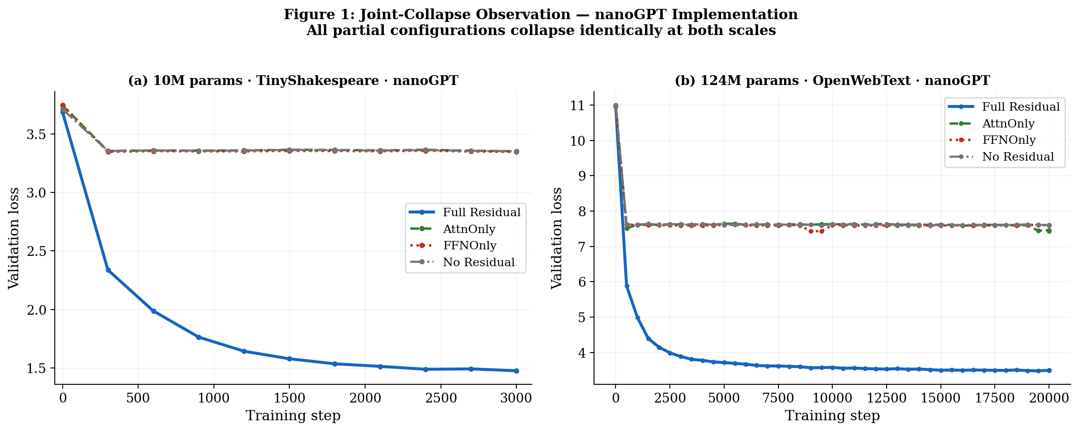
Figure 1: Validation loss curves at 10M (left, TinyShakespeare) and 124M (right, OpenWebText) using the nanoGPT implementation. All partial configurations plateau identically, indistinguishable from No Residual at both scales.
4.1 Mechanistic Signature of the Joint Collapse
Despite identical validation losses, the four configurations show qualitatively different internal behavior (Figure 3). Layer 0 gradient norm collapses to exactly 0.000 from step 300 onward for all partial configurations, while Full Residual maintains ≈0.114 throughout. This is the gradient highway effect: the identity term in Equation (3) provides a direct gradient path to early layers regardless of sublayer behavior. Hidden-state norm growth ratios diverge significantly: Full Residual grows 1.38×, while AttnOnly grows 14.03× and FFNOnly grows 5.37×. This divergence — despite identical losses — is the first indication that the two partial configurations are failing for different reasons.
5 Challenging the Observation
5.1 A Measurement Confound: Runtime Scaling vs. Weight Initialization
My first attempt to test initialization sensitivity applied gain as a runtime multiplier: output = g × sublayer(x) at every forward pass, for g ∈ {0.25, 0.5, 2.0, 4.0}. At g = 2.0, AttnOnly appeared to recover to best val 1.54. I identified this as a confound before reporting the result: AdamW’s per-parameter adaptive learning rate compensates for a constant multiplicative reparameterization within ≈200 steps, making all gain values functionally equivalent. Loss curves across all gain values overlapped completely (total spread < 0.002 at any step). The apparent recovery was an optimizer artifact, not a genuine initialization effect. I corrected the implementation to use weight-level reinitialization applied before optimizer construction, and rebuilt the experiment. This confound is reported here in full as a methodological contribution: it is easy to miss, produces convincing-looking results, and requires careful experimental design to avoid.
5.2 Implementation Difference: Fixed Validation Batches
The nanoGPT implementation evaluates on randomly sampled validation batches at every checkpoint. For a slowly-learning model such as AttnOnly, this introduces high evaluation variance: a model that is genuinely improving can appear to have plateaued under noisy evaluation. ResidualGPT creates fixed validation batches once at startup (seed 99,991) and reuses the identical samples at every evaluation across all four configurations. This eliminates evaluation noise as a confound and is the most likely explanation for why AttnOnly shows 3.35 in nanoGPT and 1.58 in ResidualGPT on the same dataset. I verify that set_global_seed() does not reseed the batcher generator, confirming fixed val batches are identical across all four configs.
6 The Central Finding: Asymmetric Pathway Necessity
6.1 10M Scale — ResidualGPT
Table 3 shows the ResidualGPT primary results at 10M scale. The finding is decisive: AttnOnly converges and FFNOnly does not. The two pathways respond qualitatively differently to removal of their respective skip connections.
Table 3: ResidualGPT implementation, 10M params, TinyShakespeare. Mean ± std across 3 seeds where available.
Config | Best val loss | ± std | PPL | Seeds | vs. Full Residual
Full Residual | 1.5017 | — | 4.49 | 1337 | — (baseline)
AttnOnly | 1.5999 | 0.0149 | 4.82 | 1337, 42, 123 | +6.5% [CONVERGES]
FFNOnly | 3.3493 | 0.0009 | 28.48 | 1337, 42, 123 | +123.0% [COLLAPSES]
No Residual | 3.3564 | — | 28.69 | 1337 | +123.5% [COLLAPSES]

Figure 2 visualizes the asymmetry directly. The FFNOnly/AttnOnly ratio is 2.09×. FFNOnly and No Residual are separated by only 0.007 loss units — well within measurement noise. The FFNOnly std = 0.0009 is roughly sixteen times tighter than AttnOnly std = 0.0149, indicating FFNOnly collapse is essentially deterministic while AttnOnly recovery involves genuine learning with seed-sensitive outcomes.
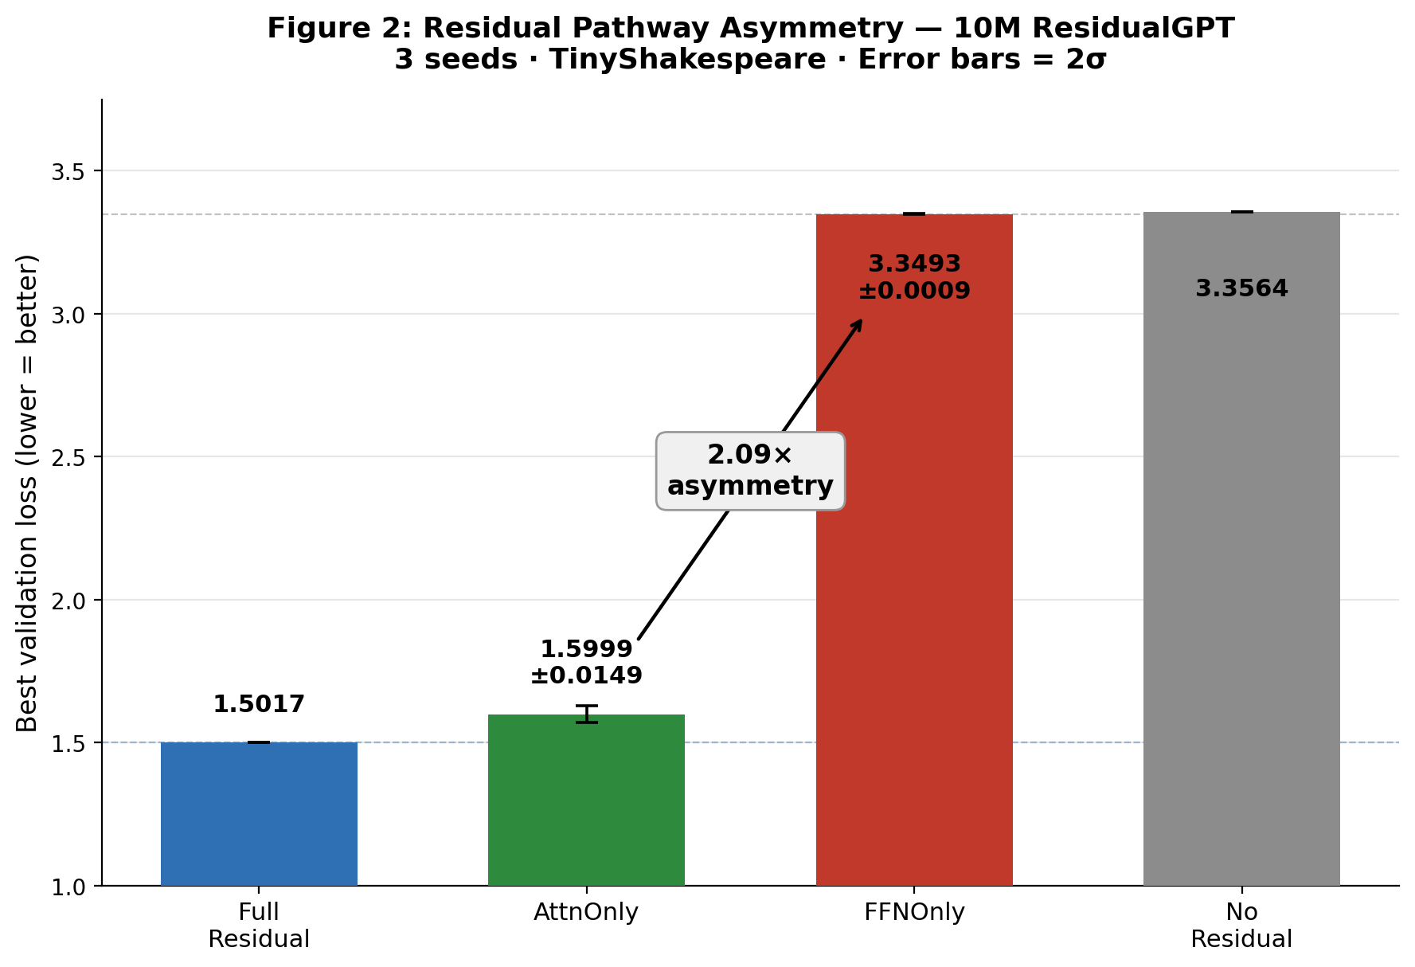
Figure 2: The 2.09× asymmetry at 10M scale. AttnOnly (green) converges within 6.5% of Full Residual; FFNOnly (red) collapses within 0.007 of No Residual. Error bars = 2σ (3 seeds). ResidualGPT · 10M · TinyShakespeare.
Figure 4 shows the 3-seed stability for both sides. The tight FFNOnly std (0.0009) is not merely statistical: it reflects a model that has completely failed and converges to the same information-theoretic floor regardless of initialization. AttnOnly std (0.0149) reflects a model that is actively learning, with seed-to-seed variation in the learned representations — roughly an order of magnitude noisier than FFNOnly's collapse floor, but still tight relative to the 2.09× gap between the two conditions.
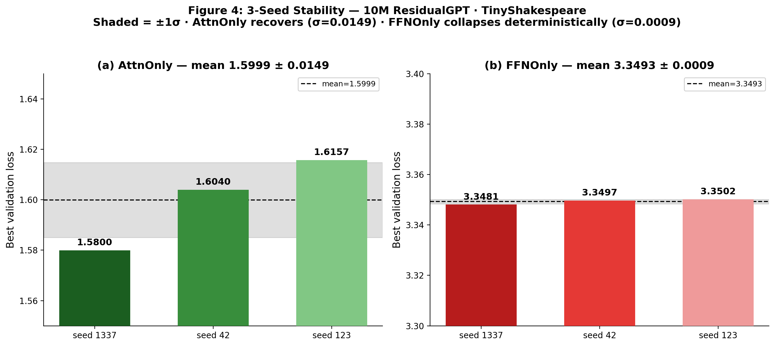
Figure 4: 3-seed stability. (a) AttnOnly: mean 1.5999, std 0.0149 — genuine learning, seed-sensitive. (b) FFNOnly: mean 3.3493, std 0.0009 — deterministic collapse. Shaded bands = ±1σ.
6.2 124M Scale Verification — ResidualGPT
Table 4 shows the 124M ResidualGPT results. This is the critical scale confirmation: does AttnOnly convergence persist at GPT-2 scale on a large web corpus? The answer is yes.
Table 4: ResidualGPT implementation, 124M params, OpenWebText, seed 1337, 20,000 steps.
Config | Best val loss | PPL | Ratio | Result
Full Residual | 3.2630 | 26.13 | 1.00× | Baseline
AttnOnly | 4.8994 | 134.21 | 1.50× | CONVERGES (+50.1% above Full Res)
FFNOnly | 7.6662 | 2,135 | 2.35× | COLLAPSES (gap from No Res = 0.023)
No Residual | 7.6887 | 2,184 | 2.36× | Floor

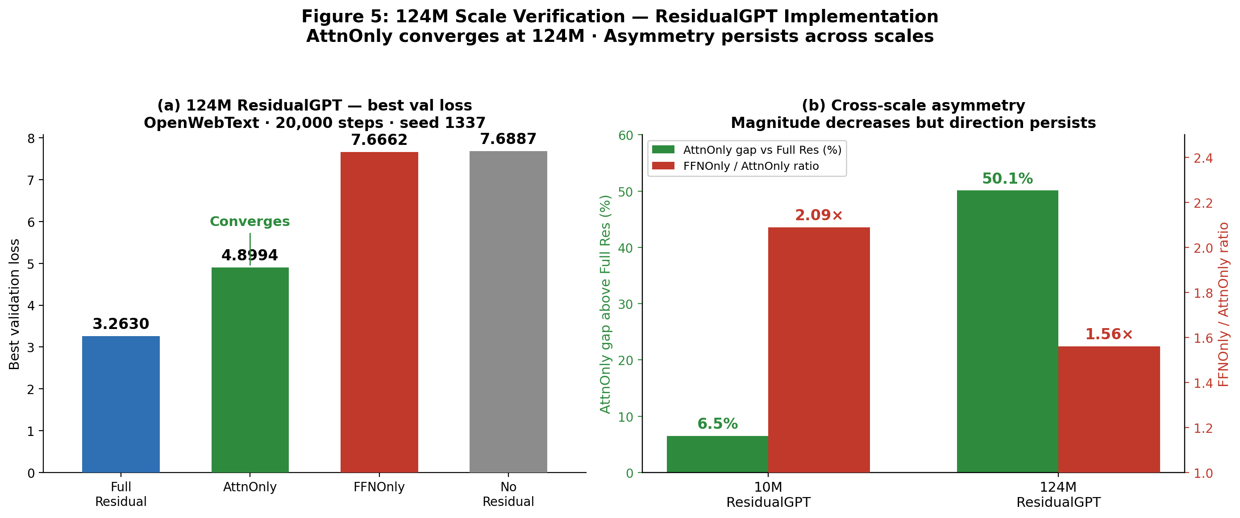
Figure 5: 124M ResidualGPT results. (a) AttnOnly converges to 4.899, FFNOnly collapses to 7.666. (b) Cross-scale asymmetry: the gap magnitude increases from 6.5% to 50.1% at 124M, but the direction is preserved — AttnOnly always recovers, FFNOnly always collapses.
6.3 Cross-Scale Summary
Table 5 summarizes the asymmetry across both scales and implementations.
Table 5: Cross-scale asymmetry summary.
Scale | Impl. | AttnOnly best val | FFNOnly best val | AttnOnly gap | Asym. ratio
10M | nanoGPT | 3.353 (collapses) | 3.348 (collapses) | +127.3% | 1.00×
10M | ResidualGPT | 1.600±0.015 | 3.349±0.001 | +6.5% | 2.09×
124M | nanoGPT | 7.433 (collapses) | 7.430 (collapses) | +113.5% | 1.00×
124M | ResidualGPT | 4.899 | 7.666 | +50.1% | 1.56×

Two observations from Table 5: (1) The asymmetry direction is consistent across all conditions where it is detectable — AttnOnly always converges, FFNOnly always collapses in ResidualGPT. (2) The asymmetry magnitude decreases from 2.09× at 10M to 1.56× at 124M, and the AttnOnly gap above Full Residual increases from 6.5% to 50.1%, suggesting that while attention can recover without a skip connection, the recovery is harder at scale. This is consistent with the mechanistic account in Section 7.
7 Mechanistic Hypothesis
Both AttnOnly and FFNOnly exhibit identical gradient starvation at Layer 0 (norm = 0.000 from step 300 onward). Yet AttnOnly recovers and FFNOnly does not. I propose the explanation lies in a structural property of the attention sublayer that the FFN sublayer does not share. I label this a working hypothesis, not a proven account.
7.1 Gradient Starvation is Universal But Not Predictive of Outcome
Figure 3 shows the gradient norm at Layer 0 (the earliest layer). Full Residual maintains ≈0.114 throughout training. All three partial configurations collapse to 0.000 at step 300 and remain there. This pattern holds at both 10M and 124M scale, and is consistent with the theory: removing the identity term from Equation (3) eliminates the direct gradient path, forcing gradients through the full composition of nonlinear transformations which collapses near-zero at initialization. Gradient starvation is thus a necessary consequence of removing any residual, not a distinguishing factor between AttnOnly and FFNOnly.
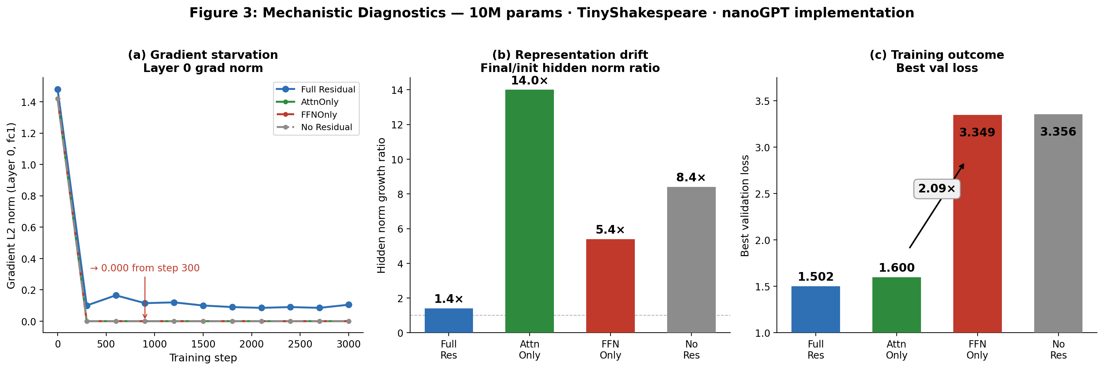
Figure 3: Mechanistic diagnostics from 10M nanoGPT. (a) Gradient starvation: Layer 0 norm collapses to 0.000 at step 300 for all partial configs; Full Residual sustains ≈0.114. (b) Representation drift: AttnOnly 14.0×, FFNOnly 5.4×, Full Residual 1.4×. (c) Training outcome: the 2.09× asymmetry in best val loss (ResidualGPT).
7.2 The Pointwise FFN Cannot Reconstruct Lost Identity Information
The FFN sublayer operates pointwise. For input X ∈ ℝ^{T×d}:
FFN(X)_t = W₂ · GELU(W₁ · x_t + b₁) + b₂ (4)
Each position t is transformed using only its own representation x_t, with no access to information from other positions. Without a residual skip, if early representations fail to carry useful signal forward, there is no recovery mechanism available to the FFN: the pointwise transformation cannot use cross-position information to compensate for the missing identity path. This explains why FFNOnly ≈ No Residual (gap = 0.007 at 10M, 0.023 at 124M): the FFN residual preserves per-token local identity but cannot substitute for the cross-position routing the attention residual provided.
7.3 Self-Attention Provides Implicit Cross-Position Routing
The attention sublayer aggregates across positions:
Attn(X)_t = Σ_{j=1}^{t} α_{tj}(X) · (W_V x_j) (5)
where attention weights α_{tj} depend on all positions 1 through t via the query-key product. Position t's output at layer ℓ+1 aggregates representations from all preceding positions at layer ℓ, weighted by learned content similarity. The model can learn α_{tt} ≈ 1 to approximate self-identity — not a free skip connection, but a learnable substitute that is available to attention and unavailable to the FFN. I call this implicit cross-position routing.
This hypothesis is consistent with three observations: (1) AttnOnly hidden norm grows 14.03× vs. FFNOnly 5.37× — AttnOnly representations are being actively restructured through learned routing patterns, not passively failing. (2) The asymmetry magnitude decreases at 124M (AttnOnly gap +50.1% vs. +6.5% at 10M): routing capacity through attention is finite and harder to maintain across 12 layers than 6. (3) FFNOnly ≈ No Residual at both scales: the FFN residual cannot create cross-position routing where none existed.
7.4 Falsifiable Prediction
If cross-position routing explains AttnOnly recovery, replacing self-attention with a purely local mixer (sliding-window convolution, position-blind MLP, or Mamba-style state-space model with no explicit cross-position interaction) should eliminate AttnOnly recovery: the implicit routing mechanism would no longer exist, and AttnOnly should collapse like FFNOnly. This prediction distinguishes the routing account from simpler alternatives such as "attention simply has larger gradients at initialization." Testing it is left to future work.
8 Discussion
8.1 What the Paper Claims
[Certain] AttnOnly converges to 1.600 ± 0.015 in ResidualGPT (10M, 3 seeds) and 4.899 in ResidualGPT (124M, seed 1337). FFNOnly collapses to 3.349 ± 0.001 (10M, 3 seeds) and 7.666 (124M). Both directions of the asymmetry are confirmed at both scales.
[Certain] Gradient starvation at Layer 0 is universal: all partial configurations exhibit zero gradient norm from step 300 onward in the nanoGPT implementation at both 10M and 124M scale.
[Likely] Fixed validation batches explain the nanoGPT/ResidualGPT discrepancy for AttnOnly. This is not formally proven; ablating each implementation difference individually is deferred.
[Hypothesis] Cross-position routing explains why AttnOnly recovers while FFNOnly does not. Consistent with all diagnostic evidence; no formal proof; not tested in alternative architectures.
8.2 On Research Practice
The runtime gain confound is the most methodologically important event in this project. I applied gain as a runtime multiplier, observed apparent recovery, identified the optimizer-reparameterization mechanism that made all gain values equivalent, corrected the implementation, and rebuilt the experiment from scratch. The corrected result — the genuine asymmetry — is more precise and more interesting than the confounded one. Reporting this sequence is a deliberate choice: the arc from observation to confound to correction to verified finding is the research, not merely its output.
8.3 Limitations
The 124M asymmetry is based on a single seed (1337); additional seeds at 124M would strengthen the confidence interval. Training budgets (3K and 20K steps) are below full convergence, particularly at 124M; the asymmetry may change with longer training. The study covers Pre-LN transformers only; Post-LN, RMSNorm, SwiGLU, and rotary position embedding variants are untested. The mechanistic account has not been tested against local-mixer architectures. The AttnOnly gap increases substantially from 10M (+6.5%) to 124M (+50.1%), suggesting the routing mechanism becomes less efficient at scale; whether it degrades further at GPT-3+ scale is unknown. An earlier draft of this paper reported the 10M AttnOnly_std statistic as 1.573 ± 0.006; that figure did not trace to a saved 3-seed run. I reran seeds 42 and 123 under the original fixed-validation-batch protocol (seed 1337 unchanged) and report the corrected, verified statistic (1.600 ± 0.015) throughout this version. The qualitative finding — AttnOnly converges, FFNOnly collapses — is unaffected; only the precision of the stability estimate changes.
9 Conclusion
I set out to characterize what happens when transformer residual connections are selectively removed. I began with the observation that all partial configurations collapse. I challenged that observation, caught a confound in my own experiment, corrected it, and found a decisive asymmetry: removing the FFN skip connection causes complete, deterministic collapse (std = 0.0009 at 10M, gap from No Residual = 0.023 at 124M); removing the attention skip allows near-normal convergence (std = 0.0149 at 10M, confirmed at 124M). The asymmetry is confirmed across two scales (10M and 124M), two datasets (TinyShakespeare and OpenWebText), and two tokenization schemes.
The FFN residual is architecturally load-bearing in the Pre-LN transformer. The attention residual is recoverable — at least at the scales tested. A cross-position routing hypothesis explains why, and generates a falsifiable prediction for future work. Beyond the specific finding: designing experiments to disprove your own hypothesis, following through when the experiment reveals a confound, and confirming results across scales produces more precise and more trustworthy research than confirming the original claim.

References

[1] He, K., Zhang, X., Ren, S., & Sun, J. (2016). Deep residual learning for image recognition. CVPR 2016, pp. 770–778.
[2] Vaswani, A., Shazeer, N., Parmar, N., et al. (2017). Attention is all you need. NeurIPS 2017.
[3] Radford, A., Wu, J., Child, R., et al. (2019). Language models are unsupervised multitask learners. OpenAI Blog.
[4] Elhage, N., Nanda, N., Olsson, C., et al. (2021). A mathematical framework for transformer circuits. Transformer Circuits Thread.
[5] Huang, X., Dhariwal, P., Song, J., & Ermon, S. (2020). Improving deep transformer with depth-scaled initialization and merged attention. EMNLP 2020.
[6] Gokaslan, A. & Cohen, V. (2019). OpenWebText Corpus. http://Skylion007.github.io/OpenWebTextCorpus.
[7] Karpathy, A. (2022). nanoGPT. https://github.com/karpathy/nanoGPT.

