**Would you be a host or a guest for Airbnb in Seattle?**

**Introduction**

Situated on the western coast of United States of America is the seaport city of Seattle. This vibrant city has always been open to welcoming people, residents and visitors alike. Be it exploring arts and culture, or nature, outdoor activities or food, Seattle has more to offer than you think.

As a tourist I am itching to visit Seattle in a month's time and now I want to know where to stay put at? Friends, families, relatives and colleagues, based on their past experience, have pitched in ideas where to stay and what to do. Airbnb is definitely one of the most popular suggestions. From a personal point of view, I need more data to make an informed decision. So, what does the data suggest?

I used data from Airbnb Seattle 2016 to take a closer look at the question. The survey data covers 6,166 listings including homes or apartments, shared room, private rooms and more recently hotel rooms.

*Given a place to visit, which neighborhood should I prefer to stay at? Which is the most expensive neighborhood and what type of accommodation makes it so?*

Average pricing of any listing in a neighborhood gives an idea of how expensive or cheap it can be. The data suggests that Westlake is the most expensive if you choose a boat as a mode of stay, costing more than $400 per night. Whereas if I am choosing a house then Fairmount and Portage Bay top the chart.

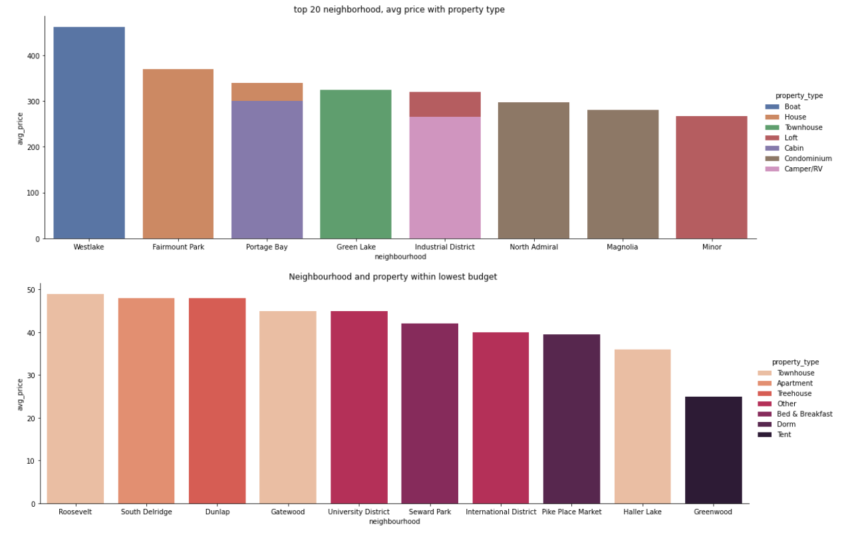

On the other hand, the average cost of a Townhouse in Roosevelt or a house in South Delridge will be less than $50 per night. Boat staycation, as it turns out, is costly.

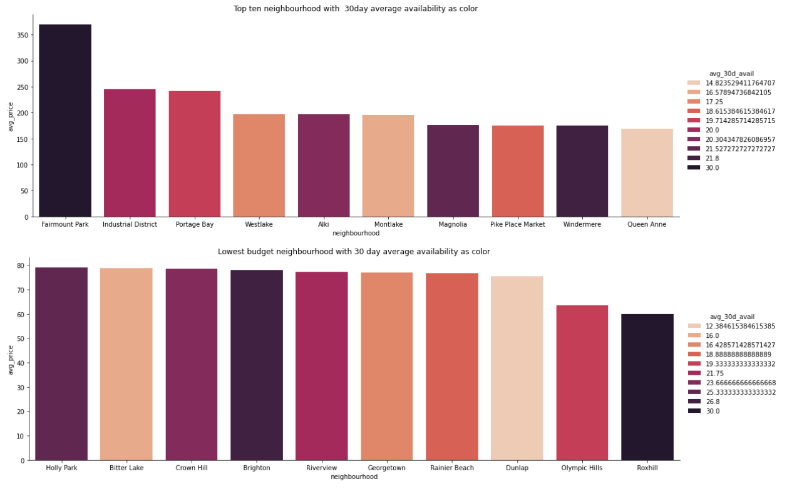

A look at the availability in the next 30 days, suggest that Fairmount is going to be fully available whereas cheaper options point to Rox hill.

*What is the busiest time to visit Seattle? What is the cost incurred during such time? What would be the budget friendly period to visit?*

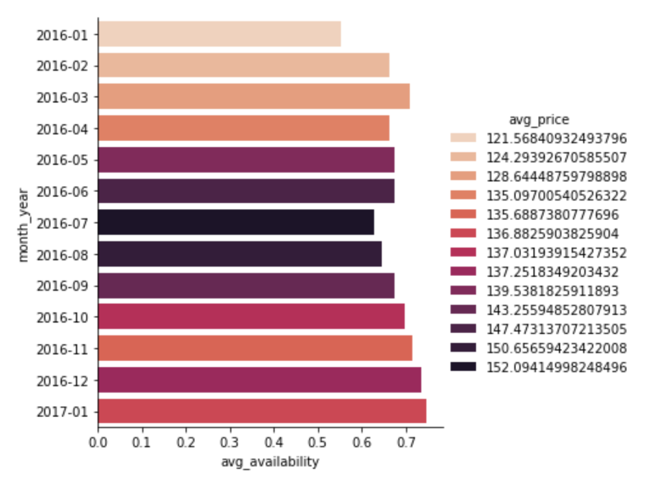

Based on the availability of listings, for the year 2016, peak season where lowest availability is seen, is January. The best time to visit Seattle is thus for the period January, February, June to August (probable indicator of best weather). November to January has the highest availability which could be because of the cold winter season. The average price is highest during June to August period and drops during the months of January till March. The price in the busiest season can rise to 25% more than the usual pricing.

*Is there any trend over time for the number of listings by hosts and for the number of visitors?*

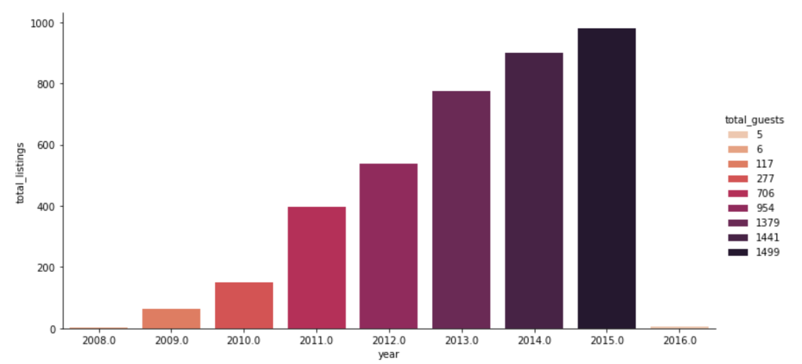

The total number of guests has been increasing upwards continuously over time, and so has the host listings. This is highly indicative of the fast-rising rental industry and how Seattle has opened to a lot more people, residents and visitors alike.

*What is the scenario from the hosts point of view? What is the occupancy rate for neighborhoods, say in the next* *30 days? Which neighborhood has seen the rise in host’s revenue, and is it attributed to any property or neighborhood?*

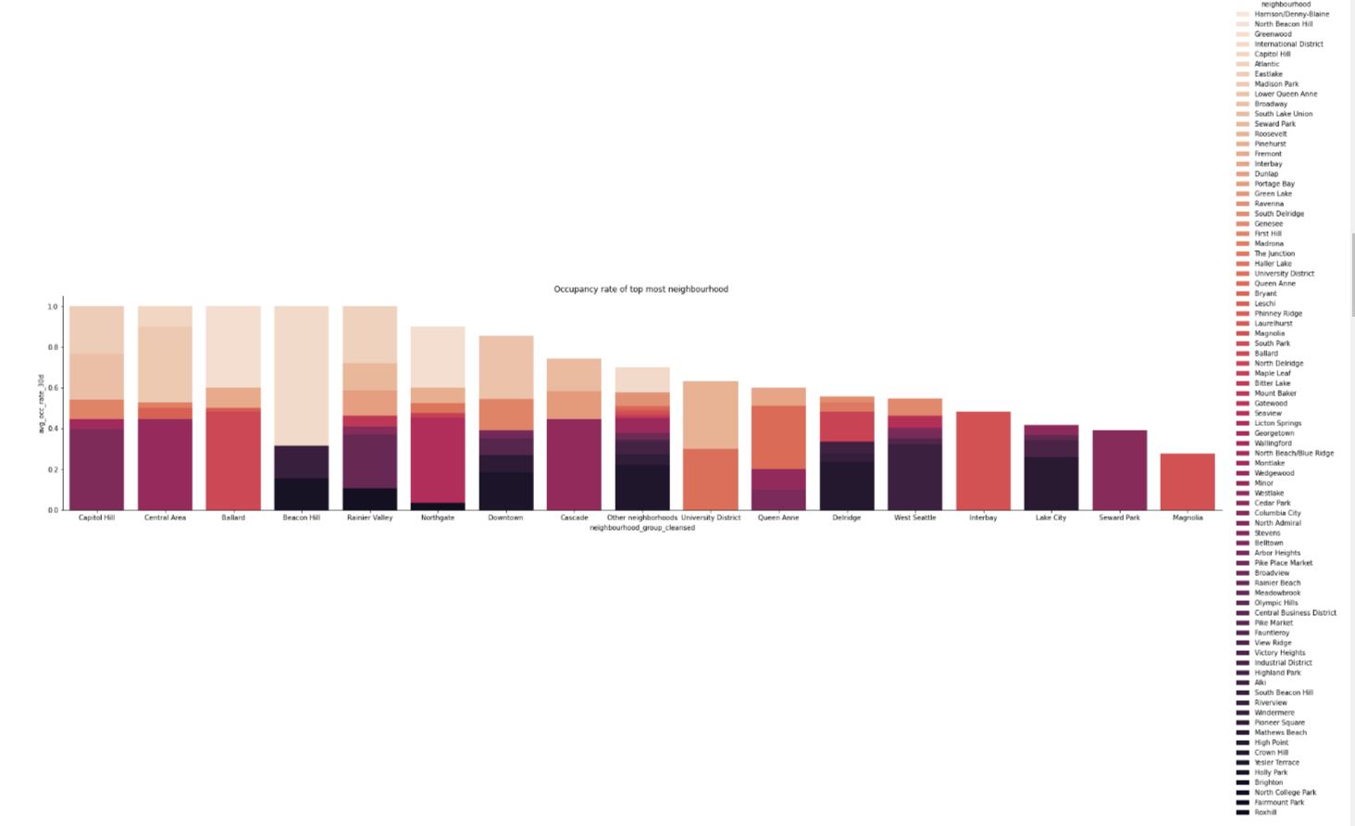

The average occupancy rate percentage, based on availability of 30-day period, is 1 for neighborhood groups Capitol Hill, Central Area, Ballard, Beacon Hill and Rainier Valley.

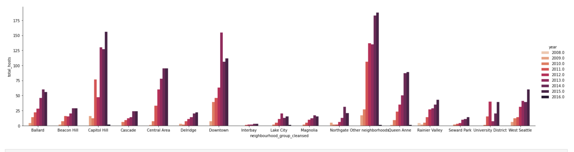

The host’s listing over time is seen to rise for Capitol Hill and Downtown for a period spanning 8 years since 2008.

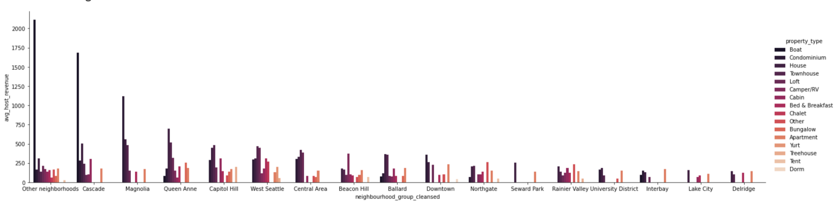

For Cascade and Magnolia, the host’s revenue seems to increase the most with Boat, Condominium, House and Townhouse contributing a major chunk. The revenue of the host has been calculated considering price per night of each property type and guests including extra people being accommodated in the said listings

All data considered my takeaway from this analysis is

1. Based on enriching my experience for a visit to Seattle, I would choose to stay preferably on a boat, making Westlake my top choice. Portage Bay is a close second with a less expensive approach for a boat stay. I can optimize on the season of travel by choosing to skip the busiest season and either go nearing the end of the season like in November or April, provided it is not marred by the rains.
2. Choosing to be a host is a lucrative option and the revenue generated via property of a house or a condo in Cascade and Magnolia is surely enticing.