03 practice examples on where, having, group by, order by
03_agreegate_functions_with_having_,group_,order_by_examples_1
P.Pratik Kumar
2520030034
- WHERE CLAUSE
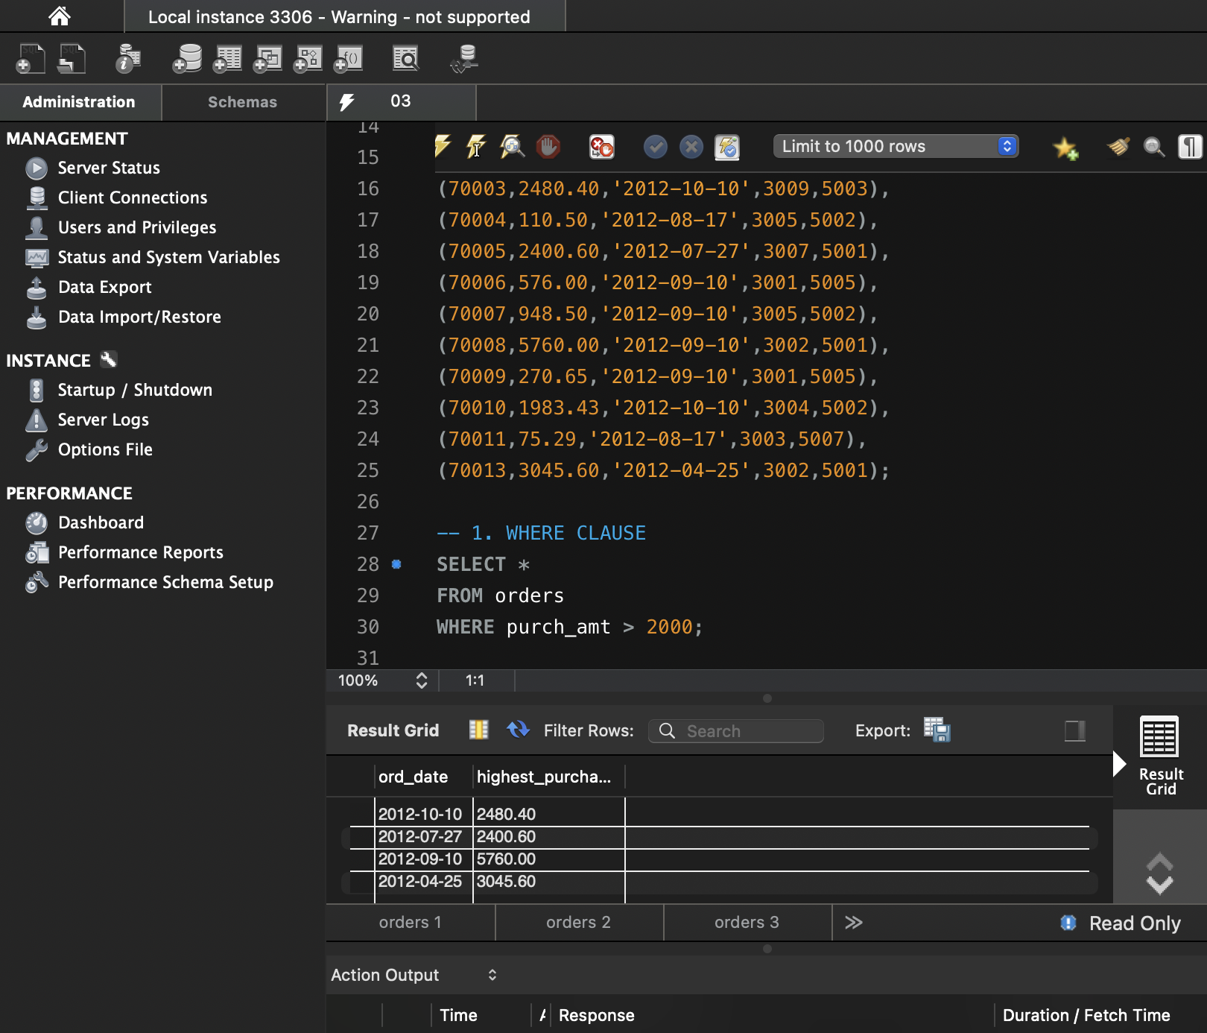
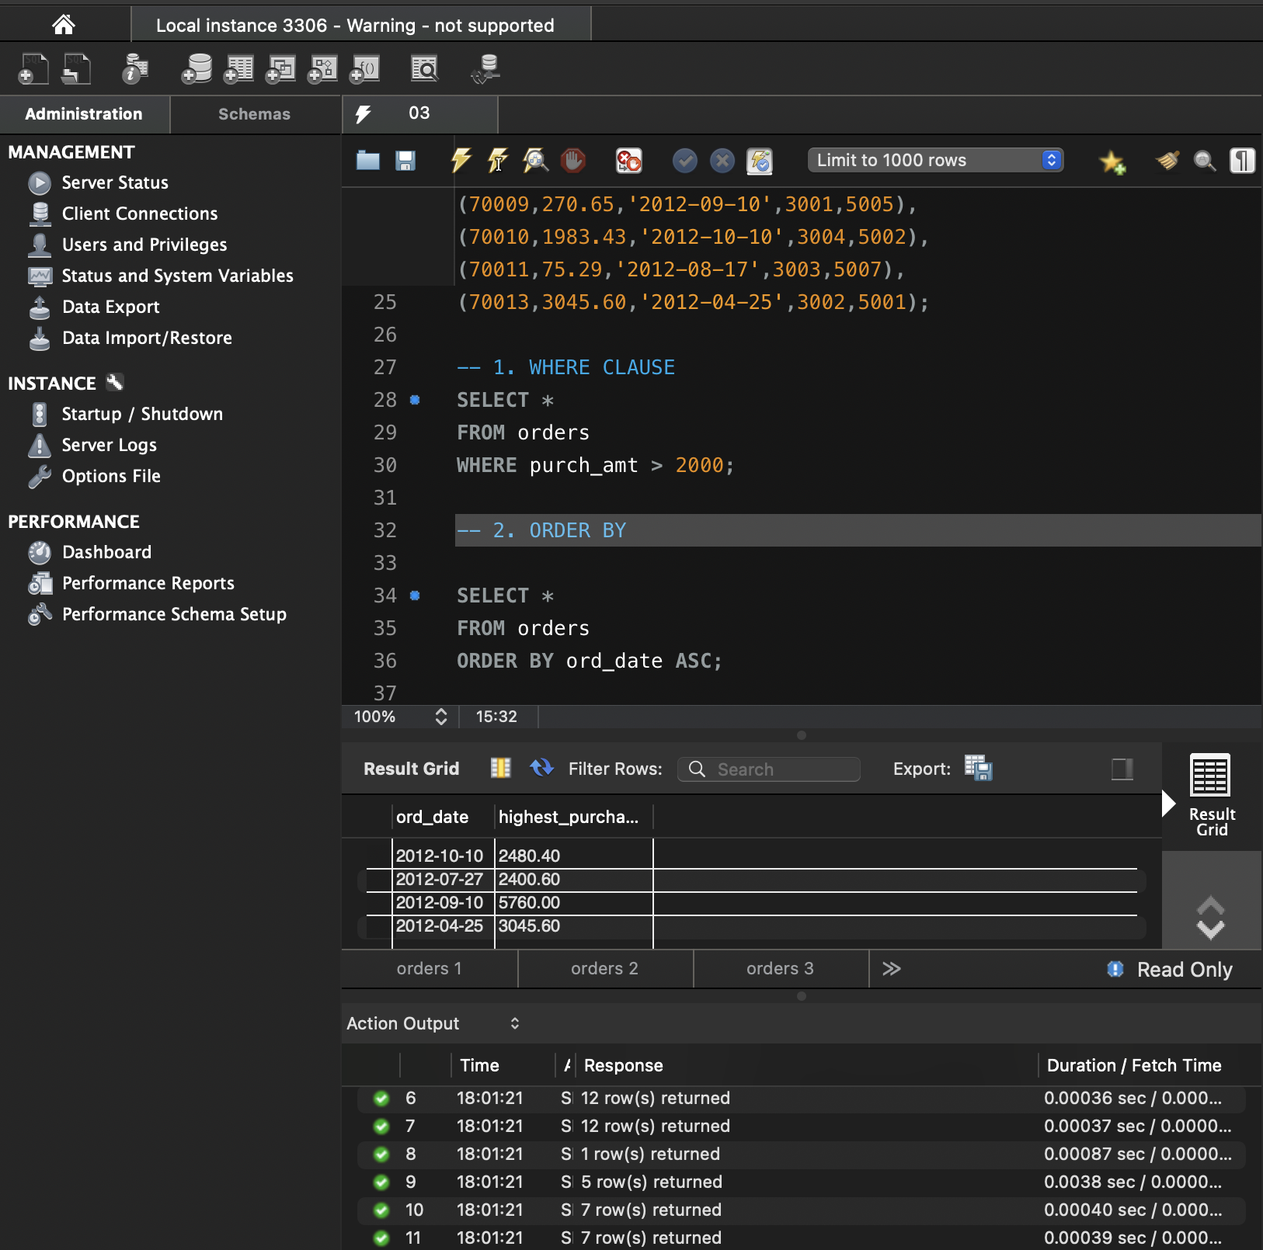

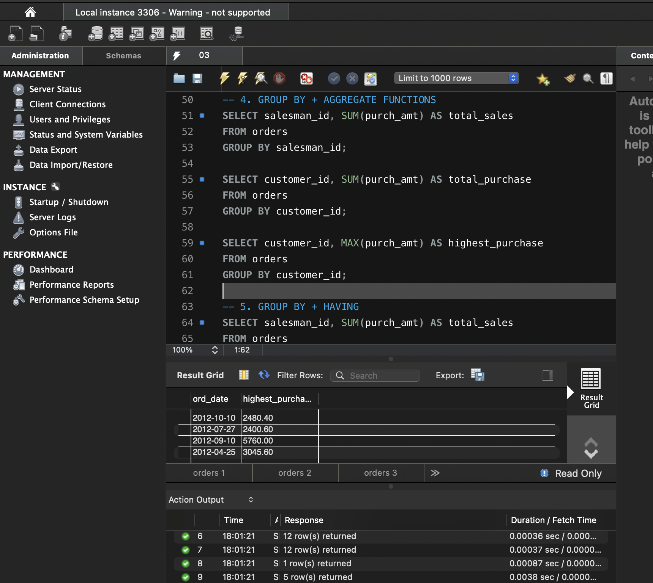

- ORDER BY
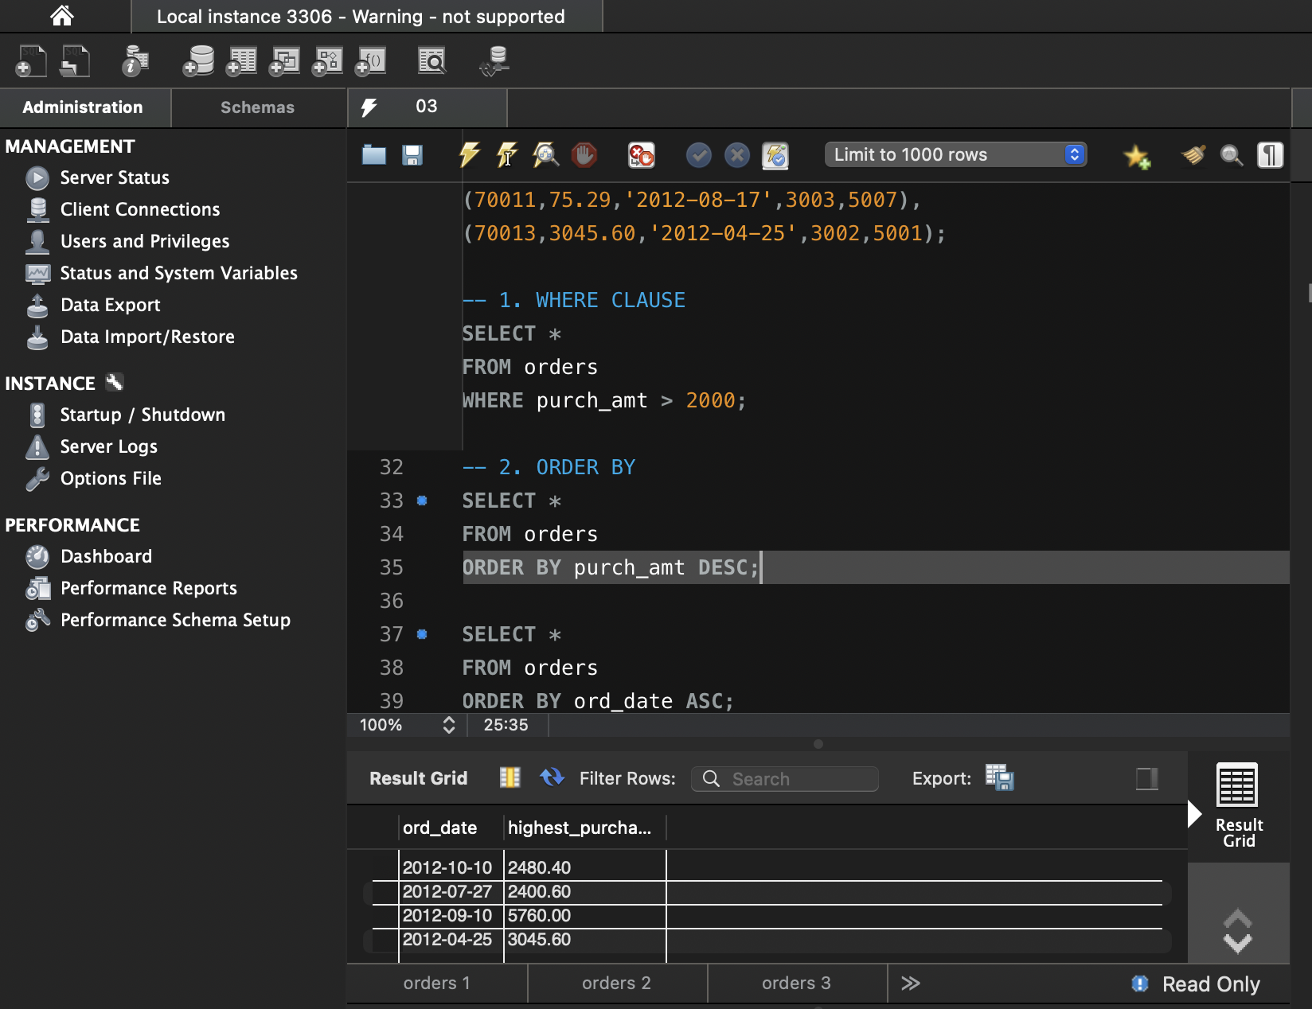
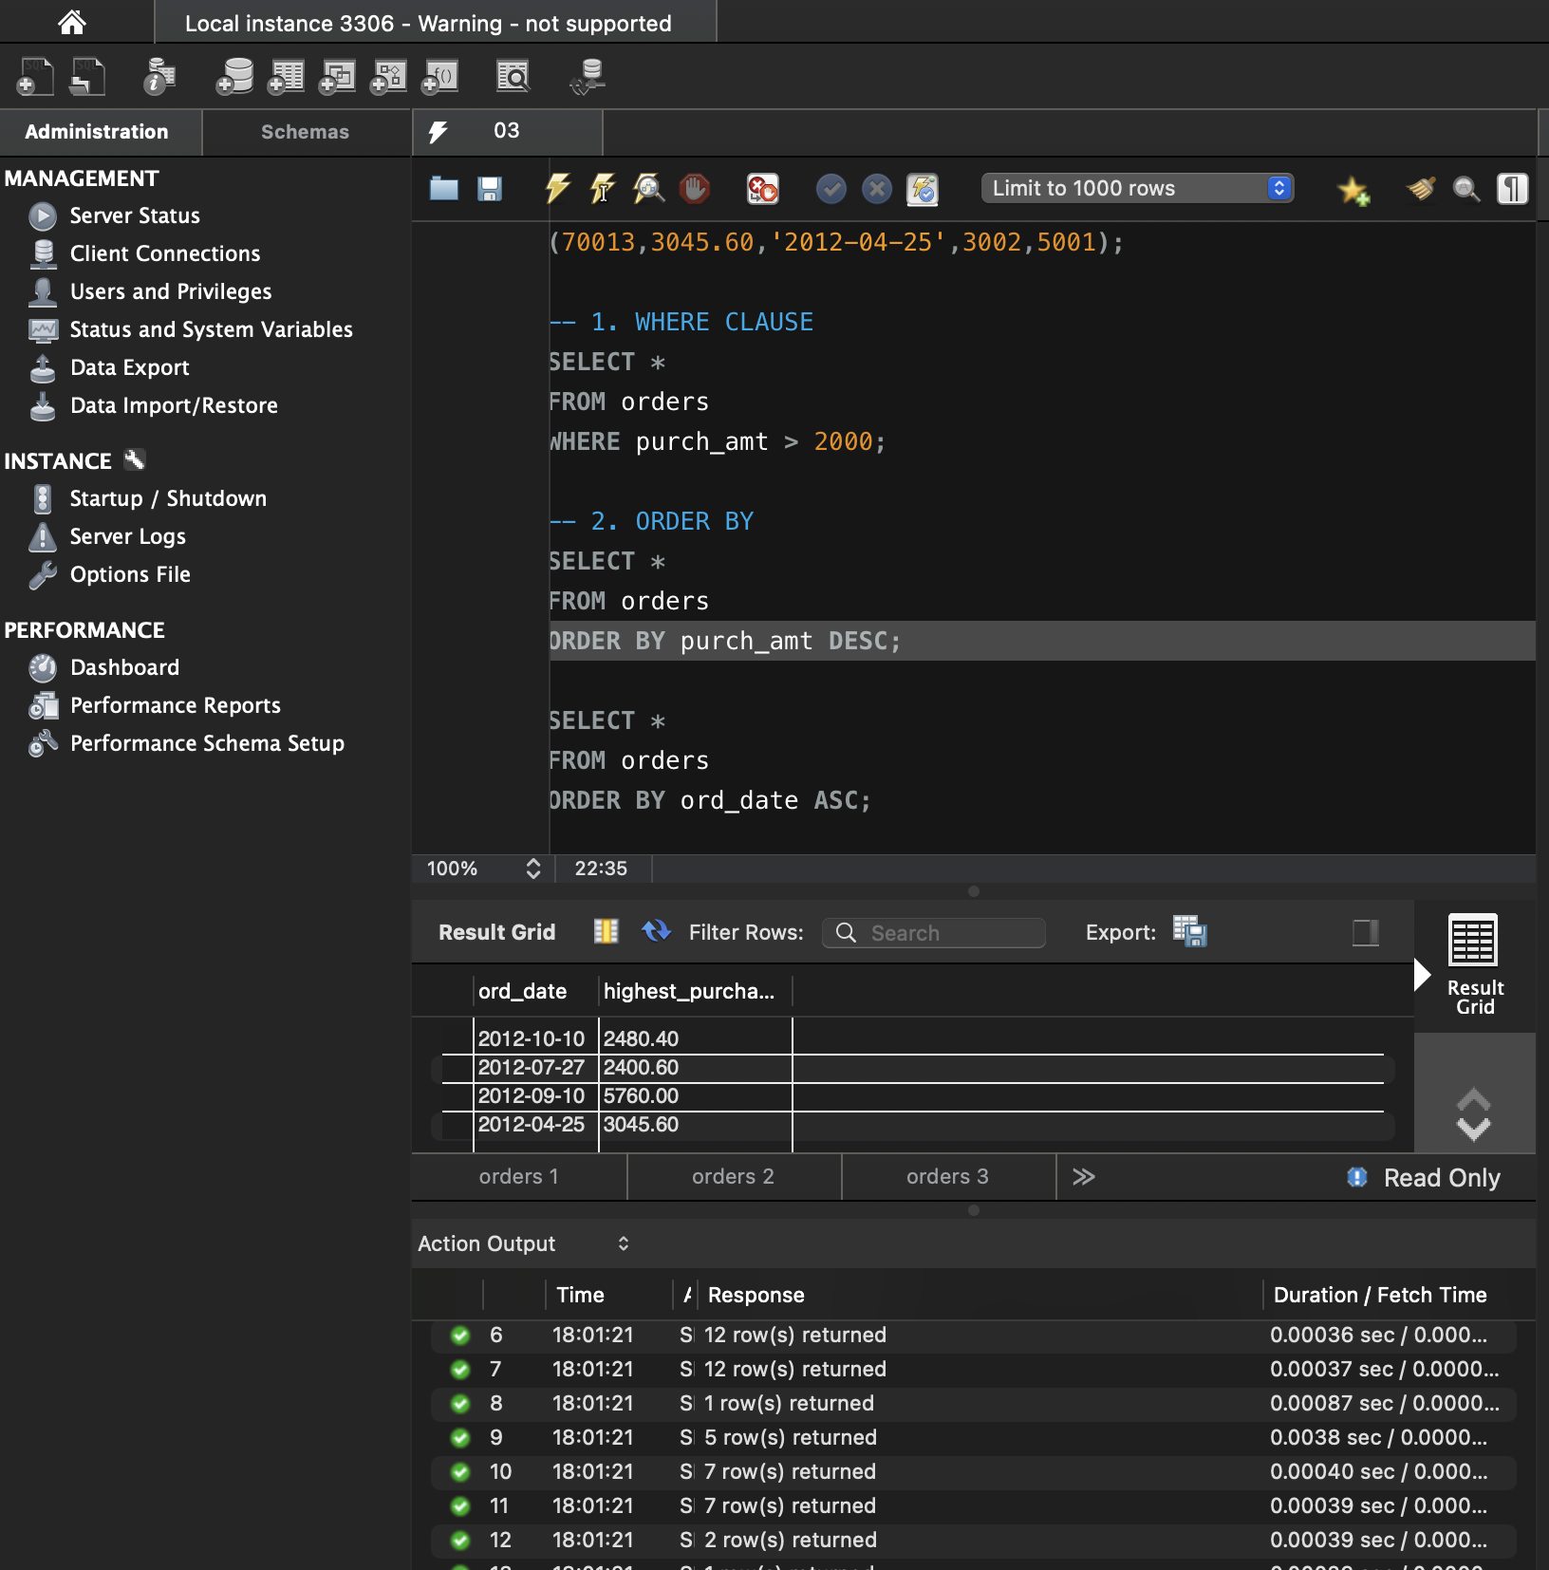

- AGGREGATE FUNCTIONS


- GROUP BY + AGGREGATE FUNCTIONS
- 

- GROUP BY + HAVING
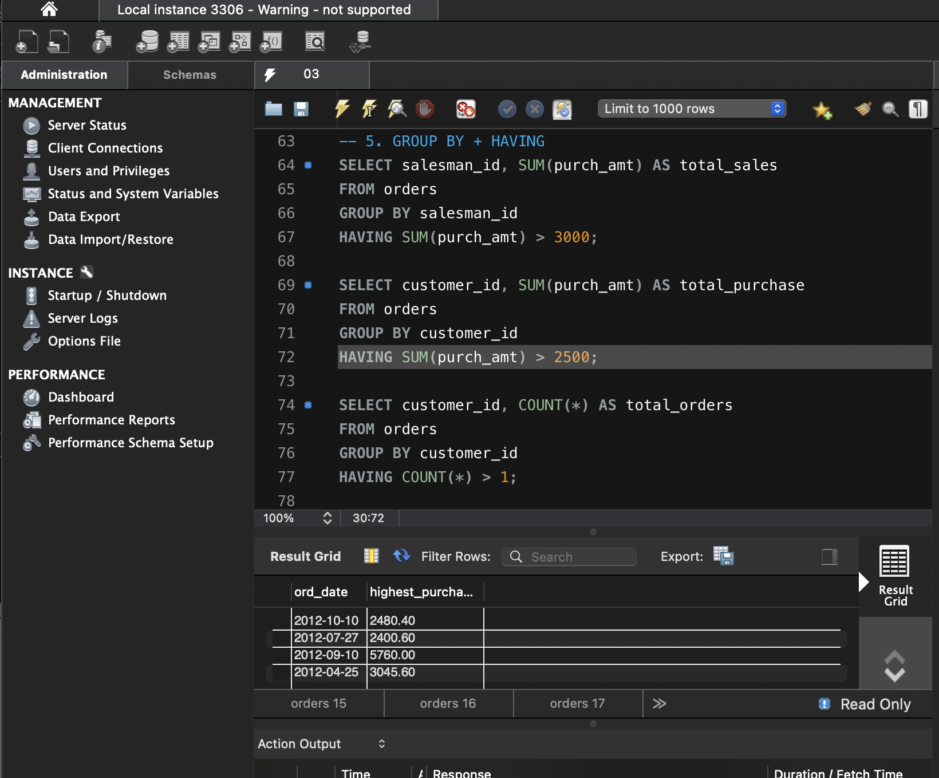

- GROUP BY + HAVING + ORDER BY
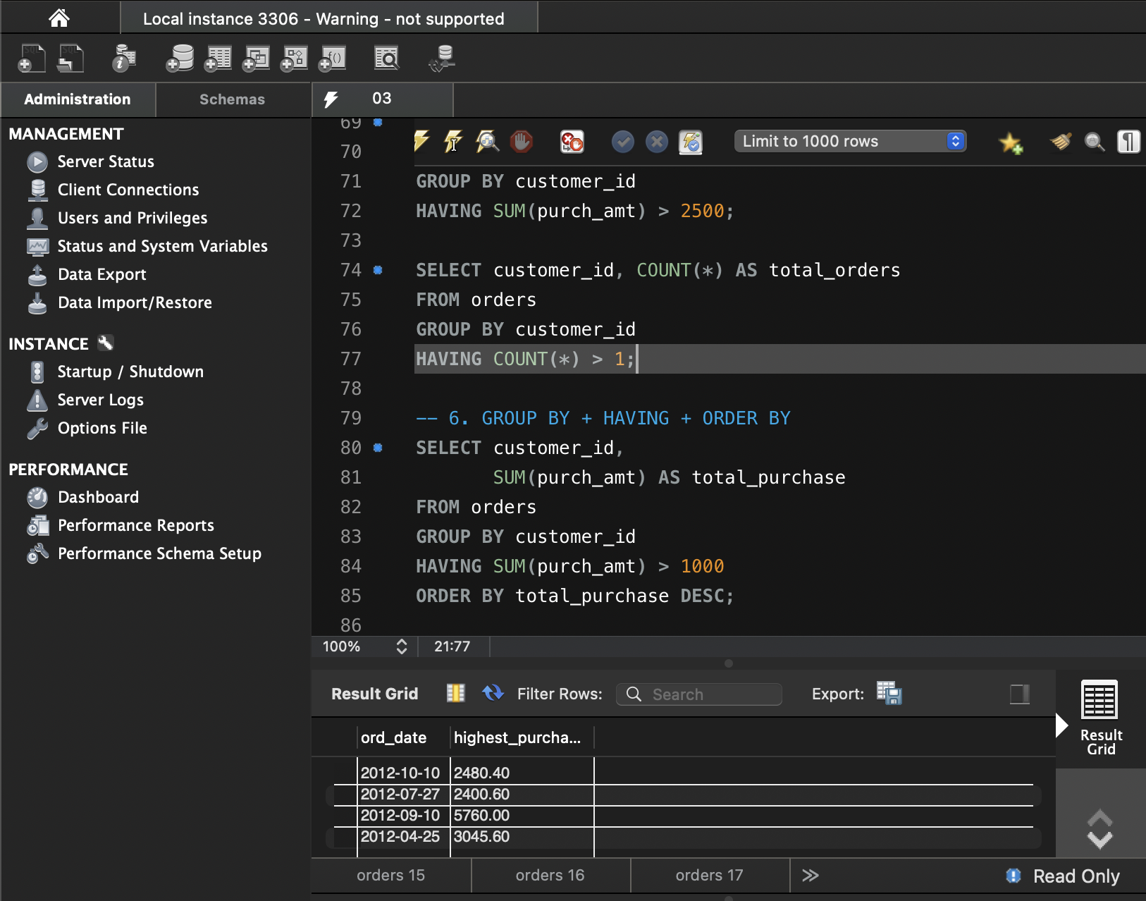
- BETWEEN + HAVING
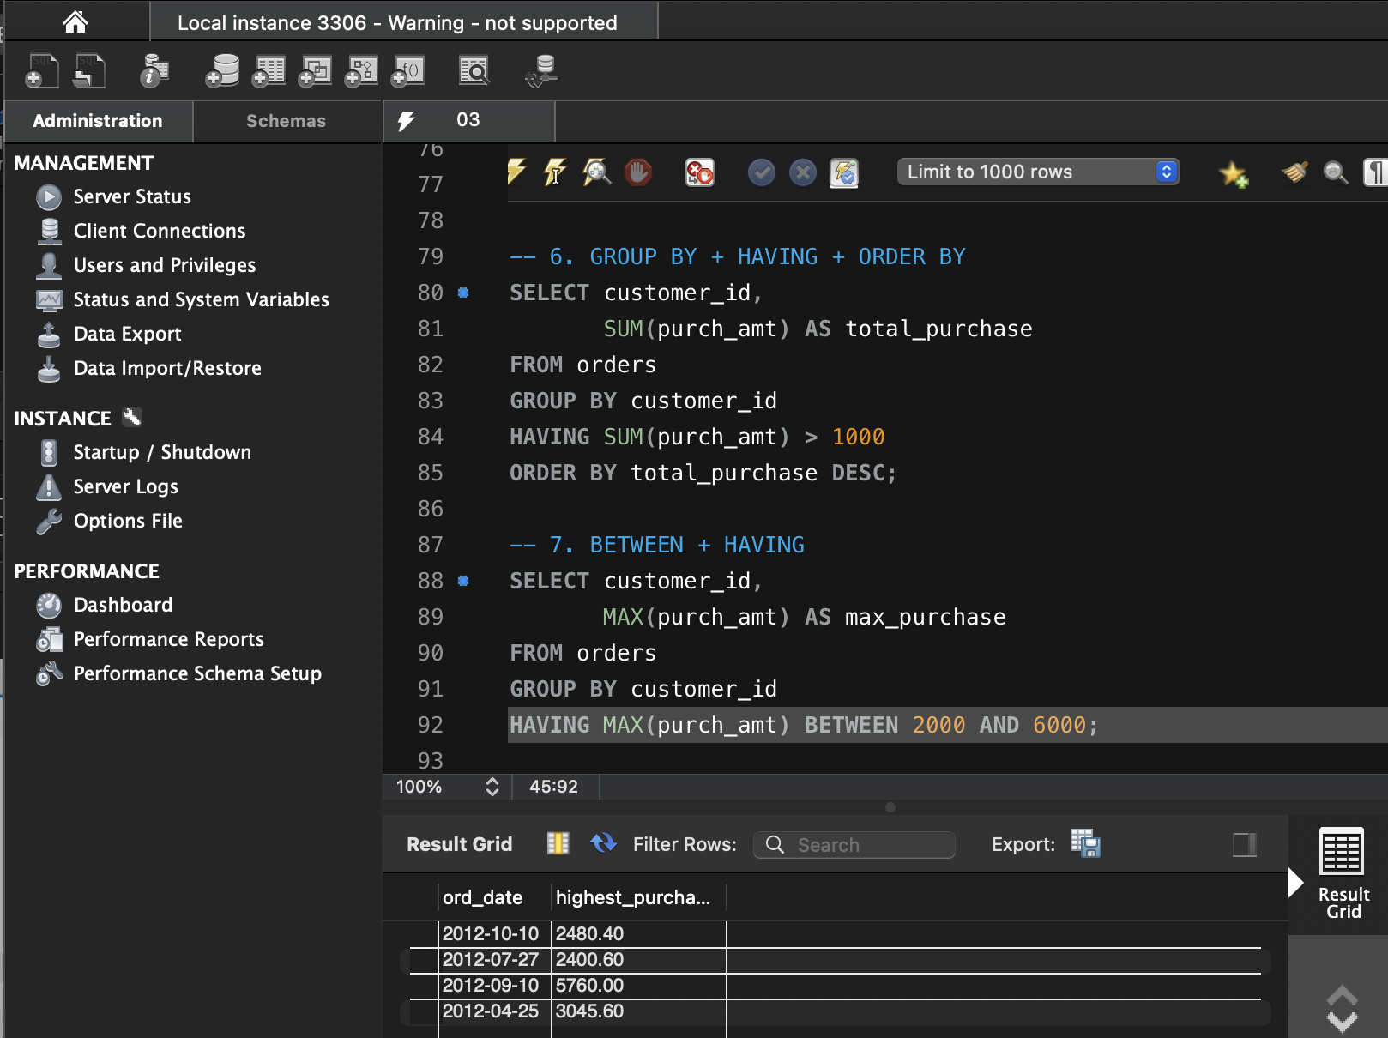

- COUNT + HAVING / MAX + GROUP BY + HAVING
\