06 BANK DATABASE – TRIGGERS AND STORED PROCEDURES
2520030034
P. Pratik Kumar
- Procedure — Branch Accounts
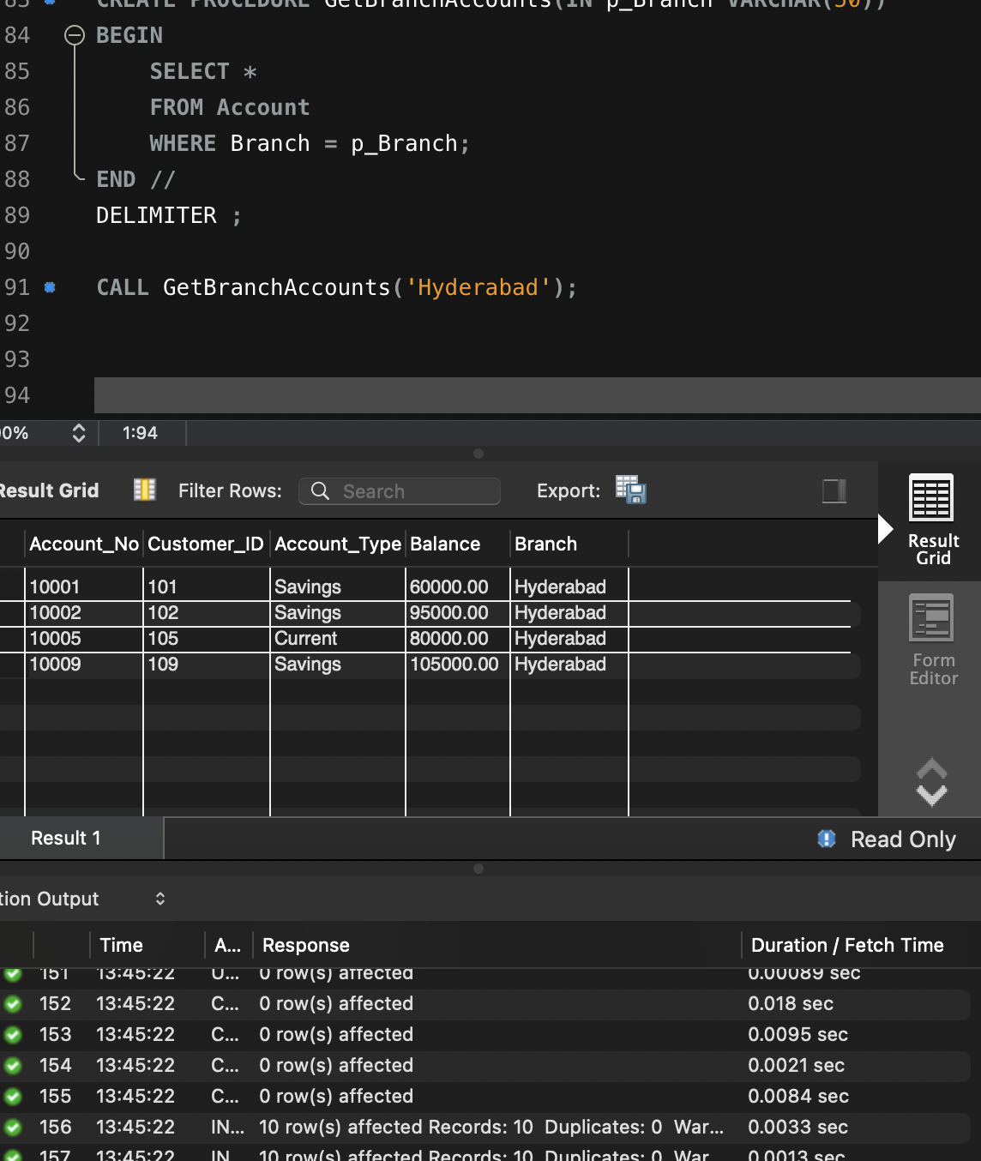

- Trigger — Prevent Negative Balance
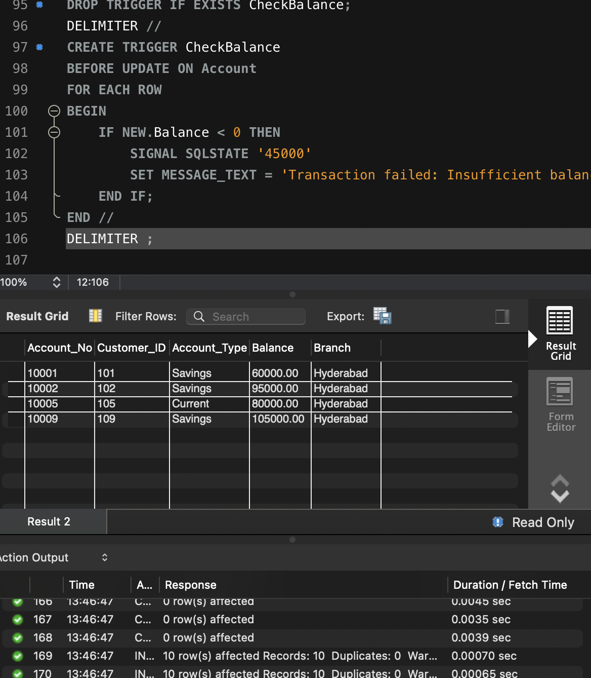
- Trigger — Transaction Audit
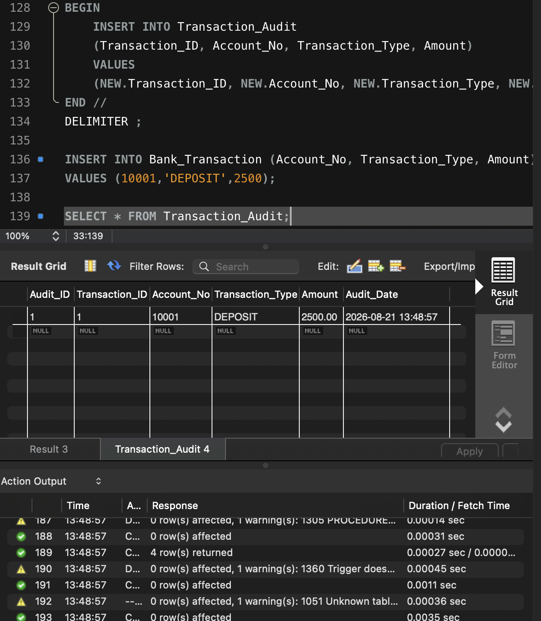
- Trigger — Automatic Deposit Balance Update
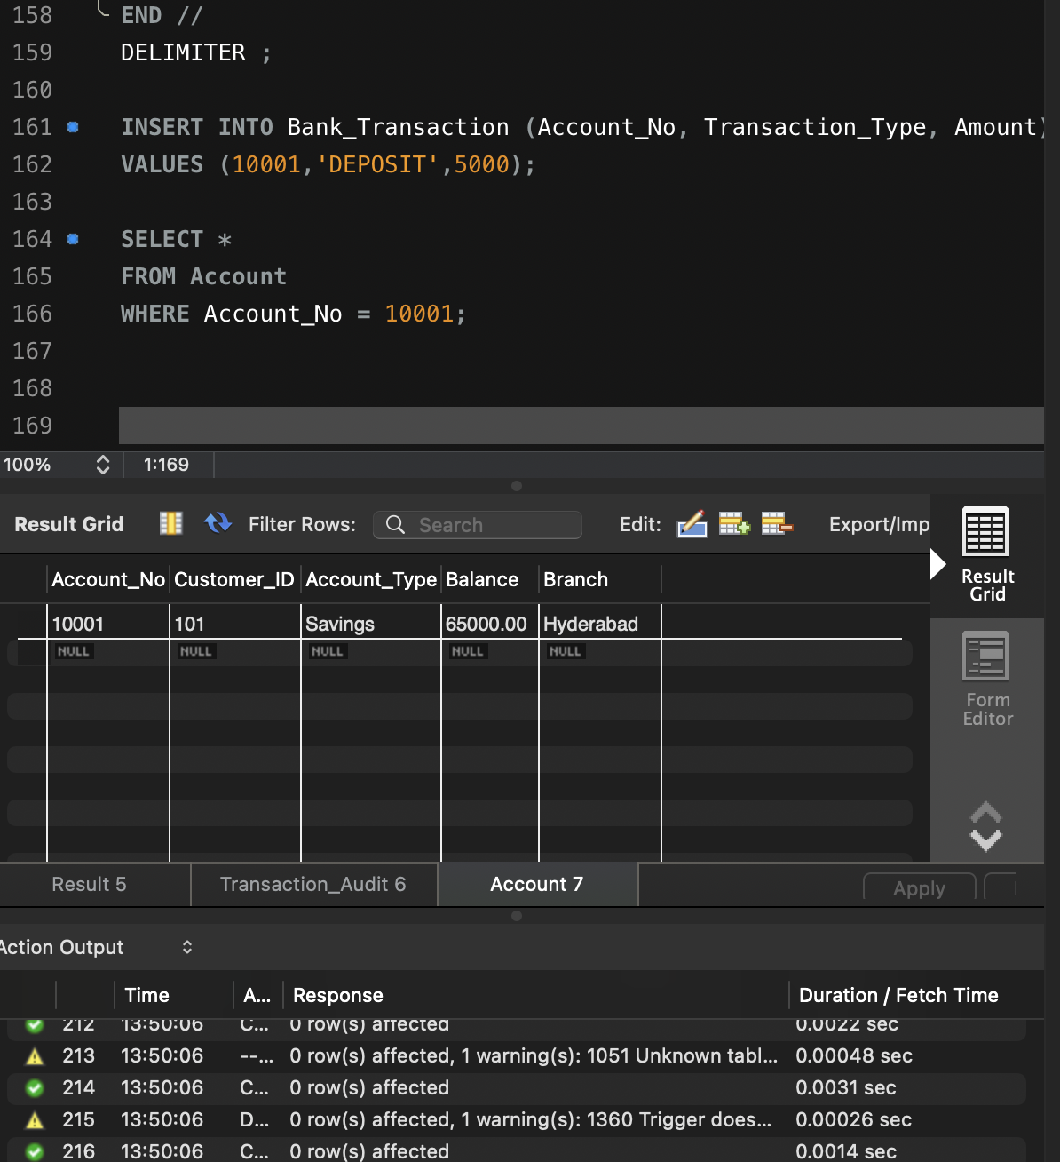
- Procedure — Money Transfer
