WEEK-2 2520030034
P. Pratik Kumar

Step 1: Create loans Table
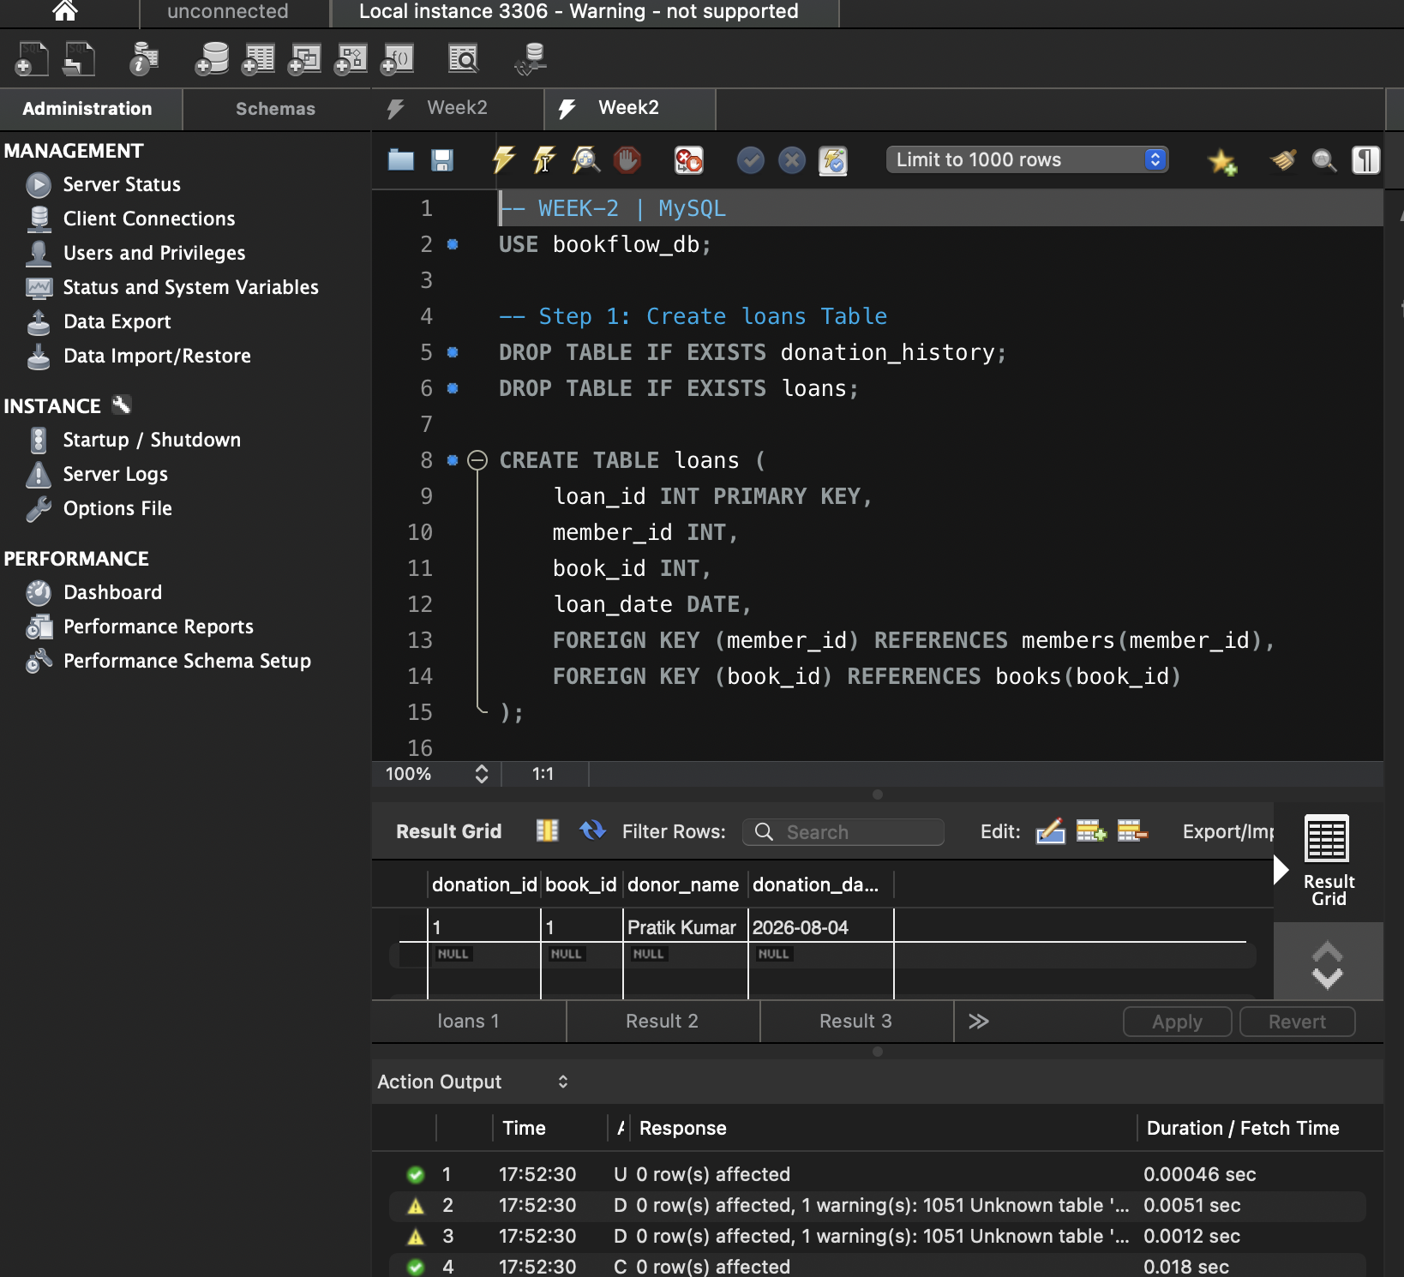

Step 2: Insert Loan Records
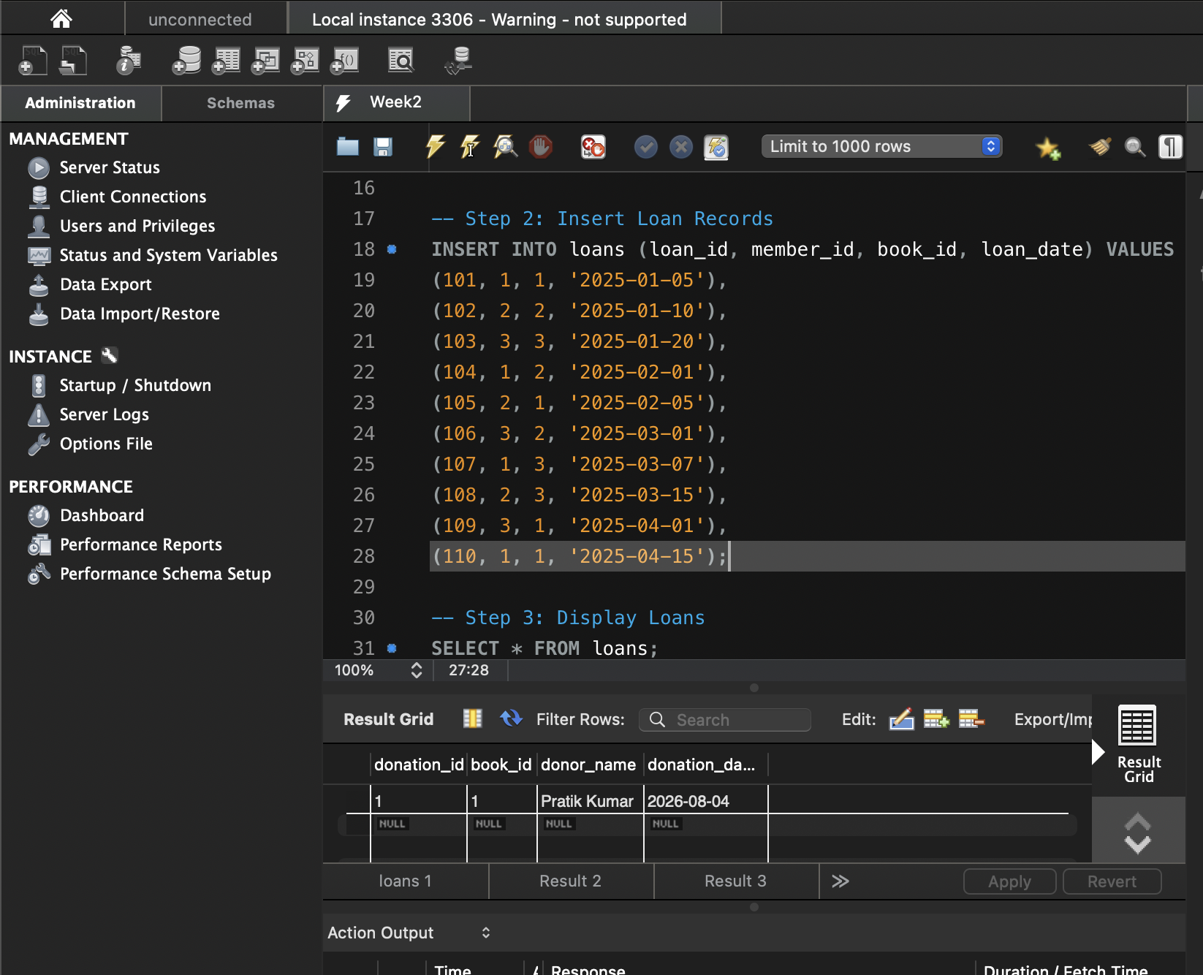

Step 3: Display Loans
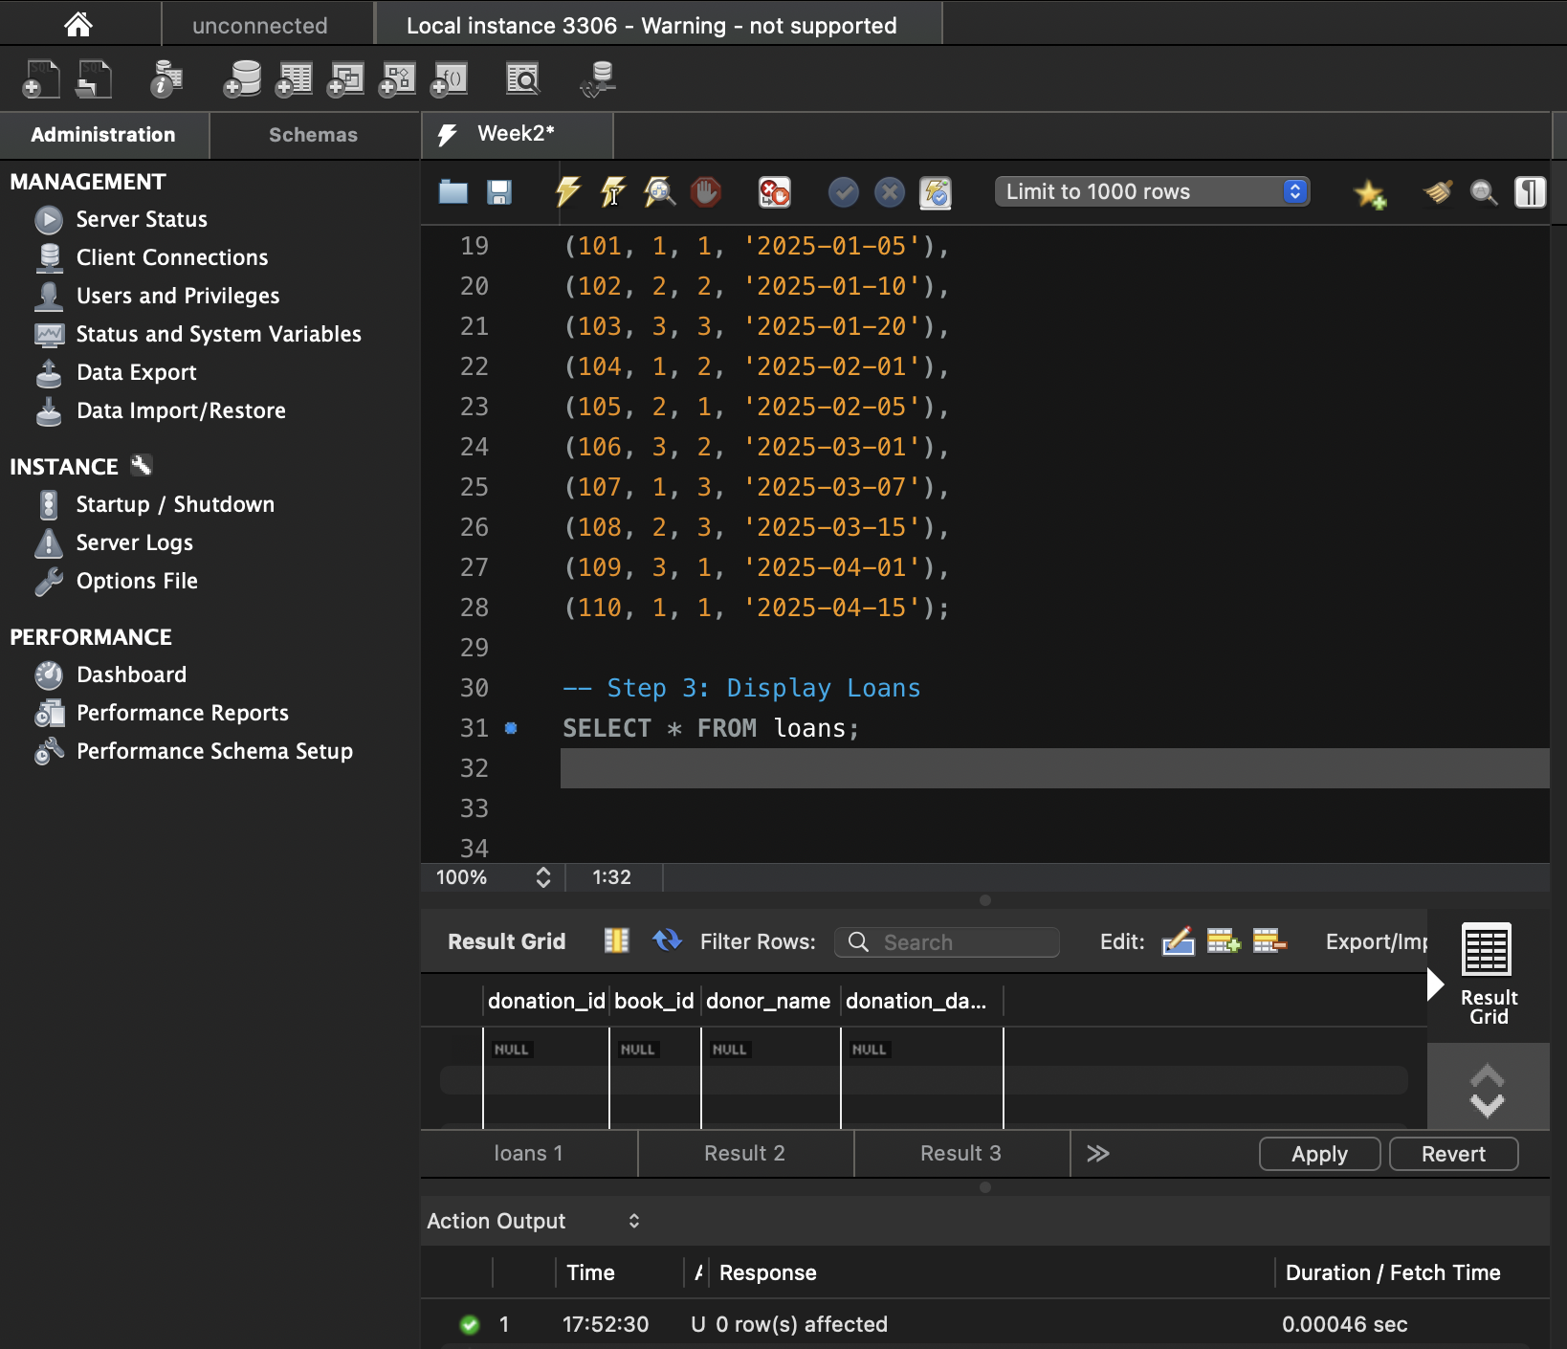

Step 4: INNER JOIN Query
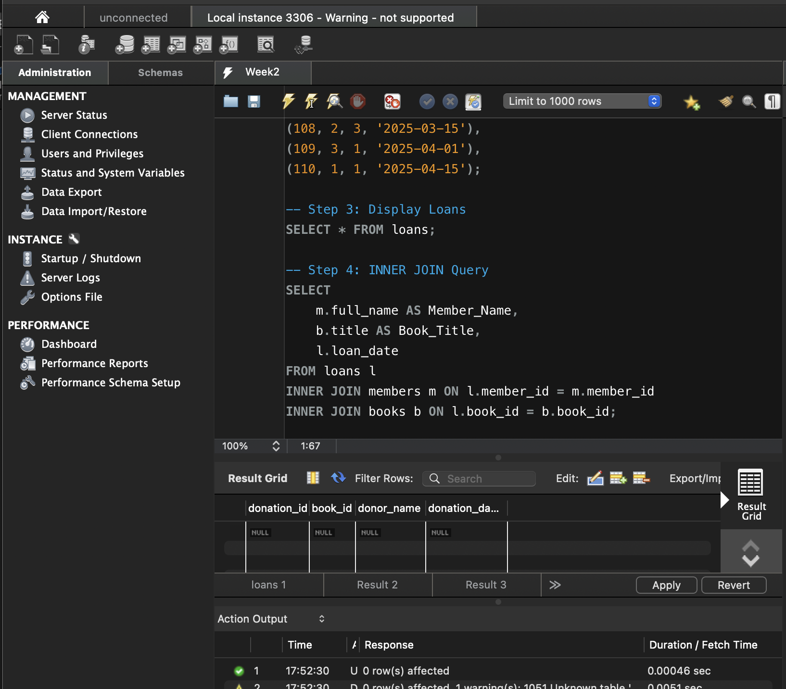

Step 5: GROUP BY Query
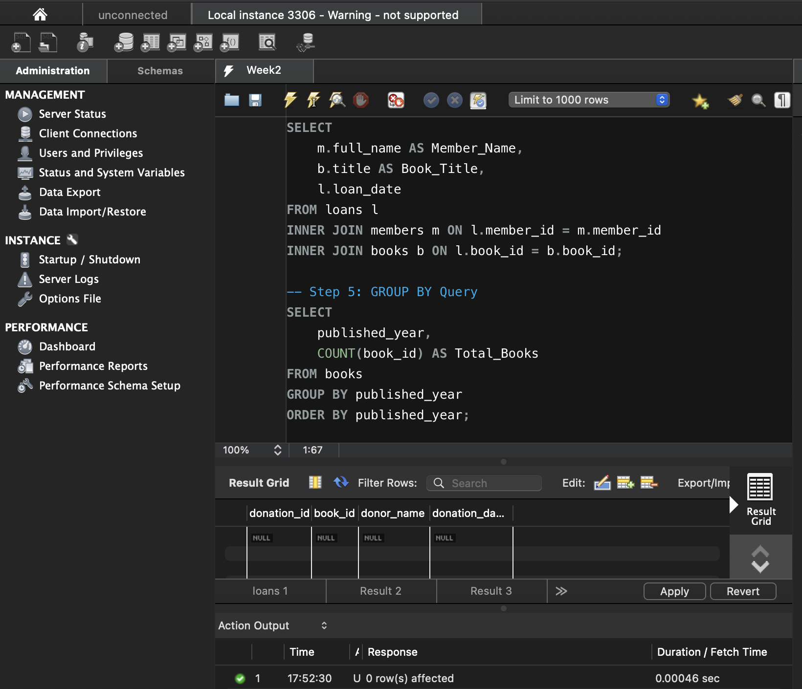
Step 6: Create donation_history Table

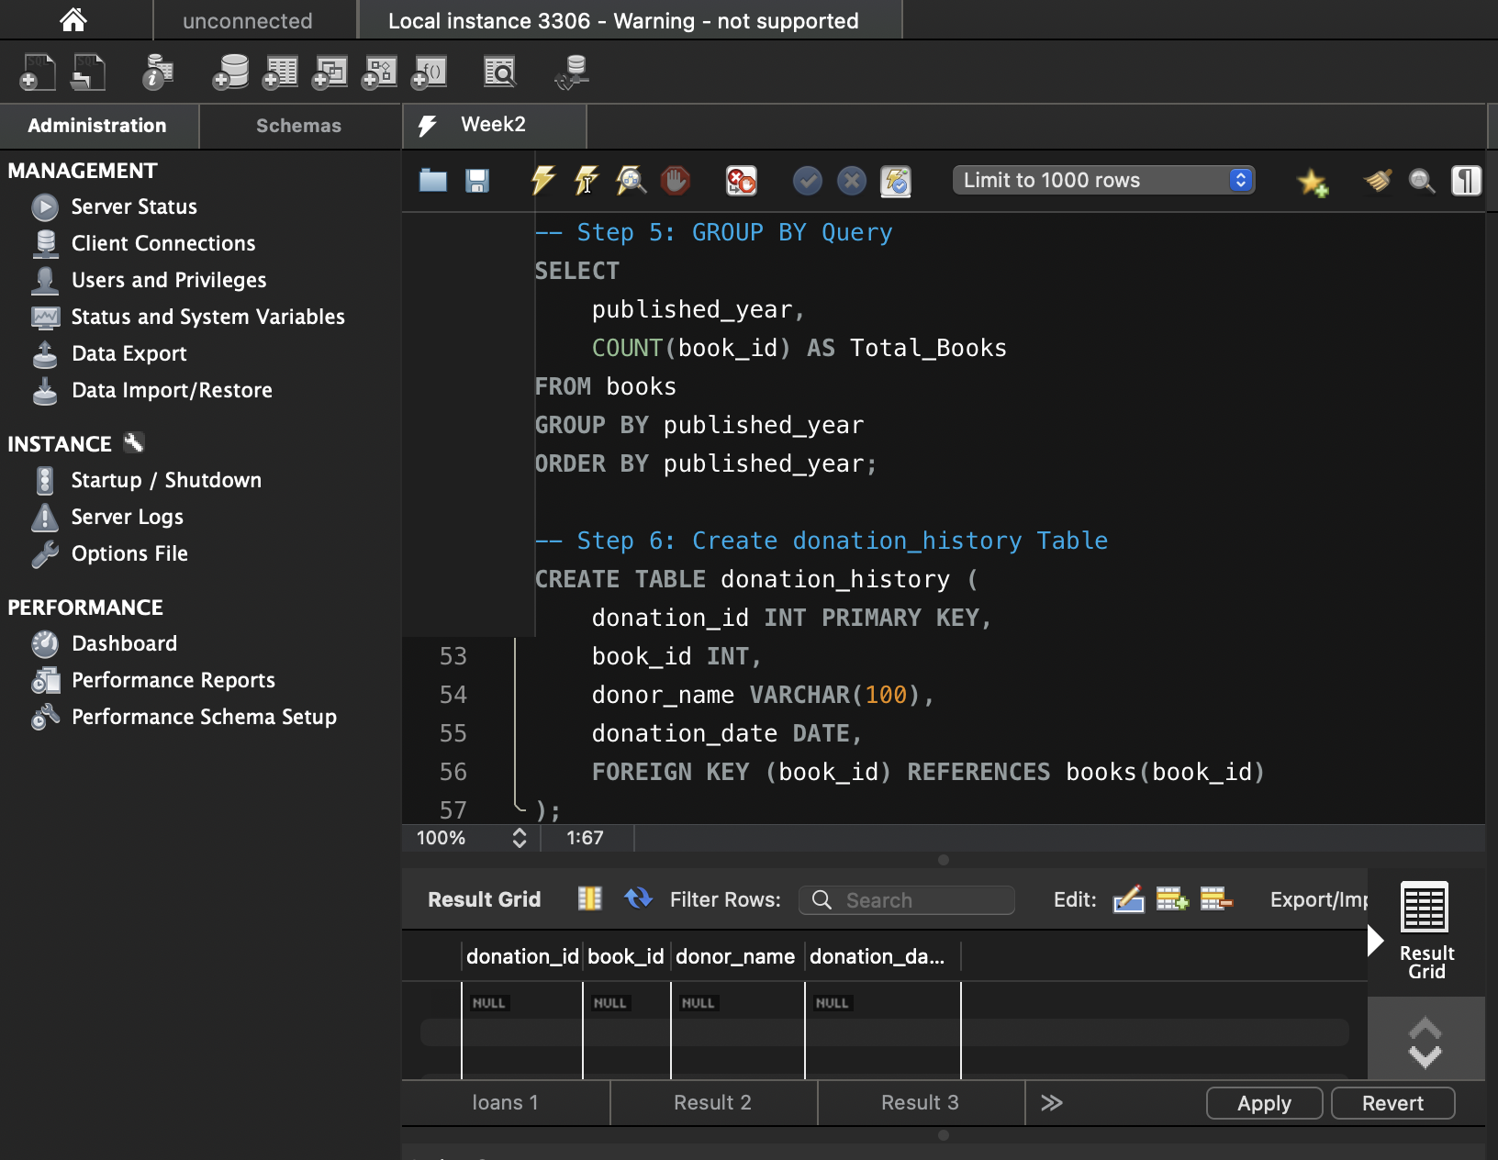
Step 7: Insert Donation Record
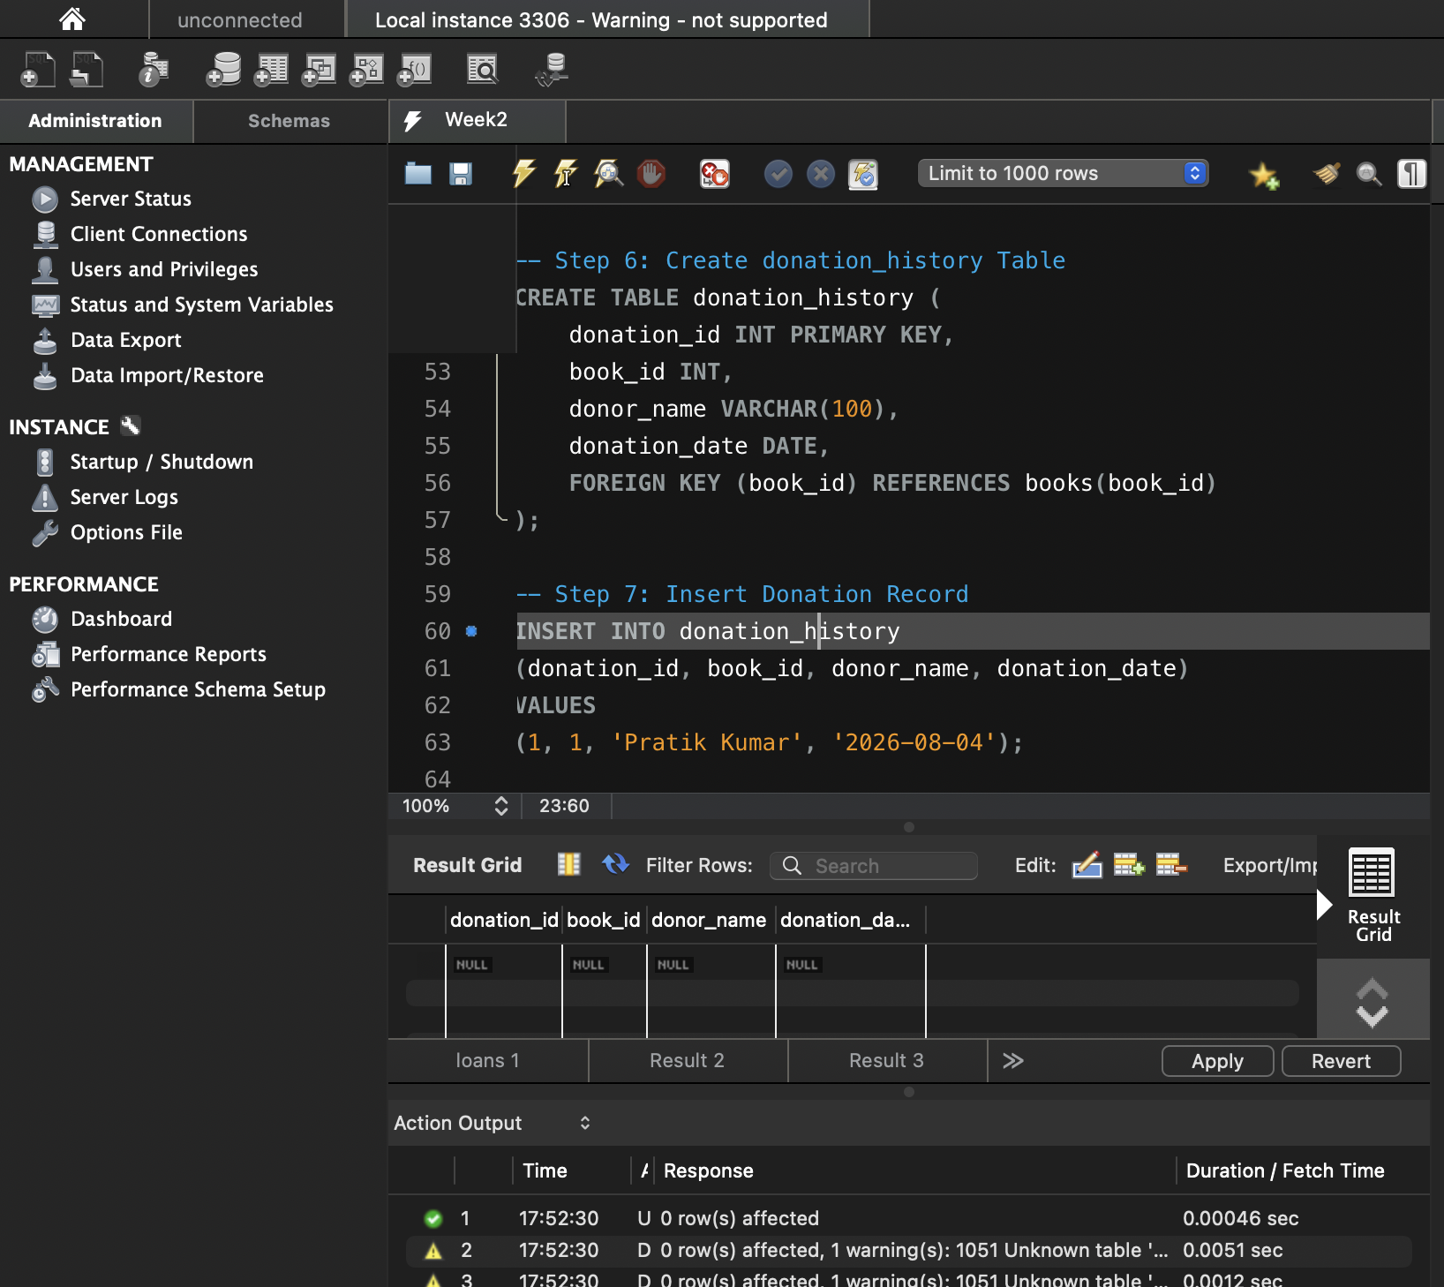
Step 8: Display Donation History
