Team DataDynamos

Members: Pratik Barot ([prbarot@syr.edu](mailto:prbarot@syr.edu)) | Mayura Vartak ([mvartak@syr.edu](mailto:mvartak@syr.edu))

Topic:

VibeHub - Entertainment Store Management System

ER Requirement Analysis:

|  |  |  |  |
| --- | --- | --- | --- |
| **Entities and Attributes** | | | |
| **Entity** | **Attribute** | **Props** | **Description** |
|  |  |  |  |
| customer | name | RC | Customer Name |
|  | email | RU | Customer Email |
|  | phone | RU | Customer Phone No. |
|  | dob | R | Customer Date of Birth |
|  | rental count |  | Customer rental count |
|  | late count |  | Customer late returns count |
|  |  |  |  |
| employee | name | RC | Employee Name |
|  | email | RU | Employee Email |
|  | phone number | RU | Employee Phone No. |
|  | dob | R | Employee Date of Birth |
|  | store | R | Employee employed at store |
|  | salary | R | Employee Salary |
|  | job title | R | Employee Job title |
|  | joining date | R | Employee Joining Date |
|  | termination date |  | Employee Termination Date |
|  |  |  |  |
| category | category | RU | Category |
|  |  |  |  |
| genre | genre | RU | Genre |
|  |  |  |  |
| store | address | RC | Store Address |
|  | contact | R | Store Contact Info |
|  |  |  |  |
| item | item name | RU | Item Name |
|  | category | RU | Item Category |
|  | actual quantity | R | Item Actual Quantity |
|  | available quantity | R | Item Available Quantity |
|  | store | R | Item Store |
|  | price | R | Item Price |
|  | late fee | R | Item Late Fee |
|  | average rating |  | Item Average Rating |
|  |  |  |  |
| transaction | store | R | Transaction Store |
|  | item | R | Transaction Item |
|  | employee | R | Transaction Employee |
|  | customer | R | Transaction Customer |
|  | rental date | R | Transaction Rental Date |
|  | estimated return date | R | Transaction Estimated Return Date |
|  | actual return date |  | Transaction Actual Return Date |
|  | amount |  | Transaction Amount |
|  | status | R | Transaction Status |
|  |  |  |  |
| rating | rated item | R | Rated Item |
|  | rating customer | R | Rating Customer |
|  | rating value | R | Rating Value |
|  | rating comment |  | Rating Comment |

|  |  |  |  |  |  |
| --- | --- | --- | --- | --- | --- |
| **Relationships** | | | | | |
| **Relationship** | **Entity** | **Rule** | **Min** | **Max** | **Entity** |
|  |  |  |  |  |  |
| customer-store | **customer** | visits | 1 | M | **store** |
|  | **store** | visited by | 1 | M | **customer** |
|  |  |  |  |  |  |
| customer-transaction | **customer** | part of | 1 | M | **transaction** |
|  | **transaction** | contains | 1 | 1 | **customer** |
|  |  |  |  |  |  |
| customer-rating | **customer** | gives | 0 | M | **rating** |
|  | **rating** | given by | 1 | 1 | **customer** |
|  |  |  |  |  |  |
| employee-store | **employee** | employed by | 1 | 1 | **store** |
|  | **store** | employs | 1 | M | **employee** |
|  |  |  |  |  |  |
| employee-transaction | **employee** | part of | 0 | M | **transaction** |
|  | **transaction** | contains | 1 | 1 | **employee** |
|  |  |  |  |  |  |
| item-store | **item** | available at | 0 | M | **store** |
|  | **store** | availability of | 1 | M | **item** |
|  |  |  |  |  |  |
| item-transaction | **item** | part of | 0 | M | **transaction** |
|  | **transaction** | consists of | 1 | 1 | **item** |
|  |  |  |  |  |  |
| item-genre | **item** | belongs to | 0 | M | **genre** |
|  | **genre** | contains | 1 | M | **item** |
|  |  |  |  |  |  |
| item-category | **item** | belongs to | 1 | 1 | **category** |
|  | **category** | contains | 1 | M | **item** |
|  |  |  |  |  |  |
| item-rating | **item** | has | 0 | M | **rating** |
|  | **rating** | for | 1 | 1 | **item** |
|  |  |  |  |  |  |
| store-transaction | **store** | processes | 1 | M | **transaction** |
|  | **transaction** | processed by | 1 | 1 | **store** |
|  |  |  |  |  |  |

Conceptual Data Model:

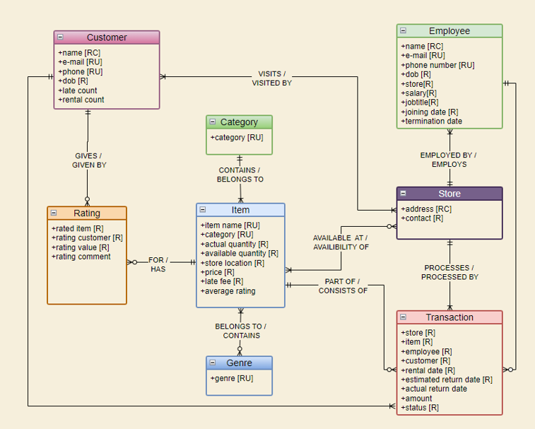

Logical Data Model:

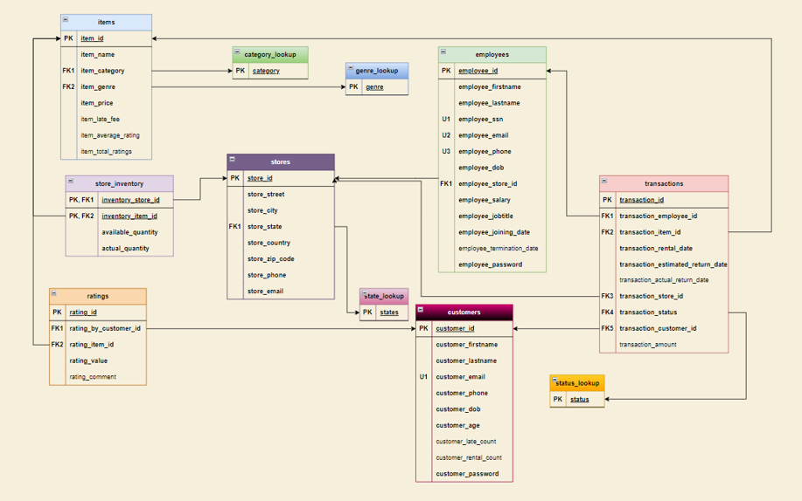

Identification of External Data Model and Logic

While a view was created for demonstration purposes, it was not further escalated is most of the external data logic is handled by the PowerApp is it manages the abstraction and encapsulation process in a different way from manual SQL codes. The limitations of integration between PowerApps and MS SQL Server made us not change the external model much with respect to the internal model since the PowerApp can directly use the internal model tables in a way that we usually use external model views. Also, our app can write to the database frequently and hence linking the functions to tables seems like a better idea than linking it to read-only views.

Physical Model & Programmability Aspects:

We have created a trigger which mainly fires upon the insertion or update of a transaction which in turn runs stored procedures for defined updates to other tables. However, the limitation of programmability feature support with PowerApp made us not include this script in our final project.

Similarly, while we have included an index in our script for table structures, it has been commented due to runtime issues within PowerApps.

Certain concepts such as Pivot, Unpivot, Window Functions, Joins, etc. were not used in the project as the reliance on PowerApps eliminated the use case for them.

Application Screens:

1. Main

1. Customer login

1. Add a new customer

1. Customer details

1. Specific item details

1. Employee login

1. Issue, return or Insights.

1. Issue item

1. Return item search.

1. Return item details and mark item returned

1. If item is already returned.

Implementation of the Actual Project:

[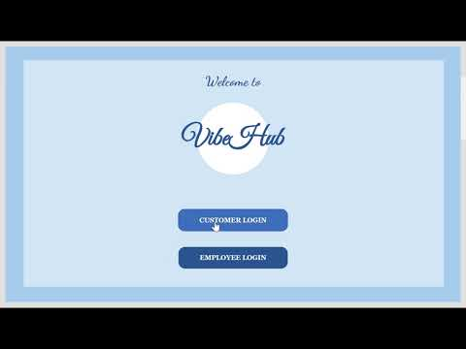](https://www.youtube.com/embed/HLn5RhiyDF8?feature=oembed)

Video Links for Reference:

YouTube: <https://youtu.be/HLn5RhiyDF8>

Kaltura: <https://video.syr.edu/media/t/1_pju0w9p4>

Team Logs:

|  |  |  |  |
| --- | --- | --- | --- |
| **Day** | **Date** | **Activity** | **Contribution** |
| Saturday | 11/25/23 | Requirement analysis | Pratik & Mayura |
| Sunday | 11/26/23 | Conceptual Data Model | Pratik & Mayura |
| Monday | 11/27/23 | Logical data model | Pratik & Mayura |
| Tuesday | 11/28/23 | Making initial data structure | Pratik & Mayura |
| Wednesday | 11/29/23 | Data generation & insertion | Pratik & Mayura |
| Thursday | 11/30/23 | Tweaking the data structure and revising conceptual & logical data models | Pratik & Mayura |
| Friday | 12/01/23 | Creation of programmability scripts (triggers, procedures, etc.) | Pratik |
| Saturday | 12/02/23 | Power apps integration (screens, navigations etc.) | Pratik & Mayura |
| Sunday | 12/03/23 | Power apps integration (logins, etc.) | Pratik & Mayura |
| Monday | 12/04/23 | Power apps UI | Mayura |
| Monday | 12/04/23 | Presentation & Demo | Pratik & Mayura |
| Wednesday | 12/06/23 | Adding rating functionality in power apps | Pratik & Mayura |

SQL Scripts:

1. 
2. 
3. 

The Trigger and Proc Script is not part of the final version of the code due to programmability integration issues with PowerApps.

Presentation and Reflection:

PowerPoint Slideshow:



Reflection:

“PowerApps made me cry.” – Mayura Vartak, 04th December 2023.

We tried to implement the learned coursework in the project to the best of our ability. We were limited in the implementation of a lot of concepts as most of our front-end work is done using PowerApps and it has a lot of limitations on integration with Programmability features and other MS SQL concepts. If we had more time, we could have integrated the dashboards and analytics for the insights part and worked on certain Quality of Life features in our App.

Despite the lack in certain areas, we were happy upon completion of this project as it marked our successful understanding and application of the knowledge gained throughout the coursework.