
LinkedIn profile: https://www.linkedin.com/in/pratik-bompilwar-33937539

Pratik Vilas Bompilwar
Programmer Analyst
.Net Full-Stack Developer
Proven success in development and leading team to smoothly deliver for the financial and banking domain projects.

pratikbompilwar@yahoo.com Address: A406,Green Valley,Kaspate wasti,Pune-411057 +91 9970507970
Areas of Expertise |  | Profile Summary  - Offering 7.8 + years of rich and indigenous experience in development and team leading.  - Experienced in working End-to-End software life cycle like requirement gathering, documentation, analysis, development, unit testing, deployment and support.  - Worked in the Banking, financial and insurance domain with my previous companies.  - Hands on experience in analysis, C#, Web API, ASP.NET MVC, Angular, SQL, Mongo Db, Azure DevOps etc.  - Engaged in frontend, back end and DevOps activities along with production support.  - Highly adaptable to fluctuating requirements situations and excellent communication skills.  - Quick Learner, Logical Skills, Willingness to learn new concepts and team player.
  C#
  ASP.NET MVC
  WEB API
  Leading Team
  Stakeholder Communication
  DevOps Activity
  Angular
  Agile
  SLA Management
Career Timeline
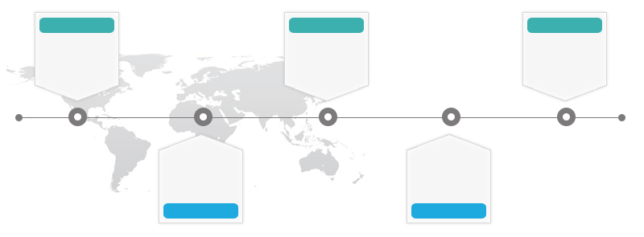
Technical Lead with Hexaware Technologies

2019
Senior Software Engineer with Accenture
2016-2017

2012-2016

Senior Software Engineer with Wipro Technologies

2017-2019

Senior Developer (AM) with CITI Corp

?
Looking for Good Opportunity
 | Education |  | - Bachelor of Engineering (Electrical) from Nagpur University (RTMNU) in 2012
 | Certifications |  | - Microsoft Certification on MVC,HTML and Web services.
 | Work Experience
 | Oct'17-Sep’19  Highlights: |  |  | Programmer Analyst (.Net Developer)  CITI Corp, Pune  Worked as Individual contributor on ASP.NET MVC UI application used for global payments.  Significant Highlights:  - Successfully delivered all the required deliverables regarding payments services globally which includes various facility given to user and admin for transaction like Create payment request, Review payments, approve & Modify payments.  - Gathered and documented all the requirements related to various countries payments rules and authority rules for development of all the related screens.  - Other than development activities, was engaged in various business meetings, daily scrum calls, sprint planning, backlog meetings, Production support at the time of installation.  - Carried out unit tests and delivered all the defects fixes within stipulated time.  - Co-ordination with various up-stream and down-stream teams for smooth delivery.
 | Aug'16-Oct'17  Highlights: |  |  | Senior Software Engineer  Accenture services Ltd, Pune  Worked as Web developer and DevOps Engineer in MVC based Web Application to provide insurance services.  Significant Highlights:  - Delivered all the deliverables for a MVC based web application and Web API.  - Contributed for the successful CICD automation in the project. Automated the build and deployment process and supported on-request deployment of Web App and Web API on lower environments like DEV, SIT etc.
 | June'12-Aug'16  Highlights: |  |  | Senior Software Engineer  Wipro Technologies, Pune  Worked as .Net Developer on WEB API project which provides services to Banking Web (UI) Application.  Significant Highlights:  - Worked on complete end to end software lifecycle such as requirement gathering, documentation, coding, unit testing, Deployment support, QA support etc.  - Leading a small team of 6 members to ensure smooth delivery of the deliverables into production.  - Contributed on value adds like internal tools , fun activities, building POC etc.
 | Sep'19- Present |  |  | Team lead,  Hexaware Technologies, Pune  Working as .Net Full-stack developer to build an POC for a upcoming project to the company.
 | Personal Details |  |  | Date of Birth: 16th January 1991

