**WORK BREAKDOWN STRUCTURE**

* Group Id :

SY. B Tech – A3

* **Student: -** 1) Pratik Borkar 221073-A3

2) Apurva Kirdat 221065 -A3

3) Shraddha Kate 221057-A3

4) Rutuja Kauthale 221058-A3

* **Project Title**

Online Food Delivery

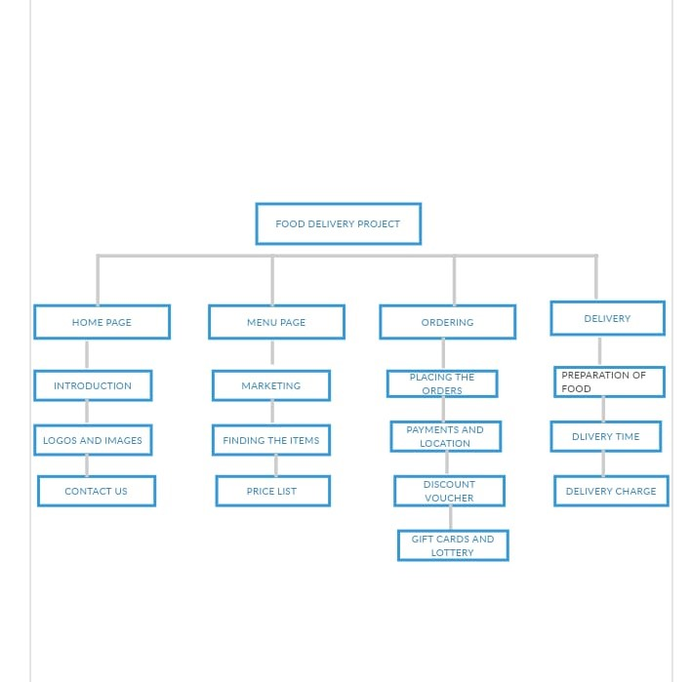

The purpose of this system is to develop an online food ordering system. It is a system that enable customer of food to place their order online at any time and any place. The reason to develop the system is due to the issues facing by the food industry. These issues such as peak hour long queue issues, increase of take away than visitors, speed major requissite of food preparation, limited proportion and advertising on current strategy, and quality control of food management issues. Our system provides a user friendly web pages and advertisement medium to a new product of thr online food restaurant at cheaper cost.