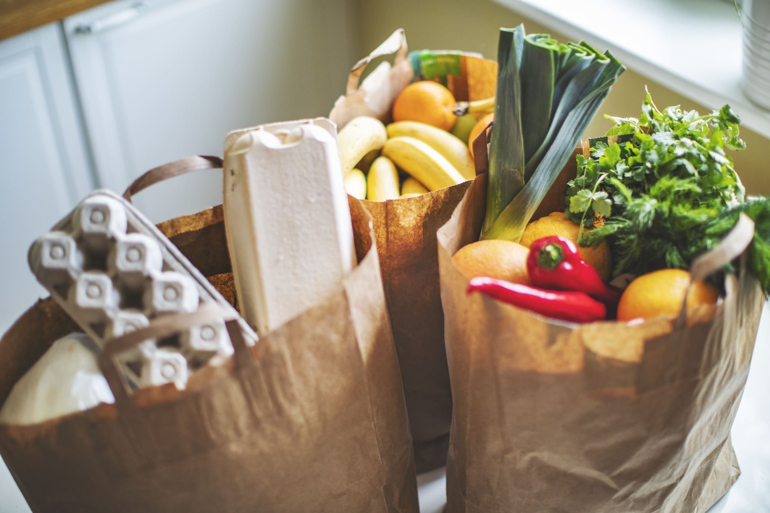

Project Name: Online Grocery Store

**Group Members:**

Pratik Chorghe

**Description:**

The Online Grocery Store project aims to provide customers with a convenient platform to purchase groceries online. This platform will be developed using ReactJS for the front-end, HTML, CSS, and JavaScript for the design and functionality, and NodeJS for the back-end. The MongoDB database will be used to store customer details, orders, and product information.

**Project Scope:**

The scope of the project includes developing a user-friendly e-commerce website where customers can browse and purchase groceries online. The website will have features such as product categorization, search functionality, user registration, shopping cart, payment gateway, order tracking, and admin panel for managing orders and inventory.

**Deliverables:**

1. User-friendly e-commerce website
2. Admin panel for managing orders and inventory
3. Product categorization and search functionality
4. Shopping cart and payment gateway
5. Order tracking system
6. User registration and login system
7. Database schema and documentation
8. User manual and technical documentation

Timeline:

The project is expected to be completed within 5 months

**Budget:**

The estimated budget for the project is [budget amount] and includes expenses for personnel, hardware, software, and any other expenses related to the development and deployment of the platform.

**Resources**:

* ReactJS for the front-end
* HTML, CSS, and JavaScript for design and functionality
* NodeJS for the back-end
* MongoDB for the database

**Methodology:**

The project will follow the Agile software development methodology, which includes iterative development, continuous integration, and regular feedback from stakeholders. The team will use JIRA for project management, Git for version control, and automated testing for quality assurance.

**Risk Assessment:**

The potential risks associated with the project include:

1. Technical issues with the implementation of payment gateway and order tracking system
2. Delays in delivery of hardware and software components
3. Security vulnerabilities in the e-commerce website

**Quality Assurance:**

To ensure the quality of the project deliverables, the team will follow best practices for software development, including code reviews, unit testing, and continuous integration. The team will also conduct regular user testing to gather feedback and make necessary improvements.

**Conclusion:**

The Online Grocery Store project aims to provide customers with a convenient platform to purchase groceries online. The platform will be developed using ReactJS, HTML, CSS, JavaScript, NodeJS, and MongoDB, and will include features such as product categorization, search functionality, user registration, shopping cart, payment gateway, order tracking, and admin panel for managing orders and inventory. The project will follow the Agile software development methodology, and quality assurance processes will be in place to ensure the project meets its objectives.

**References:**

[Insert any references used to develop the project synopsis, including research papers, articles, or other materials that were consulted.]