;l
Foundations of Programming
Assignment No. : 01
1. PROBLEM STATEMENT:
Write a program in C to check whether a given year is a Leap Year OBJECTIVE:
1. To understand the use of conditional statements in C programming. 2. To implement logical conditions for solving real-world problems. 3. To develop problem-solving skills using decision control structures.
THEORY:
1. Theory for conditional statements with syntax (if , if-else, if-else ladder) are used in C programming
The if statement is the simplest form of a conditional statement. if statement is executed only if the condition is true.
Syntax:
if (condition)
{
// statements to be executed if condition is true
}
Example :
#include <stdio.h>

int main() {
int num = 10;

if (num > 5) {
printf("The number is greater than 5.\n");
}

return 0;
}
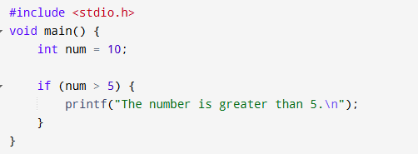
Output
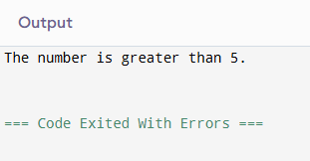

The if-else statement provides two possible paths of execution. If the condition is true, the if block is executed; otherwise, the else block is executed.
Syntax :
if (condition) {
// Code to be executed if condition is true
} else {
// Code to be executed if condition is false
}
Example :
#include <stdio.h>

int main() {
int age = 15;

if (age >= 18) {
printf("You are eligible to vote.\n");
} else {
printf("You are not eligible to vote yet.\n");
}

return 0;
}
Output :
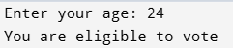

An if-else ladder is used when multiple conditions need to be checked in sequence. As soon as one condition becomes true, its corresponding block is executed, and the rest are skipped.
Syntax:
if (condition1)
{
// statements if condition1 is true
}
else
if (condition2)
{
// statements if condition2 is true
}
else
if (condition3)
{
// statements if condition3 is true
}
else
{
// statements if none of the above conditions are true
}

eg:
#include
int main()
{
int marks; printf("Enter your marks: ");
scanf("%d",&marks);
if(marks>=90){ printf("Your grade is A");
}
else if(marks>=80)
{
printf("Your grade is B");
}
else if(marks>=70)
{
printf("Your grade is C");
}
else if(marks>=50)
{
printf("Your grade is D");
} else if(marks>=35)
{
printf("Your grade is E");
}
else
{
printf("You are grade is F");
}
return 0;
}
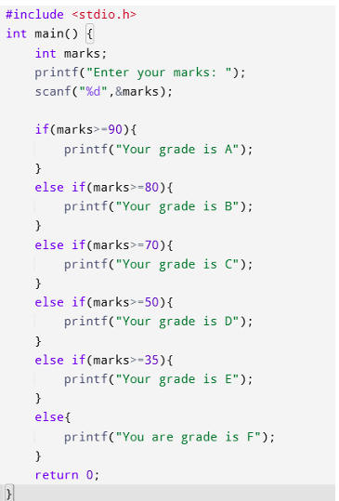
Output:
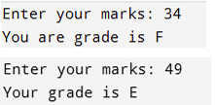
2. Theory for a Leap Year - year that contains 366 days instead of the usual 365 days.
Rules:
• A year is a leap year if it is divisible by 400, OR
• A year is a leap year if it is divisible by 4 but not divisible by100.
#include <stdio.h>
void main(){
int a;
printf("\n enter the year:");
scanf("%d",&a);
if ((a%4==0 && a%100!=0) || a%400 ==0 )
{printf("year is leap");}
else{
printf("year is normal");
}
}
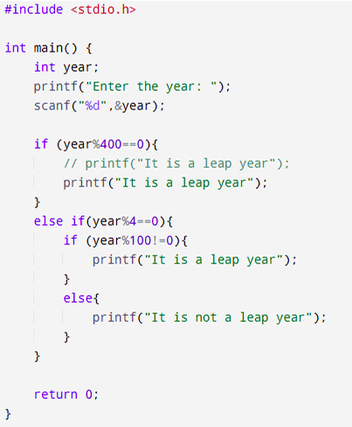
Output:
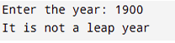
3. Algorithm
Step 1 = start
Step 2 = enter a year
Step 3 = if year%4==0 && year%100!=0) || year%400 ==0
Step 4 = if condition is true then year is leap year otherwise not a leap year
Step 5 = stop
PLATFORM: Linux
INPUT: Enter a year (integer value).
OUTPUT: Displays whether the entered year is a Leap Year or Not a Leap Year.
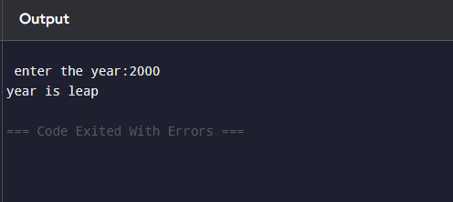
Sample Input
2024
Sample Output
2024 is a Leap Year
CONCLUSION: Thus, the program successfully checks whether a given year is a Leap Year using conditional statements in C.
FAQs:
1. What is a leap year?
2. Why is the year 1900 not a leap year but 2000 is? 3. Which operators are used in this program? 4. Difference between if and if–else statements.

