GemFinder Statistical Core Refinement
Code Explanation and Team Handover Guide
Plain-English draft for GitHub / team onboarding
Purpose of this document
This guide explains what the pipeline does, why each stage exists, what the important variables mean, what the figures show, and what the current limitations are. It is written for a teammate who may understand Python but is new to the GemFinder statistical method.

Project context: the code evaluates and refines the existing GemFinder statistical core using real historical RY25 subgroup comparisons, the existing EXP002 ONNX neural network, rho sensitivity analysis, and a separate Bayesian uncertainty evaluation.
Status: draft team guide. Numerical EXP002 Gamma results should be treated as provisional until the rate-scaling interpretation in common.py is confirmed against the original validated inference implementation.

Contents
- 1. Project objective in simple words
- 2. What the pipeline does from start to finish
- 3. Data and model inputs
- 4. Key concepts and variable dictionary
- 5. File-by-file code explanation
- 6. One simple example from raw data to final result
- 7. Why each statistical approach was used
- 8. What the pipeline measures
- 9. What each final graph means
- 10. Current results from this run
- 11. Limitations and why they exist
- 12. How to run the code
- 13. What to say when explaining the code to a teammate
- 14. Suggested next steps
One-sentence summary
The pipeline first checks whether a real subgroup comparison is suitable for the existing EXP002 model, then evaluates robustness and uncertainty, and finally produces tables and figures that show what is trustworthy, what is sensitive, and what remains data-dependent.

1. Project objective in simple words
The existing GemFinder system compares how two groups answered the same survey question. The aim of this code is to make that statistical process easier to evaluate, safer to use, and easier to explain.
The code does not try to replace the existing EXP002 model automatically. Instead, it asks four practical questions:
- Does this comparison look like the type of data EXP002 was trained to handle?
- If assumptions about response reliability (rho) change, does EXP002 change a little or a lot?
- How uncertain are the observed group-response differences?
- Which parts can be supported by the available data, and which parts require additional information?
What outcome am I presenting?
A reproducible eight-stage pipeline that creates real historical subgroup comparisons, screens them, runs the existing model where appropriate, tests sensitivity, adds Bayesian response uncertainty, benchmarks the methods, and produces a final results table plus six presentation-ready figures.

2. What the pipeline does from start to finish
RY25 survey data + rho matrices + EXP002 model
|
v
01 Prepare real subgroup comparisons
|
v
02 Screen inputs: SAFE / WARN / REJECT
|
+------ SAFE/WARN ------> 03 EXP002 inference
|
+------ flagged --------> 04 Fallback route (implementation external)
|
v
05 Rho + sample-size sensitivity
|
v
06 Bayesian response uncertainty
|
v
07 Historical benchmark
|
v
08 Final tables + six figures + summary

A useful way to think about this is an assembly line: each file has one main job, and the output of one stage becomes the input to the next stage.

3. Data and model inputs
Input | What it is | Why the pipeline needs it
RY25_PreMay10.csv / RY25_PostMay10.csv | Historical survey responses | Build real group comparisons and response-count histograms.
unreliability-matrices.json | Question-specific 4 x 4 rho matrices | Represents test-retest response unreliability for each survey item.
EXP002_nn_optimal_epoch.onnx | Existing trained neural network | Predicts Gamma parameters for the existing GemFinder pathway.
EXP002.json | Model metadata and training min/max values | Defines the 40 model features and the ranges used for normalisation and compatibility checks.
B_matrix.txt | Projection matrix used in the d_hat calculation | Removes the redundant dimension caused by response proportions summing to one.
Optional test-retest transition counts | Paired original-to-retest response counts | Would be required to estimate Bayesian uncertainty in rho itself.

4. Key concepts and variable dictionary
The names below are the main variables a teammate will see in the code and result files. They are explained as if the reader is new to the statistical method.
Variable / term | Meaning | Newbie-friendly interpretation
item | Survey question name, e.g. ry9. | The question being compared.
group_a / group_b | The two real subgroups. | Example: Grade 4 versus Grade 7.
counts_a_1 ... counts_a_4 | Number of Group A respondents choosing options 1 to 4. | Example: [100, 300, 500, 600].
counts_b_1 ... counts_b_4 | Same counts for Group B. | Example: [120, 280, 520, 650].
n_a / n_b | Total valid responses in each group. | Sum of the four response counts.
sample_size_ratio | Larger group size divided by smaller group size. | Shows whether one group is much larger than the other.
rho | 4 x 4 response unreliability matrix. | rho[1,2] means probability of changing from response 1 to 2 on retest.
rho_valid | Whether rho is usable. | Checks shape, finite values, non-negative values and acceptable row sums.
rho_asymmetry | How directionally different rho is. | Changing 1->2 may not have the same probability as 2->1.
d_hat | Estimated distance between two response distributions. | Bigger value means stronger observed difference.
d_hat_norm | Sample-size-scaled version of d_hat used by the project. | The main distance statistic used in historical and Bayesian evaluation.
EXP002 | Existing GemFinder neural network. | Fast approximation of the Gamma distribution that would otherwise require expensive simulation.
alpha | Gamma shape parameter predicted by EXP002. | Controls the shape of the Gamma distribution.
beta | Gamma rate parameter predicted by EXP002. | Controls the Gamma distribution scale; mean = alpha / beta.
gamma_mean | Mean of the EXP002 Gamma distribution. | Typical value under the modelled retest distribution.
gamma_q95 | 95th percentile of the EXP002 Gamma distribution. | Only 5% of that modelled Gamma distribution lies above it.
screening_status | SAFE, WARN or REJECT. | Compatibility status only; it is NOT a significance result.
warning_features | Which feature caused a warning. | Example: euclid_dist_XY outside the model training range.
DIRICHLET_PRIOR_ALPHA | Bayesian prior amount added to each response category. | 0.5 is a weak symmetric prior used before adding observed counts.
POSTERIOR_DRAWS | Number of Bayesian samples. | 20,000 plausible response distributions are generated by default.
bayes_dhat_mean | Average d_hat_norm across posterior draws. | A Bayesian uncertainty-aware summary of the group difference.
bayes_dhat_ci_low / high | 95% credible interval bounds. | Range containing 95% of posterior d_hat_norm draws.
epsilon | Minimal-effect threshold. | A boundary used to ask whether d_hat_norm is above a chosen level.
OFFICIAL_EPSILON | Official threshold if supplied externally. | Currently None, so no official Bayesian minimal-effect decision is claimed.
diagnostic thresholds | Empirical q25/q50/q75/q90 values from historical d_hat_norm. | Exploratory reference points only, not official decision thresholds.
fallback_used | Whether a non-EXP002 fallback actually ran. | Currently false because the team fallback implementation is external/not integrated.
runtime_ms | Execution time in milliseconds. | Used to compare computational efficiency.

4.1 What exactly is rho?
rho is a 4 x 4 matrix describing how stable a survey answer is if the same person answers the same question again. Each row represents the original response and each column represents the retest response.
Example rho row for original response = 1:
[0.80, 0.15, 0.04, 0.01]
Interpretation:
80% answer 1 again
15% change to 2
4% change to 3
1% change to 4

The diagonal values (1->1, 2->2, 3->3, 4->4) therefore represent staying with the same response. Large diagonal values usually indicate more stable responses.
Why rho matters
Two groups may appear different partly because real respondents are not perfectly consistent on retest. GemFinder uses rho so this response unreliability is part of the statistical model.

4.2 What are d_hat and d_hat_norm?
d_hat is an estimated statistical distance between two groups' response distributions after accounting for the covariance structure implied by rho. d_hat_norm is the scaled version used by this project so the statistic is comparable under the GemFinder setup.
Simple interpretation
Small d_hat_norm = the two response distributions are more similar. Large d_hat_norm = they are more different. It is a distance/statistic, not by itself a final yes/no significance decision.

5. File-by-file code explanation

config.py
The settings panel
Keeps important values in one place so the rest of the code does not contain hard-coded choices everywhere.

What it does: Sets the random seed, 20,000 posterior draws, prior alpha 0.5, minimum group size 5, grade pairs, rho perturbations, sample-size grid and plotting limits.
Main output: Nothing statistical is calculated here; other scripts import these settings.

common.py
The shared toolbox / kitchen
Avoids copying the same maths and file-reading logic into every stage.

What it does: Finds the supplied assets, validates and normalises rho, builds the 40 EXP002 features, normalises features, runs ONNX inference, calculates d_hat_norm, generates Bayesian draws, and perturbs rho.
Main output: Most of the core mathematical helper functions live here.

01_prepare_comparisons.py
Build the real comparison cases
The model needs two response-count vectors, not one giant raw CSV.

What it does: Reads the selected RY25 dataset, keeps valid four-option items with rho, creates Grade 4 vs 7, Grade 11 vs 6 and Grade 12 vs 5 comparisons, and saves response counts.
Main output: results/comparisons.csv

02_screen_inputs.py
Safety/compatibility gate
A neural network should not be trusted blindly on inputs unlike its training data.

What it does: Checks rho validity and selected EXP002 feature ranges. Labels each comparison SAFE, WARN or REJECT and records the exact warning feature.
Main output: results/screening_results.csv

03_standard_exp002.py
Run the existing GemFinder model
Keeps the original model as the baseline method instead of retraining it.

What it does: For SAFE/WARN rows, sends the comparison through the ONNX model and reports alpha, beta, Gamma summaries and runtime.
Main output: results/exp002_results.csv

04_fallback_inference.py
Make the routing visible
If a case is unsuitable for EXP002, the architecture should route it elsewhere rather than silently trust the model.

What it does: Marks flagged cases as FALLBACK_REQUIRED. It does not invent an alternative method when the team fallback implementation is unavailable.
Main output: results/fallback_results.csv

05_uncertainty_analysis.py
Stress-test assumptions
A robust model should not produce wildly different answers after a small reasonable change in assumptions.

What it does: Changes rho off-diagonal error mass by -10%, -5%, -1%, 0%, +1%, +5%, +10%. Separately changes sample size while keeping response proportions approximately fixed.
Main output: results/rho_sensitivity.csv and sample_size_sensitivity.csv

06_bayesian_evaluation.py
Quantify response uncertainty
Observed response percentages are estimates from finite samples, not exact population truths.

What it does: Uses exact Dirichlet posteriors for Group A and B response probabilities, samples plausible response distributions, propagates them through d_hat_norm, and reports posterior summaries. It only estimates rho uncertainty if genuine transition counts are supplied.
Main output: results/bayesian_response_results.csv, diagnostic_thresholds.csv, bayesian_rho_summary.md

07_historical_benchmark.py
Combine the experiment into one benchmark
The team needs one table showing what happened for every real historical comparison.

What it does: Merges comparisons, screening, EXP002, fallback status and Bayesian results, preserving the distinction between EXP002 Gamma quantities and Bayesian d_hat_norm quantities.
Main output: results/historical_benchmark.csv

08_compare_and_report.py
Presentation/report layer
Raw CSVs are difficult to explain in a review meeting.

What it does: Creates final_pipeline_results.csv, final_summary.md, the compliance table and the six core figures.
Main output: results/final_pipeline_results.csv, results/final_summary.md, figures/final/*.png

run_pipeline.py
Master controller
Makes the analysis reproducible with one command.

What it does: Runs stages 01 to 08 in order and passes Bayesian draw/epsilon/transition-count options to the relevant stages.
Main output: A complete pipeline run.

requirements.txt
Dependency list
Lets another teammate install the required Python packages.

What it does: Lists numpy, pandas, scipy, matplotlib and onnxruntime.
Main output: Reproducible environment setup.

README.md
Human instructions
Code is not useful to a team if only the original author knows how to run it.

What it does: Explains the project, file layout, commands, outputs and statistical rules.
Main output: GitHub-facing documentation.

6. One simple example from raw data to final result
Suppose we are comparing survey item ry9 for Grade 4 and Grade 7. The numbers below are illustrative so the logic is easy to follow.
Grade 4 counts: [100, 300, 500, 600] -> n_a = 1500
Grade 7 counts: [120, 280, 520, 650] -> n_b = 1570

Stage | What happens
Stage 1 | The code creates one comparison row and stores the eight response counts plus group sizes.
Stage 2 | It validates ry9 rho and checks whether the EXP002 features are inside known training ranges. Suppose this row is SAFE.
Stage 3 | EXP002 receives the response distributions, n_a, n_b and rho and predicts Gamma shape/rate parameters.
Stage 5 | The same comparison is rerun after controlled rho changes and sample-size changes to test robustness.
Stage 6 | The Bayesian branch treats the observed percentages as uncertain. It generates many plausible response distributions and recalculates d_hat_norm for each draw.
Stage 7/8 | The EXP002, screening, Bayesian, runtime and routing information is merged into the benchmark and final report.

Important distinction
EXP002 Gamma summaries and Bayesian d_hat_norm posterior summaries are shown side-by-side for evaluation, but they should not be interpreted as the same statistical quantity.

7. Why each statistical approach was used
Approach | Why it is used
Real subgroup comparisons | A Grade 4 vs Grade 7 comparison is a realistic use case. Comparing the whole Pre file with the whole Post file could mix many different populations and does not represent a normal GemFinder query.
Compatibility screening | Neural networks interpolate best on data similar to training data. Screening makes out-of-range cases visible instead of hiding extrapolation.
Existing EXP002 as baseline | The project is evaluating/refining the current statistical core, so the original trained model should remain the reference pathway rather than being silently replaced.
Fallback routing | A production architecture needs a safe path when EXP002 is unsuitable. The code exposes the route without inventing a team method that has not been delivered.
Rho sensitivity | rho is an assumption about response reliability. If small rho changes cause large inference changes, that is important evidence about model robustness.
Sample-size sensitivity | GemFinder compares groups of different sizes. Testing multiple n values helps show whether the model behaves consistently and where it leaves training support.
Bayesian response uncertainty | Observed histograms come from finite samples. A posterior distribution shows a range of plausible group-response distributions instead of treating the observed percentages as exact.
Bayesian rho uncertainty only with real transitions | A probability matrix by itself does not tell us how certain those probabilities are. Transition counts are needed to estimate the Dirichlet concentration/effective evidence behind rho.
Diagnostic thresholds | Historical quantiles provide useful exploratory reference points when no official epsilon has been supplied. They are explicitly not labelled official.
Runtime benchmarking | The original motivation for EXP002 is computational efficiency. Measuring runtime shows the trade-off between very fast neural inference and slower uncertainty evaluation.

8. What the pipeline measures
Question | Measurement | Simple meaning
Input compatibility | SAFE / WARN / REJECT | Can EXP002 reasonably be used on this comparison?
Observed difference | d_hat_norm | How different are the two observed response distributions under the GemFinder distance calculation?
Existing model output | alpha, beta, Gamma mean, q95 | What Gamma distribution does EXP002 predict for the current case?
Rho robustness | Change in EXP002 outputs under rho perturbations | How much does the existing method depend on the reliability assumption?
Sample-size robustness | EXP002 outputs at different n values | How does model behaviour change when group size changes but approximate response proportions stay the same?
Bayesian response uncertainty | Posterior mean, median, SD and 95% credible interval of d_hat_norm | How uncertain is the observed response-distribution difference because we only have finite samples?
Threshold probability | P(d_hat_norm > epsilon | data) | How much posterior support is there that the distance is above a selected threshold?
Computational cost | runtime_ms | How fast is EXP002 compared with Bayesian evaluation?

9. What each final graph means
The figures below are the actual outputs from the supplied pipeline run. Their purpose is to make the technical results easier to present.
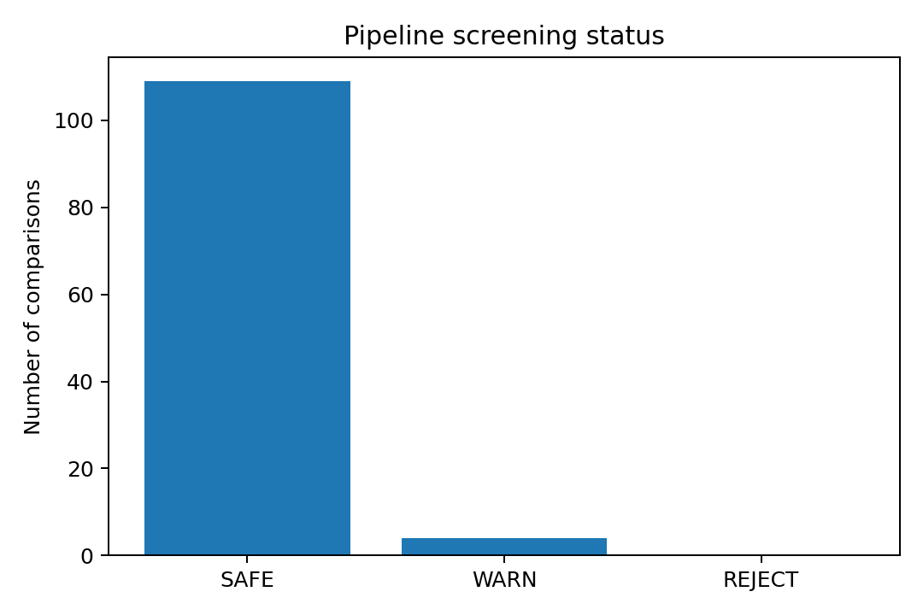
Figure 1. Pipeline screening status
What this graph means in simple words
Shows how many real historical comparisons were SAFE, WARN or REJECT for EXP002 compatibility. In this run, most cases were SAFE, which suggests the selected subgroup comparisons generally fall within the model checks used by the pipeline.

Important interpretation note
SAFE does not mean “no statistical difference”. It only means the input looks compatible with the model checks.

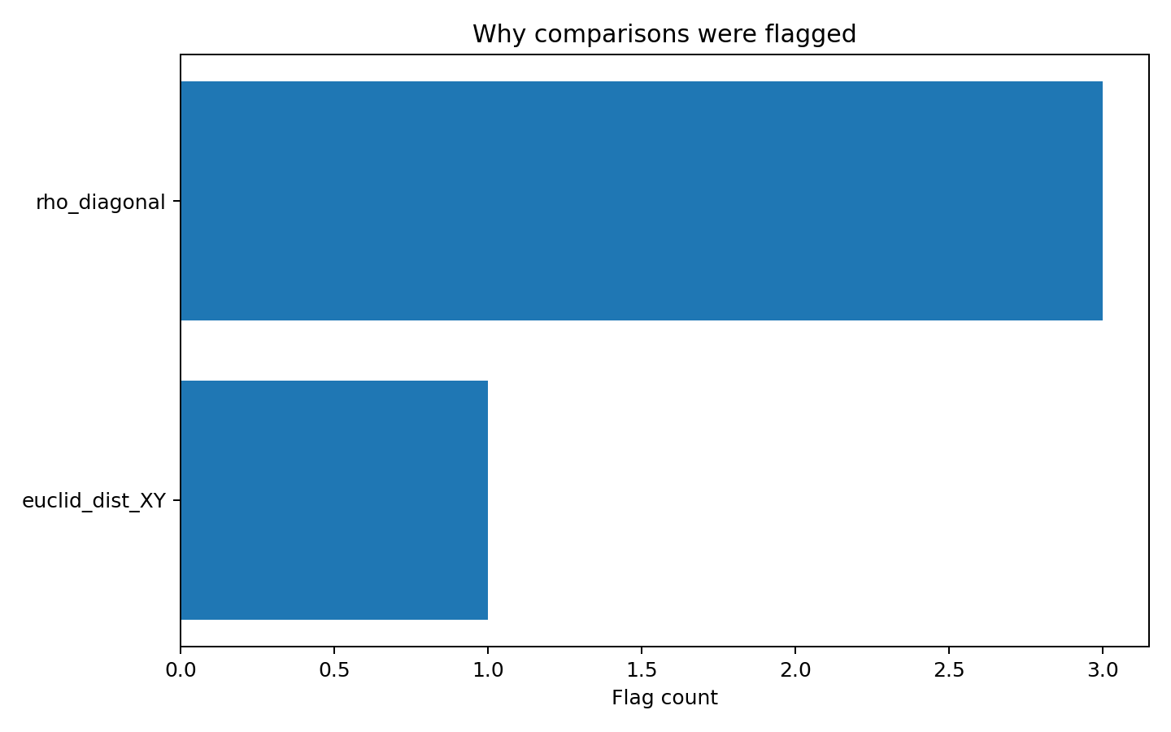
Figure 2. Why cases were flagged
What this graph means in simple words
Counts the reasons WARN cases were flagged. Here, three warnings came from a rho diagonal check and one from euclid_dist_XY being outside the stored EXP002 training range.

Important interpretation note
A warning is a transparency signal. WARN rows may still be evaluated for research, but the warning must stay attached to the result.

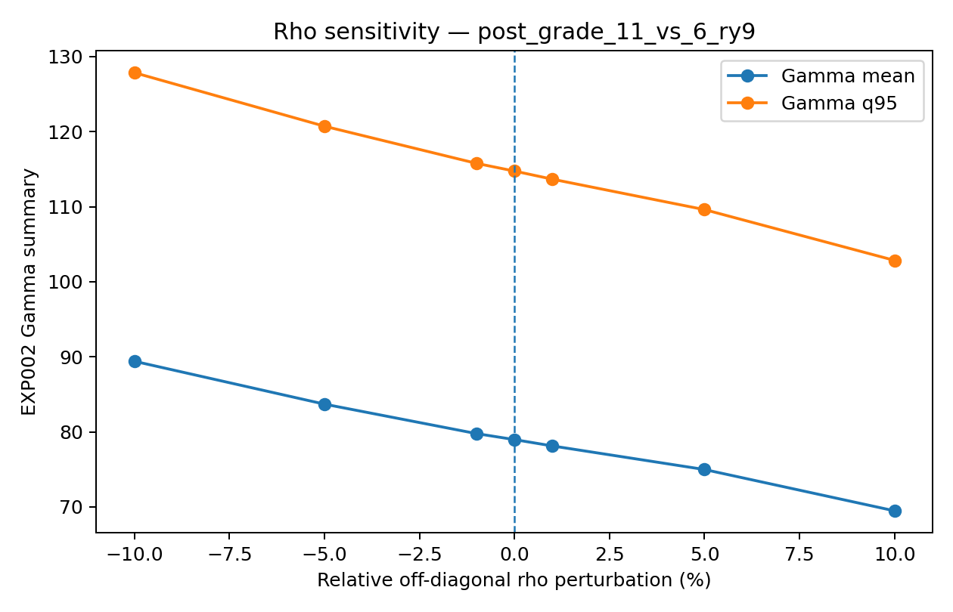
Figure 3. EXP002 sensitivity to rho
What this graph means in simple words
Shows how the EXP002 Gamma summary changes when the off-diagonal error mass of rho is deliberately reduced or increased. The key research question is the trend: does the inference remain stable or move substantially as the reliability assumption changes?

Important interpretation note
The current pipeline run applies an additional EXP002 rate transformation that should be verified against the original validated inference code before final numerical Gamma mean/q95 values are reported. Treat the present y-axis values as provisional until that check is resolved.

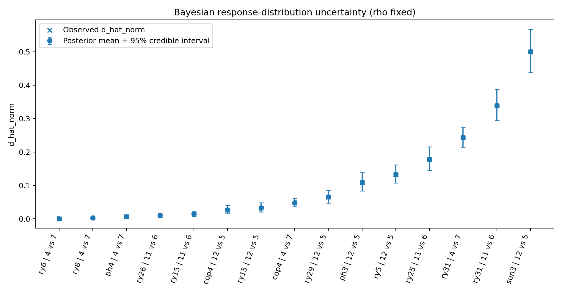
Figure 4. Bayesian response-distribution uncertainty
What this graph means in simple words
Each comparison has a posterior mean and a 95% credible interval for d_hat_norm. The “x” marker is the directly observed d_hat_norm. Narrow intervals mean the response-based estimate is relatively precise; wider intervals mean more uncertainty.

Important interpretation note
rho is held fixed in this graph. The interval represents uncertainty in response probabilities, not uncertainty in rho.

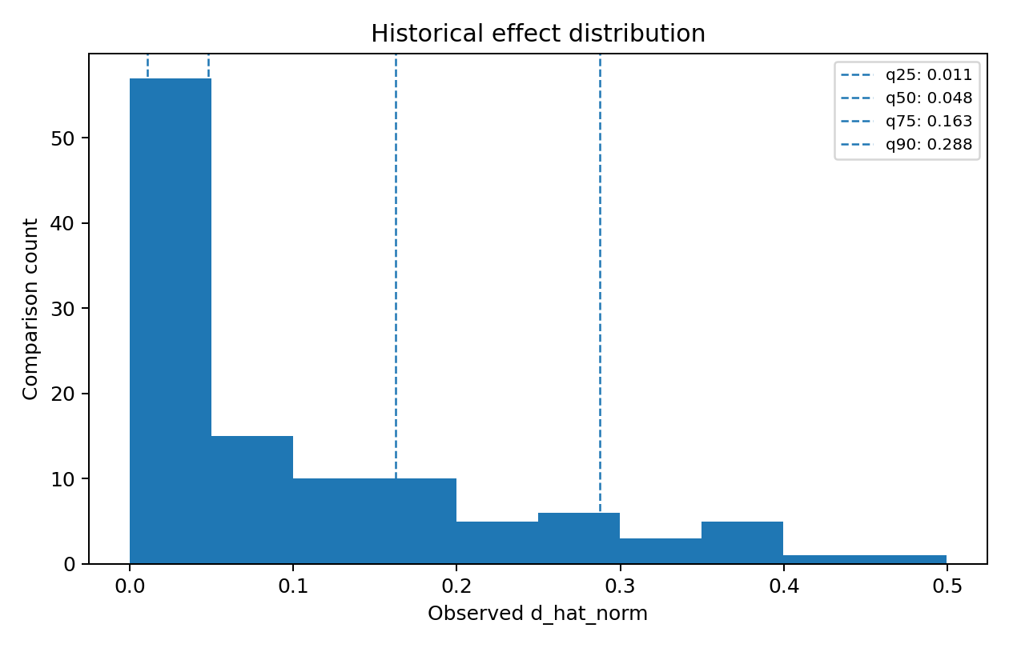
Figure 5. Historical distribution of observed d_hat_norm
What this graph means in simple words
Shows how the observed distances are distributed across the real historical comparisons. Dashed lines are empirical q25, q50, q75 and q90 reference points, helping the team understand what “small”, “typical” and “large” values look like in this historical sample.

Important interpretation note
These dashed lines are exploratory diagnostic thresholds, not official GemFinder minimal-effect boundaries.

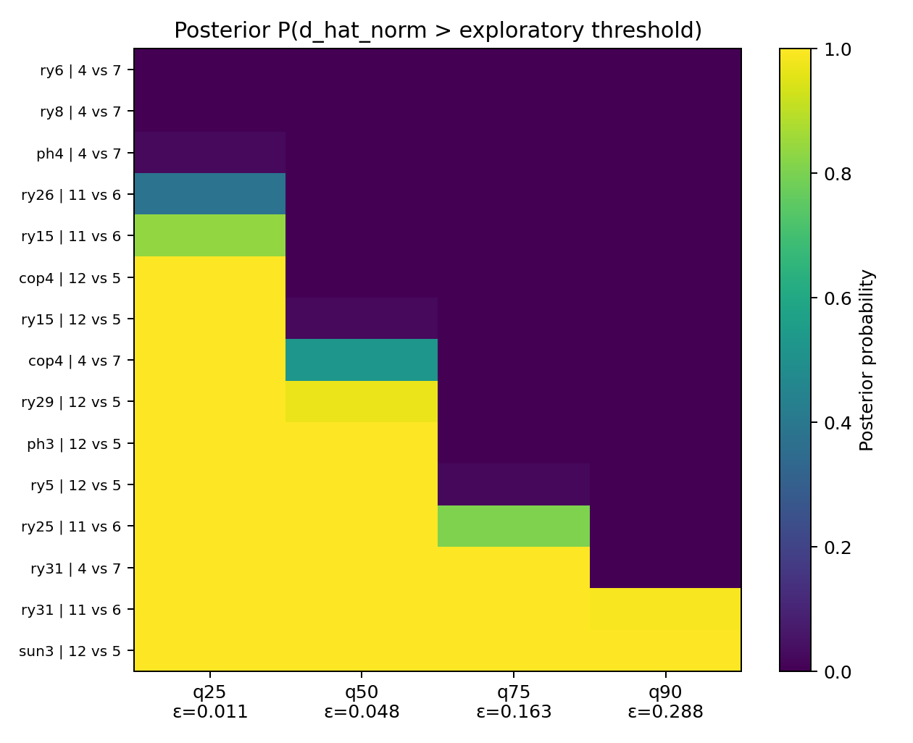
Figure 6. Posterior probability above exploratory thresholds
What this graph means in simple words
For representative comparisons, the heatmap shows P(d_hat_norm > epsilon | data). Darker/higher cells mean stronger posterior support that the comparison is above that historical reference threshold.

Important interpretation note
Do not turn these exploratory probabilities into an official pass/fail decision unless an externally justified official epsilon and decision rule are supplied.

10. Current results from this run
Result | Current value/status | What it means
Historical comparisons | 113 | Real grade subgroup comparisons across usable four-option survey items.
Screening | 109 SAFE, 4 WARN, 0 REJECT | Most comparisons passed the implemented compatibility checks.
Warning causes | 3 rho_diagonal; 1 euclid_dist_XY | The exact reason for each warning is recorded.
Bayesian response evaluations | 113 completed | Every prepared comparison received response-distribution posterior summaries.
Median Bayesian 95% CI width | about 0.0309 | Typical amount of response-based uncertainty in d_hat_norm for this run.
Diagnostic q25 | about 0.0110 | Exploratory historical reference.
Diagnostic q50 | about 0.0480 | Exploratory historical median.
Diagnostic q75 | about 0.1625 | Exploratory historical reference.
Diagnostic q90 | about 0.2877 | Exploratory historical reference.
Bayesian rho uncertainty | Not identifiable | No genuine paired test-retest transition counts were supplied.
Fallback | Routing present; method external | The pipeline shows where fallback is required but does not invent an implementation.
Official Bayesian decision | Not available | OFFICIAL_EPSILON is intentionally None.

EXP002 result caution
Do not quote the current Gamma mean/q95 values as final until the rate-scaling interpretation in common.py has been confirmed. The screening, comparison construction, Bayesian response results and limitation statements are separate from that issue.

11. Limitations and why they exist
Limitation | Reason | Practical effect
No genuine test-retest transition counts | The supplied rho matrices contain probabilities but not the number of paired observations behind each transition. | Bayesian uncertainty in rho cannot be identified. The pipeline keeps rho fixed and uses sensitivity analysis instead.
No official epsilon | The project has not supplied an externally justified official minimal-effect boundary. | The code can show exploratory historical thresholds and posterior probabilities, but cannot claim an official Bayesian minimal-effect decision.
Fallback method not integrated | The team-owned fallback implementation is not part of this code package. | Flagged cases are visibly routed to FALLBACK_REQUIRED, but no fake fallback result is generated.
EXP002 rate interpretation needs final verification | The current helper reverse-normalises network rate and then applies an additional sample-size-based transform. Comparison with the original validated inference path indicates this may double-transform the rate. | Current EXP002 beta/Gamma mean/q95 values and rho/sample-size sensitivity magnitudes should be treated as provisional until corrected/confirmed.
Sample-size-ratio range not populated in this run | The current run does not contain the original instance_data files needed by the helper to derive the empirical ratio range. | Feature-range screening still operates, but the separate empirical ratio-range check should be restored or disclosed as unavailable.
Only four-option items with usable rho are analysed | The statistical helpers and available rho matrices are defined for four response categories in this pipeline. | Other item formats are intentionally excluded from this version.
Bayesian branch is evaluation-only | It quantifies uncertainty in response probabilities but does not recreate the full original minimal-effects boundary test. | It should be presented as an exploratory evaluation/extension, not as a deployed replacement for GemFinder.
Historical comparison scope is selected grade pairs | The pipeline uses three preselected realistic subgroup pairs. | Findings demonstrate the method on those comparisons; broader subgroup coverage could be added later.

12. How to run the code
From the project root, install the required packages and run the master script. The assets root can point to the folder containing the extracted data/model files or the supplied archives supported by the helper logic.
pip install -r pipeline_v2/requirements.txt
python pipeline_v2/run_pipeline.py --assets-root data

Optional arguments:
python pipeline_v2/run_pipeline.py --assets-root data --draws 20000
# Only if an official threshold is supplied:
python pipeline_v2/run_pipeline.py --assets-root data --official-epsilon <value>
# Only if genuine test-retest transition counts are supplied:
python pipeline_v2/run_pipeline.py --assets-root data --transition-counts <file.csv>

Main places to look after a run:
- pipeline_v2/results/final_pipeline_results.csv
- pipeline_v2/results/final_summary.md
- pipeline_v2/figures/final/

13. What to say when explaining the code to a teammate
60-second explanation
I built the code as an eight-stage evaluation pipeline around the existing GemFinder EXP002 model. First I convert real RY25 data into realistic grade-group comparisons. Then I screen each case so we do not blindly trust the neural network outside the types of inputs it understands. For compatible cases I run the existing EXP002 model. I then stress-test the result by changing rho, which represents survey response unreliability, and by changing sample size. Separately, I use a Bayesian Dirichlet model to show uncertainty in the observed response distributions and propagate that uncertainty into d_hat_norm. I combine all of this into a historical benchmark and six simple figures. Where data are missing, such as genuine test-retest counts for rho uncertainty or an official epsilon, the code reports the limitation instead of inventing a result.

14. Suggested next steps
- Resolve/confirm the EXP002 rate-scaling interpretation in common.py, then regenerate EXP002 results and Figure 3.
- Run the pipeline with the complete original network instance_data so the empirical sample-size-ratio compatibility range is available.
- Integrate the team-owned fallback implementation when it is ready.
- If genuine paired test-retest transition counts become available, enable the Bayesian rho uncertainty branch.
- If the industry partner supplies an official minimal-effect epsilon and exact decision rule, add the official Bayesian probability/decision comparison and agreement analysis.
- Optionally expand historical benchmarking to more justified subgroup definitions while keeping the same screening and reporting structure.

Appendix A. Quick glossary
Term | Remember it as...
rho | Probability model for how answers may change on retest.
d_hat_norm | Scaled distance between two response distributions.
EXP002 | Existing neural network that predicts Gamma parameters.
Gamma alpha/beta | Shape and rate parameters of the EXP002 distribution.
SAFE/WARN/REJECT | Input compatibility labels, not significance labels.
Dirichlet posterior | Bayesian distribution for plausible response probabilities after observing counts.
95% credible interval | Range containing 95% of posterior d_hat_norm draws.
epsilon | Minimal-effect threshold; official value not currently supplied.
sensitivity analysis | Deliberately change an assumption/input to see how much the result changes.
fallback | Alternative method intended for cases where EXP002 is unsuitable.

Appendix B. Team interpretation rules
- Do not say SAFE means statistically significant or non-significant.
- Do not call the exploratory q25/q50/q75/q90 thresholds official GemFinder thresholds.
- Do not compare the Bayesian d_hat_norm posterior mean with the EXP002 Gamma mean as if they are the same parameter.
- Do not say rho uncertainty was estimated when rho was held fixed.
- Do not use Pre/Post survey files as if they were paired test-retest transition counts.
- Do not call Monte Carlo propagation variational inference.
- Do not hide out-of-training-range warnings.
End note for GitHub
This document is intended as a teammate-friendly explanation of the codebase. The README should stay short and operational; this guide can be linked from the README for anyone who wants the statistical reasoning and file-by-file walkthrough.

