Bitcoin Market Sentiment & Trader Performance Analysis
DS Task — Round 0 Submission

Executive Summary
- Traders in this dataset performed best during Extreme Greed (89.2% win rate) and Fear (87.3%), and worst during Extreme Fear (76.2%) and Greed (76.9%) — performance follows a jagged, non-linear pattern rather than a simple "fear = losses, greed = gains" story.
- Positioning is contrarian at the extremes: 68.8% of new positions opened during Extreme Fear were LONG, while only 45.1% of new positions during Extreme Greed were long (54.9% short) — this cohort buys dips and fades euphoria rather than following the crowd.
- Performance is highly concentrated: the top 5 of 32 accounts generated over 60% of all positive PnL, meaning sentiment-based patterns are partly driven by a handful of skilled/large traders rather than the full population.
- Coin-level behavior diverges sharply — BTC and HYPE were consistently profitable across all sentiment regimes, while smaller/altcoin tickers (e.g. @107) swung from a loss in Extreme Fear to the largest single gain in Extreme Greed, suggesting altcoins amplify sentiment-driven momentum far more than BTC.

Datasets & Methodology
Two datasets were merged on calendar date: the Bitcoin Fear/Greed Index (daily sentiment classification, 2018–2025) and Hyperliquid historical trade data (211,224 trades across 32 accounts and 246 tokens, May 2023–May 2025). 99.997% of trades matched to a sentiment reading for their execution date.
"Realized" trades were defined as rows with non-zero Closed PnL (29,808–20,853 trades per sentiment bucket). Win rate is the share of realized trades with positive PnL. "New position" direction (Open Long / Open Short) was used to measure directional bias independent of position-closing activity.

Finding 1: Win Rate & PnL by Sentiment
The relationship between sentiment and profitability is not linear. Both extremes of sentiment (Extreme Greed and Fear) produced the strongest results, while the moderate-negative and moderate-positive zones (Extreme Fear, Greed) underperformed:
Sentiment | Trades | Win Rate | Avg PnL/Trade | Total PnL
Extreme Fear | 10,406 | 76.2% | $71.03 | $0.74M
Fear | 29,808 | 87.3% | $112.63 | $3.36M
Neutral | 18,159 | 82.4% | $71.20 | $1.29M
Greed | 25,176 | 76.9% | $85.40 | $2.15M
Extreme Greed | 20,853 | 89.2% | $130.21 | $2.72M

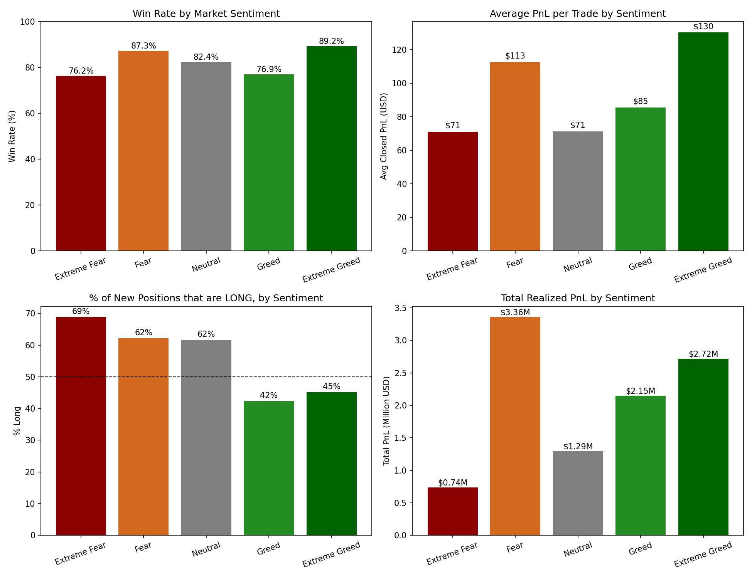

Finding 2: Contrarian Positioning
New long vs. short position openings shift sharply with sentiment, and in the opposite direction from what naive sentiment-following would predict:
Sentiment | % New Positions Long | % New Positions Short
Extreme Fear | 68.8% | 31.2%
Fear | 62.1% | 37.9%
Neutral | 61.7% | 38.3%
Greed | 42.3% | 57.7%
Extreme Greed | 45.1% | 54.9%

This cohort is disproportionately long during Fear/Extreme Fear and disproportionately short during Greed/Extreme Greed — classic contrarian, "buy the dip / fade the euphoria" behavior, and it corresponds with some of their best win rates (87–89%).

Finding 3: Performance Concentration Across Accounts
Of 32 unique accounts, the top 5 by total realized PnL account for over 60% of all positive PnL generated across the dataset. Several accounts show a strong Extreme-Fear-specific edge (e.g. one account earned $261.9K in Extreme Fear alone with no Extreme Greed activity), while others concentrate gains almost entirely in Extreme Greed (one account earned $478.8K in Extreme Greed vs. $30.8K in Extreme Fear). This suggests distinct trader archetypes: dip-buyers vs. momentum/euphoria traders, rather than one uniform strategy.

Finding 4: Coin-Level Sentiment Sensitivity
BTC and HYPE (the two highest-volume tokens) were profitable in every sentiment regime, with BTC's strongest single period being Fear ($482.6K total PnL, 87.6% win rate). By contrast, the token labeled @107 lost $136.1K during Extreme Fear (42.4% win rate — the weakest win rate of any coin/sentiment pair in the dataset) but generated $1.99M during Extreme Greed (92.1% win rate) — the single largest PnL figure of any coin-sentiment combination. Lower-cap tokens appear to amplify sentiment swings far more than BTC.

Strategic Implications
- The data supports increasing long exposure into Fear/Extreme Fear and trimming or flipping short into Greed/Extreme Greed, consistent with how the most profitable accounts in this dataset already behave.Fade extremes, don't follow them:
- BTC/HYPE exposure appears more robust across all sentiment states, while smaller-cap tokens carry much higher sentiment-driven variance — appropriate for higher risk tolerance and precise regime-timing rather than passive holding.Differentiate by asset:
- Average trade size was highest in Fear ($7.8K) and lowest in Extreme Greed ($3.1K) among this cohort, even though Extreme Greed had the best win rate — suggesting risk is already being managed down at euphoric extremes, which a strategy could formalize (smaller size, tighter stops, in Greed/Extreme Greed).Position sizing should account for regime:
- Because 5 accounts drive most of the profit, any strategy "learned" from this dataset should be validated out-of-sample rather than assumed to generalize to the median trader.Watch for survivorship/concentration bias:

Limitations
- Only 32 unique accounts are represented — not a large or necessarily representative trader sample.
- No explicit leverage column was present in the trade data despite being mentioned in the brief; leverage effects could not be directly analyzed.
- Fear/Greed Index is a market-wide (BTC-driven) sentiment measure, applied here to trading activity across 246 different tokens, some with low correlation to BTC sentiment.

