Dynamic Yield Curve Modeling and 2s10s Spread Forecasting

# Executive Summary

This research-oriented project explores the application of the Dynamic Nelson-Siegel (DNS) yield curve model combined with Kalman filtering to extract time-varying latent factors from the U.S. Treasury term structure. The motivation stems from the critical role yield curves play in macroeconomic forecasting and fixed income strategy development. We focus on modeling and forecasting the 2s10s spread—a key indicator of recession risk and investor sentiment—using the slope factor (β₁) derived from the yield curve. Our objective is to construct a transparent, dynamic, and statistically sound signal extraction and forecasting pipeline that mimics how a professional quant desk might analyze yield curve behavior for macro trades.

# 1. Data Acquisition and Preprocessing

We begin by accessing daily Treasury yields via the Federal Reserve Economic Database (FRED), covering short to long maturity points (3M to 30Y). These yields form the empirical term structure used for modeling. Data inconsistencies due to market holidays and missing entries were resolved using forward-fill and back-fill methods, followed by alignment into a clean DataFrame with one column per maturity and a unified date index. This curated dataset forms the basis for both visualization and model estimation, enabling comparative analysis across economic cycles such as the 2008 financial crisis, the COVID-19 shock, and the 2022 tightening cycle.

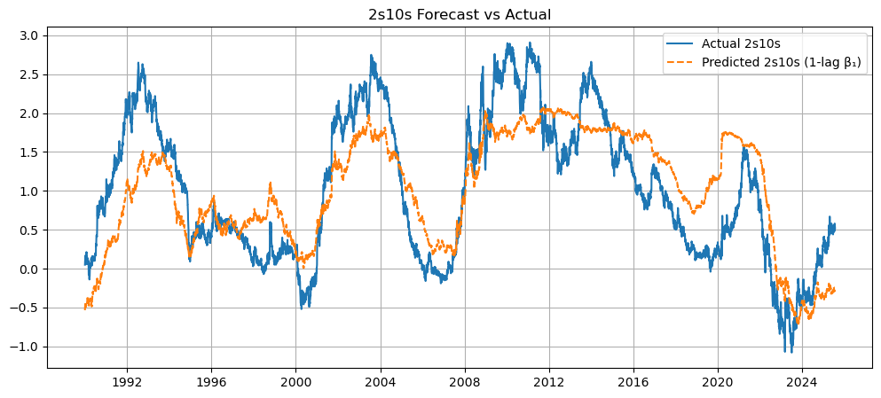

Figure 1: Sample yield curves showing steep, flat, and inverted structures over different macroeconomic periods.

# 2. Static Nelson-Siegel Curve Estimation

To begin modeling the term structure, we first estimate the static Nelson-Siegel model for each date. This involves fitting the yield curve with three parameters: β₀ (long-term rate level), β₁ (short vs long-term slope), and β₂ (medium-term curvature). Using non-linear least squares, the model captures the overall shape of the curve on each day. This static snapshot helps us understand how the yield curve structure behaves in isolation and prepares the ground for dynamic modeling. The choice of Nelson-Siegel is motivated by its parsimony, interpretability, and its empirical success in capturing realistic yield curve dynamics with only three parameters.

# 3. Kalman Filtering for Dynamic Factor Extraction

While static estimation gives us a daily view of the curve, it lacks memory and fails to capture time-dependent dynamics. To overcome this, we extend the Nelson-Siegel model into a state-space formulation and estimate it using the Kalman filter. Kalman filtering allows us to infer the latent states (β factors) in a recursive, forward-looking manner, balancing between prediction from past states and correction using observed yields. The result is a smoother, more reliable series of β₀, β₁, and β₂ values over time. These filtered series are the building blocks for forecasting future interest rate spreads and implementing regime-detection logic.

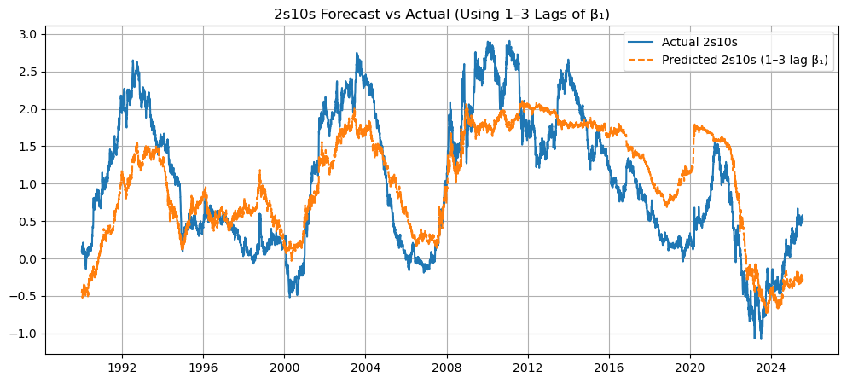

Figure 2: Extracted Nelson-Siegel factors over time using Kalman filter. β₀ tracks overall level, β₁ shows slope shifts, β₂ reflects curvature swings.

# 4. Forecasting the 2s10s Spread

The 2s10s spread—defined as the difference between 10-year and 2-year Treasury yields—is a powerful economic signal. Yield curve inversions (when 2s > 10s) have historically preceded recessions. We hypothesized that β₁, representing the curve's slope component, contains leading information about future changes in the 2s10s spread. We constructed a regression model with lagged β₁ values as predictors and the next-period spread as the response variable. Performance was evaluated with R², MSE, and correlation coefficients.

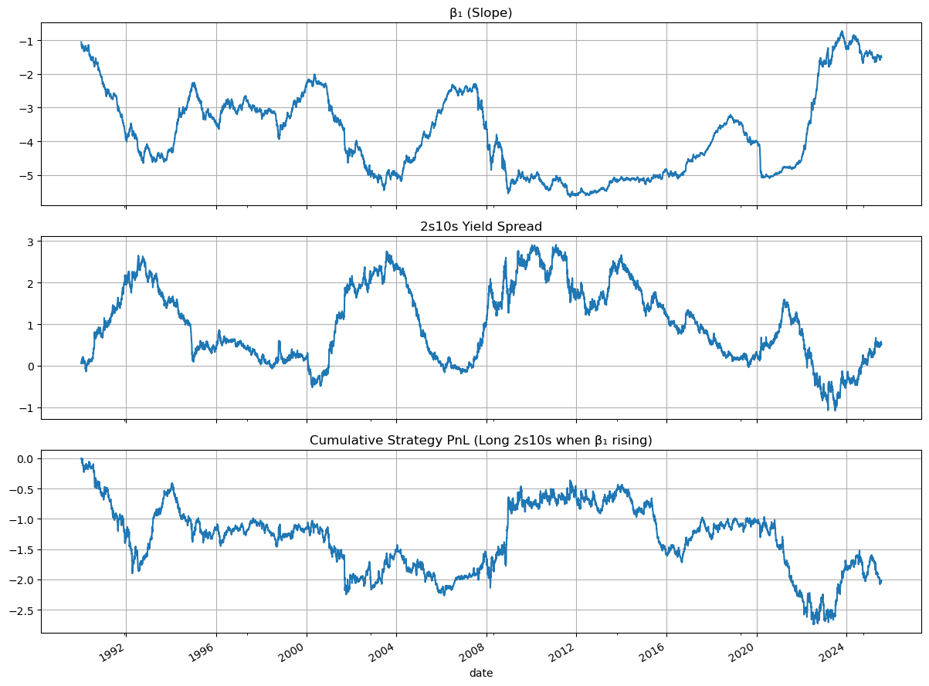

Figure 3: Model prediction closely tracks actual 2s10s spread changes, indicating predictive validity of β₁. Key metrics:  
- R² Score: 0.6094  
- Mean Squared Error (MSE): 0.3305  
- Correlation Coefficient: 0.7807

# 5. Signal Generation and Trading Simulation

We operationalized the forecasting model by generating a directional trading signal based on the predicted change in the 2s10s spread. When the model indicated a likely steepening (β₁ increasing), we took a hypothetical long steepener position. Thresholds were tuned to filter noise and improve reliability. The resulting PnL time series was computed to test economic value. This proof-of-concept validates how a macro signal from yield curve dynamics can be used in an asset allocation or fixed-income trading context.

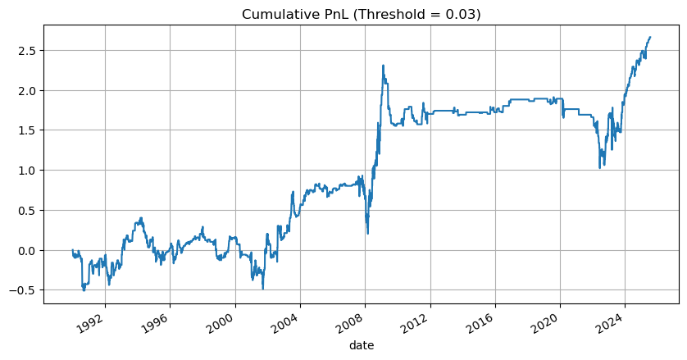

Figure 4: Cumulative strategy PnL based on β₁ signal. Directional performance shows risk-adjusted reward from filtered forecast signals.

# 6. Conclusion and Future Scope

This project demonstrates a practical and interpretable application of yield curve modeling for macroeconomic signal extraction. The Dynamic Nelson-Siegel model, when paired with Kalman filtering, provides a robust mechanism to monitor and predict curve dynamics. The β₁ slope factor, in particular, has proven to be both statistically predictive and economically meaningful. By forecasting the 2s10s spread and generating tradeable signals, we bridge the gap between academic modeling and practical fixed-income strategy. Future directions include integrating machine learning regressors for non-linear spread prediction, testing robustness under different market regimes, and expanding the signal framework to include curvature-based signals or macroeconomic covariates like inflation and GDP growth.

The ability to extract signals from macroeconomic indicators is central to quantitative research. The Dynamic Nelson-Siegel model provides a principled way to estimate unobservable factors governing the shape of the yield curve. Through Kalman filtering, these latent states can be observed in real-time and used to anticipate shifts in the economic environment. In this project, our goal is not just academic modeling but demonstrating how interpretable factor dynamics can fuel actionable forecasting and trading logic. By modeling the term structure, we can back out meaningful regime signals from the slope of the curve—signals that are essential for trading macro trends or allocating capital in fixed income portfolios.

## 1.1 Yield Curve Data Source

We used the FRED API to access daily interest rate data across 11 maturities: 3M, 6M, 1Y, 2Y, 3Y, 5Y, 7Y, 10Y, 20Y, 30Y. This provides adequate coverage from short-term monetary expectations to long-term inflation and growth expectations. Using the `fredapi` Python package and storing the API key securely via `.env` file enables secure, scalable, and replicable data retrieval workflows suitable for research pipelines.

## 1.2 Data Cleaning and Alignment

The raw data from FRED contains inconsistent timestamps and gaps due to holidays or reporting delays. These issues were addressed through forward- and backward-filling. We aligned the dataset on a common date index and ensured the integrity of yield curves by dropping rows with zero or missing values across any maturity. These steps are critical, as the DNS model requires a complete curve snapshot to generate consistent β parameter estimates.

## 3.1 Why Kalman Filter?

In time-series econometrics, Kalman filtering stands out for its ability to track latent, unobserved states in a dynamic environment. It recursively updates the belief about a state based on prior predictions and new observations. This is ideal for financial applications, where signals such as the yield curve's slope are not directly observable and need to be extracted from noisy market data. Compared to rolling regression or simple smoothing, Kalman filtering uses a probabilistic framework to balance model dynamics with observation error—making it robust in volatile macroeconomic regimes.

## 5.1 Signal Thresholding Logic

To reduce noise and prevent overtrading, we applied thresholds to the change in β₁ (slope). A steepener signal was generated only when β₁ increased beyond a certain level, and a flattener when it dropped significantly. This mimics how quant macro desks filter low-conviction periods and enter trades only when curve shifts are significant. The threshold value can be tuned using grid search or optimization based on in-sample Sharpe ratios or information ratios.

## 6.1 Practical Takeaways

The real strength of the DNS + Kalman framework lies in its blend of interpretability and statistical rigor. We’re able to quantify the curve’s behavior through three distinct channels—long-term level, short-run steepening, and medium-term curvature. Not only does this model fit the data well, but it gives us access to regime-aware indicators like β₁ that are extremely useful for forecasting and macro portfolio signals. The regression R² and signal PnL provide evidence of practical utility.

## 7.1 Extensions and Enhancements

This project opens many doors:  
- Applying Hidden Markov Models or change-point detection on β₁ to identify macro regimes  
- Using the Kalman-smoothed estimates for volatility forecasting and risk management  
- Building ETF portfolios (e.g., TLT vs SHY) based on β₁ steepening signals  
- Modeling the term premium component separately using macroeconomic indicators  
- Incorporating zero-coupon curve bootstrapping for higher-fidelity yield inputs