Design Lab–1 (ME-205) Project Report

Magnetometer-Based Force Sensing Instrument
Using TPU Hexagonal Structure

Group-C (Section-B)

Team Members:
Hadiya Pratik Ghanshyambhai (2024MEB1347)
Kanav Dumra (2024MEB1356)
Kodepaka Aravind Stalin (2024MEB1361)
Manav Gulati (2024MEB1366)
Pratyush Sahu (2024MEB1373)

Supervised by: Dr. Prabhat K. Agnihotri
LA: Rupinder Singh Mundra
Date: 30 April 2026

Abstract:
This project presents the design and experimental validation of a magnetometer-based force sensing instrument using a flexible hexagonal TPU structure. The system works on the principle that mechanical deformation leads to change in the distance between magnet and magnetometer, which further leads to a change in the magnetic field, which is detected using a magnetometer.
A hexagonal structure was designed and fabricated using Thermoplastic Polyurethane (TPU). A permanent magnet was fixed at one end, while a magnetometer sensor connected to an ESP32 microcontroller was placed at the opposite end. Compression of the structure results in displacement of the magnet, causing measurable variations in magnetic field.
The project involves:
- Calibration of magnetic field vs distance using a Gauss meter
- Measurement of magnetic field variation under deformation
- Mechanical characterization using UTM (Universal Testing Machine)
The results demonstrate a clear relationship between force, deformation, and magnetic field variation, validating the concept of low-cost force sensing.
Introduction:
Force sensing is essential in applications such as robotics, prosthetics, and material testing. Traditional sensors (load cells, strain gauges) can be expensive or rigid. This project explores a flexible and low-cost alternative using:
- Soft material (TPU)
- Magnetic sensing
- Embedded electronics (ESP32)
The working principle is simple:
Applied Force → Deformation → Change in Magnet Distance → Magnetic Field Variation → Electrical Signal
Unlike complex multi-layer metamaterial designs, this project focuses on a single hexagonal unit.
Objectives:
- To study magnetic field variation with distance
To experimentally determine how the magnetic field strength varies with distance from a permanent magnet using a gauss meter, and to establish a calibration curve for further analysis.
- To simulate magnetic field distribution around a permanent magnet
To simulate and analyse the distribution pattern of magnetic field lines around a block magnet
- To measure magnetic field variation under deformation
To analyze how compression of the hexagonal structure affects the distance between the magnet and magnetometer, and to record the resulting changes in magnetic field using an ESP32-based setup.
- To correlate force, deformation, and magnetic response
To develop a relationship between applied force, structural deformation, and corresponding magnetic field variation, thereby demonstrating the working principle of the force sensing mechanism.
- To validate results using UTM testing
To perform mechanical testing using a Universal Testing Machine (UTM) on both a standard TPU specimen and the hexagonal structure.
Theoretical Background:
Force vs Deformation (F–Δx Relationship)
The mechanical behavior of the TPU hexagonal structure can be approximated using Hooke’s Law for elastic materials:
$$F=k⋅Δx$$
Where:
- $F$= Applied force (N)
- $k$= Effective stiffness of the structure (N/mm)
- $Δx$= Deformation (mm)
Explanation
- When force is applied, the hexagonal structure compresses
- Initially, the behavior is approximately linear (elastic region)
- The slope of the graph gives stiffness:
$$k=\frac{F}{Δx}$$
In our Project
- From UTM results:
  - We obtained stress vs strain
  - From that, stiffness can be estimated
- For the hexagon:
  - Stiffness is lower than solid cylinder, which was used earlier for experimentally identifying the Young’s Modulus using ASTM standards.
  - Because of geometric flexibility
Magnetic Field vs Distance
The magnetic field produced by a magnet decreases with distance. For a bar magnet, it approximately follows:
$$B∝\frac{1}{r^{n}}$$
Where:
- $B$= Magnetic field
- $r$= Distance from magnet
- $n≈2\text{ to }3$
In our Experiment
- We measured:
  - Magnetic field vs distance (10 cm → 1 cm)
- This serves as calibration data
Magnetic Field vs Deformation (ΔB vs Δx)
When the hexagon compresses:
- Distance decreases:
$$r=r_{0}-Δx$$
- So the magnetic field becomes:
$$B=f(r_{0}-Δx)$$
Thus:
$$ΔB=B(Δx)-B_{0}$$
Key Insight
- Small deformation → small increase in B
- Larger deformation → rapid increase in B
- Relationship is non-linear
Force vs Magnetic Field (F–ΔB Relationship)
Combining both relations:
$$F=k⋅Δx$$
and
$$B=f(Δx)$$
We can write:
$$F=k⋅f^{-1}(B)$$
Practical Meaning
- Magnetometer gives magnetic field
- From calibration, we get deformation
- From deformation, we calculate force
Simplified Relation
If small deformation:
$$ΔB∝Δx$$
Then:
$$F∝ΔB$$
So:
Force is approximately proportional to change in magnetic field (for small deformation range)
COMSOL Simulation:
Simulation of Simple Bar Magnet
Objective
To understand how magnetic field varies with distance from a magnet.
Model Description
- Geometry: Simple bar magnet
- Domain: Air surrounding the magnet
- Physics: Magnetic Fields
Result
- Magnetic field decreases with distance
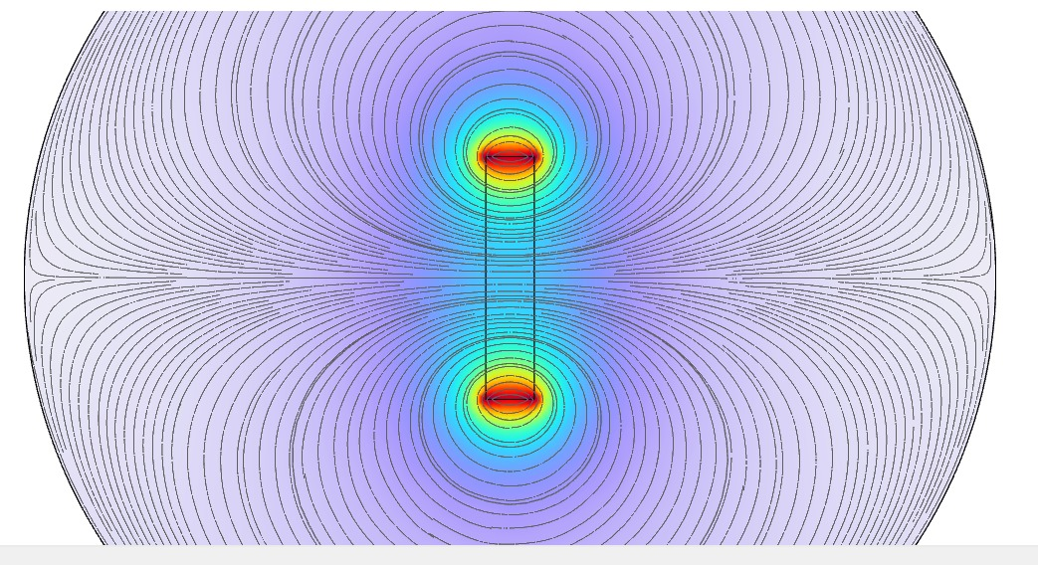
Conclusion
- Validates the theoretical relation:
$$B∝\frac{1}{r^{n}}$$
Working Principle:
The system operates based on the relation between magnetic field and distance.
As the structure compresses:
- Distance between magnet and sensor decreases
- Magnetic field strength increases
This relationship can be approximated as: $B∝\frac{1}{r^{n}}$
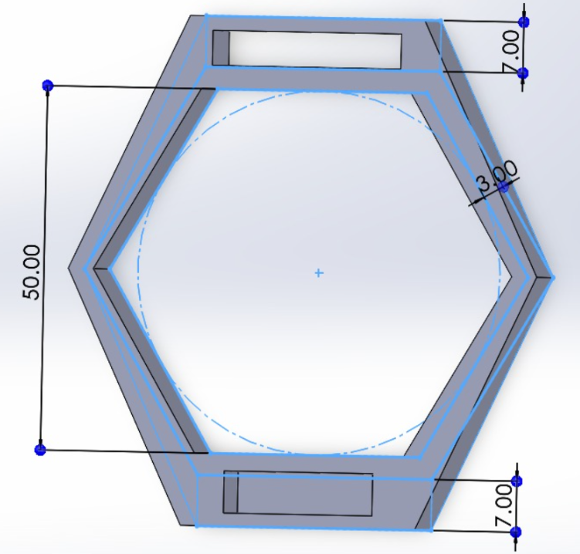
Design and Fabrication:
CAD Model
- Geometry: Hexagonal structure
- Software used: SolidWorks
- Thickness: 20mm
Material
- Material: Thermoplastic Polyurethane (TPU)
- Properties:
  - Elastic modulus: $E≈1.3×{10}^{5} Pa$
  - Density: 30 %
Experimental Setup:
Components Used
- Magnetometer: SmartElex MLX90393 Triple Axis Magnetometer (Used to measure the magnetic field variation due to deformation)
- Microcontroller: ESP32 (Used for data acquisition, processing, and real-time output)
- Magnet:
  - Shape: Cubic
  - Size: 1 cm × 1 cm × 1 cm
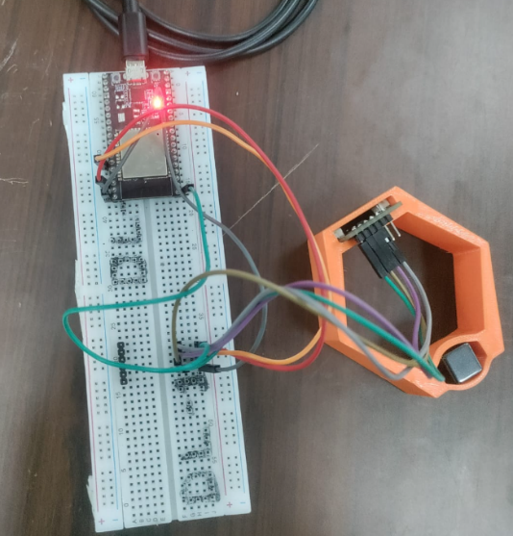
- Hexagonal Structure:
  - Material: Thermoplastic Polyurethane (TPU)
  - Fabrication method: 3D Printing
- Additional Equipment:
  - Gauss meter (for calibration)
  - Connecting wires and power supply
Setup Description
The experimental setup consists of a flexible hexagonal TPU structure with a magnet and magnetometer placed at opposite ends. The arrangement is designed such that any applied force leads to deformation, which changes the distance between the magnet and the sensor.
- The permanent magnet is rigidly fixed at one end of the hexagonal structure.
- The magnetometer sensor is mounted at the opposite fixed end, ensuring it remains stationary during the experiment.
- The ESP32 microcontroller is connected to the magnetometer to record magnetic field readings in real time and transmit the data to a serial monitor or computer.
Working Configuration
- When no force is applied:
  - The structure remains in its original shape
  - Distance between magnet and sensor is maximum
  - Magnetic field reading is at baseline
- When force is applied:
  - The hexagonal structure compresses
  - Distance between magnet and sensor decreases
  - Magnetic field strength increases
Key Considerations
- Proper alignment of magnet and sensor is maintained to ensure accurate readings
- The structure is compressed along its axis of symmetry
- External disturbances (vibration, misalignment) are minimized
Magnetic Field Calibration:
Objective: To determine the relationship between magnetic field strength and distance from the magnet, which is required for interpreting sensor readings in later experiments.
Procedure
- A Gauss meter was used to measure magnetic field strength.
- The magnet was kept fixed, and the distance between the magnet and probe was varied from 10 cm to 1 cm.
- Readings were recorded at different distances while maintaining proper alignment and minimizing external disturbances.
Observations
Distance (cm) | Magnetic Field (Gauss)
10 cm | 0.1
9 cm | 0.1
8 cm | 0.4
7 cm | 1.0
6 cm | 2.0
5 cm | 4.1
4 cm | 7.7
3 cm | 18.1
2 cm | 52.7
1 cm | 181.2

Result
- The magnetic field increases as the distance decreases.
- The variation is non-linear, with a sharper increase at smaller distances.
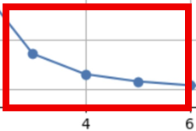
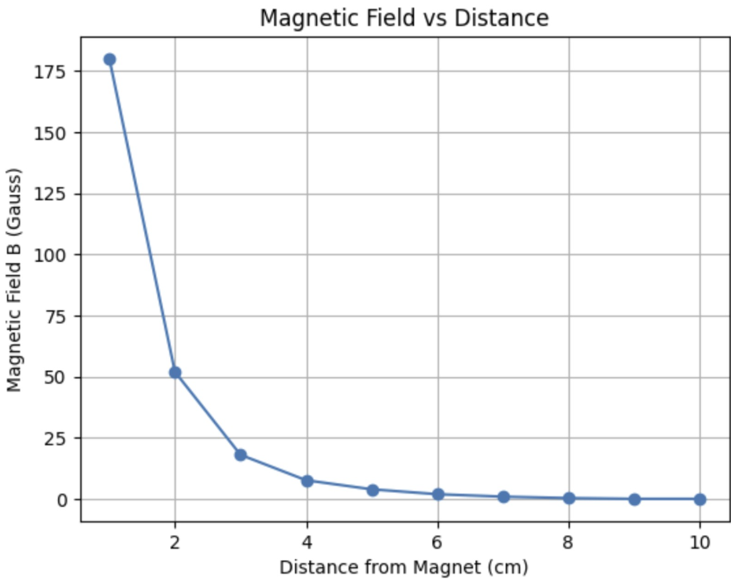
Compared with the practical graph
Conclusion: The calibration confirms the expected inverse relationship between magnetic field and distance. This serves as a reference for relating magnetic field changes to deformation in the hexagonal structure.
Deformation vs Magnetic Field Experiment:
Objective
To study how mechanical deformation of the hexagonal structure affects the magnetic field, and to establish a relationship between deformation and magnetic field variation.
Procedure
- The fabricated TPU hexagonal structure was placed in a controlled setup.
- The sensor was calibrated in the absence of the magnet.
- At the undeformed state, four different values of the magnetic field were recorded, and the average value was used as the reference value for the undeformed state.
- Compression was applied gradually.
- As the structure compressed, the distance between the magnet and magnetometer decreased.
- The magnetometer readings were recorded in real time using the ESP32 microcontroller.
- Corresponding values of deformation and magnetic field were noted for multiple loading conditions.
Axis Calibration and Vector Correction in 3-Axis Magnetometer
- Introduction: In a 3-axis magnetometer system, the measured magnetic field components $\left(B_{x} , B_{y} , B_{z}\right)$are affected not only by the external magnetic field but also by sensor misalignment, scaling errors, and cross-axis coupling. During experimentation, it was observed that even when the magnet is moved along a single axis (e.g., X-direction), all three components change. This behavior arises due to the vector nature of the magnetic dipole field and imperfect alignment between the magnet and sensor axes.
- Need for Axis Calibration: Axis calibration is required to ensure that:
- Each axis responds uniformly to the same magnetic field strength
- Cross-axis interference is minimized
- The measured field accurately represents physical motion of the magnet
- Distance estimation based on magnetic field becomes reliable
Without calibration, the sensor output forms an ellipsoidal distortion instead of a spherical response, leading to inaccurate field interpretation.
- Physical Observation of Cross-Axis Coupling: When a magnet is moved along the X-axis, the expected behavior is that only $B_{x}$should vary. However, experimentally:
- $B_{x}$, $B_{y}$, and $B_{z}$all change simultaneously
- This occurs because the magnetic field of a bar magnet follows a 3D dipole distribution
- The field at any point depends on position vector $\left(x , y , z\right)$, not independent axes
Thus, axis separation is not perfect in raw sensor data.
- Mathematical Representation: The magnetic field of a dipole is given by:
$$B(r)=\frac{μ_{0}}{4πR^{3}}\left[3(m⋅\hat{r})\hat{r}-m\right]$$
This implies that:
- Each component $B_{x},B_{y},B_{z}$depends on all spatial coordinates
- Movement in one axis inherently affects all three components
- Practical Axis Calibration Method: Instead of relying on theoretical alignment, an experimental calibration approach is used:
Step 1: Data Collection
- Move the magnet in all directions (3D motion)
- Record raw values:
$$B_{x},B_{y},B_{z}$$
Step 2: Hard Iron Correction
Remove constant offset:
$$B_{offset}=\frac{B_{max}+B_{min}}{2}$$
Step 3: Soft Iron Correction
Normalize scaling differences:
$$B_{scaled}=\frac{B_{corrected}}{Scale factor}$$
Step 4: Axis Alignment Approximation
Since perfect rotation matrices are complex for this setup, an effective axis is constructed:
$$B_{aligned}=aB_{x}+bB_{y}+cB_{z}$$
where $a,b,c$are experimentally determined weights based on sensitivity.
- Preferred Practical Approach: For this project, instead of relying on individual axis accuracy, the magnetic field magnitude is used:
$$∣B∣=\sqrt{B_{x}^{2}+B_{y}^{2}+B_{z}^{2}}$$
Advantages:
- Independent of sensor orientation
- Eliminates axis misalignment effects
- Provides stable and smooth response
- Suitable for distance estimation models
- Conclusion: Axis calibration improves the reliability of magnetometer readings by correcting offsets, scaling errors, and misalignment effects. However, due to inherent cross-axis coupling in magnetic dipole fields, complete axis separation is not physically achievable. Therefore, the most robust approach for this project is to use vector magnitude $∣B∣$, which provides orientation-independent and stable measurements suitable for distance estimation and force sensing applications.
Observations
Deformation (mm) | Magnetic Field (Gauss)
59.92 | 3.511
57.98 | 3.8756
54.39 | 4.6947
50.46 | 5.8797
46.40 | 7.5637
41.10 | 1.0879
36.54 | 1.5487
31.39 | 2.4432
29.98 | 2.8042
28.94 | 3.1179

Graphical Representation
A graph was plotted between:
- X-axis: Deformation (mm)
- Y-axis: Magnetic Field
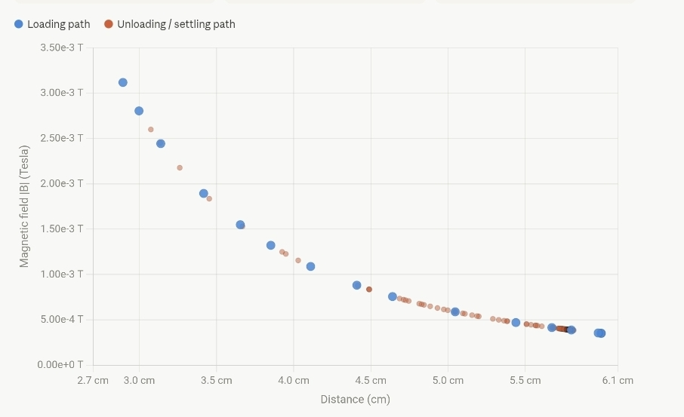
Results and Analysis
- It was observed that the magnetic field increases with increasing deformation.
- This is because compression reduces the distance between the magnet and sensor.
- The relationship is non-linear, with a steeper increase at higher deformation values.
Key Insight
- Small deformation produces measurable changes in magnetic field
- Sensitivity increases as the magnet comes closer to the sensor
Conclusion
The experiment confirms that deformation of the hexagonal structure leads to a predictable change in magnetic field. This validates the working principle of the system and shows that magnetic field variation can be used to estimate deformation and applied force.

UTM Testing:
Objective: To determine the mechanical properties of TPU material and the hexagonal structure by obtaining their stress–strain behavior, and to relate this behavior to the deformation observed in the force sensing experiment.
TPU Cylindrical Sample
- A standard TPU cylindrical specimen was prepared according to ASTM standards.
- The sample was tested using a Universal Testing Machine (UTM) under compressive loading.
Procedure
- The specimen was placed between the compression plates of the UTM.
- Load was applied gradually, and corresponding deformation was recorded.
- Stress and strain values were calculated from the load and displacement data.
Graph: Stress vs Strain
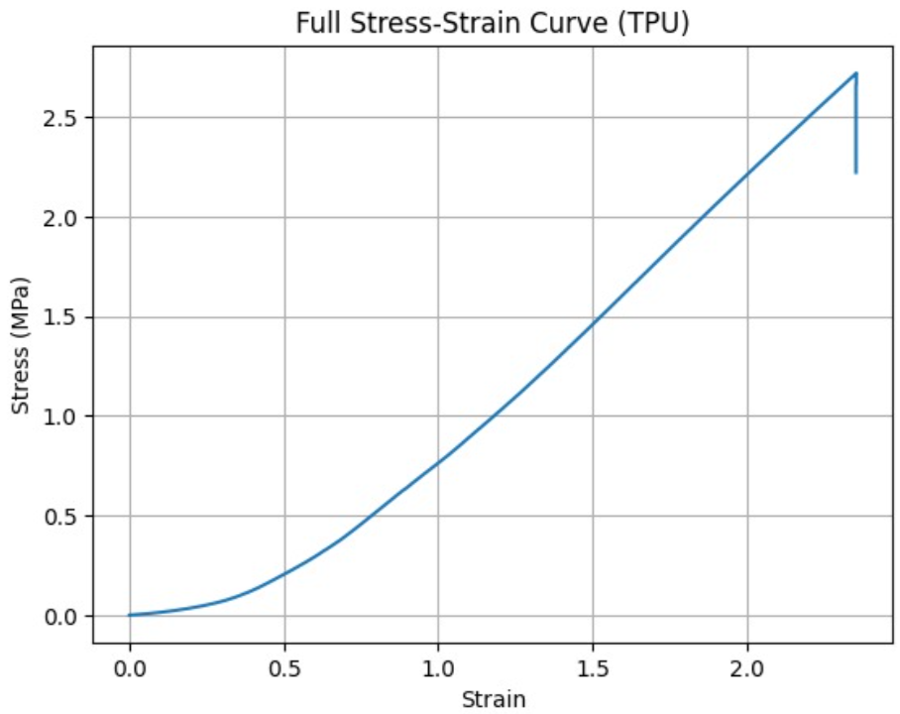
Young’s Modulus (calculated using the graph): $E≈1.3×{10}^{5} Pa$
Hexagonal Structure Testing
- The same compression test was performed on the 3D printed hexagonal TPU model.

Procedure
- The hexagonal structure was placed in the UTM.
- Load was applied along its axis of symmetry.
- Deformation and corresponding force were recorded.
Graph:
Force vs Displacement:
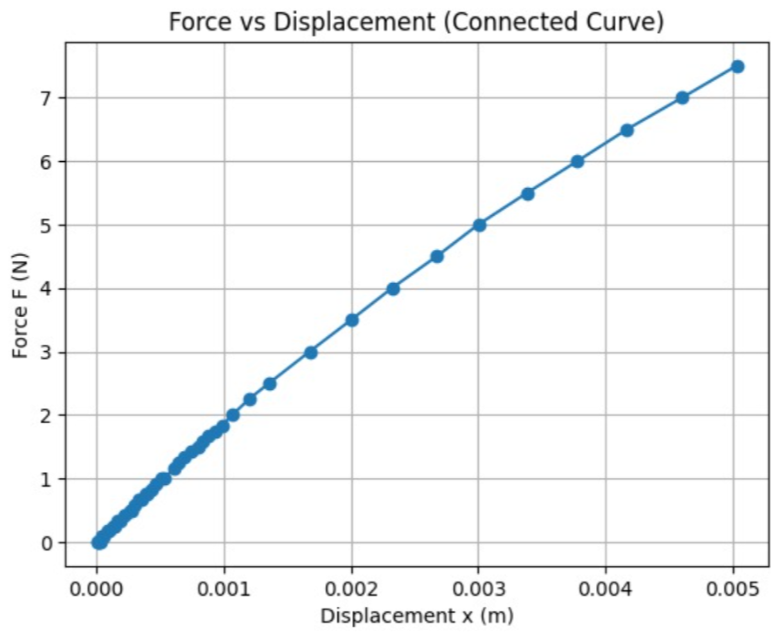
Stress vs Strain:
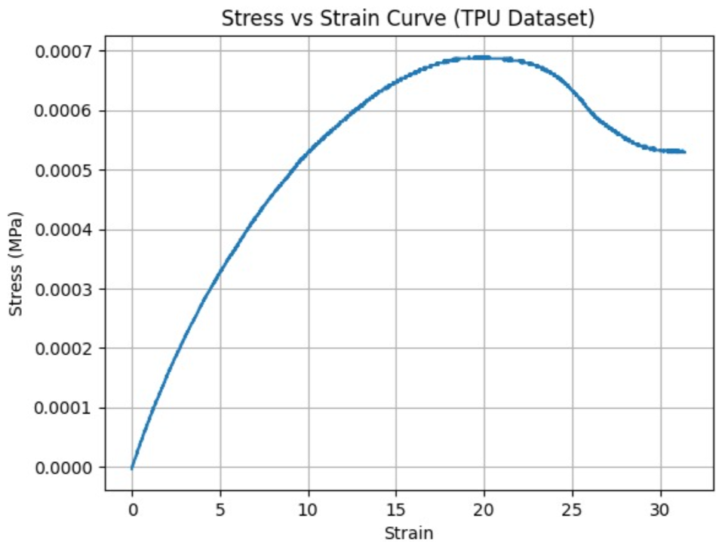
Equivalent Spring Constant (calculated from the above curve): $k≈1500 N{.m}^{-1}$
Results and Comparison
- The TPU cylindrical sample showed a relatively uniform and predictable stress–strain curve, representing the base material behavior.
- The hexagonal structure exhibited:
  - Lower stiffness
  - Higher deformation for the same load
  - Non-linear behavior due to geometry
Key Insight
- The difference in behavior confirms that:
Geometry plays a major role in flexibility and deformation, not just material properties.
Conclusion
UTM testing successfully provided the mechanical characterization of both the material and the structure. The results help in understanding how applied force leads to deformation, which is essential for correlating force with magnetic field variation in the sensing system.
Results and Discussion:
The experimental study provides a clear relationship between mechanical deformation and magnetic field variation. The system demonstrates that even small compressive forces applied to the TPU structure lead to measurable changes in magnetic field intensity.
Magnetic Field vs Distance Behavior
The calibration results confirm that magnetic field strength increases sharply as the distance between magnet and sensor decreases. The observed trend follows a non-linear inverse relationship, consistent with theoretical dipole field behavior.
Key observations:
- Strong sensitivity at small distances (< 5 cm)
- Gradual flattening of response at higher distances

Deformation Response
Under compression, the hexagonal TPU structure behaves elastically within the tested range. The deformation causes a proportional increase in magnetic field reading.
Important findings:
- Initial region shows near-linear response between deformation and magnetic field
- At higher compression, slight non-linearity appears due to geometric instability
Force–Magnetic Coupling
By combining UTM data with sensor output, a coupled relationship between force and magnetic field can be established. This enables indirect force sensing using only magnetic measurements.
Difficulties Faced During Experiment:
During the execution of the project, several practical challenges were encountered:
Alignment Issues: Maintaining perfect alignment between magnet and magnetometer was difficult. Even small angular misalignment caused fluctuations in readings.
Manual Loading Errors: Force was applied manually in initial trials, leading to inconsistent deformation rates and non-uniform data points.
Sensor Noise: The magnetometer readings showed minor fluctuations due to electromagnetic interference and ESP32 ADC noise.
Calibration Limitations: Limited access to precision gauss meter reduced the resolution of magnetic field calibration.
Weekly Progress Report (8 Weeks):
Week 1
- Literature review on magnetometer-based sensing
- Initial concept development
Week 2
- CAD design of hexagonal TPU structure
- Selection of material and magnet
Week 3
- Simulation of magnetic field distribution (COMSOL basic model)
- Refinement of geometry

Week 4
- TPU 3D printing and prototype fabrication
- Basic assembly of magnet and sensor setup
Week 5
- ESP32 programming and sensor interfacing
- Initial data acquisition tests
Week 6
- Magnetic field vs distance calibration experiments
- Data logging improvements
Week 7
- UTM testing of TPU samples
- Force vs deformation data collection
Week 8
- Final integration of all datasets
- Graph plotting, analysis, and report preparation
Future Scope:
Stackable Integrated Model (Helmet Application)
A major extension of this work is the development of a stacked multi-layer sensing system, where multiple hexagonal TPU units of small size are integrated vertically and embedded into a wearable structure such as a helmet.
Concept:
- Each hexagonal unit acts as an individual force sensor
- Multiple units stacked to form a 3D sensing grid
- Entire structure embedded inside protective gear

Helmet-Based Application:
- Impact detection in helmets
- Crash force mapping in real time
- Directional force sensing (front, side, top impacts)
Improvements
- Replace a single magnet with calibrated magnetic arrays
- Use digital force actuators for controlled testing
- Improve sensor fusion using multiple magnetometers
- Wireless data transmission system
Applications:
- Soft robotics
- Wearable force sensing systems
- Helmet impact detection systems
Conclusion:
The project successfully demonstrates a low-cost and flexible force sensing system using a TPU hexagonal structure and magnetometer-based detection. The results validate that mechanical deformation can be effectively translated into measurable magnetic field variations, establishing a clear coupling between applied force, structural deformation, and magnetic response.
The experimental observations from both calibration and deformation testing confirm that the system is capable of capturing consistent trends, particularly in the low to moderate force range. Despite minor experimental limitations such as alignment errors and sensor noise, the overall behavior remains stable and repeatable, making the concept viable for practical sensing applications.
Furthermore, the integration of ESP32 for data acquisition proves that real-time monitoring is feasible with low-cost embedded systems. The project also highlights the potential of soft materials like TPU in developing compliant sensing structures that can replace or complement traditional rigid sensors.
The system shows strong potential for future development into wearable and stacked sensing architectures, particularly for safety and biomedical applications.
References:
- ASTM standards for TPU testing
- ESP32 technical documentation
- Research papers on magnetic sensing in soft robotics

