**TITLE:** Internet of Things - Based Pump Control System

**INTRODUCTION:**

The ‘Thing’ in IoT can be any device with the ability to collect and transfer data over a network without manual intervention. The embedded technology in the object helps them to interact with internal states and the external environment, which in turn helps in decisions making process.

A document containing the standards, logic, errors & exceptions will be added to the tester. Again, if there are any issues it can be resolved. It may take multiple iterations & in this manner a smart application will be created.

When a user gathers the data through his/her analysis, user sends it over the network to the controller by Wi-Fi module connected to the motor of the pump so that it can be started or to be stopped.

**OBJECTIVE:**

To Control the Pump from ANYWHERE!

**SYSTEMS:**

* + Control Unit system
  + User Interface (Cloud)

**Control Unit**

Controller

Wi-Fi Module

Relay

Current Sensor

Indicator

**Controller Requirements**

RAM : 64 kb

Flash Memory: 4 Mb

Clock Speed : 80 MHz

Networking : 2.4GHz 802.11n wireless

Operating Voltage: 5 V

**User Interface**

Web Page (Cloud)

* + - Pump Connection Status
    - Pump Control
    - Pump Status
    - Pump Current Range Status

**ARCHITECHTURE**

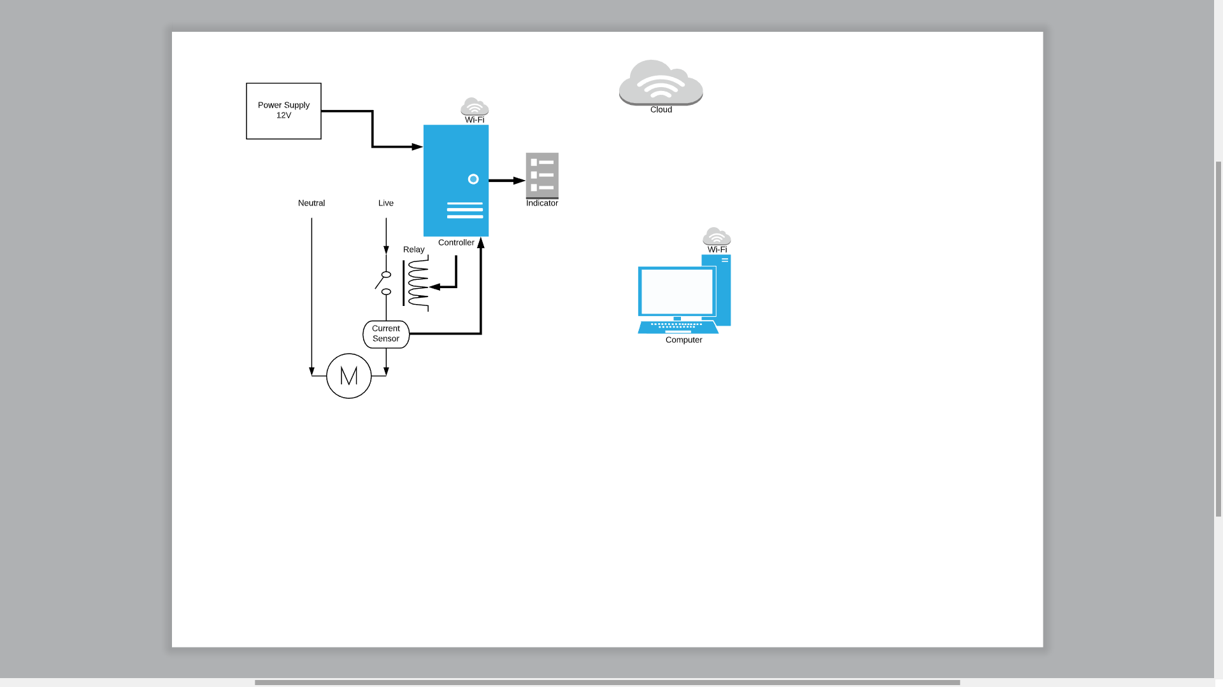

**WORKING**

**BUDGET ESTIMATION**

|  |  |  |
| --- | --- | --- |
| Sr. No. | Requirement | Approx. Cost (Rs.) |
| 1 | Controller |  |
| 2 | Wi-Fi Module | 160 |
| 3 | Relay | 130 |
| 4 | Current Sensor | 200 |
| 5 | LEDs (3) | 15 |
| 6 |  |  |
| 7 |  |  |
|  | Total | Rs. 505 |