ANNASAHEB DANGE COLLEGE OF ENGINEERING AND TECHNOLOGY, ASHTA

**DEPARTMENT OF MECHANICAL ENGINEERING**

**PROJECT SYNOPSIS**

**Name of program** : Mechanical Engineering

**Name of student** : Pratik Haribhau Rohane

**Name of guide** : Mr A. S. Dabhole

**Title of Project** : IOT Based Pump Control System

**Domain of Project** : Internet of Things & Automation

**INTRODUCTION**

The ‘Thing’ in IOT can be any device with the ability to collect and transfer data over a network without manual intervention. The embedded technology in the object helps them to interact with internal States and external environment, which in turn helps in decisions making process.

A document containing the standard, logic, error and exceptions will be added to the tester. Again, if there are any issues it can be resolved. It may take multiple iterations and in this manner a smart application will be created.

When the User send the data over the internet to the Controller by Wi-Fi module, the state of the motor connected to Pump can be controlled through the Cloud.

**OBJECTIVE:**

* Monitor Pump Status
* Send Command to the Controller
* Control Pump System over Internet

**SYSTEMS:**

* + - Control Unit system
    - User Interface (Cloud)

**Control Unit**

Controller

Wi-Fi Module

Relay

Current Sensor

Indicator

**Controller Requirements**

RAM : 64 kb

Flash Memory : 4 Mb

Clock Speed : 80 MHz

Networking : 2.4GHz 802.11n wireless

Operating Voltage: 5 V

**User Interface**

Web Page (Cloud)

* + - Pump Connection Status
    - Pump Control
    - Pump Status
    - Pump Current Range Status

**ARCHITECHTURE**

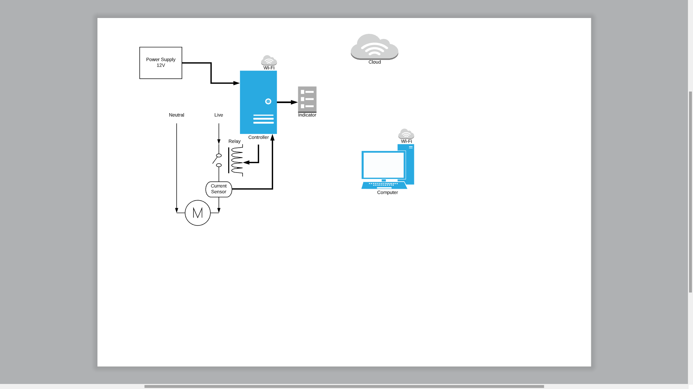

**WORKING**

To monitor the Motor status LEDs of Indicator should be Steady. The Indicator having the three LEDs which indicate System ON/OFF, Wi-Fi connection and Internet available. System Led will ON if the power supply will provide the system. Wi-Fi Led and Internet Led will blink continuously till the Wi-Fi network and Internet will not available. Once it steady means the system can be monitor from the web page or Cloud.

The 12V power supply will be provided from the adaptor which will further be rectified to 5V using Transistor and provide to the Controller. A controller connected to the Internet through the Wi-Fi module. Relay is attached to the Live wire of motor power supply which works as a Switch and that can control through the Cloud via controller. The Live wire is connected with the Current Sensor which measures the current and it will be displayed on the Cloud. Measuring Current helps to find out Overload and Dry run Condition and the Working Range. If the Current exceed the Working Range motor will turn OFF automatically.

On the cloud, the User interface provides with Motor status which shows the system is connected with the power supply and Wi-Fi network having a proper internet connection. One Button is provided on the dashboard which can control the relay from anywhere over the Internet.

Date:

Place: ADCET, Ashta

**Guide, Head,**

Mr. A. S. Dabhole Dr. S. P. Chavan

Mech. Engg. Dept. Mech. Engg. Dept.