1. **What are different artifacts you need to create - name of the artifacts and its purpose**

azuredeploy.json & [azuredeploy.parameters.json](https://github.com/pratikibm/Maersk_Assesment/blob/master/azuredeploy.parameters.json)

1. **List the tools you will to create and store the ARM templates.**
   1. Visual Studio Code with Azure Resource Manager tools extension installed can be used to create ARM template
   2. ARM template can be stored in Azure Repos. It will also provide Version controlling.
2. **Explain the process and steps to create automated deployment pipeline.**

Following steps are needed to create automated deployment pipeline:

* 1. ARM template must be present in the Repository.

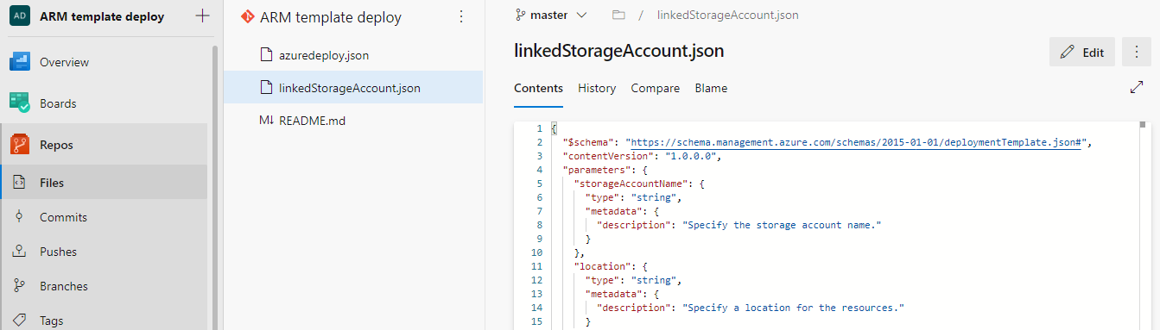

**Fig. ARM template in Repos**

* 1. Service Connections of “Azure Resource Manager” will also be needed. Following details are needed to create Service Connections.
     1. Subscription Id
     2. Subscription Name
     3. Service Principal Id (Client ID)
     4. Service principal key
     5. Tenant ID

Goto **Project Settings** -> **Pipelines** -> **Service connections -> Create service connection** to create service connection

* 1. Once the above steps are completed create a new Pipeline. And add following tasks.
     1. Azure Key Vault
     2. ARM template deployment

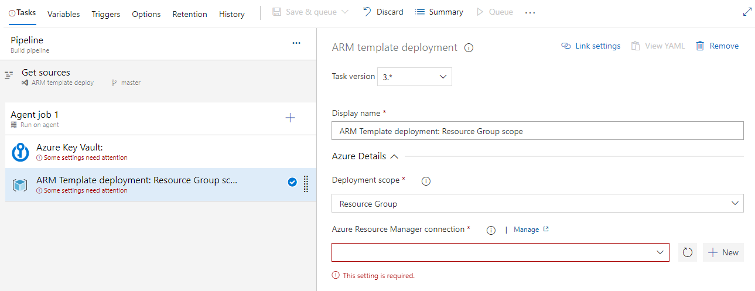

**Fig. Tasks in Azure Pipeline**

* 1. Select **Azure Key Vault** and fill in the details.

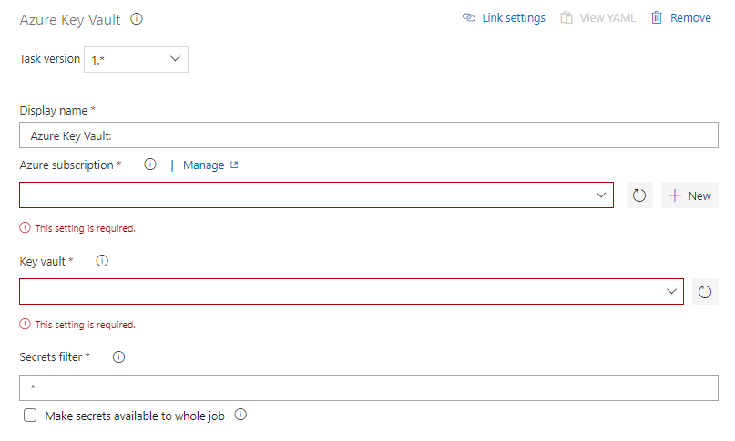

**Fig. Azure Key Vault**

* + 1. **Azure Subscription**: Select the Service Connection created earlier form drop down.
    2. **Key vault:** Select the Key vault to use.
    3. **Secret filter:** Enter the comma separated list of secret names. To load all use “*”.
  1. Select the **ARM template deployment** taskand enter the details.
     1. **Template:** Select the template from the Azure Repos.
     2. **Override template parameters:** Enter values in this format

**-adminPassword “$(vmpassword**)”

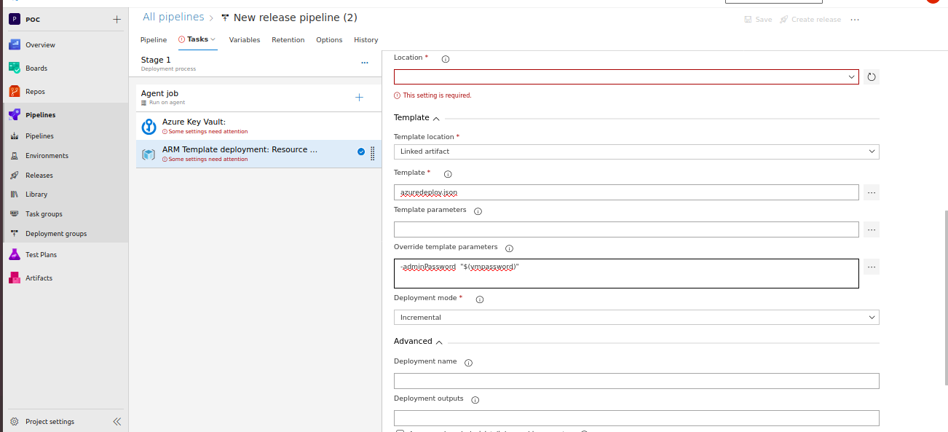

**Fig. ARM template deployment**

1. **Create a sample ARM template you will use to deploy a Windows VM of any size**

please check repository for sample Arm template code.

1. **Explain how will you access the password stored in Key Vault and use it as Admin Password in the VM ARM template.**
2. In Azure DevOps it is possible to Connect to Azure Key Vault using a task named in “Azure Key Vault”. It will load the latest values for the secrets specified in the task. (If * is used all the secrets in the Key Vault will be loaded in Azure Devops).
3. The secrets will be available to all the tasks in the pipeline unencrypted.

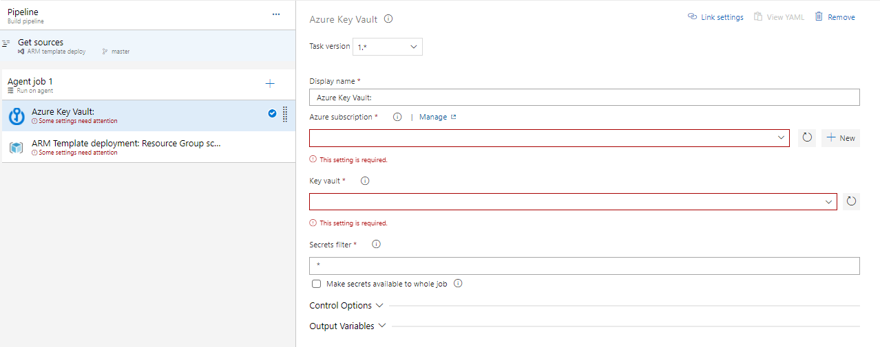**Fig. Azure Key Vault**

1. Following details will be needed to create Service principle for the task:
   * + 1. Subscription Id
       2. Subscription Name
       3. Service Principal Id (Client ID)
       4. Service principal key
       5. Tenant ID
2. This task will assign the secrets to a variable named same as the name of secret in Key Vault.

Eg. A secret name “adminPassword” in Key Vault will be named as “$(vmpassword)” in Azure DevOps which can be directly used in the “ARM template deployment” task for Overriding template parameters.

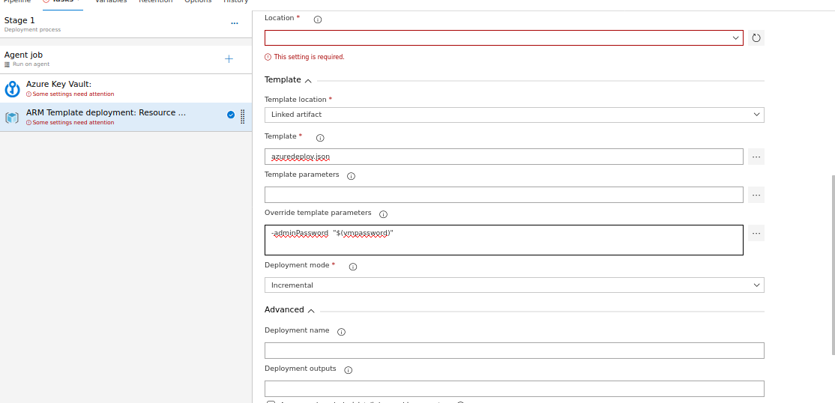

**Fig. Secret Substitution in ARM template**